Wavell School-GCSE History
Paper 3: Germany 1919-39
Class Revision Booklet

Name:
Class:
Teachers name:
Classroom:

Germany | Timing – Paper =1 hr 20 mins | With 25% Extra Time = Approx. 1 hour 40 mins
Q1 – 4 marks | -5 mins | -7 mins
Q2 – 12 marks | -15 mins | -20 mins
Q3A – 8 marks | -15 mins | -20 mins
Q3B – 4 marks | -10 mins | -12 mins
Q3C – 4 marks | -5 mins | -7 mins
Q3D – 16 marks (+4 SPaG) | -30 mins | -34 mins

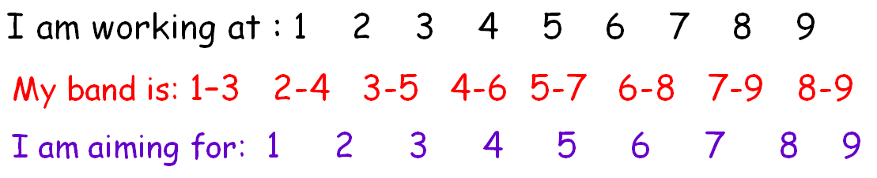

My Mock Feedback and assessment feedback:

Keywords

- Abdication – a leader, like a King or Queen, giving up their throne or position
- Anti-Semitism - hostility to or prejudice against Jews
- Armistice - an agreement made by opposing sides in a war to stop fighting for a certain time; a truce
- Boycott – withdrawing from something as a punishment or protest
- Censorship – Censorship involves banning information or ideas. It sometimes involves banning the vehicles for delivering ideas, such as newspapers, pictures, radio, or film. Censorship therefore controls attitudes by forbidding certain information
- Civil servant – somebody who works for the government in some way
- Communist – Communism is an extreme form of government, in which representatives of the workers set up a government and take over ownership of all land, property and resources in a country. It was associated with Germany’s enemy, Russia
- Constitution – the rules which set out how a country is run
- Democracy - a system of government formed through elected representative
- Dictatorship - a country governed by one ruler with total power
- Diktat – Imposing something upon someone without them agreeing to its terms (this is how German’s viewed the Treaty of Versailles)
- Dolchstoss – the stab in the back
- Electorate – people who are allowed to vote in an election
- Freikorps – Soldiers who has been released from the army after WW1
- Hyperinflation - monetary inflation occurring at a very high rate
- Inflation - a general increase in prices and fall in the purchasing value of money
- Lander – The local governments within the Weimar Constitution
- Nationalism – A political outlook in which all policies are organised to make the nation stronger and more independent
- Paramilitary force – a private group run like a military force
- Propaganda – A way of controlling public attitudes. Propaganda uses things like newspapers, posters, radio, and film, to put ideas into people’s minds and therefore shape attitudes.
- Putsch – A violent uprising intended to overthrow existing leaders
- Real wages – a measure which does not reflect the actual monetary value of wages, but the buying power of wages
- Republic – the people and their elected representatives hold supreme power, and there is an elected or nominated president rather than a monarch
- Reichstag – the more powerful house of the German parliament which controlled taxation
- Reichsrat – The lower house of the constitution which could delay new laws unless the Reichstag overruled it by a two-thirds majority
- Socialism – a political outlook, which stresses that a country’s land, industries and wealth should all belong to the workers of that country
- Trade unions – Groups of workers formed to protect the rights and interests of workers in various occupations
Knowledge Audit | Confident | Unsure | Not at all
Key Topic 1: The Weimar Republic 1918-29
The legacy of WW1- abdication of the Kaiser, the armistice and revolution 1918-19
The Treaty of Versailles – its terms and effects
Reasons for German resentment of the treaty
How a new constitution was agreed
The terms of the new Weimar constitution
The weaknesses of the constitution
The bankruptcy of the new Weimar government
The occupation of the Ruhr
Inflation and hyperinflation
The main political groups in the Weimar Republic
The political unrest in the Weimar Republic during 1918-23 – threat from left and right
Stresemann’s reforms to end the currency crisis
Reducing reparations: the Dawes Plan and Young Plan
Successes abroad: the League of Nations, Locarno, Kellogg-Briand
Changes in society 1924-29 – standard of living, women, cultural changes e.g. architecture, art, cinema.
Key Topic 2: Hitler’s Rise to Power
Hitler’s first political activity
The German Workers’ Party (DAP) when Hitler joined
The early Nazi Party, its aims and early features, including the SA
The causes, events and results of the Munich Putsch
The political ideas of the Nazi Party after 1924, including nationalism, socialism and totalitarianism
Traditional German values, struggle and ‘racial purity’
How Hitler improved the organisation and finances of the NSDAP. The Bamberg Conference 1926.
The growth of the SA, the start of the SS
Joseph Goebbels and Nazi propaganda
Weak Nazi results in national elections 1924-29
The causes of the Great Depression in Germany
The effects of the Great Depression in Germany
How much the support for the Nazis grew, 1929-32
Who supported the Nazis, 1929-32
Hitler standing for election as president
A series of chancellors falling from power
Hitler becoming Chancellor in January 1933
Key Topic 3: Nazi Control and dictatorship, 1933-39
The Reichstag Fire and election of March 1933
The Enabling Act, the banning of political parties and trade unions
The Night of the Long Knives
The death of President Hindenburg
Himmler, the SS and the Gestapo
Nazi concentration camps and the law courts
Repression of the Church in Nazi Germany
How the Nazis used censorship to ban information and ideas which they don’t like
How the Nazis used propaganda to publicise information and ideas which they wanted to promote
The extent of support for the Nazis
Opposition to Hitler from the Church
Opposition to Hitler among some young people
Key Topic 4: Life in Nazi Germany 1933-39
Schools in Nazi Germany
Hitler’s youth movement
Nazi views on the role of women
Nazi policies to increase marriage and childbirth
Opposition to Nazi views on women
Hitler’s policies for German workers
Hitler’s policies for Germany’s unemployed
Hitler’s policy of rearmament and its economic effects
Rises in employment, wage levels and consumer spending
Changes in working conditions
Rises in prices
The overall effect of the above three changes on German living standards
The persecution of the Jews in Nazi Germany
Nazi persecution of other racial minorities
Nazi persecution of other minority groups in society

Task: Write down your top 3 actions that you need to work on for the Germany unit and how you will do it:
1.
2.
3.
I can attend revision/catch-up/ homework help on………………………………………………………………………………………
The aim of this booklet is that you will complete all tasks and try to move onto the next task. There will be exam practice questions at the end of each lesson – you must try to get to these. Planning or answering the questions as directed – planning can go next to the question. There are lined pages at the back of the booklet.
You may not take these booklets home until your teacher says you can e.g. when the unit has been fully revised.

Exam Question Criteria
Section A: 20 mins
- Question 1 – 4 marks (5 mins)
- 2x supported inferences
- Question 2 – 12 marks (15 mins) -3 x PEE – you will need to explain causation and show key knowledge.
Section B: 60 mins
- Question 3 (a) – 8 marks (15 mins) This question will ask you how useful two sources are. Analyse each source – COP (Content, own knowledge and provenance (nature, origin and purpose) –explain how useful they are in telling us about the topic in the question focus.
- Question 3 (b) – 4 marks (10 mins) This question will ask you how two interpretations differ. Remember to identify a main difference and then use details from both interpretations to support your answer. 1XPE – make a point and back it up with evidence from both sources – clearly show the difference e.g. Interpretation 1 says …..’…..’, whereas Interpretation B says…….’……..’..
- Question 3 (c) – 4 marks (5 mins). -This question will ask you why the interpretations differ. Give a clear reason for the difference between the views in the interpretations (maybe historians have chosen to give weight to different evidence? Came to different conclusions using the same evidence? Have a different emphasis on the topic?). Then use both sources to show this difference.
Structure:
The interpretations may differ because…. For example in Source …. it describes/suggests that …. This supports Interpretation … as it says….. Whereas, Source …. suggests that ……..which supports Interpretation … as it says…..
- Question 3 (d) – 16 marks (4SPaG marks) (30 mins) This question will ask you how far you agree with an interpretation.
Structure:
- State the view given in the interpretation using evidence from the interpretation stated in the Q. itself.
- Agree with the view given in interpretation …. (the one in the Q.) using your own knowledge.
- Disagree with the view given in interpretation …. (the one in the Q.) using the other interpretation.
- Disagree with the view given using your own knowledge.
- Make a judgement – how far do you agree with the interpretation – why? Weigh up the evidence? Are any other reasons important?
Date: Lesson 1: The origins and early challenges to the Weimar Republic 1919-23
L.O. To revise the origins of the Weimar Republic and the problems it faced in its early years.
The Weimar Republic, 1918-33

The Weimar Republic was set up after World War One when Germany was defeated. In its early years it experienced a number of difficulties. However, between 1924-29 it experienced a period of recovery but was later badly affected by the Great Depression.
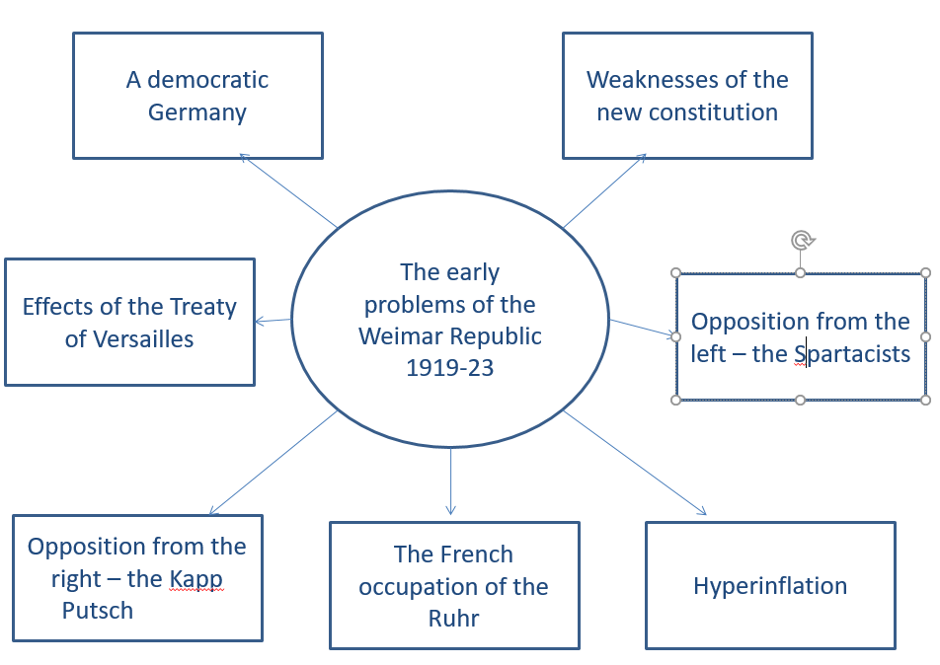
Key terms:
- Weimar Republic – a republic is a country without a hereditary ruler, such as a king or emperor. The new Government first met in the town of Weimar.
- Abdication – to give up the throne.
- Kaiser – emperor.
- Chancellor – Chief minister (like the Prime Minister of Britain).
- Armistice – a ceasefire.
- Constitution – an agreed method of governing a country, with the details usually written down and agreed on by those being governed.

The Legacy of the First World War
- Germany had endured a long war against the Allies (Britain, France, Russia, Italy and the USA).
- The German government’s debts trebled between 1914 and 1918, from 50 billion marks to 150 billion.
- The German people suffered too – over 750,000 Germans died because of food shortages during the war.
- There was a revolution in Germany Oct-Nov 1918
- The British navy had imposed a naval blockade of German ports which left Germany short of food and essential supplies. The winter of 1917-18 became known as the ‘turnip winter’
- The British, French and US armies had driven the German troops out of France and Belgium and were close to the German borders.
- A flu epidemic was sweeping the country, killing thousands of people already weakened by rations.
- The revolution began with sailors in the port of Kiel, who in October refused to go to sea and marched on Berlin instead.
- In Berlin, the Kaiser and his ministers had lost control.
Setting up the Weimar Republic 1918-19
- On 9 November, the Kaiser was forced to abdicate and went into exile in the Netherlands, there was a new German Republic
- The leader of the SPD, Friedrich Ebert, made an agreement with the army and named 6 moderate politicians who would form the Council of People’s Representatives. Ebert’s representatives signed the armistice ending WW1
- The nine months from November 1918 to July 1919 were uneasy for the new Republic, however, Ebert won the support of the trade unions, and leading industry officials.
The Armistice: On the 11th November – Ebert’s representative, Matthias Erzberger, signed the armistice. It was the formal agreement between Germany and the Allies to end WWI. This was their first major decision.
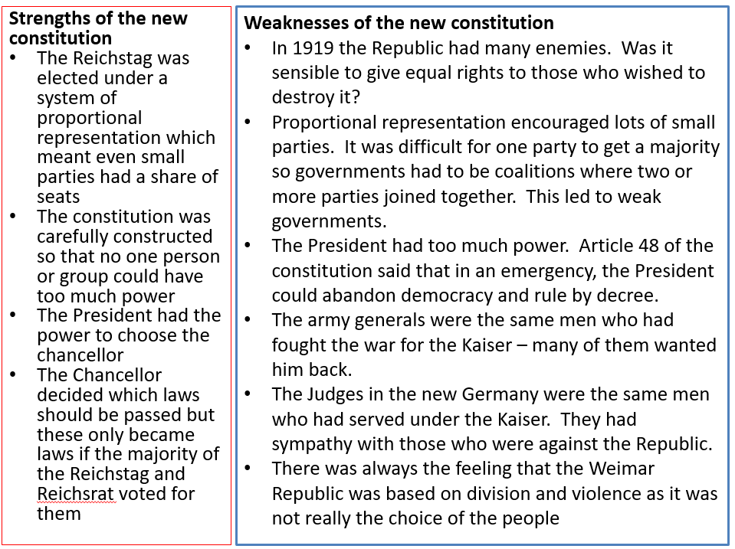
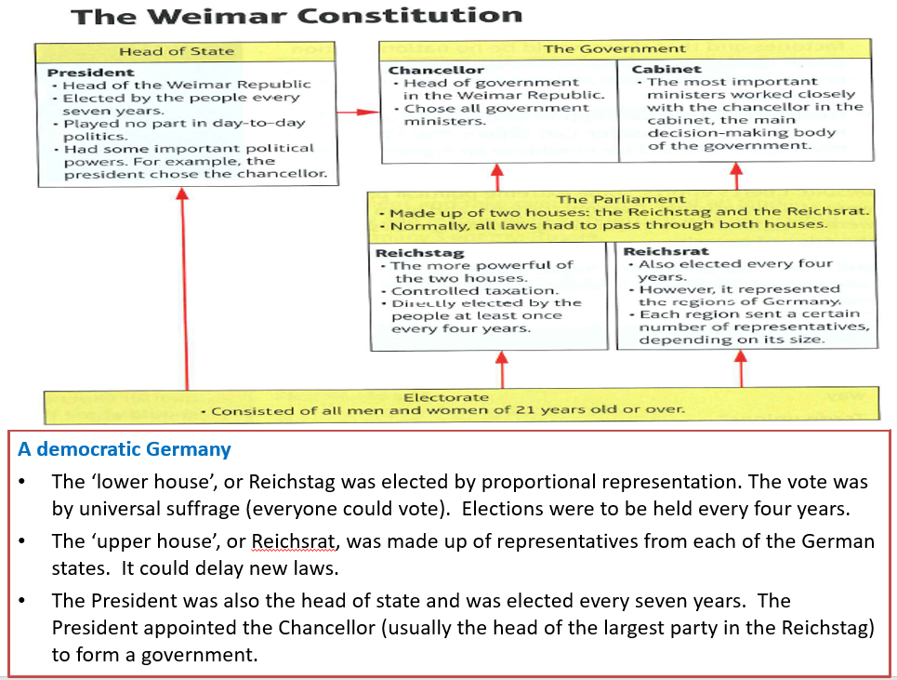
 | Terms | German reaction
Military terms |  | Humiliation- felt weakened and vulnerable. Angry at loss of strength and power.
War guilt | Article 231 – Germany had to accept all of the blame for the war. | Diktat – dictated peace – unfair that they did not get a say in the terms. Blamed the ‘November Criminals’ – the Weimar Government for accepting the terms.
Rhineland | Demilitarised – not allowed to keep troops there. | Humiliation – can’t protect Germany.
Reparations | Set at 6.6 billion  Paid in ………………. | Angry and bitter – the terms were too harsh. Germany could not afford it. Hated the Allies
Loss of land |  | Angry and humiliated. Lost resources and people. Germany not as great and was weakened.
Treaty of Versailles

The Freikorps: They were anti-communist and worked with the regular army. Wanted strong Kaiser type leader. By March 1919, there were 250,000. Members of the Freikorps took the law into their own hands and used violence to further their political cause.
Political murders by the right wing
There were several political assassinations e.g. Hugo Haase (member of House of Representatives), Matthias Erzberger, the politician who signed the surrender to the Allies in 1918, was shot and killed in August 1921 and Ebert’s foreign minister Walther Rathenau was machine-gunned to death in Berlin in June 1922. There were 376 political murders between 1919-22 of left wing or moderate politicians. Not a single right-wing murderer was convicted and executed – the legal system was often filled with right-wing supporters. The Freikorp helped Ebert fight the left.
Threats 1919-23 | Outline of events | Consequences e.g. on Germany/ the Weimar Republic
Spartacist revolt (left wing  Date: | Led by: Karl Liebnecht and Rosa Luxenburg  Why? Wanted a soviet style revolution. Wanted to be ruled by worker’s councils or soviets.  What happened?
Kapp Putsch (Right wing)  Date: | Led by: Dr Wolfgang Kapp  Why? Liked the Kaisers dictatorial style government. Wanted Germany to be strong – army, empire etc.  What happened?
French Invasion of the Ruhr  Date: | Why?  What happened?
Hyperinflation  Date: | What is it?  What caused it?  Events?  Who suffered and why?  Who benefitted?
Exam questions: Question 1: This is an inference question – you get 5 minutes for this question. You need two supported inferences:
Sentence starters: I can infer………… Details in the source that tell me this are …..
I can also infer…………. Details in the source that tell me this are …..

Question 1: Give two things you can infer from Source A about German reaction to the Treaty of Versailles. (4 marks)
Source A – From a German newspaper, Deutsche Zeitung, 28 June 1919
Vengeance! German nation! Today in the Hall of Mirrors [Versailles] the disgraceful treaty is being signed. Do not forget it. The German people will, with unceasing work, press forward to reconquer the place among nations which it is entitled. Then will come vengeance for the shame of 1919.

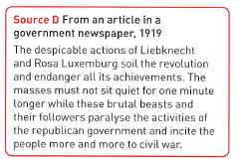
Question 1: Give two things you can infer from Source D about the Spartacists. (4 marks)

Question 2)
Tip: A good answer will:
- Include 3 factors – 3 xPEE – link your explanation to the question – e.g. why, what did it lead to?
- Contain detailed information about each factor
- You get at least 2 pages of lines for this question.
- You would have 15 minutes to answer this question.
Structure:
Paragraph 1: Explain the first factor given as stimulus - PEE.
Paragraph 2: Explain the second factor given as stimulus - PEE.
Paragraph 3: Explain a third factor of your own - PEE.

Q2: Explain why there were economic problems in the Weimar Republic from 1919 to 1923.
You may use the following in your answer:
- reparations
-the French occupation of the Ruhr
You MUST also use information of your own. (12 marks)

Date: Lesson 2: The recovery of the Republic, 1924-29
L.O. To revise the recovery made by Germany under Stresemann and changes in society 1924-29
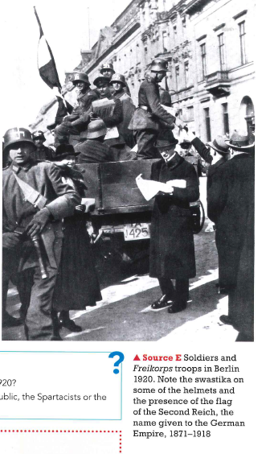
Question 1: Give two things you can infer from Source E about the Freikorps. (4 marks)
I can infer……………………………………………………………………………………….
…………………………………………………………………………………………………………….
Details in the source that tell me this are ………………………………
…………………………………………………………………………………………………………..
I can also infer…………………………………………………………………………………
…………………………………………………………………………………………………………….

Details in the source that tell me this are ………………………………
…………………………………………………………………………………………………………..

Task: How had Germany changed in the years 1923 – 29 as a result of Stresemann’s policies?
- 1923 Occupation of the Ruhr
- 1923 Hyperinflation
- 1923 Munich Putsch
- 1923 Stresemann becomes Chancellor of Germany
- 1924 Dawes Plan
- 1924 – 1929 The Golden Years of Weimar
- 1929 The Wall Street Crash

How had Germany changed in the years 1923 – 29 as a result of Stresemann’s policies?

 | 1923 | 1929
The economy | - Invasion of the Ruhr Jan 1923 over reparations payments.  - To meet demand the government printed more money = hyperinflation  - The mark became worthless and the economy collapsed | Rentenmark, Nov 1923  Dawes Plan, 1924  The Young Plan
Political Situation | - Many people were unhappy with the terms of Versailles and were unhappy with a Republic that accepted it.  - By supporting passive resistance during the Ruhr crisis many were happy to have a government that stood up for Germans.  - For others - unrest led to the Munich Putsch in November 1923 | Impact of domestic policies? Impact of Stresemann’s attempts to remove hardships?
Foreign policy | - Germany very isolated from the world community | The Locarno Pact, 1925  Germany joined the League 1926  Kellogg-Briand Pact 1928

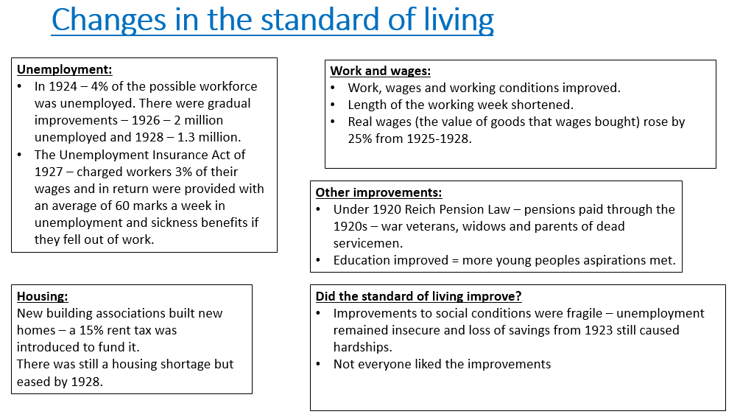
Changes for women
- Politics – women were given the right to vote by the Weimar Government. In elections the turnout of women was 90%. By 1932- 112 women had been elected to the Reichstag.
The Weimar Constitution: Women had equal rights with men. Marriage was an equal partnership, with equal rights. Women should be able to enteral professions on an equal basis
- Work – during WWI more women worked – by 1918 – 75%. Under the Weimar Republic women’s lives generally went back to the way they were before the war. By 1925 – 36% of women were in work.
- Despite the new laws – women were not treated equally: Where men and women were in the same job – on average they were paid 33% less than men. Women were expected to give up work once married. Few women entered the high-status professions
- There was some progress: In booming retail and service sectors – there were plenty of part-time jobs. In some liberal professions like education and medicine = more progress
- Leisure – the job opportunities for young unmarried working women = more financial independence (‘new women’). They bought more clothes, went out more (also unaccompanied), wore their hair short, make-up, smoked and drank. But – some felt this threatened tradition. Birth rates fell and divorce rates rose.
- Society divided – - Limited improvements: Women felt liberated. Some men accepted changing roles for women. Conservatives and traditionalists in society complained – women should concentrate on being wives and mothers. Some people blamed economic instability on women upsetting the labour market.

Cultural Changes
- By 1928 – the moderate parties had 136 more seats than the radicals – and parties co-operated
- The ‘Golden Age’ had seen an explosion of art and literature and many people had enjoyed new freedoms.
- The situation for many ordinary Germans seemed considerably better than it had just a few years before.
- The 1920s became in Germany a time of real cultural creativity:
- Art – painters like Otto Dix – often painted expressionist versions of scenes from German life which were very critical of German society
- Architecture – the Bauhaus school of design – influenced architects, like Erich Mendelsohn e.g. he designed the Einstein Tower, an observatory in Potsdam (futuristic – looked like a rocket)
- Cinema – some German films were innovative. Director Fritz Lang – directed Metropolis in 1926 – a science fiction film about life and technology in the 20th century. The first sound film was made in 1930.
- Music and Cabaret – Berlin famous for night life

Not everyone approved – there were attacks from the left (those e.g. KPD – thought spending on the arts was extravagant) and right (nationalists like the Nazis said it undermined traditional German culture)
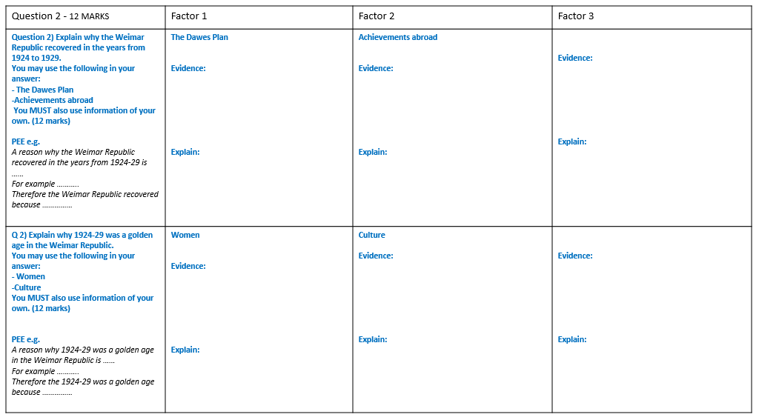

Date: Lesson 3: Hitler’s Rise to power 1919-32
L.O. To revise the founding of the Nazi Party – it’s early growth 1919-23, the Munich Putsch and the lean years 1923-29
Starter: | What did the Nazis stand for in the early 1920s?
The Weimar Constitution
The Treaty of Versailles
The German people
The Nazis’ Twenty-Five Point Programme
Hitler’s own views
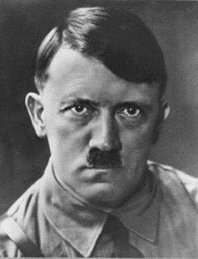
Hitler’s political beliefs
- National Socialism. This meant loyalty to Germany, racial purity, equality and state control of the economy.
- Racism – The Aryans were the Master Race. All other races, especially the Jews were inferior.
- Armed force – Hitler believed that war and struggle were an essential part of the development of a healthy Aryan race.
- Living space (Lebensraum) – Germany needed to expand as its people were hemmed in. This expansion would be mainly at the expense of Russia and Poland.
- The Fuhrer – debate and democratic discussion produced weakness – strength lay in total loyalty to the leader (the Fuhrer)
The Start of the Nazi Party 1920-23
- The Nazi Party began in its earliest form as the German Workers’ Party (DAP), led by Anton Drexler.
- On joining in 1919 Hitler so impressed Drexler that he was put in charge of Propaganda and the political ideas of the party. He created a Twenty Five Point Programme.
- Renamed the Nationalist Socialist German Workers’ Party (NSDAP) in 1920 (later - Nazi’s for short). In 1921 Hitler removed Drexler as party leader.
Tactics of the early 1920’s:
- Military uniforms demonstrated strength at a time when the government was weak
- Use of force against communists and Trade unionists was popular with businesses
- Populist policies and rhetoric were employed to discredit opponents and develop support.
- References to traditional values and reminders of ‘who was to blame’ for the economic crisis builds support.
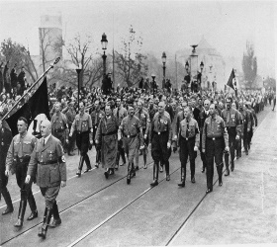
The role of the SA (brownshirts) 1920-22 - Sturmabteilung, or stormtroopers, were a paramilitary force often recruited from ex-soldiers. The SA was used to violently control crowds. Hitler selected members of the SA to be his personal bodyguard, known as the Strosstrupp

The Munich Putsch, 1923
- At first, the Nazis were just a terrorist group. Hitler assembled a large group of unemployed young men and former soldiers, known as the storm troopers (the SA), which attacked other political groups. Hitler hoped to take power by starting a revolution.
- During the crisis of 1923, therefore, Hitler plotted with two nationalist politicians - Kahr and Lossow - to take over Munich in a revolution.
- But then, on 4 October 1923, Kahr and Lossow called off the rebellion. This was an impossible situation for Hitler, who had 3,000 troops ready to fight.
- On the night of 8 November 1923, Hitler and 600 storm troopers burst into a meeting that Kahr and Lossow were holding at the local Beer Hall. Waving a gun at them, Hitler forced them to agree to rebel - and then let them go home. The SA took over the army headquarters and the offices of the local newspaper.
- The next day, 9 November 1923, Hitler and his Nazis went into Munich on what they thought would be a triumphal march to take power.
- However, Kahr had called in police and army reinforcements. There was a short scuffle in which the police killed 16 Nazis.Hitler fled, but was arrested two days later.
Exam tip: If asked about the effects of the Munich Putsch on Hitler and the Nazi Party, remember to give a balanced view. It was a short-term failure but brought more long term-term benefits to the party.

An important exam skill is to prioritise factors:
Had the Nazis achieved anything up to 1930?
- Hitler’s performance as a speaker
- Understanding the power of propaganda
Hitler decided that he would never come to power by revolution; he realised that he would have to use constitutional means, so he organised:
- the Hitler Youth
- propaganda campaigns
- mergers with other right-wing parties
- Reorganisation of party branches - local branches of the party, which tried to get Nazis elected to the Reichstag
- To win the support of big businesses
- Hitler didn’t trust the violent stormtroopers so he forced Rohm to work abroad. So he set up the SS as his personal bodyguard, which was set up in 1925. It was this strategy of gaining power legitimately that eventually brought him to power.
- Shifting focus away from Industrial workers

Why did the Nazis have little success before 1930?
- Disastrous Putsch of 1923
- Disruption of meetings by political enemies
- Lack of support in police and army
- Most industrial workers supported left-wing parties
- Nazi aims were irrelevant to most Germans
- Successes of the Weimar government (e.g. Economy, foreign policy)

- Choose the most important reason why the Nazis had little success before 1930 - explain
……………………………………………………………………………………………………………………………………………………………………………………………………
……………………………………………………………………………………………………………………………………………………………………………………………………..
……………………………………………………………………………………………………………………………………………………………………………………………………
- Choose the most important achievement up to 1930, explain your choice
……………………………………………………………………………………………………………………………………………………………………………………………………
……………………………………………………………………………………………………………………………………………………………………………………………………..
……………………………………………………………………………………………………………………………………………………………………………………………………
……………………………………………………………………………………………………………………………………………………………………………………………………..
The Bamberg Conference of 1926
- The local power of Gauleiters was creating a split.
- There was a potential split in the party because Nazi’s in the north (Strasser and Goebbels) were emphasising the Socialist values, whilst Nazi’s in the south were emphasising the nationalist values.
- Other party leaders like Hitler wqere in more southern rural areas – they emphasised the nationalist part of national socialism.
- Hitler called a national conference in Bamberg of the Nazi Party to address the split –leaders like Stasser were allowed to state their views.
- Hitler spoke for five hours making it seem the ‘socialist’ wing of the party were more like communists. He managed to win Goebbels over – Stasser called him a ‘scheming dwarf’.
As a result:
- Goebbels was promoted to Gauleiter of Berlin as a reward
- Rohm was forced to resign as Hitler was concerned by the violence of the SA and his orders being followed – Pfeffer took over the SA
- Hitler, therefore, increased his control and weakened any socialist principles within the party

The Lean Years, 1924-29
This was a period of mixed fortunes for the Nazi Party. On the one hand, the Nazi Party did not do well.
- It won only twelve seats in the election of 1928
- There were quarrels and disagreements within the party during Hitler’s period in prison
On the other hand, there was progress
- Hitler had learnt from the mistake of the Munich Putsch and was determined to achieve power through legal methods – by securing a majority of seats in the Reichstag he reorganised the party to make it more efficient, setting up a headquarters in Munich and branches of the party all over Germany.

The Great Depression, 1929-33
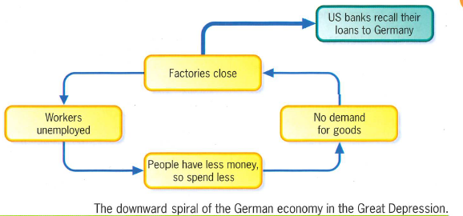
In 1929, the Wall Street Crash plunged the USA into economic depression. The Americans were alarmed, so they called in their loans to other countries and put up customs barriers to stop imports of foreign goods. This created a depression across the rest of the world. In Europe, Germany was worst affected because American banks called in all of their foreign loans at very short notice. These loans, agreed under the Dawes Plan in 1924, had been the basis for Weimar’s economic recovery from the disaster of hyperinflation. The loans funded German industry and helped to pay reparations. Without these loans German industry collapsed and a depression began.
Task: Turn the diagram into a paragraph of writing explaining the downward spiral of the German economy in the Great Depression.
……………………………………………………………………………………………………………………………………………………………………………………………………
……………………………………………………………………………………………………………………………………………………………………………………………………..
……………………………………………………………………………………………………………………………………………………………………………………………………
……………………………………………………………………………………………………………………………………………………………………………………………………..

The impact of the Great Depression, 1929 – 33
The period of recovery under Stresemann ended in 1929 with the Wall Street Crash. In 1929, disaster struck with the Wall Street Crash.
- Many American banks were forced to recall their loans. German companies were unable to pay.
- German banks were major investors in shares on the US stock exchange and suffered huge losses. They lost so much money German people thought they would not be able to access money in their accounts. Banking collapsed as people queued in panic to get to their money!
- German businesses lost their markets abroad Sales fell as workers could not afford to buy as much.
- German businesses began to close. Millions lost their jobs.

Unemployment and the rise of extremism
From 1928 to 1930, German unemployment rose from 2.5 million to 4 million. This was an opportunity for extremist groups such as the Communists and the Nazis as people lost faith in democracy
- As unemployment rose, more and more people felt let down by the Weimar Government and began to support extremist parties.
In March 1930 the German Chancellor, Hermann Müller, resigned when his government could not agree on how to tackle the rise in government spending caused by the rise in unemployment. He was replaced by Heinrich Brüning. His policies were ineffective in dealing with the unemployment crisis and further undermined Germans’ faith in democracy:
- In July 1930 Chancellor Brüning cut government expenditure, wages and unemployment pay. This added to the spiral of decline and unemployment continued to rise, as well as making those who had lost their jobs even poorer.
- However, Brüning could not get the Reichstag to agree to his actions, so President Hindenburg used Article 48 of the Weimar constitution, which gave the President the power to pass laws by decree, to govern. This undermined democracy and weakened the power of the Reichstag – arguably opening the way for Hitler’s later dictatorship.
- The government were unable to pay unemployment benefits as the numbers grew.
- People had invested their savings in shares = no money to fall back on if jobless.
- Workers suffered as taxes went up. Employers also cut wages.
- People became homeless and shanty towns were set up.
- Boredom turned to violence.
- In the 1930 election, the Communists increased their number of seats in the Reichstag from 54 to 77.
- Nazi support increased from 12 seats in 1928 to 107 in 1930. The Nazis were now the second largest political party in the Reichstag.

Q3A - You need to analyse the usefulness (utility) of the source by considering the content and NOP (provenance) of the source, supported by evidence from the source and knowledge of the historical context. You must assess the usefulness of the information.

Structure:
C – Content – what does the source say that is useful in relation to the enquiry?
O- Own knowledge – what do you know about the context of the time?
P – provenance – how do the nature (type of source ), origin (who wrote it? when? Is their view worth knowing? or purpose (for what reason was the source produced? How will this affect the utility of the source?) effect the usefulness of the source? Does it make it reliable? Typical? Comprehensive? (you only need one aspect of provenance)

Sentence starts you could use:
C - Source ……. is useful as it tells me … (try and keep it specific to the effect the fighting had on caring for the wounded). My evidence for this is…
O - From my own knowledge I know that ……………(add something from your own knowledge that isn’t included in the source). This makes the source useful as …………
P - Source ……… is a …. (what) which means it is useful as……
It was written by … in … This makes it useful as …………..…
The source is reliable/typical as …………………….
Overall the source is …………..useful for the enquiry.

Q3A) Study Source H and Source I. How useful are Sources H and I for an enquiry into the development of the Nazi Party, 1924-29? Explain your answer, using Source H and Source I and your own knowledge of the historical context. (8 marks)

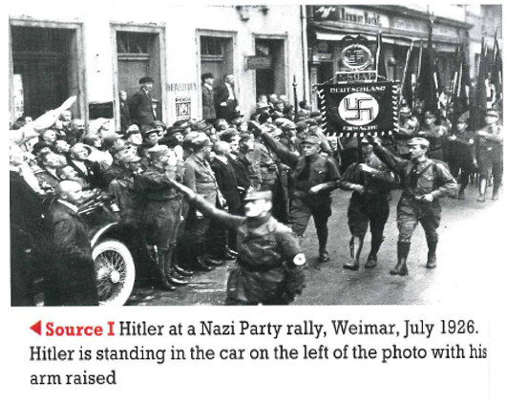

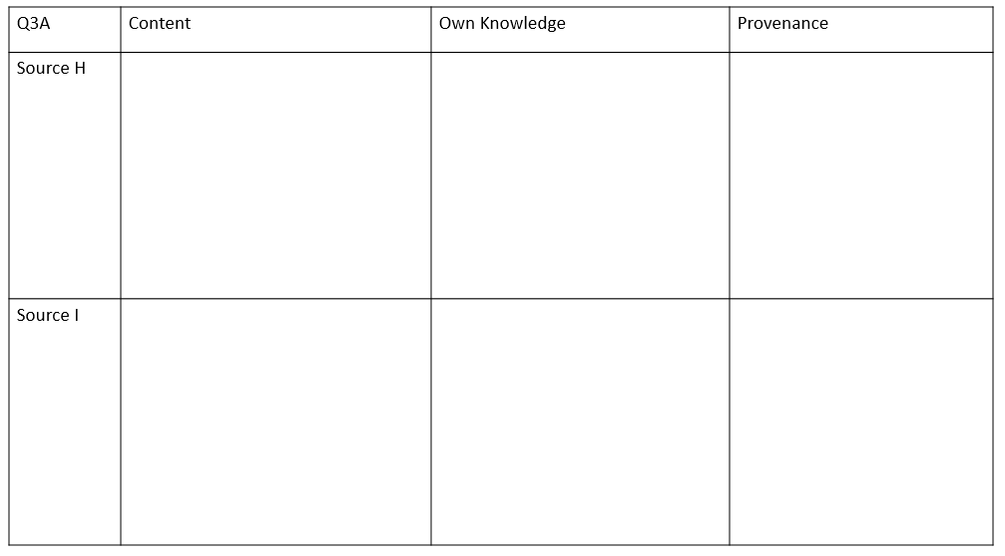
Date: Lesson 4: How did Hitler come to power 1933-34?
L.O. To be able to explain how Hitler became Chancellor and how he turned chancellorship into dictatorship.
How the Depression helped Hitler
- It caused a period of chaos in Germany.
- No government could take control of the situation and solve Germany’s terrible economic problems.
- Unemployment was the big issue. By January 1932, it stood at six million.
- Real wages in 1932 – were 15% lower than 1928
- Hitler promised to get people back to work
- Through clever campaigning and his brilliant speaking skills
- Hitler gained support in many parts of German society, including that of wealthy and powerful industrialists.
- Joseph Goebbels was responsible for the Nazi propaganda and election campaigns. He realised the attraction of Hitler’s speeches and used air travel to move Hitler quickly from place to place.
- There were frequent street battles between the Communists and the police. In contrast the SA gave an impression of discipline and order. Many people felt that Germany needed this kind of order.
- The Weimar Government seemed to be doing nothing to ease German’s problems.

In two years, Hitler led the Nazi Party from being the second largest party in the Reichstag to being the only legal party in Germany. By July 1933, the Weimar Republic and the democracy it represented had been destroyed.
Why more votes for the Nazis?
- Appeal of Hitler- he was a strong leader who promised to restore law and order, get other countries to scrap the Treaty of Versailles and treat Germany fairly.
- The SA – made the Nazis seem organised, disciplined and reliable. They could help keep law and order – when there was a lot of violence in Germany. The SA also broke up political meetings by the opposition. The Nazis had a larger private army than the communists.

Unity -something for everyone! Policies and propaganda target everyone!

- Big business – Hitler persuaded them that the Nazis were the best hope of protection from rise of the communists. Businessmen like Krupp – provided party funds – e.g. to pay for propaganda
- Working class – the Nazis tried to seem like a worker’s party – they were appealed by policies e.g. traditional German values, creating a stronger Germany. They were promised ‘work and bread’.
- Middle class – they often owned land or businesses and had savings. The Depression hurt this group a lot. They were afraid the communists would abolish private ownership of land and businesses. Many believed there was a decline in morals under the Weimar Republic.
- Farmers – the Nazis changed the 25 Point Programme of 1920 in 1928 which said they would confiscate all private land – the change was that it would only be taken from Jews. This reassured farmers and would protect them from the Communists.
- Young people – for many the Nazi Party was exciting, the rallies were colourful and full of atmosphere. Hitler’s speeches were stirring and promised more than traditional parties.
- Women – at first many didn’t support the Nazis – the party argued women should play a traditional role. But propaganda made special appeals to women – claiming the Nazis were better for their country and families.

How did Hitler become Chancellor?
- 1930 – general election – Nazis won 107 seats in the Reichstag (18% of the vote - communists = 13% and the SDP =25%). Chancellor Brüning (Centre Party) wanted to get a majority government so he could pass laws – he was relying on Hindenburg and Article 48. He still didn’t get it. He had to use Article 48 to cut government spending, reduce civil servants wages and tax cuts – making him very unpopular.
- March 1932 – Presidential Elections – Hitler won 11 million votes. Hindenburg 18 million. No candidate got 50% of the vote.
- April 1932 – Presidential Elections –Hitler won 13 million votes and Hindenburg 19 million. Hindenburg was re-elected. Hitler had campaigned furiously.
- May 30th 1932 – Chancellor Brüning resigned – he lost support in the Reichstag by banning the SA/SS. He planned to buy up land from the large landowners – alienating Hindenburg and the landowning class.
- May 1932 – Von Papen became chancellor due to von Schliecher’s advice. von Schliecher thought he could control the Nazis.
- July 1932 – Reichstag elections – von Papen needed to get a majority party in government. There was more violence. Nazis won 230 seats – 38% - they were the largest party in the Reichstag. Hindenburg refused to make Hitler Chancellor.

The use of Article 48 and the chancellors not being able to pass laws meant confidence in the Weimar Republic and democracy was in danger. Hindenburg needed a popular chancellor who could get the Reichstag to agree to pass laws.

- November 1932 – von Papen was asked to resign – there were concerns he didn’t have control of the Reichstag and Schliecher said the country could descend into Civil War. Hindenburg had to ask him to resign.
- December 1932 – Schliecher became chancellor – but he had no real political support – in the Reichstag or the public. He asked Hindenburg to suspend the constitution and make him the head of a military dictatorship. There were concerns of an army coup.
- Von Papen came up with a solution – make Hitler Chancellor and himself as Vice Chancellor – von Papen and Hindenburg thought they could make all the decisions themselves and use Hitler as a figure head.
- January 1933 – Hitler became chancellor.

Why Hitler? Schliecher, von Papen and Hindenburg underestimated Hitler. Hindenburg never fully supported the idea of a republic. Schliecher and von Papen – were right wing conservative – they wanted a ‘stronger’ government led by wealthy industrialists and land owners, they also plotted to replace Brüning and advised Hindenburg.

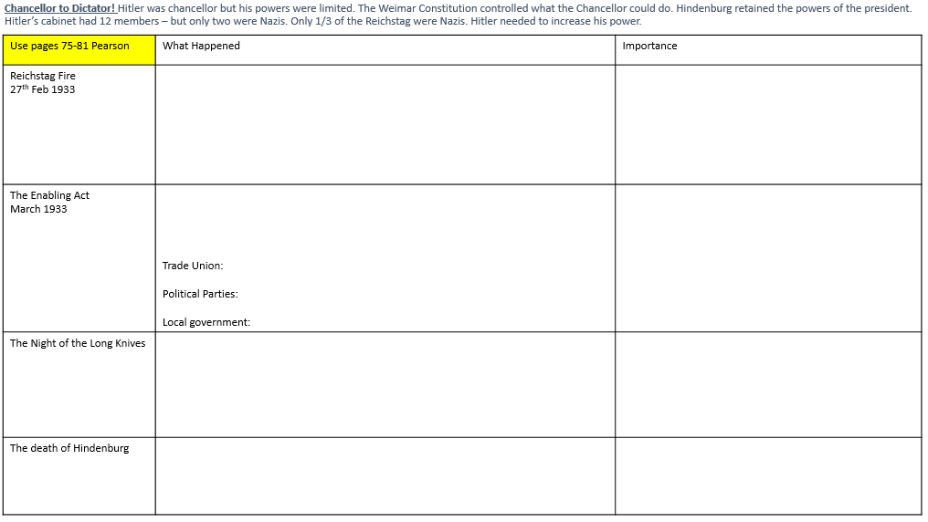
Question 2) Explain why there was increased support for the Nazis in the years 1929-32.
- You may use the following in your answer:
- - Unemployment
- -Goebbels
- You MUST also use information of your own. (12 marks)
3xPEE -15 minutes – to write up

Question: 3A. Study Source N and Source O.
How useful are Sources N and O for an enquiry into the role of Hitler in increasing support for the Nazis in the years 1929-32?
Explain your answer, using Source N and Source O and your own knowledge of the historical context. (8 marks)
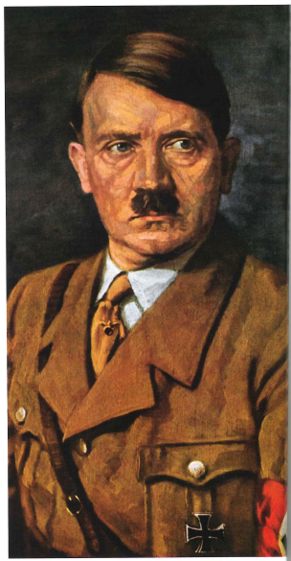
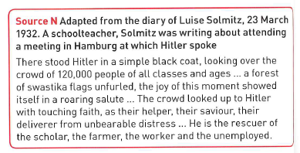
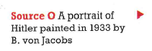

C –

O –

P-

C –

O –

P-

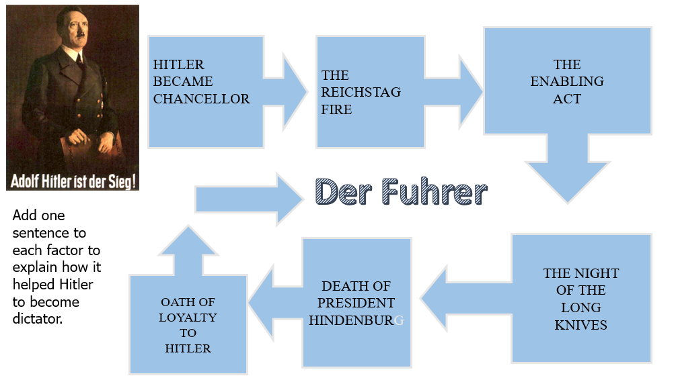
Date: Lesson 5: Nazi control and dictatorship 1933-29
L.O. To be able to explain how Hitler controlled and influenced Germany: the legal system, police, religious systems, propaganda

The Nazis took control of key areas of everyday life. The dictatorship was based on fear, through the police state, persuasion, censorship and propaganda
How did the Nazi’s control people?
The Police State:
July 1933 – Germany became a one party state. The aim was to create a totalitarian state.
- The SS (Hitler’s body guard): formed in 1925 and led by Himmler. They used terror tactics to destroy opposition.
- Death’s Head unit: responsible for concentration camps.
- Waffen-SS : special armoured regiments which fought alongside the regular army.
- The Gestapo (secret state police): under the control of Heydrich – they arrest people on suspicion and send them to concentration camps.
- The police and law courts: the legal system was controlled by the Nazis. There were no trials by jury and the judges were Nazis. High ranking police jobs were given to Nazis.
- Concentration camps: the ultimate sanction for ‘enemies’ e.g. Jews, Socialists, Communists, trade unionists, churchmen and liberals.
- The Christian religion was repressed by Hitler’s police state. The point of friction was the Nazis glorification of strength and violence and the churches preaching of tolerance and peace.
- The Churches posed a real problem for the Nazis. Christianity preached tolerance, respect and peace whereas Nazi propaganda advocated strength, violence and racial superiority. The two were bound to clash. In the early days of the regime the Nazis encouraged the churches to work with them but this situation did not last.
The Nazis and the Churches
The Catholic Church | The Protestant Church
Approximately one third of Germany’s population was Catholic.  - On social issues Catholics owed their first allegiance to the Pope  - Catholics had their own schools which taught different ideology  - Hitler at first tried to reach an agreement with the Catholic Church. In July 1933 he reached a Concordat (agreement) with the Pope. This agreement:  - Confirmed freedom of worship for Catholics  - Said that they would not interfere with Catholic schools  - Catholics would not interfere in politics  - German bishops would swear loyalty to the National Socialist regime  - Hitler didn’t keep his promise. As the 1930s went on:  - Catholic priests were harassed and arrested, many ended up in concentration camps  - Catholic schools were brought in line with state schools or closed  - Catholic youth activities like the Catholic Youth League were banned  By 1937,Pope Pius XI realised that the Concordat was worthless. He issued a stinging criticism of the Nazi regime known as ‘Mit Brennender Sorge’ (‘With Burning Anxiety’) | - At first some Protestants were so grateful that Hitler had protected them from anti-Christian communists that they worked with the Nazis  - They allowed Nazi flags to be displayed inside their churches  - The Nazis set up the Reich Church and tried to merge all Protestant Churches under the Nazis  It was led by Pastor Ludwig Muller the Reich Church was set up in September 1933. Church members called themselves German Christians, with "the Swastika on their chest and the Cross in their heart."  - Protestant Pastors who supported Hitler could carry on with their normal church services.  - Protestant pastors who supported Hitler were allowed to carry on with their church services as normal
The German Faith Movement
This was encouraged by the Nazis, in the hope of replacing Christian values and ceremonies with pagan (non-Christian) ideas. However, only about 5% of the population joined it. They worshipped the sun and seasons.

Q - How did the Nazis deal with the Protestant and Catholic Church?
………………………………………………………………………………………………………………………………………………………………………………………………………………………………………………………………………………………………………………………………………………………
Propaganda and Censorship: Dr Joseph Goebbels was the Minister for Enlightenment and Propaganda. He was highly effective in his role throughout the Nazi reign and fed the German people with material deemed acceptable to the Nazi state. He was an ardent believer in Hitler as the saviour of Germany. He organised huge rallies, such as those at Nuremberg. The aim was to show power, make it clear who the leader was, give people a sense of belonging, provide drama and excitement and the order of the Nazi’s.
Complete the table on - Controlling and Influencing the German people – Nazi propaganda and censorship
Controlling and Influencing the German people – Nazi propaganda and censorship |  | Explanation
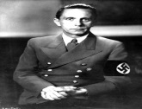 | By the 1930’s Goebbels (Minster of propaganda and enlightenment) had learned many ways to publicise the Nazi Party – from 1933 he could use all of the resources of the government to publicise Hitler and his views on society. Tactics included: Posters advertised Nazi views; the use of rallies and parades were extended and aeroplanes were used to transport Hitler quickly from place to place, so he could be seen by millions of people. | Used multiple methods to persuade the German people to believe policies. Looked like Germany was strong and that Hitler cared.
The Nuremberg Rallies | A mass rally was held each year at Nuremberg to create a sense of German unity and advertise the strength of the Nazi Party. There were bands, marches, flying displays and Hitler’s brilliant speeches. They brought some colour to people’s lives and gave them a sense of belonging to a movement. It showed the power of the state and convinced them that ‘every other German’ supported the Nazis. Goebbels recognised that the Nazis main attraction was creating order out of chaos.
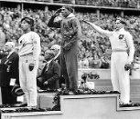  Sport | Hitler and Goebbels used sport to show Nazi Germany in a good way. Their best opportunity to do this came in the 1936 when the Olympic Games were held in Berlin. The Nazis built an Olympic stadium which could hold 110,000 people (and was the largest in the world). After countries like the USA threatened to boycott – the Nazis added a token Jew to their team.  All events were faultlessly organised to show off German efficiency. Germany won 33 gold medals, more than any other country (and silver and bronze). The Nazis claimed this was evidence of Nazi superiority. Although the Nazis were a bit embarrassed that the American black athlete Jesse Owens, broke Olympic records 11 times in heats and finals and won 4 gold medals. Hitler refused to present medals to any of the nine black US medal winners.
The press | Newspapers were encouraged by the Nazis – but they had to provide views which the Ministry agreed with or face the consequences. Within months of the Nazi takeover Jews were pushed out of jobs (e.g. as editors/ printers) and anti-Nazi papers closed down. There was no free press. Journalists were given briefings about what they could publish and sometimes what they should write.
Universities | The Nazis had little respect for academic research. Between 1933 and 1938, 3000 professors and lecturers were dismissed from their jobs. All academics that remained had to agree publically to everything even if it was nonsense e.g. physics was the creation of the German mind. | Criticism from leading academics was removed – they were most likely to write against incorrect beliefs and teachings.
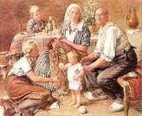  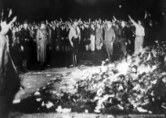  The Arts | Goebbels set up the Reich Chamber of Culture. Writers, musicians, artists and actors had to be members. Those whom the Nazis disapproved were banned.  - Music was censored. Jazz music was banned (seen as black music and therefore inferior). The work of Mendelssohn was banned as he was partly Jewish. Richard Wagner was promoted because he put to music heroic German legends from the past.  - Books - No book could be published without Goebbels’s permission (funnily enough – Mein Kampf was the bestselling book!). In 1933 he organised a high-profile ‘book-burning’. Millions of books were taken from universities and public libraries and burned on huge, public bonfires. On one occasion, students in Berlin burned 20,000 books written by Jews, communists and anti-Nazi authors, destroying books by Freud and Einstein etc.  - Art – as an artist Hitler had strong views and art was heavily censored on racial and political grounds or just as a matter of taste. The Ministry disapproved of most modern art – they preferred to show images of perfect German men and women or heroic German folk tales.  - Theatre – plays about German history and politics were favoured so long as they reflected Nazi views. For this reason cheap tickets were made available – plays were a good way to get these views across.  - Film – cinema was closely controlled – all films had to carry a pro-Nazi message. Pre-film newsreels were full of Hitler’s greatness and the achievements of Nazi Germany (Although there is some evidence that some Germans arrived late to avoid them!).
Radio | Goebbels used the power of radio to spread messages. Cheap radios were made available so most people could afford one and loudspeakers were placed in the streets to ensure everyone had access. The radio stations were tightly controlled and played Hitler’s and other leaders speeches on repeat e.g. ideas about the inferiority of Jews, German expansion into Eastern Europe.

Opposition, resistance and conformity
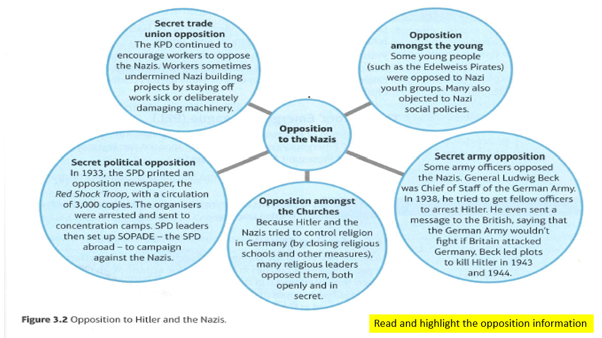
Opposition and conformity
Generally | Catholic Church
- In the years 1933-39 there were about 1.3 million people sent to concentration camps.  - Nevertheless – there was a lot of support for Hitler due to his successes e.g. economic, foreign policy e.g. Saar was returned in 1935)  - In 1938 – Hitler removed certain generals who criticised his foreign policy e.g. Blomberg. Later in 1938 – some army leaders planned to overthrow him but the plan was set aside when he successfully took over parts of Czechoslovakia  - There were 3 assassination attempts before 1939.  - Organised opposition e.g. political parties and trade unions were banned  - Unofficial opposition = very risky – criticism could be reported to the Gestapo. | - Around 400 Catholic priests were eventually imprisoned in the Priest’s Block at Dachau concentration camp.  Limits:  - Although many church leaders did voice opposition to the Nazis it was limited.  - There were big attendances at church services, in defiance of the Nazis.  - Some Germans even publicly applauded Church leaders who opposed the Nazis.  - There were few who were brave, or foolish enough to oppose the Nazis openly.
Protestant Church | Young
Many Protestants opposed Hitler’s policies; some even spoke out against him e.g. Pastor Martin Niemoller.  In 1934 Niemoller set up the Confessional Church (followed traditional German Protestantism) opposing the Nazis.  - Niemoller was one of the Protestants who set up the Pastors’ Emergency League (PEL), to campaign against Nazi actions  - In 1937 Niemoller was sent to a concentration camp with 800 of his fellow ministers and the PEL was banned  By this time Hitler treated the Christian Church with contempt | Most young people conformed to the Hitler Youth Movement. Some however objected to Nazi social policies.  - The Nazi Youth groups were made compulsory in 1936 – the law was tightened in 1939 as youths could avoid it.  - Popularity declined and an anti-Hitler Youth movement appeared  Edelweiss Pirates: emerged in the late 1930s – in working class districts of big cities. Used the symbol of the white edelweiss flower to show their allegiance. Had local names e.g. Navajos from Cologne. Had boys and girls – resented the military discipline of the youth groups and lack of freedom. They went hiking and camping. Boys wore their hair longer and they copied USA styles of clothing. They would taunt and attack the Hitler Youth.  The Swing Youth: mainly teenagers from the wealthy middle-class families located in big towns. They admired American culture e.g. played swing music e.g. the Glen Miller Orchestra. They also drank, smoked, held illegal dances, listened to Jazz.  Opposition or resistance? The actions of the youth were limited – they resisted Nazi expectations but did little to actually oppose them. The Pirates and Swing Youth wanted freedom from Nazi controls – they were not political opponents.  - The numbers were limited compared to the Hitler Youth membership – so they were not typical of young people.

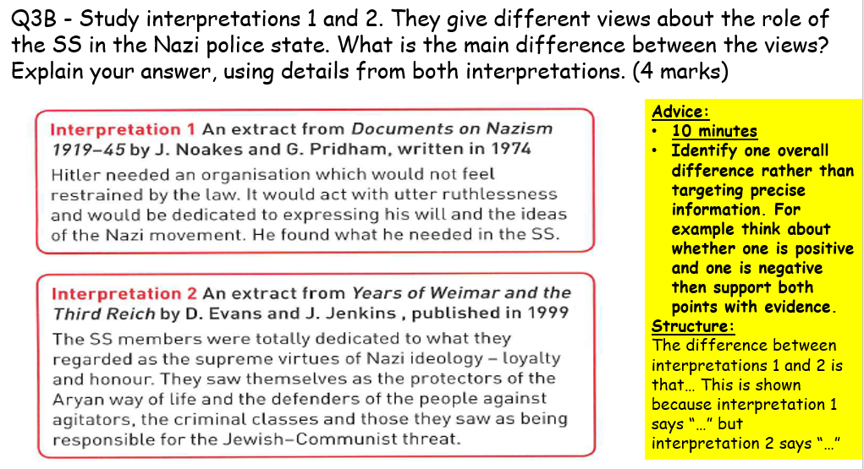

Date: Lesson 6: Life in Nazi Germany, 1933-39
LO: To be able to explain Nazi policies towards the German people
Knowledge Test:
- Who was in charge of the police state?
- How did the Nazis take control over the law courts?

- Who led the gestapo?
- State two types of people who were sent to concentration camps:

- How did the police state ensure control over Germany?
- When was the Concordat with the Catholic Church signed?
- What protestant church was set up that united all protestant churches in Germany?
- Who helped set up the Confessional Church in protest of the Nazis?
- State one way that Goebbels controlled the arts.
- What did Goebbels ensure everyone had access to?
- What did the Nazis hope the 1936 Berlin Olympics would show?
Task: Use Edexcel Pearson book pages 109 – 137 to complete the information boxes
Women: Nazi view on women and the family:
Policy aims:

Appearance

Employment

Marriage

Remember to add how policies changed towards women as war approached

Young people -
Policy aims:

Education:
Teachers:

Curriculum:

Youth movements
- Boys aged between 6-10 years joined the Little Fellows; then from 10-14 years they went to the Young Folk; finally, from 14-18 years they became members of the Hitler Youth (it was a good training ground for the army).
- Girls joined the Young Girls between 10-14 years, and from 14-17 years they joined the League of Maidens
- Under the Hitler Youth Law 1936 membership to the Hitler Youth became compulsory and other non-connected youth clubs (i.e. church or with other political parties) were shut down.

Activities for boys:

Activities for girls:

Popularity of the Hitler Youth:

Employment and standard of living
Policies to reduce Employment:
- RAD – National Labour Service -

- Rearmament –

- Invisible unemployment –

- SS and Gestapo expanded = jobs.

Standard of living:
DAF – German Labour Front –

Strength Through Joy –

Beauty of Labour –

Volkswagen scheme –

Better off - 1933 4.8 millions in 1933 – fell to 0.5 million by 1939.
Wage levels rose by 20% (1933-1938), sales increased by 45% by 1938 = sale of consumer goods and luxury items = higher standard of living. SdA set up – Beauty of Labour – organisation – tried to ensure good standards at work e.g. safety, hot meals etc. KdF set up – Strength through Joy – provided leisure activities for workers e.g. sports facilities. Volkswagen scheme. Hitler’s success was because of his economic success.
Worse off – workers lost freedoms and worked longer days. Unemployment figures were artificially low. Food prices rose by 20% (1933-3) – Nazis limited farmers output to keep their incomes high. People compared their living standards to the Depression so of course seemed better. Hitler’s policies were unsustainable e.g. until 1936 had a balance of imports and exports. After – rearmament after this meant government spent more than it got in taxes and imports rose higher than exports – if war had not intervened they would have run out of money!

………………………………………………………………………………………………………………………………………………………………………………………………………………………………………………………………………………………………………………………………………………………

Persecution of minorities
Treatment of Jews from 1933
- April 1933 Hitler ordered the SA and SS to organise a boycott of Jewish shops and businesses.
- In 1934 Jews were banned by law from public places such as swimming pools and parks
- Laws were also passed making it possible to sack teachers, civil servants and lawyers who happened to be Jewish.
1936 Nuremberg Laws – Jews were no longer allowed to be German citizens and inter-racial marriage forbidden.

1936 - further laws banning Jews from holding property and from working.

1938 Kristallnacht -
Causes:

Events:

Consequences of Kristallnacht:

1941 - Final solution – mass killing of Jews by special SS units
Other minorities –
Slavs:
‘gypsies’:
Homosexuals:
Those with disabilities:

Explaining why historians’ interpretations differ
- Interpretations of history are created by historians. We have to appreciate that historians writing about any society have to make choices and they have to make judgements. They also come to views about the topics they research. Historians choose what enquiries to make of the materials available to them.
- Historians may be focussing on different aspects, using different sources, or reaching different conclusions on the same sources – this is because the evidence from the past doesn’t provide us with an answer. Once they decide a focus, they look for evidence to pursue their enquiry.
- Historians have to work out an answer from the evidence. Often the evidence points in different directions. Then, the historians have to make judgements.
- Differences may arise because:
- They have given weight to different sources
- They have reached different conclusions on the same sources
Think about it – in a court the jury hear the same evidence, but they can disagree about the verdict.

Q3C) Suggest one reason why Interpretations 1 and 2 give different views about the attitudes of the young to Nazi policies.
You may use Sources B and C to help explain your answer. (4 marks)
Advice:
Give a clear reason for the difference (maybe historians have chosen to give weight to different evidence?). Then use both sources to show this difference.

Structure:
The interpretations may differ because….
For example in Source …. it describes/suggests that ….
This supports interpretation … as it emphasises….
On the other hand, Source …. suggests that ……..which supports Interpretation … as it emphasises….
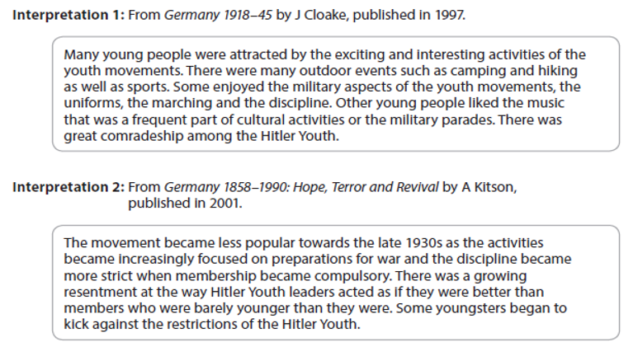
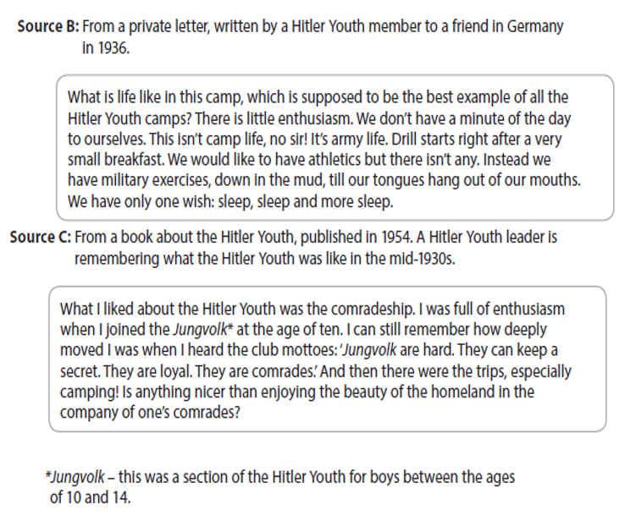
…………………………………………………………………………………………………………………………………………………………………………………………………………….
…………………………………………………………………………………………………………………………………………………………………………………………………………….
…………………………………………………………………………………………………………………………………………………………………………………………………………….

…………………………………………………………………………………………………………………………………………………………………………………………………………….
…………………………………………………………………………………………………………………………………………………………………………………………………………….

Question 3D:
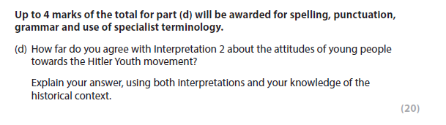
This is worth over one third of your marks for the WHOLE modern depth study. Make sure you leave 30 minutes at the end of your exam for this and plan your answer.

YOU SHOULD SPEND 30 minutes on this question.

Complete the planning grid.

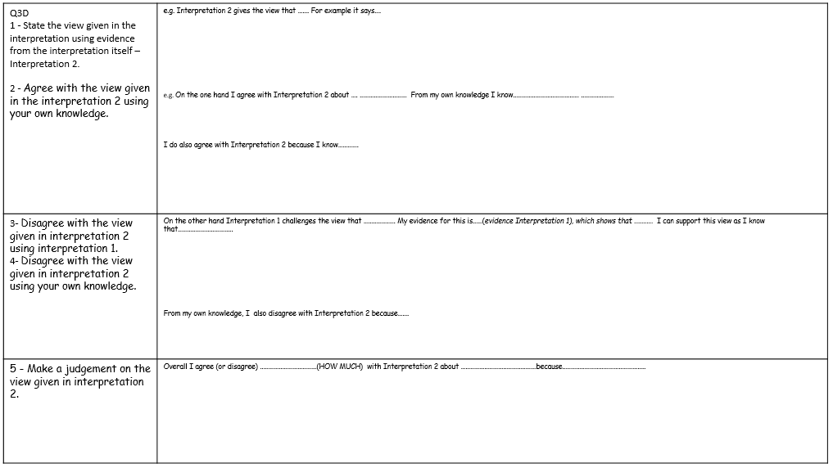
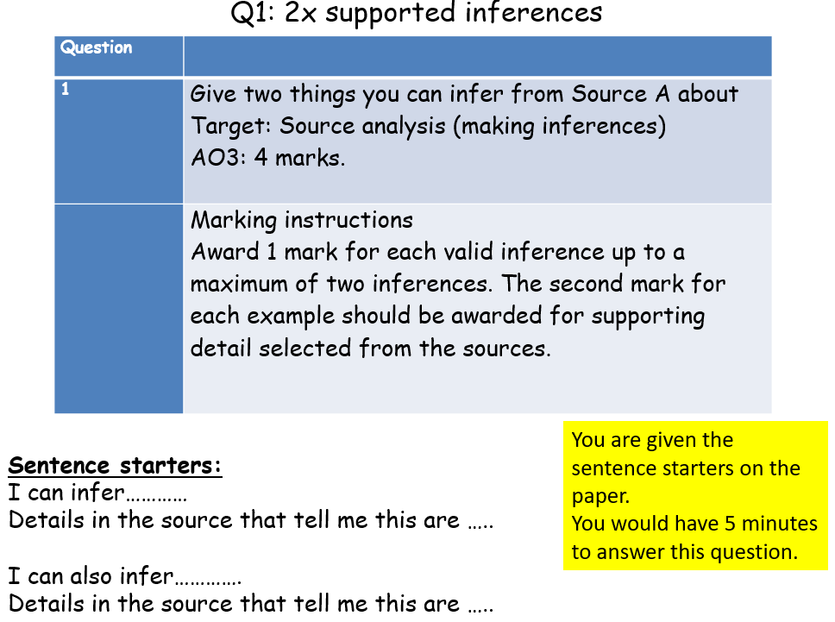
Date: Lesson 7 and 8: Exam Literacy
LO: To work on exam technique

Task:
Complete the Q1 grid using the sources below

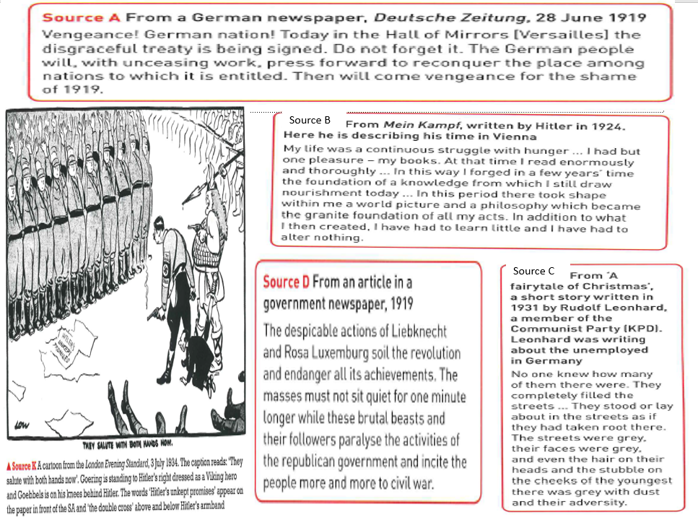
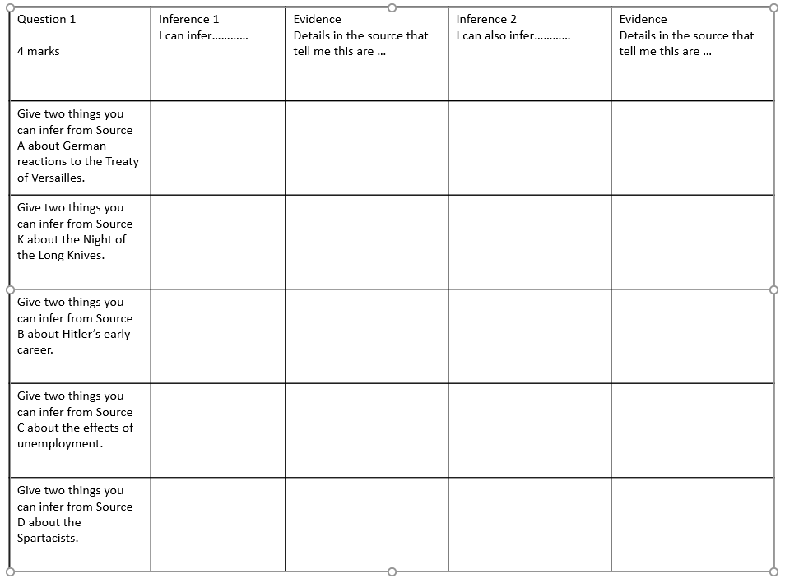
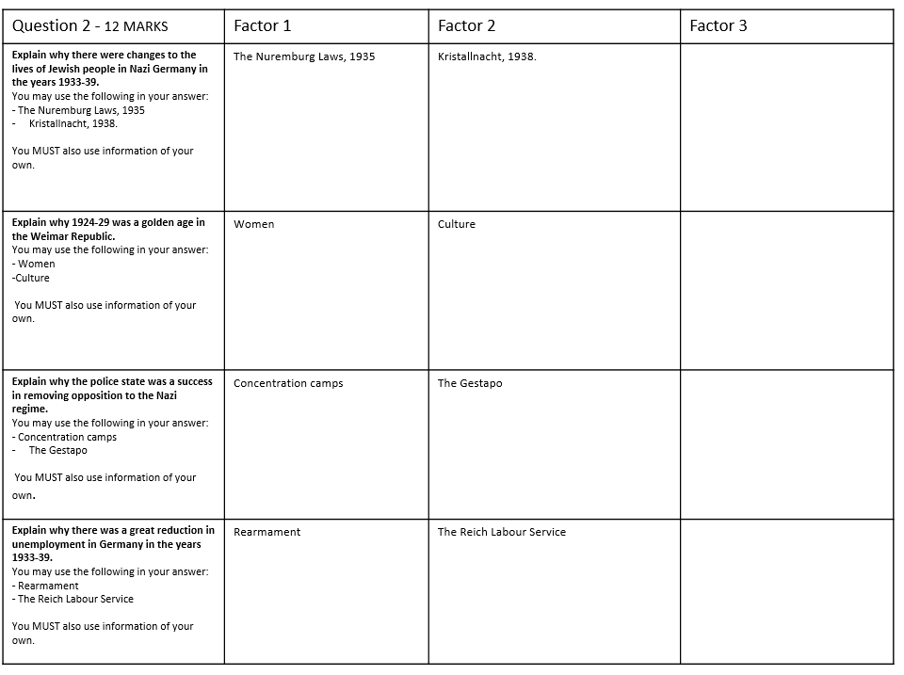
Question 3 is made up of 4 questions.
They should be treated as four parts to the same question.
There will be two sources and two interpretations in a separate booklet from your exam question booklet.
Definition:
- A source - is just what the word properly means - an origin. It is one of the original (primary) pieces of information which inform us about what was happening at the time.
Of course it comprises opinions as well as facts, but it is essentially a building brick, which historians/commentators/interpreters later use to build their constructs. The work you do on sources is therefore, about reliability, usefulness, relevance.
- An Interpretation - Is a view given of the past – an event, a movement, the role of an individual etc.
It could be a view given by a historian, from a textbook, from a history website.
The writer has the benefit of hindsight and is able to consult a variety of sources of evidence to give their view of what took place.

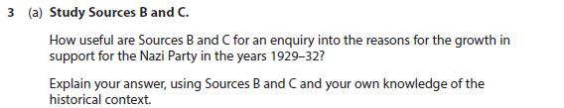

Structure:
C – Content – what does the source say that is useful in relation to the enquiry?
O- Own knowledge – what do you know about the context of the time?
P – provenance – how do the nature (type of source ), origin (who wrote it? when? Is their view worth knowing? or purpose (for what reason was the source produced? How will this affect the utility of the source?) effect the usefulness of the source? Does it make it reliable? Typical? Comprehensive? (you only need one aspect of provenance)

Sentence starts you could use..
C - Source ……. is useful as it tells me … (try and keep it specific to the effect the fighting had on caring for the wounded). My evidence for this is…
O - From my own knowledge I know that ……………(add something from your own knowledge that isn’t included in the source). This makes the source useful as …………
P - Source ……… is a …. (what) which means it is useful as……
It was written by … in … This makes it useful as …………..…
The source is reliable/typical as …………………….
Overall the source is …………..useful for the enquiry.

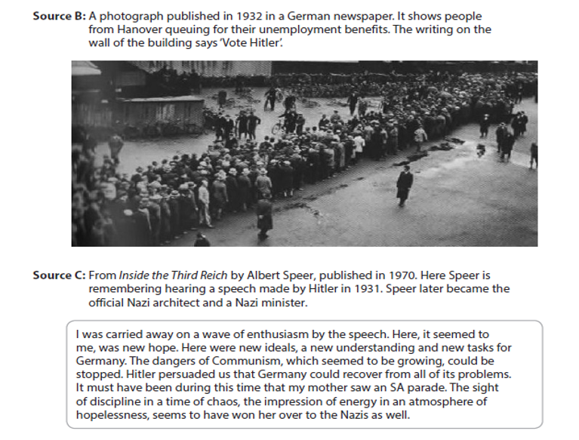
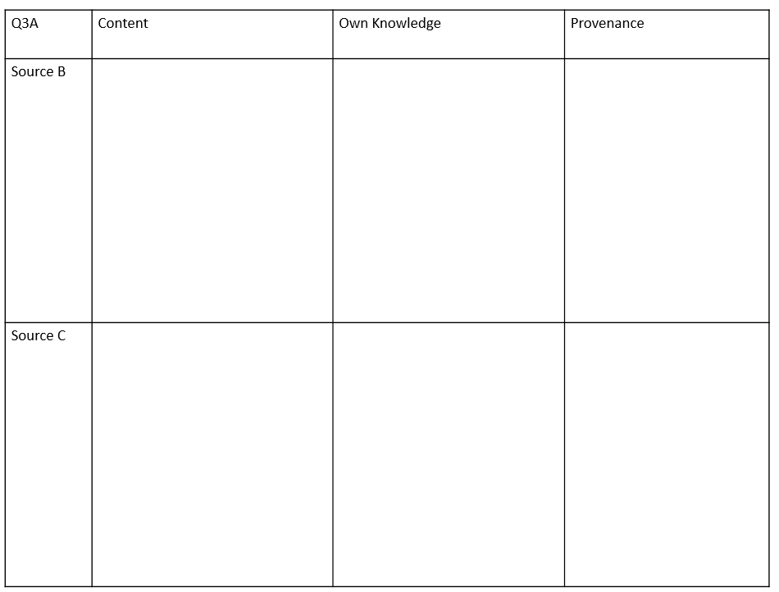
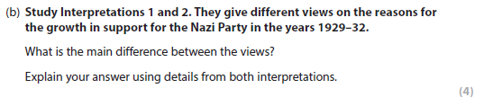
Advice:
Identify one overall difference rather than targeting precise information. For example think about whether one is positive and one is negative then support both points with evidence.
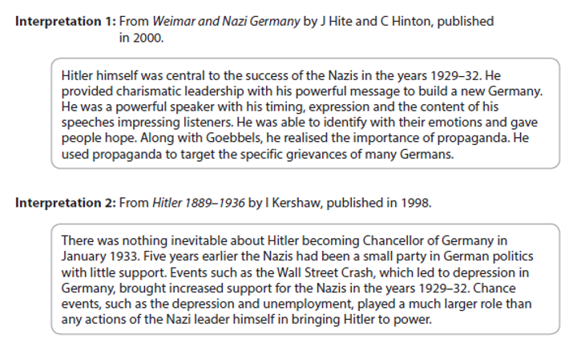
Structure:
The difference between interpretations 1 and 2 is that… This is shown because interpretation 1 says “…” but interpretation 2 says “…”

……………………………………………………………………………………………………………………………………………………………………………………………………………………………………………………………………………………………………………………………………………………………………………………………………………………………………………………………………………………………………………………………………………………………………………………………………………………………………………………………………………………………………………………………………………………………………………………………………………………………………………………………………………………………………………………………………………………
Question 3c
- Historians have to work out an answer from the evidence. Often the evidence points in different directions. Then, the historians have to make judgements.
- Differences may arise because:
- They have given weight to different sources
- They have reached different conclusions on the same sources
- Q3C - Advice on style:
- Option 1: The interpretations may differ because they give weight to different sources. For example Source C provides some support for Interpretation 1, which stresses the importance of the part played by Hitler in bringing the Nazis to power, while Source B provides some support for Interpretation 2 which emphasises the part played by unemployment in increasing support for the Nazis.
- Option 2: The interpretations may differ because they are partial extracts. Interpretation 1 focusses on the role of Hitler especially his speeches in increasing support for the Nazis. Interpretation 2 focuses only on the part played by external events such as the depression in encouraging people to vote for the Nazis.
- Option 3: The interpretations may differ because the authors have a different emphasis, with Interpretation 1 dealing with the importance of one individual in increasing support for the Nazis and Interpretation 2 focussing on the importance of wider, external links.

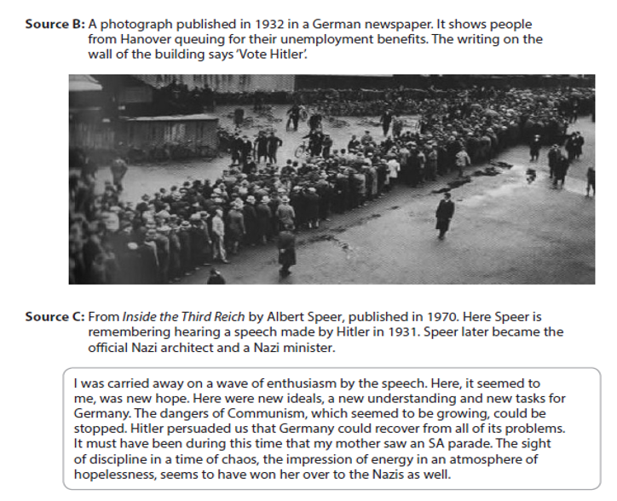
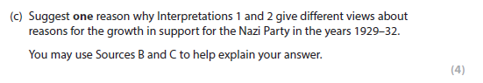
Structure:
The interpretations may differ because….
For example in Source …. it describes/suggests that ….
This supports interpretation … as it emphasises ………
On the other hand, Source …. suggests that ……..which supports Interpretation … as it emphasises ………

………………………………………………………………………………………………………………………………………………………………………………………………………………………………………………………………………………………………………………………………………………………………………………………………………………………………………………………………………………………………………………………………………………………………………………………………………………………………………………………………………………………………………………………………………………………………………………………………………………………………………………………………………………………………………………………………………………………………………………………………………………………………………………………………………

Question 3D
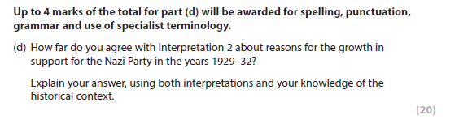
*This is worth over one third of your marks for the WHOLE modern depth study. Make sure you leave 30 minutes at the end of your exam for this and plan your answer
Structure:
- State the view given in the interpretation using evidence from the interpretation itself.
- Agree with the view given in interpretation 2 using your own knowledge.
- Disagree with the view given in interpretation 2 using interpretation 1.
- Disagree with the view given in interpretation 2 using your own knowledge.
- Make a judgement on the view given in interpretation 2.










