Wavell School-GCSE History
Paper 2: Anglo-Saxon and Norman England
Class Revision Booklet
Name:
Class:
Teacher’s name:
Classroom:

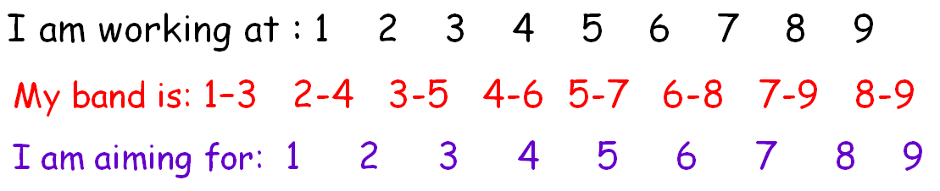

Paper 2 timings | Timing – Paper =1 hr 45 mins | With 25% Extra Time = Approx. 2hours 11 mins
Cold War booklet
Q1 – 2X 4 marks | -10 mins | -14 mins
Q2 – 8 marks | -15mins | -18 mins
Q3 – 2X 8 marks | -25 mins | -30 mins
Anglo-Saxon and Norman England booklet
Q1 – 4 marks | -5 mins | - 7 mins
Q2 – 12 marks | -20 mins | -25 mins
Q3i or 3ii – 16 marks | -30 mins | -37 mins

My Feedback:

Key words
Anglo-Saxon – People who had settled in England after the Romans left Britain. They came under different parts of what is now Germany, Belgium and the Netherlands
Aristocracy – The people in society who are seen as being important because of their wealth and power, which they have often inherited from their parents and ancestors
Ceorls – ‘free’ peasant farmers not tied to their land
Hides – The measurement used for land in Anglo-Saxon and Norman England. One hide was about 120 acres: the amount a family needed to support themselves
Earls – Highest Anglo-Saxon aristocracy. The word came from the Danish ‘jarl’ and meant a chieftain who ruled a region on behalf of the King. The area controlled by an earl is called an earldom.
Oath – A solemn promise to do something. Anglo-Saxons swore oaths on holy relics to make them especially binding. A relic was often a body part of a dead saint, kept in a special casket.
Shire reeve – An official of the king: his sheriff. Sheriffs managed the king’s estates, collected revenue for him and were in charge of local courts
Anointed – to put sacred oil on someone as part of a religious ceremony
The Danelaw – The part of England where Danish (Viking) power had been strongest and which had kept some of its Danish laws instead of Anglo-Saxon ones
Embassy – An official visit by representatives of one ruler to another
Housecarls – Highly-trained troops that stayed with their lord wherever he went: a bodyguard
Fyrd – The men of the Anglo-Saxon army and fleet. Every five hides provided one man for the fyrd
Hundreds – A unit of land administration. In some parts of England, a hundred was 100 hides of land, but in other areas it didn’t have this direct connection
Tithings – An administrative unit that was a group of ten households – originally equivalent to a tenth of a hundred in some areas
Geld tax – a tax on land, originally to pay off the Vikings. It went to the King
Blood feuds – a revenge system based on family loyalties and honour. If someone was killed, the victim’s family had the right to kill someone from the murderer’s family, who then had the right to revenge themselves, and so on
House of Godwin – The ‘house’ of Godwin refers to the Godwin family. The current British royal family is the house of Windsor, for example
Hostages – People given to another as part of an oath or agreement. If the oath or agreement was broken, the hostages could be killed or maimed
Succession – the process that decides who should be the king r queen and ‘succeed’ to the throne
Beacon signals – Fires lit along a chain of high places (cliffs, hill tops) to signal over long distances that an invasion had occurred
Shield wall – A military tactic used by both Viking and Anglo-Saxon armies. Troops were set out in a line, several men deep. The men at the front overlapped their shields, with their spears sticking out, to create a strong defensive formation
Castellan – The governor of a castle and its surrounding lands (castlery); its lord or a steward of the local lord
Harrying – an archaic (old) word meaning to lay waste to something and devastate it
Guerrilla war – when small bands attack a larger force by surprise and then disappear back into local population. It is a modern term.
Tenants-in-chief – the large landowners of Norman England who held their land directly from the king
Forfeit – To lose something as a punishment for committing a crime or bad action
Tenure – ‘to hold’ in Latin – it is a short, but precise, way of talking about landholding or landownership
Vassal – Someone who held their land in return for their land in return for services to their Norman lord
Reconciliation – to find ways for former enemies to forgive each other
Magnate – the historical term for a great man, an important and influential figure
Excommunication – cutting off someone from the Church community so that they ae unable to confess their sins before they die, which people believed would prevent them from ever going to heaven. The idea was not to punish someone permanently, but to convince them to act properly so they could then re-join the church
Fief – land held by a vassal in return for service to a lord. Also called a ‘feud’ (ie: feudalism)
Knight service – The duty to provide a mounted knight to the king in exchange for a grant of land. The vassal had to ensure he had the right armour, weapons and equipment to carry out their service
Barony – the lands held by a baron from the king
Homage – to demonstrate allegiance to another person publicly
Regent – someone appointed to act for a king or queen when they are underage, unable to rule because of illness or out of the country
Submission – formal acceptance of and surrender to authority
March – an Anglo-Saxon term for border
Colonisation – When one country encourages the migration of its people to another country
Motte – the mound of earth that the castle stood
Bailey – the outer part of the castle, surrounding the motte and protected by a fence or wall
Demesne – The land that the king or a tenant kept for his own use rather than granting it as a fief to an under-tenant. It is pronounced ‘de-mean’
Logistics – the planning and organisation of supplies for troops and moving troops around
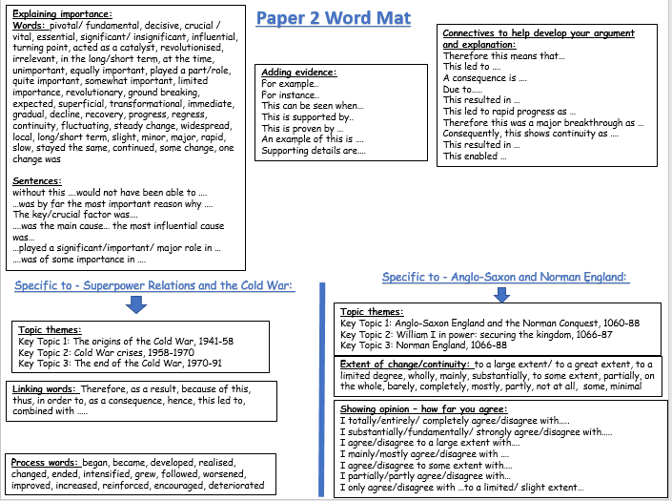

Anglo-Saxon and Norman England – Timeline
- The House of Godwin began in 1018
- King Edward married Edith of Wessex, Godwin's daughter, in 1045
- 1050 - Dover Fracas” (fracas = disaster). A street fight in Dover during the visit of the Count of Boulogne (a Norman). The king blamed the people of Dover and ordered Godwin to punish the town. Godwin was exiled
- 1051 - Godwin returned with an army and asked for his earldom back. Edward had agreed to avoid a war.
- 1053 – Death of Earl Godwin, Harold succeeded him
- In 1055, Tostig Godwinson became Earl of Northumbria.
- In 1057, the Earldom of East Anglia was given to Gyrth Godwinson.
- In 1057, a smaller earldom in the south-west Midlands wen to Leofwine Godwinson.
- 1064 – Harold’s Embassy to Normandy
- 1065 – Northumbria revolted against Tostig
- 5th January 1066 – Edward died leaving no heir, Harold becomes king
- September 1066 Harald Hardrada, King of Norway, invades England
- 20 September 1066 Harald Hardrada, King of Norway, defeats the English at the Battle of Fulford
- 25 September 1066 Harold II defeats and kills Harald Hardrada at the Battle of Stamford Bridge
- 28 September 1066 William of Normandy lands at Pevensey on the south coast of England
- 14 October 1066 William of Normandy defeats and kills Harold II at Hastings
- 1066 – Godwinson’s lands forfeited
- 1066-1087 – Normans replaced the Anglo-Saxons as landholders
- 25 December 1066 William of Normandy is crowned king of England
- 1068 – revolt of Edwin and Morcar – but collapsed quickly
- 1068 – Maerleswein’s lands forfeited
- 1068-1070 – William replaced almost all the Anglo-Saxon Church leaders with his own men.
- January 1069 – Robert Cumin murdered
- 1069 – Edgar the Aethling came down from Scotland– revolts, joined by Northumbrian rebels.
- 1069 – King Sweyn of Denmark sent a fleet of ships led by his brother Asbjorn to help Edgar and the rebels.
- 1070-Stigand was replaced as Archbishop of Canterbury by a reformer named Lanfranc
- 1070- Morcar’s lands forfeited
- 1070 First Norman stone castle is built in Wales
- 1070-71 – Hereward the Wake and the rebellion at Ely – Ely fell.
- 1069-70 William the Conqueror subdues the north of England – the ‘Harrying of the North’
- 1071 – Edwin’s land forfeited
- 1071 – Edwin and Morcar escaped imprisonment
- After 1071 – William used land more effectively to keep control
- 1075: 'Revolt of the Earls – plotted by Ralph, Earl of East Anglia and his wife Emma', Robert, Earl of Hereford and Waltheof, Earl of Northumbria. (Ralph escaped to Brittany, Roger was imprisoned for life)
- May 1076 - the execution of Waltheof, Earl of Northumbria
- 1076 – Waltheof’s land forfeited – Judith his wife (and William’s relative) kept most of them.
- 1076 – Odo was tried of illegal land acquisition
- 1077 Bayeux Tapestry illustrating the Battle of Hastings is completed
- 1079 –Robert and William fought against each other and Robert was disinherited
- 1080- Matilda reconciled Robert and William. William restored Robert as heir of Normandy.
- 1082 – Odo was imprisoned in disgrace by William
- 1084 – a heavy geld tax was levied
- 1085 – William raised a huge army to defend England from Viking attack
- Christmas 1085 Domesday Book is instituted to survey the English lands of William the Conqueror
- 1086 – another heavy geld tax was levied
- August 1086 Landholders swear loyalty to William the Conqueror at Salisbury
- 9 September 1087 William the Conqueror dies at Rouen, Normandy. Odo was pardoned on his death bed
- 26 September 1087 William II (Rufus) is crowned at Westminster Abbey. He FOUGT Robert twice for Normandy
- 1087 -88– Odo led a rebellion against William II but failed
- 1100-1135 Henry, William’s youngest son became King. He fought Robert and imprisoned him for life.
Who is who?
Saxons |  | Scandinavians |  | Normans
- Edward the Confessor (King) - King of England until 1066  - Edith (Queen) – daughter of Earl Godwin and wife of King Edward  - Earl Godwin: The most powerful Earl in Anglo – Saxon England, could rival the King’s power. The father of Harold, Tostig and Edith.  - Earl Aelfgar: Earl of Mercia he was exiled twice in the 1050s and teamed up with the Welsh King Gruffudd ap Llyweyn, to fight for the return of his earldom. When he died Edward and Earl Godwin acted swiftly to stop Llywelyn challenging their interests in Mercia.  - Aldred/Ealdred (Bishop): served Edward the Confessor. Archbishop of York. Crowned William  - Stigand (Bishop): The last Anglo – Saxon Archbishop, he was the Archbishop of Canterbury until he was replaced by Lanfranc.  - Edgar the Aethling: King Edward’s nephew. The Witan announced him as King after Harold’s death.  - Harold Godwinson Earl of Wessex. Crowned King by the Witan after Edward the Confessor’s death. Died at the Battle of Hastings.  - Tostig Godwinson: Earl Godwin’s third son, made Earl of Northumbria but was exiled by Edward the Confessor. Made an alliance with Hardrada and invaded north, was killed at the Battle of Stamford Bridge. Married to Judith of Flanders.  - Leofwine: son of Earl Godwin and Earl of Kent 1057  - Gyrth: Son of Earl Godwin and Earl of Anglia 1057  - Wulfnoth: Son of Earl Godwin and a Norman hostage from 1051  - Edwin: Earl of Mercia and brother of Morcar, He was defeated at Fulford Gate. He submitted to William’s rule at Winchester. Fled and attempted to revolt in 1068  - Morcar: Brother of Edwin. Took over as Earl of Northumbria after Tostig expelled. Was defeated at Fulford Gate. He submitted to William’s rule at Winchester. Fled and attempted to revolt in 1068. He was imprisoned in Normandy until his death 1087.  - Edith the fair: married to Harold Godwinson. Daughter of Earl Aelfgar.  - Gospatric: rewarded by William – made Earl of northern Northumbria after paying William a large amount of money. Supported Edwin and Morcar’s revolt against William 1068.  - Hereward the Wake: A thegn from East Anglia who joined with King Sweyn in 1070 on the Isle of Ely  - Waltheof: Earl of Northumbria, revolted against William in 1075  - Eadric the wild: a thegn who led a rebellion against William |  | King Cnut - King of England 1016 – 1035  Harold Hardrada (king) - King of Norway, claimed the English throne based on relations to Cnut. Fought and died at the Battle of Stamford Bridge for the crown of England.  Swein (King Sweyn) – of Denmark – sent a fleet of ships and warriors led by his brother Asbjorn in 1069. They teamed up with Edgar the Aethling against William. Also joined Hereward the Wake in 1070. Was going to join revolt in 1075 but arrived too late. |  | - William (King): William Duke of Normandy, Edward the Confessor had promised the throne to him. Defeated Harold Godwinson at the Battle of Hastings and was crowned King of England on Christmas Day 1066.  - Matilda (Queen): Wife of William, they had 9 children  - Robert Cumin: Made Earl of Northumbria after Gospatric betrayed William. Killed in Durham in 1069 which sparked the second rebellion  - Roger de Montgomery: Marcher Earl of Shrewsbury, looked after Normandy when William was fighting in England.  - William FitzOsbern: Marcher Earl of Hereford, fought alongside William at the Battle of Hastings  - Bishop Odo: He was William’s half-brother. He was made Bishop of Bayeux in 1049. He fought alongside William at the Battle of Hastings. 1083 he was imprisoned by William, he was pardoned on William’s death bed. In 1088 he led a revolt against William II in an attempt to seize power.  - Ralph de Gael: Earl of East Anglia, revolted against William in 1075  - Roger de Breteuil: Earl of Hereford, son of William FitzOsbern, revolted against William in 1075  - Emma – sister of Roger de Breteuil and married to Ralph de Gael – the revolt of the earls 1075 was plotted at their wedding  - Lanfranc (Bishop): Replaced Stigand as Archbishop of Canterbury, introduced religious reforms of the church e.g. priests should live apart from their communities living spiritual lives.  - Bishop Wulfstan of Worcester and the abbot of Evesham – used troops to help stop the revolt of the Earls 1075 and rebellions after William died.  - Robert of Normandy: William’s eldest son, Robert revolted against his father 1077 – 1080. They finally reconciled in 1080. Robert became Duke of Normandy on his father’s death.  - William Rufus: William’s favourite son, he became King of England after his father’s death and was crowned king by Lanfranc in Sept 1087 at Westminster. Tried to take Normandy from Robert. Was killed in a hunting accident in 1100  - Henry: King of England 1100-1135. Youngest son. He beat Robert in battle and held him prisoner for the rest of his life

Knowledge Audit - Anglo-Saxon and Norman England, C1060-88
Key topic 1: Anglo-Saxon England and the Norman Conquest | Confident | Unsure | No idea
Anglo-Saxon Society - Monarchy and government. The power of the English monarchy. Earldoms, local government and the legal system. The economy and social system. Towns and villages. The influence of the Church.
The last years of Edward the Confessor and the succession crisis - The house of Godwin. Harold Godwinson’s succession as Earl of Wessex. The power of the Godwins. Harold Godwinson’s embassy to Normandy. The rising against Tostig and his exile. The death of Edward the Confessor.
The rival claimants for the throne - The motives and claims of William of Normandy, Harald Hardrada and Edgar. The Witan and the coronation and reign of Harold Godwinson.
Reasons for, and significance of, the outcome of the battles of Gate Fulford and Stamford Bridge.
The Norman invasion - The Battle of Hastings - Reasons for William’s victory, including the leadership skills of Harold and William, Norman and English troops and tactics.
Key Topic 2: William I in power: securing the kingdom, 1066-87
Establishing control - The submission of the earls, 1066. Rewarding followers and establishing control on the borderlands through the use of earls. The Marcher earldoms. Reasons for the building of castles; their key features and importance.
The causes and outcomes of Anglo-Saxon Resistance, 1068-71 - The revolt of Earls Edwin and Morcar in 1068. Edgar the Aethling and the rebellions in the North, 1069. Hereward the Wake and rebellion at Ely, 1070-71.
The legacy of resistance to 1087 - The reasons for and feature of Harrying of the North, 1069-70. Its immediate and long-term impact, 1069-87. Changes in landownership from Anglo-Saxon to Norman, 1066-87. How William maintained royal power.
Revolt of the Earls, 1075 - Reasons for and features of the revolt. The defeat of the revolt and its effects.
Key Topic 3: Norman England, 1066-88
The feudal system and the Church - The feudal hierarchy. The role and importance of tenant-in-chief and knights. The nature of feudalism (landholding, homage, knight service, labour service); forfeiture.
The Church in England: its role in society and relationships to government, including the roles of Stigand and Lanfranc. The Normanisation and reform of the Church in the reign of William I. The extent of change to Anglo-Saxon society and economy.
Norman government - Changes to government after the Conquest. Centralised power and the limited use of earls under William I. the role of regents. The office of sheriff and the demesne. Introduction and significance of the ‘forest’. Domesday Book and its significance for Norman government and finance.
The Norman aristocracy - The culture and language of the Norman aristocracy. The career and significance of Bishop Odo.
William I and his sons - Character and personality of William I and his relations with Robert. Robert and revolt in Normandy, 1077-80. William’s death and the disputed succession. William Rufus and the defeat of Robert and Odo.
Task: Write down your top 3 actions that you need to work on for the Germany unit and how you will do it:
1.
2.
3.

I can attend revision/catch-up/ homework help on………………………………………………………………………………………
The aim of this booklet is that you will complete all tasks and try to move onto the next task. There will be exam practice questions at the end of each lesson – you must try to get to these. Planning or answering the questions as directed – planning can go next to the question. There are lined pages at the back of the booklet.
You may not take these booklets home until your teacher says you can e.g. when the unit has been fully revised.
Exam Question Criteria
You will need to use linking and process words!
Section A: Cold War
- Question 1 – 2x 4 marks (10 mins) 2x developed PEE. The question wants you to explain the results of something. What difference did it make? Use phrases such as ‘as a result’, ‘as a consequence’ or ‘the effects of this was’.
- Question 2 – 8 marks (15 mins) – aim 3x factors (mini PEE – clear links and process words). The key to this question is to explain how one event leads to the next in a logical and structured way. To do this: As it is a narrative – you should write in chronological order. Put the events in the correct order and show how one event is connected to another. You need a beginning, middle and an end.
- Question 3 – 2x 8 marks (25 mins). 2x Developed PEE The question asks you to explain the importance of events and developments. Don’t just tell a story about the event – explain the importance e.g. the impact, what did the event affect or lead to? What difference did they make? Why do they matter?
Section B: Anglo-Saxon and Norman England.
- Question 4 (a) – 4 marks – 5 minutes. Describe two features of…. (2xPE)
Make a point and support with evidence. Do this twice.
- Question 4 (b) – 12 marks- 20 minutes. Explain why …. (3xPEE) You will be given two stimulus points but will also need to come up with at least one of your own. Aim to give at least three explained reasons
- Question 4 (c) – 16 marks – 30 minutes. How far do you agree? (choose (i) or (ii).
You will have a choice of two questions. This question will be worth half of the total marks so make sure you have kept 30 minutes to answer it. You must consider both sides of the argument. You must reach a judgement on how far you agree

Date: Lesson 1: Key Topic 1: Anglo-Saxon England and the Norman Conquest, c1060-88

LO: To be able to explain the key features of Anglo-Saxon society, the role of the king and the power of the Godwins.
Starter: Read through the keywords, who is who sheet, timeline and complete the knowledge audit

Keywords:
- Ceorls – ‘free’ peasant farmers not tied to their land
- Hides – The measurement used for land in Anglo-Saxon and Norman England. One hide was about 120 acres: the amount a family needed to support themselves
- Earls – Highest Anglo-Saxon aristocracy. The word came from the Danish ‘jarl’ and meant a chieftain who ruled a region on behalf of the King. The area controlled by an earl is called an earldom.
- Oath – A solemn promise to do something. Anglo-Saxons swore oaths on holy relics to make them especially binding. A relic was often a body part of a dead saint, kept in a special casket.
- Shire reeve – An official of the king: his sheriff. Sheriffs managed the king’s estates, collected revenue for him and were in charge of local courts
- Anointed – to put sacred oil on someone as part of a religious ceremony
- Danelaw – The part of England where Danish (Viking) power had been strongest and which had kept some of its Danish laws instead of Anglo-Saxon ones
- Embassy – An official visit by representatives of one ruler to another
- Housecarls – Highly-trained troops that stayed with their lord wherever he went: a bodyguard
- Fyrd – The men of the Anglo-Saxon army and fleet. Every five hides provided one man for the fyrd
- Hundreds – A unit of land administration. In some parts of England, a hundred was 100 hides of land, but in other areas it didn’t have this direct connection
- Tithings – An administrative unit that was a group of ten households – originally equivalent to a tenth of a hundred in some areas
- Geld tax – a tax on land, originally to pay off the Vikings. It went to the King

Plot what you can remember on the map below:

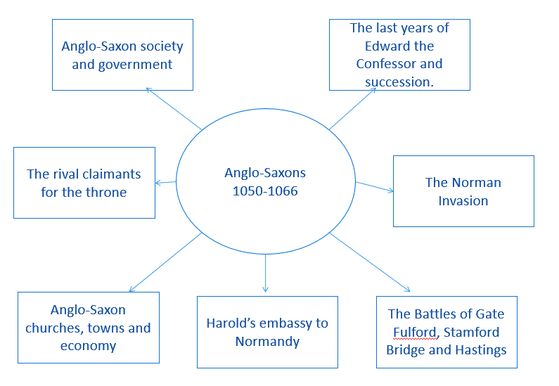

Task: Read through the information about Anglo-Saxon Society and highlight any SPECIFIC FACTUAL DETAIL – then add a brief summary to the revision mat on page 14
Anglo-Saxon Society
- Anglo-Saxon society was hierarchical, which meant it was arranged in a clear order of rank or status.
- Everyone knew their status, and what was expected of them. A person’s status could increase if they paid for it. People could also move down in status if they committed a crime. Anglo-Saxon law ruled that some crimes were punishable by being made a slave.
- The King was at the top and then the Earls.
- Thegns (less than 1% of the population) were nobles, but less powerful than earls. They were primarily warriors who defended the King. In return, he granted them land. They carried out local duties such as guarding tax from attack and organising the repair of fortifications, roads or bridges.
- Ceorls (roughly 10% of the population), sometimes called freemen, owned their own small area of farmland. Being free meant they did not have to work for their lord every week. All male ceorls had to serve in an army if needed.
- Peasants (over 70% of the population) had to work on the lands of their lords for up to 3 days a week and do any jobs he requested, such as taking animals to market. On other days they farmed their own rented land to grow enough food to survive and pay their rent which could be paid in money or goods like milk, eggs or pigs). Every male peasant could be asked by their lord to fight in wartime.
- Slaves (around 10% of the population) were not free and had no land. They worked on their lord’s land or in his house as servants. Their master dictated every aspect of their life, including the amount they worked, the food they ate, and sometimes even who they would marry.
The King: The King was the head of the government and took all the important decisions. His four most important tasks were to:
- Defend his country and his people from attack, usually by commanding the army himself; military skills were therefore important, although not essential
- Pass good laws and to make sure the laws
- Defend the church and appoint its leaders
Powers of the king | Duties of the people
Law-making – pass laws and ensure they were obeyed. | Obey the law
Controlled money production | Use the king’s coins and don’t forge
Land ownership of large estates | Pay tax and military service for land
Could raise a national army and fleet (ships) | Landholders had to provide and equip soldiers
Decided what national taxes should be paid and when | Landholders had to pay taxes
- Manage his earls and other nobles so they co-operated with his decisions and helped him run the country effectively. The king could punish and reward his nobles.
- The king had only a small number of administrators. The administrators wrote down the king’s laws and sent out written orders called writs to officials around the country.
- The groups of people around the king were known as the royal household and the royal court.
- The King’s household consisted of the king, his family and his household soldiers, called housecarls, plus the servants needed to care for the royal family.
- The court consisted of the king’s household plus his advisors – the chief landowners and bishops were the king consulted on important decisions.

Advantages for Edward?
- As a religious leader people believed God guided him
- He was a respected law maker
- He was married to Edith, daughter of Earl Godwin

Limits to Edward’s power?
- He had no children to succeed him
- He had few supporters in England as he had lived most of his life in exile in Normandy.
- Anglo-Saxon kings ruled all of England but half of this was made up of the Danelaw, which had kept some Danish laws and customs – these people wanted local men to rule them.
- Edward’s real problem was Earl Godwin (militarily more powerful) = pressure the king to get what he wanted
The Witan
- When king’s needed a meeting for advice at the Witanagmot, or Witan was called
- The Witan did not have regular meetings or a regular membership.
- It met whenever the king decided to hold a meeting and only those who he summoned could attend e.g. these included earls, thegns and senior members of the church. Even then the king took the final decision but it showed he respected their views so they were more likely to support his decision.
- The Witan would meet and make a recommendation or decision about who would be the next king, but in most cases the real decision was made by who had the most military support.
Local government:
- The king was the centre of government, so he and his followers were known as the ‘central government’. However he could not govern every part of the country on his own. He needed people to run things locally, making sure the law was upheld and taxes collected.
- The top layer of government consisted of the earls, the most powerful land owners. Earls owned large areas of land and could not collect every tax or deal with all criminals. So the king created a more detailed systems - the shires and the hundreds.

The earls
Earldoms were given to the leader of the most important family in around 15 parts of the country. Larger earldoms meant an earl could be very powerful. They had the following powers and responsibilities:
- Collecting taxes from their earldom, earls received a third of these – this made them rich
- Justice and legal punishments allowed them to control the way people lived
- Great military power – Earls were the king’s ‘generals' and controlled many hundreds of thegns and had an elite bodyguard called housecarls
Limits to the earls’ powers:
- Had to show obedience and could be punished by the king
- When a strong King like Cnut who was in charge, the earls had less power than the king. But a King like Edward the Confessor was not strong as he didn’t have a lot of support. It seems likely he depended on Earl Godwin in particular.
- Earls needed to govern their earldoms properly or their thegns would not support them; e.g. Earl Tostig, lost his earldom in Northumbria.

The shires and the hundreds – each earldom was divided into shires.
There were about 40 shires or counties. The king appointed a local thegn as sheriff (shire-reeve) – his chief official in each shire.
Each shire had special functions:
- Social: they had their own courts for trying cases and giving punishments
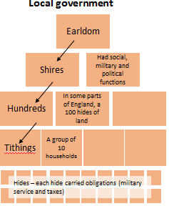
- Political: the shire reeve acted as the king’s representative
- Economic: each shire had a burh (fortified town) as its trading and administrative centre
- Military: each shire provided troops for the fyrd. By 1060 the hundreds within each shire could pay a fee instead and professional soldiers were hired.
- Shire Reeves (sheriffs) were the king’s local government officials. They:
- Collected revenue from the king’s land
- Collected the geld tax
- Collected fines from the shire court
- Enforced the law at the shire court
- Helped organise men for the fyrd and keep roads and forts in good condition
- Military service – the fyrd:
- Each group of five hides was obliged to provide one man to the fyrd when requested by the king.
- There was a select fyrd which found men to fight anywhere and the general fyrd which found men to fight in just that local area.
- The select fyrd was made up of thegns and their followers but would only stay away from their homes for 40 days (or the management of their farms would suffer)
- The hundreds (called wapentakes in the north) were sub-divisions of the shires. Hundreds each contained around 12 villages. Each hundred had its own reeve who held a hundred-court each month to deal with serious crimes.
The Legal system
The shire-and hundred –courts were the heart of the legal system, along with the kings laws. The king made the laws in order to keep peace. The people of England expected the king to keep peace and to provide justice: to treat everyone the same social standing in the same way. The system was strong as every member of the community knew their role but it was hard to prevent powerful men like the earls break laws.
Punishments
- Blood feuds and the Wergild: compensation was paid to the victims/victims families to avoid long running blood fueds. The criminal would pay a fine to the victim’s family based on their status: A ceorl – 20 shillings, a thegn -1,200 shillings and an earl or archbishop – 3,600 shillings (1 shilling is roughly £100 today).
- Capital and physical punishment: A small number of serious crimes carried the death penalty, such as treason against the king or betraying your lord (to deter others and show the importance of loyalty). Anyone from who stole from churches paid a fine and got a hand cut off. Reoffenders were also punished harshly e.g. mutilation such as cutting off a hand, ear or nose or by ‘putting out’ the eyes. Prisons were rarely used as they were expensive and were used only for holding criminals before trial.
- Collective responsibility: If a crime was committed the victim or witness was expected to raise the ‘hue and cry’ – the entire village was expected to down tools and join the hunt to catch a criminal. The sheriff could ask the community to help him. Tithings (every man over 12 years old = group of 10 men) were responsible for their behaviour together, if someone from the tithing was proved to have done wrong, they all had to pay a fine.
- Trials: there were two types of trial:
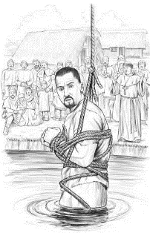
- Trial by jury in the hundred-or-shire court. The jury consisted of men who knew both the accuser and accused.
- When a jury could not decide, the accused was subjected to trial by ordeal in a church.
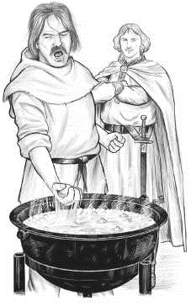
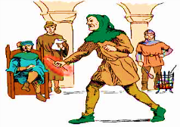
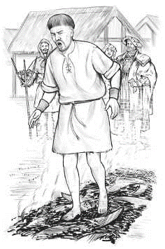
Trials: Ordeal by cold water, hot water and by fire

The economy
Anglo-Saxon England was one of Europe’s wealthiest countries with strong trading links across the seas. England’s towns were trading centres, though almost everyone worked in farming.
What gave England its strong economy?
- There was a good climate for farming.
- Wool and cloth were important exports for England. Western England was well-suited to rearing sheep (livestock).
- Eastern England was dry and fertile: excellent for growing crops.
- England had strong trade links across the North Sea to Scandinavia and across the Channel to Normandy and Flanders.
- The efficient tax system boosted the earnings of the king and also the income of his nobles and the Church, who kept some of the tax.
- Central control of money supply and trading centres (burhs) meant that money was reliable (kept its value) and trade could be taxed, benefitting the nobility.
Villages:
- Villages had an agricultural economy.
- Peasants and ceorls mainly produced wheat, barley and vegetables. They also raised animals which provided meat, milk, eggs and wool.
- Peasants and ceorls produced just enough food and clothing to feed and clothe/ provide for their own families – this is called a subsistence economy.
- Some peasants and ceorls produced extra goods which they would use to barter at market
- It was the earls and thegns who depended on coins to buy, for example, military equipment or the luxury goods that showed their status.
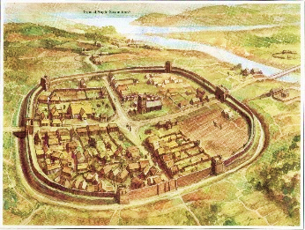
Towns:
- By 1066 c. 10% of the population lived in towns.
- Each shire had its main town, called a burh. Burh = fortified towns every 15 or 20 miles apart.
- The burhs were trading hubs. – the king's laws demanded that all trade worth more than a set amount must take place there (to be taxed). It was mainly an exchange economy e.g. bartering.
- Designed to protect people from Viking raids. Strong defensive walls and ramparts.
- Linked by roads so that troops could move quickly between them.
- They had a mint (where coins were made) and a market place.
- Administration and upkeep of the town and its fortifications was the responsibility of the burhs inhabitants
- Towns grew in importance during this period due to international trading links e.g. York with Denmark; London with Germany, Flanders, France, Normandy.
Anglo-Saxon Church:
Religion was important to Edward. The King was an agent of God, and his conduct had to reflect this.
The Church, power and government | The Church and everyday life
- The church was clearly organised. It was divided into large areas controlled by a bishop. At the top were the two archbishops, of Canterbury in the south and York in the North.  - Bishops were rich and powerful. They controlled large Church districts.  - Bishops served on the Witan as the kings advisors.  - Local priests were usually local community members, with wives and landholdings (farmed) and were not well educated.  - Monasteries and nunneries existed but these were in decline. Monks and nuns prayed and wrote histories, created tapestries and acted as teachers and advisors to lords. They sold crops – making them wealthy.  - The church was rich and powerful and owned 25% of the land.  - English bishops stuck to their old ways and did not make the changes coming from Rome. | - Religion was important and and the Church influenced ordinary people who were worried about the afterlife.  - Everybody believed that they would spend time in the afterlife being punished for their sins, so they spent time praying and other religious activities to reduce this punishments.  - They had to go to church if they wanted their soul to go to heaven.  - Religion played a part in celebrations and holy days.  - People did not work on the major Holy Days- often with feasts and games!
Test yourself:
- Name 3 of the Chief Earldoms
- What was the king’s chief official in each county called?
- What was the Anglo-Saxon term for ‘wisemen’?
- What was the name given to the rank of nobles below the earls?
- What was a tithing?
- List two major responsibilities of Anglo-Saxon Kings
- What name was given to free villagers?
- Name two of the largest towns in England
- What was a mint?
- Name two items imported from overseas
- What were hundreds?
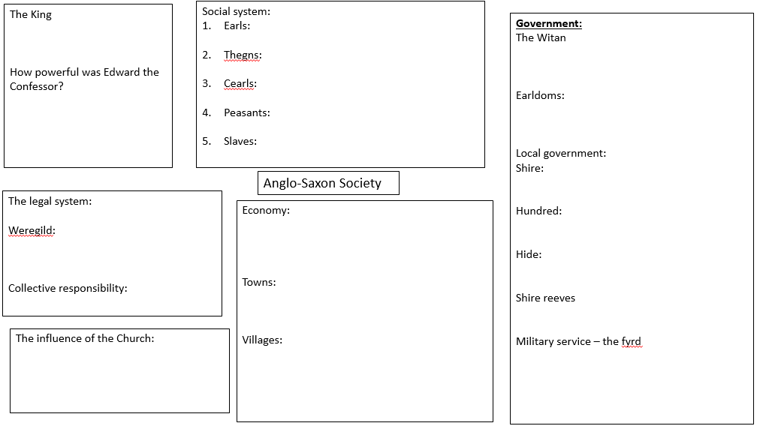
Task: Read and highlight the key information on the House of Godwin and then complete the revision mat – ‘Why was
the Godwin family so powerful in Anglo-Saxon England
House of Godwin
The house of Godwin began in 1018 when the invading king Cnut made his favourite advisor, Godwin, the earl of Wessex. Godwin had helped Edward the Confessor to become king in 1042.

Why were they so powerful?
Money – Wessex was the richest earldom, they owned so much land they were as rich as the king.
Army – The Godwins were lords to many hundreds of thegns, they were militarily more powerful than the king.
Church – The Godwins had convinced Edward to appoint many bishops who favoured them.
Lands – the lands they held were very important e.g. Wessex was key to defending England from attacks from the sea
Alliances – The Godwins had made political marriages
Political Marriages: 3 Edith’s and a Judith
- Edward married Edith of Wessex, Godwin's daughter, in 1045 to strengthen their alliance.
- Harold Godwinson was married to Edith of Mercia, daughter of Aelfgar
- Tostig Godwinson married Judith, daughter of Baldwin of Flanders

Why were there problems between Godwin and Edward?
One cause: misbehaviour of Swegn (Godwin’s eldest son). He was involved in the murder of an earl and was disgraced.
Another cause: the death of the Archbishop of Canterbury in October 1050. The monks wished to elect a kinsman of Godwin but Edward chose Robert of Jumièges.
- The trigger: the “Dover Fracas” (fracas = disaster). A street fight in Dover in 1050 during the visit of the Count of Boulogne (a Norman). The king blamed the people of Dover and ordered Godwin to punish the town. Godwin refused to punish Dover. Godwin was then forced into exile (by Edward with the help of Earls Siward and Leofric.
- Result: The Godwins were to be tried in London. However on his way to London Godwin was deserted by some his men and realised he had no support from the earl of Northumbria or Mercia. Godwin and his sons decided to flee. Edward sent his wife to a nunnery.
= the Godwin’s in exile
Godwin returned with an army in 1051 and asked for his earldom back. Edward had agreed to avoid a war.

Edward did try to free himself of Earl Godwin’s dominance in the 1050s, some think he turned to his Norman friends for support and that this is where the promise to William came from.
Harold’s Succession
- Harold succeeded his father of Earl of Wessex.
- In 1055, Tostig Godwinson became Earl of Northumbria. That gave the Godwins a powerbase in the far north of England.
- In 1057, the Earldom of East Anglia was given to Gyrth Godwinson, Harold’s teenage brother.
- In 1057, a smaller earldom in the south-west Midlands wen to Leofwine Godwinson – another younger brother of Harold.
Why did Edward allow the Godwins to increase their power so extensively?
- Edward’s marriage to Edith was important – making him kin with the Godwins.
- England was under threat from Norway – he needed strong military leaders e.g. like Tostig (the Earl Siward of Northumbria’s son Waltheof was too young).
- Harold married Edith the Fair, which influenced the Godwins gaining East-Anglia (she inherited large estates in that area).
How did Harold Godwinson increase his power in 1062?
- The only significant rival to the Godwins was Aelfgar, Earl of Mercia.
- In the 1060s he allied with the Welsh king, Gruffudd ap Llywelyn, to fight for the return of his earldom which he had lost.
- When Aelfgar died, probably in 1062, King Edward and the Godwins acted swiftly to stop Llywelyn interfering again.
- Harold took a fleet round the coast of South Wales while Tostig led an army overland into North Wales.
- Llywelyn was replaced by a new ‘puppet’ king for Wales whom Harold could control.
- Harold became‘ sub regulus’ – the king’s deputy, leader of his armies: by far the most powerful of Edward’s earls.
- Harold’s economic and military success won him many supporters
- He had a lot of support from local thegns (who were rewarded well)
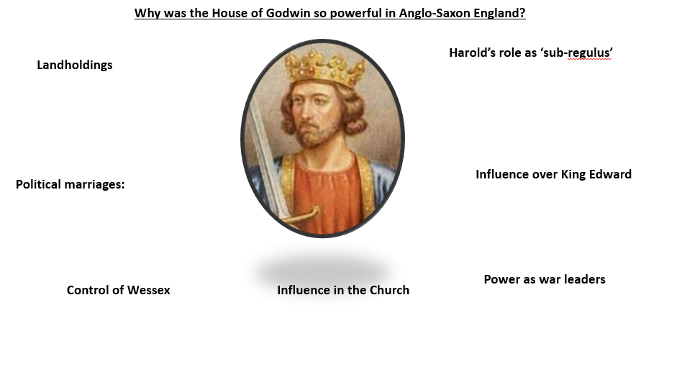
- He had a lot of influence e.g. with bishops
Explain: why were the Godwin’s so powerful?
……………………………………………………………………………………………………………………………………………………………………………………………………………………………………
What did this mean for the power of King Edward?
……………………………………………………………………………………………………………………………………………………………………………………………………………………………………
Task: Read through the information on the Embassy to Normandy and highlight any SPECIFIC FACTUAL DETAIL – then add a brief summary to the revision flow chart on Harold’s Embassy to Normandy at the bottom of this page.
Harold’s Embassy to Normandy - Harold Godwinson went to Normandy in the early summer of 1064 (or possibly 1065) on a mission for King Edward – a type of visit called an embassy.
Why?
- The Norman view: King Edward asked Harold to go to talk to Duke William about plans for William to become king of England and the visit involved Harold swearing allegiance to him as his future king.
- The Anglo-Saxon view: Harold went to recover two hostages from William – Harold’s brother and his nephew, Wulfnorth and Hakon.
Events:
King Edward sent Harold to Normandy but we do not know what message he wanted him to give William.
- Harold was taken prisoner by Count Guy of Ponthieu but William rescued him. Harold fought for William and William rewarded him with gifts of weapons (symbolic of the relationship between a lord and his warrior).
- Harold made a solemn oath to William but we do not know for certain what promise he was making. The Normans sources say he swore on two holy relics – loyalty to William and to help him become king of England.
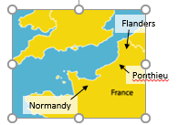
Why was the Embassy significant?
- It shows that Harold was King Edward’s right-hand man for politics as well as military campaigns.
- The Normans claimed that the embassy was about the plan for William to succeed to the throne after Edward died. William used it to legitimise his claim after the conquest.
- It was used by the Normans to portray Harold as an oath-breaker when he took the crown himself rather than support William’s claim.

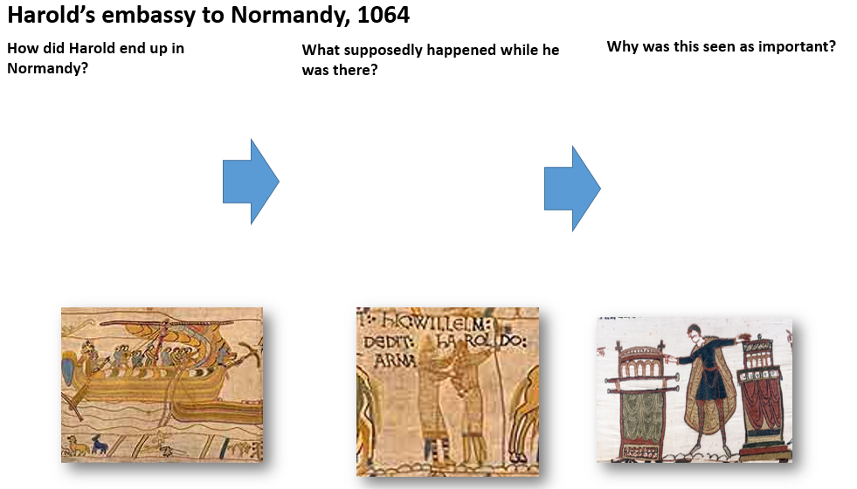
This story is told in Norman sources – after 1066 – so we cannot be sure that all of the details are true- so we have to use words like ‘probably’ or ‘possibly’.
- Read through the information on the Rising against Tostig and highlight any SPECIFIC FACTUAL DETAIL – then add a brief summary to the revision mat ‘- Page 18
Why was there a rising against Tostig?:
Causes:
- Tostig went too far in his crackdown on lawlessness, abusing his power to threaten nobles and assassinating rivals (some were highborn Northumbrians who had been his guests).
- He became friendly with Malcolm III of Scotland instead of fighting him.
- He overtaxed Northumbria (Danelaw areas were not used to this)
- Tostig was a southerner and Northumbria had always been ruled by northerners. He spent most of his time in the South.
Events:
- October 1065: Northumbrian thegns revolt against Tostig, marching on York.
- Northumbrians invite Morcar (the brother of Edwin, earl of Mercia after 1062) to be earl instead
- King Edward orders his earls to put down the uprising, but they find ways not to obey
- Instead, Harold agrees to the rebels’ demands on king Edward’s behalf: Tostig is to be replaced by Earl Morcar
- By 1 November, Tostig is exiled
Consequences:
- Harold weakened House Godwin, but perhaps strengthened his own claim to the throne
- Tostig angrily accused Harold of having conspired against him, saying that the rising was a plot to replace him.
- Edward therefore had no choice but to accept the rebels’ demands. Their choice of Morcar was diplomatic – another southerner, like Edward himself, when the rebels could have pushed for a Northumbrian, such as Waltheof, the son of their old earl, Siward.
- It is significant that the earls, led by Harold, failed to obey Edward’s command.
- The refusal to lead an army against the rebels therefore shows that the power of the king could sometimes be challenged: if the king was weak and if it was in the interests of all the major earls to act together.
Why didn’t Harold stand up for his brother? It is likely that Harold suspected Edward did not have long to live and did not have an heir. Perhaps Harold thought his claim would be stronger without Tostig. Harold may also have known that he needed to show that he could act in the good of England, rather than for his family, if he was going to get the support of the Witan to support his claim. Harold needed England to be united and a war a war with Mercia and Northumbria would weaken English defences.
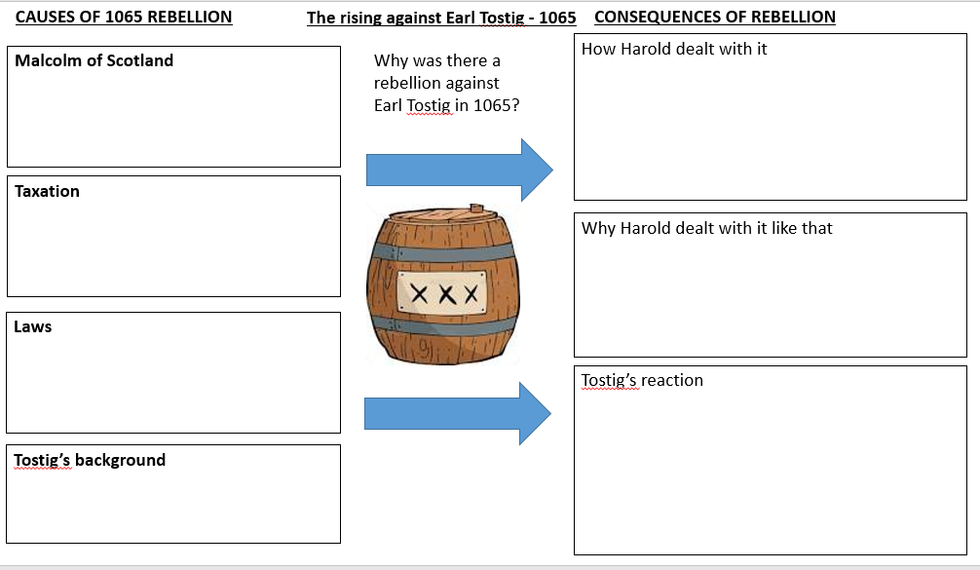
Edward the Confessor died on 5th January 1066 – with no heir there was a succession crisis.
Q. Why did Tostig loose his Earldom?
……………………………………………………………………………………………………………………………………………………………………………………………………………………………………
Q. Why might Tostig be a danger to Harold when he became king?
……………………………………………………………………………………………………………………………………………………………………………………………………………………………………
Q4A – Describe two key features of ….(4 marks – 2XPE – 5 mins)

- Describe two features Anglo-Saxon towns. (4)

- Describe two features of the Anglo-Saxon legal system (4)

- Describe two features of earldoms in Anglo-Saxon England. (4)

- Describe two features of Harold Godwinson’s embassy to Normandy. (4)

- Describe two features of the power of the Godwin family. (4)

- Describe two features of the social system of Anglo-Saxon England. (4)

- Describe two features of the Witan. (4)

- Describe two features of the Anglo-Saxon Church (4)

- Describe two features of village life (4)

- Describe two features of the work of the king (4)

Date:
Lesson 2: The Norman Conquest
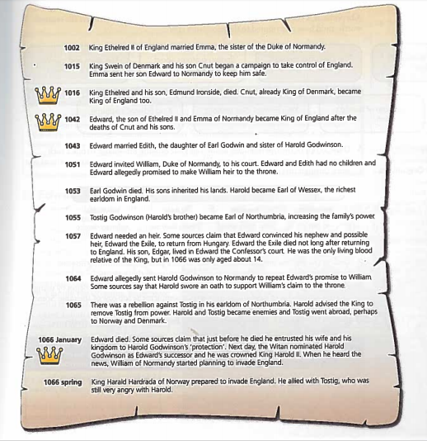
LO: To be able to explain why there was a succession crisis and the causes, events and consequences of the battles of 1066
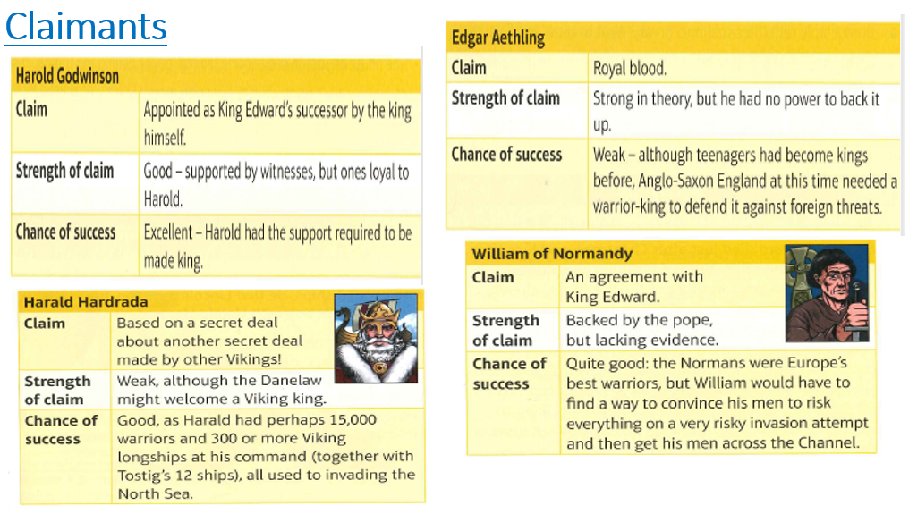
Starter: Who had the best claim to the throne in 1066? …………………………………………………………………………………………………………………………………………………………………………………………………………………………………………………………………………………………………………………………………………………………………………………………………………………………………………………………………………
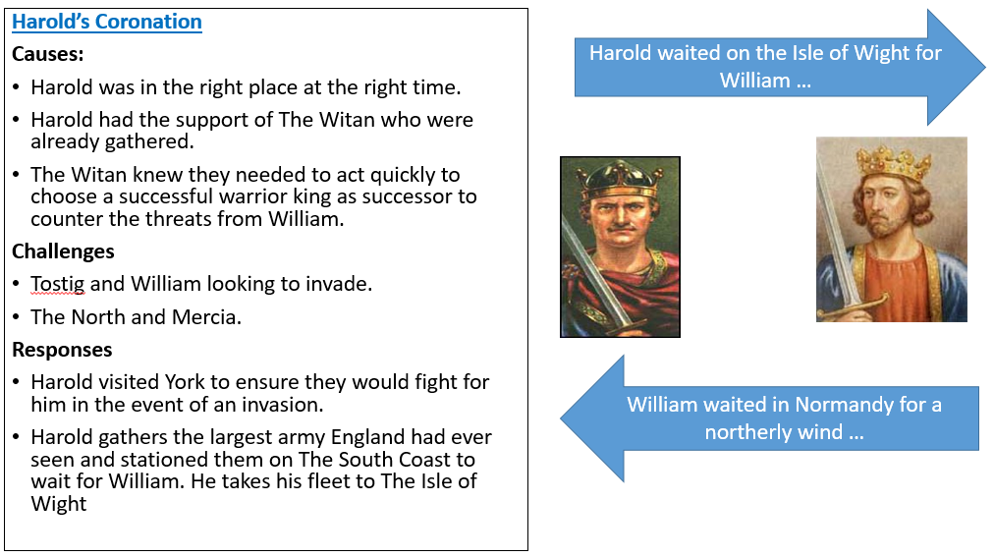

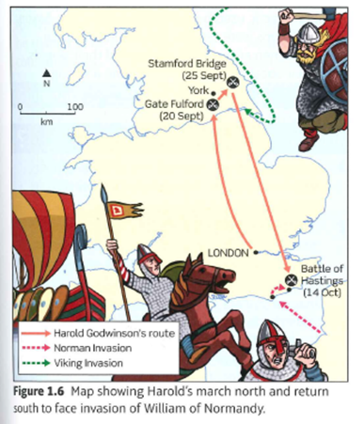
Task: Read and highlight the information
The right call?
- By September, Harold’s troops were getting restless so he sent most of the army home.
- They had been watching the south coast for months, they were bored and underfed.
- Harold may have worried about losing their loyalty – it was harvest time and men were needed in their villages to reap crops, or next spring families would go hungry.
- It was also the end of the sailing season – so perhaps Harold hoped that William would not be able to cross to England.
- Harold would have hoped that if William did cross he would have enough of a core army to hold William back while the army was reassembled.
The Battle of Gate Fulford – 20th September 1066
Why?
Hardrada lands in The North with 200-300 longships carrying around 10,000 soldiers. He sails up The Humber and marches towards York. Tostig and Hardrada launch their attack
Their way was blocked by an army led by Morcar and Edwin (Earls of Northumbria and Mercia) at Gate Fulford who met Hardrada in open battle, rather than defend the fortified city of York. They had approximately 6000 soldiers
Events:
Edwin and Morcar were outnumbered
As the English shield wall surged forward against Tostig’s weaker troops pushing them back. However, Hardrada hit them with his best warriors from the side (a clever flanking tactic)
The English got stuck retreating
The English had positioned themselves with marshland behind them, which meant that they became stuck in mud and were massacred
Outcome:
Crushing defeat for Edwin and Morcar
Harold Godwinson had to march 185 miles North to deal with Hardrada- leaving the south-coast undefended (although the first storms had started – so he thought it was too late for William to cross the channel
Thousands of English troops were killed or wounded, making them unable to fight against the Norman invasion
York surrendered and agreed to send hostages
Stamford Bridge - 25th September 1066
Why?
- Harold and his housecarls marched 180-210 miles in five days to fight Hardrada and Tostig after hearing of the invasion
- It is possible Harold heard about the hostage deal as he travelled
Events:
- Harold surprised Hardrada who was waiting at Stamford Bridge for hostages.
- A Viking Champion held the bridge killing 40 English soldiers before he was killed by a Saxon who stabbed him from below
- The battle lasted 5 days – but Harold’s housecarls broke the Viking shield wall
- The Saxons attacked the outnumbered and unprepared Vikings (they had weapons and shields but no armour which was left on their ships) and killed most of them before the reinforcements from their ships turned up
Outcome:
- Hardrada and Tostig were killed
- Only 24 ships returned to Norway
- Vikings felt misled as had been told the English hated King Harold
- Harold achieved a great victory
- William invaded in the south – so Harold had to move rapidly south, tiring his housecarls
- Edwin and Morcar both survived the battle but were did not fight at Hastings. The battles in the north may have prevented troops reaching Hastings from Mercia and Northumbria – or they simply failed to help Harold!
- Harold had disbanded The Fyrd only three days before Harada landed as they needed to tend their crops.
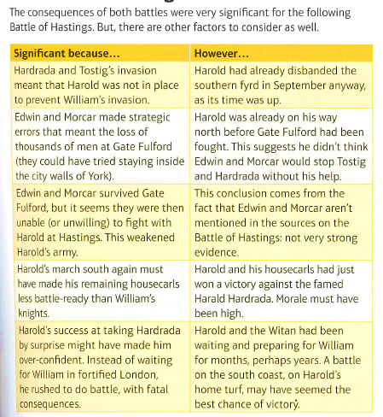
Q. Answer: What position was Harold in after these battles?
……………………………………………………………………………………………………………………………………………………………………………………………………………………………………
Task: Read and highlight the information on Hastings and then complete the grid on ‘why did William win the battle of Hastings?’ – add key notes.
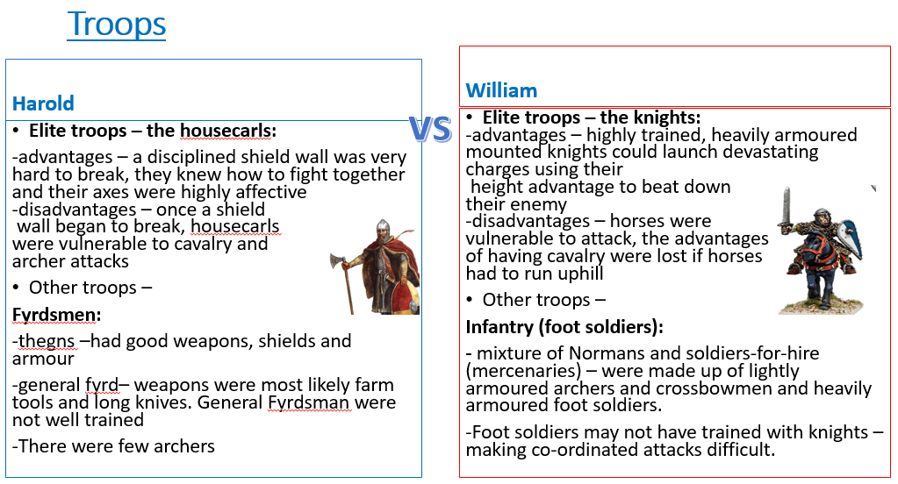
The Battle of Hastings
During 1066 – William had rallied support from his followers and gathered an army.
- William secured the backing of Pope Alexander using propaganda that Harold was an oath breaker (his help made it a holy crusade).
- William’s invasion was held up because the wind was blowing against his ships, when he did try to set off a storm damaged some of his fleet and men drowned.
- William had ships built to carry warhorses and his men.
- He kept them well fed for over two months while they waited to sail (13 tonnes of grain and 13 tonnes of hay were needed to feed the 2,000 horses)
- When the wind changed direction on 27th September William set sail, landing at Pevensey the next day. Some ships got lost and landed at Romney – the English soldiers attacked and killed the crews.
- Harold was still in the north so William was able to march his army a few miles inland. He ordered motte and bailey castles to be built to protect his army.
- Don’t forget Harold had already disbanded the southern fyrd – so was hastily collecting (levy) an army as he rushed south
- William’s men pillaged and plundered the local area, hoping to provoke Harold into battle.

Battle of Hastings – Key Events
- William’s scouts spotted Harold’s advancing army – Harold failed to achieve a surprise attack.
- Harold’s army was able to position itself along a ridge at the top of a hill. That meant that William had to attack uphill.
- The battle lasted 8 hours – a very long time for medieval battles. This was perhaps because the 2 sides were quite evenly matched. There were different phases to the battle.
- William’s archers were first to attack, but the archers had to stay out of English javelin range and the English shield wall knew how to catch arrows on these shields.
- William’s foot soldiers and knights were beaten back by the shield wall initially. The English housecarls did great damage to horses and men with their two- handed axes.
- At one point the Norman army was panicking that William had been killed. William tipped back his helmet to show that he was still alive.
- A feigned retreat (or a real retreat) meant English fyrdsmen left the shield wall to chase after retreating Normans. The English were then surrounded and cut down.
- The shield wall was gradually thinned out. Norman knights then charged through it and caused great damage. Norman archers also became more effective as the shield wall failed.
- Harold and his brothers, Gyrth and Leofwine, and their housecarls, made final stands at the top of the hill, fighting to the death. Harold and his brothers were killed.
- The rest of the English army then ran for it. The Bayeux Tapestry says they ‘turned and fled’.
Battle advantages
Harold  - Harold was fighting on home ground: Wessex  - The house carls were experienced, disciplined and skilled warriors  - The English had the best position on the battlefield: on a ridge at the top of the hill | William  - William’s troops were trained in tactics that the English had never experienced before, including the feigned retreat  - His troops had to fight to survive: they would not be able to retreat or escape  - William had obtained the pope’s blessing for his invasion and he and his men believed that God was on their side
Battle disadvantages
Harold  - The men of the general fyrd were inexperienced and lacked discipline  - The core of his army were tired from fighting at Stamford Bridge and marching south. They may also have been demoralised by having to fight yet another battle.  - A lack of archers – it is possible that English archers were among the fyrd troops who arrived in London after Harold had already rushed off to Hastings | William  - Having to fight uphill made knights and archers less effective  - Although his knights had trained for years in their battle tactics, many of his foot soldiers were mercenaries who had not trained to fight in combination with knights  - Knights had trained to change against other knights: charging a shield wall was probably something entirely new
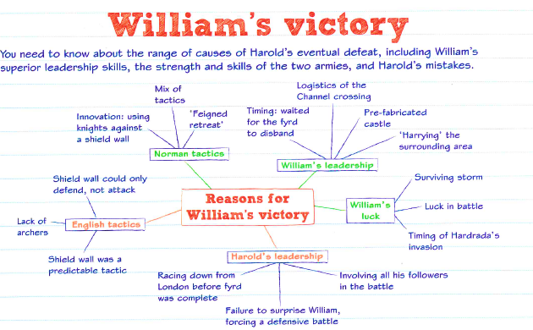
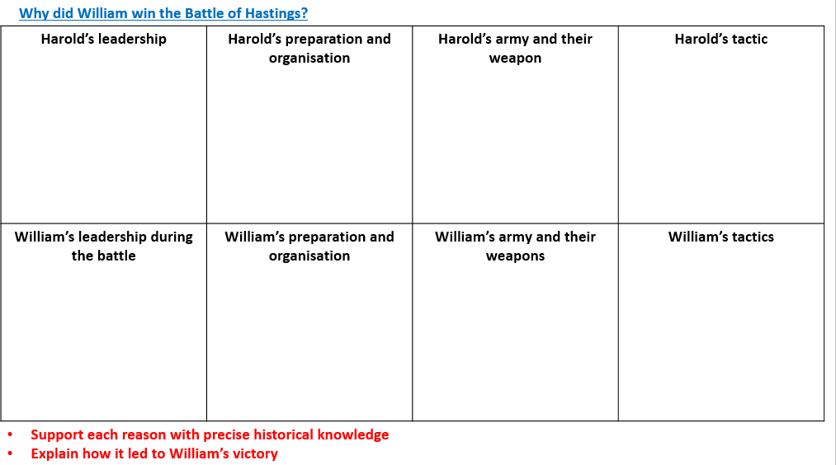
Which of these was the most important reason why William won?
- William had archers and Harold didn’t.
- Harold hadn’t been able to take William by surprise.
- Many of Harold’s soldiers were inexperienced and his best troops were tired from Stamford.
- William’s tactic of the feigned retreat.
- William’s army had been blessed by the Pope.
- Another reason??
The most important reason William won is……………………………….…………….………………… …………………………………………………………………………………………………………………………………………………………………………………………………………………………………………………………………………………………………………………………………………………………………………………………………………………………………………………………………………
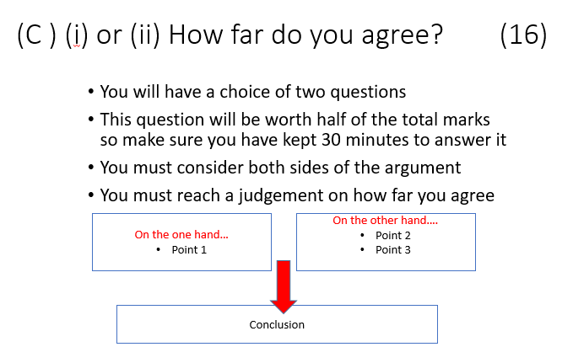
Question C:
Q4c - ‘The main reason for the English defeat at the Battle of Hastings was superior Norman tactics.’
How far do you agree? Explain your answer:
You may use the following in your answer:
- The feigned retreat
- The shield wall
You must also use information of your own. (16)
Advice: You need to have clear criteria for reaching a judgement:
- If you are judging the importance of a factor (causes/consequences) you could analyse and evaluate the immediate impact, the short-term impact and the long-term impact.
- Judgement - think of a set of scales. What are the heaviest pieces of evidence either side?
Exam questions:
- Q4A - Describe two features of William of Normandy’s claim to the English throne. (4)
- Q4A - Describe two features of William’s troops at the Battle of Hastings. (4)
- Q4B - Explain why Earl Harold of Wessex became king of England in 1066.
You may use the following in your answer:
- The Witan
- The power of the Godwin family
You must also include information of your own. (12)

Date:
Lesson 3: Key Topic 2: William I in power: securing the kingdom
Establishing Control and Defeating Resistance
LO: To be able to explain how effectively William controlled England and dealt with the revolts
Starter: Complete the knowledge quiz (no cheating!)
Knowledge Tests – AO1
Q. | Question | Answer
1 | Why did William and his army pillage and plunder the south of England?
2 | When did the Battle of Hastings take place?
3 | What defensive formation did Harold adopt?
4 | Who are the Housecarls?
5 | What 3 types of soldiers did William have?
6 | What made the battle turn the way of William?
7 | What did William do when his men thought he had been killed?
8 | What tactic did William instruct some of his men to do?
9 | How is Harold supposed to have died?
10 | What date was William crowned king of England?
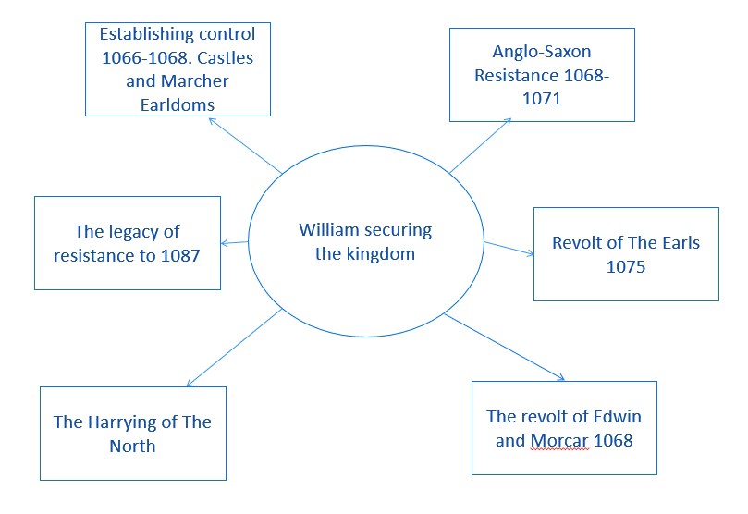

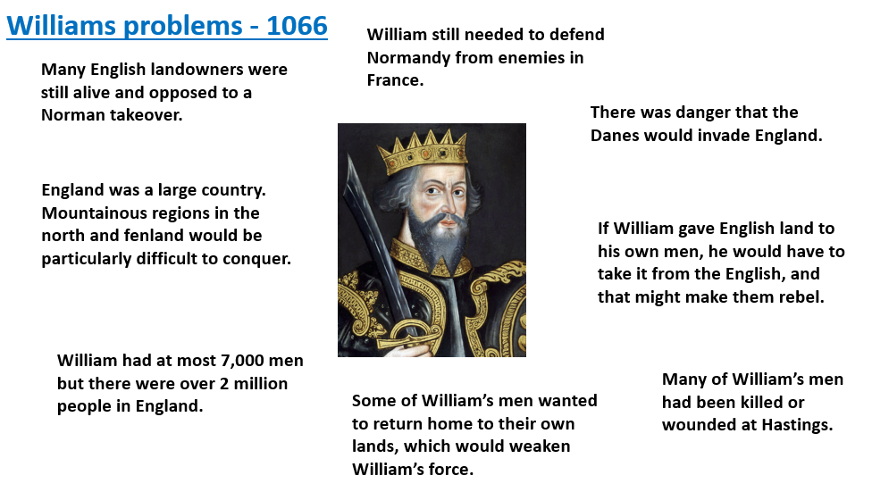
Task: Read the information on how William Established control and then complete the table- making key notes table on page 30
Motte and Bailey Castle:

Establishing control after 1066
The Submission of the Earls 1066
Why did the Earls submit to William after his march to London?  The March to London and Berkhamstead  - William waited in Hastings for The Anglo-Saxon Earls to come and swear loyalty to him.  - He then went to Dover to secure the port so he could get reinforcements from Normandy.  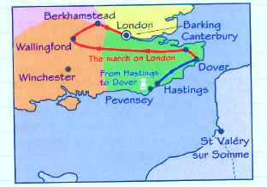  - Saxons survivors fled to London where Edwin and Morcar declared Edgar king – they did not attack Dover.  - Having recovered, William led his army on a brutal march through south-east England, destroying homes and farms  - Towns and villages were intimidated and surrendered.  - William marched round London, through Winchester and Wallingford to Berkhamsted rather than attacking London directly (it was well defended).  Edgar, Edwin and Morcar submitted to William at Berkhamstead. William promised to be a gracious lord. | Why submit (without a fight!)?  Earls strong:  - London was fortified.  - Edgar had a good claim to the throne – the Witan had already chosen Harold’s successor.  - Williams troops were tiny (5000) compared to The Fyrd that could be raised by The Earls. They were in enemy territory.  - The English should have attacked William at Dover – but perhaps Edgar and the earls could not agree on action  - Mercia and Northumbria represented half the country and were undefeated.  - Edgar had little to reward his followers as William had control of the treasury  William Strong: he was an effective leader:  - William quickly seized Winchester and controlled the royal treasury.  - London was strong but William was threatening to cut it off from supplies and reinforcements from the North.  - England’s best warriors had been killed at Hastings.  - Did the English earls think William had God on his side because he won? Hastings had been a crushing defeat.  - Edgar had not long returned to England so had little support.
Rewarding followers: When William was crowned king on 25th December 1066 – he swore an oath to run England like the best Anglo-Saxon kings if the people were loyal to him. Many thought this meant he was going to be like Edward the Confessor. Historians agree he wanted a trouble free takeover, with Anglo-Saxons continuing in important roles. But the problem with this was that he had to reward his own followers.
Rewarding Normans: William had promised his followers great riches in return for their support for the invasion of England.  - He sent lavish gifts to the pope (probably from the English royal treasury).  - He set a heavy geld tax, to pay his mercenaries (paid-professional soldiers).  - He declared that all land in England belonged to him.  - He granted land and earldoms to his followers.  - The biggest winners were William’s followers and closest advisors:  - Odo (brother and Bishop of Bayeux) – received all of Kent – he was Earl of all Kent and Dover  - William FitzOsbern (trusted advisor and relative) – was given the Isle of Wight, much of Hampshire and large areas in the west.  - Robert of Montgomery (had governed Normandy during invasion) – was rewarded land in Essex and Shrewsbury (Earl of Shrewsbury). | Rewarding Anglo-Saxons  - Earls like Edwin and Morcar kept their earldoms – although they were smaller than before.  - Edwin was promised William’s daughter in marriage – although it never occurred.  - Gospatric was made earl of northern Northumbria – although he had to pay William a lot of money for it.  - Archbishops Stigand and Ealdred kept their positions as they swore loyalty to William.  - Everyone who fought against William lost their land (e.g. the Godwin’s) – although all of this land goes to William and his followers, not to Anglo-Saxons
Marcher Earldoms - controlling the borderlands
Causes: William didn’t want Wales to be a threat.
Events: William set up 3 new earldoms centred on Chester (Hugh d’Avranches), Shrewsbury (Roger de Montgomery) and Hereford (William FitzOsbern) – these were called the Marcher earldoms
Key features:
- Shire-sized, centred on shire town = smaller than the great earldoms and easier to control as well as ensure the Marcher earls were not as powerful as the king.
- Special privileges to create settlements = The Marcher earls had rights that the king normally had – to create boroughs (towns) and markets, and to establish churches (to replace Anglo-Saxon ones). Attacked colonisation from Normandy.
- Granted the full power of the law = can respond quickly to disobedience and unrest.
- Exempted from tax - unlike other earls = rewards loyalty and allows them to build new settlements and defences.
- The right to build castles - anyone else had to apply to the king = castles could control the area and launch attacks into Wales.
Why did William I build so many castles?
William built approximately 500 castles throughout his reign starting at Pevensey Bay where he landed.  Why were castles important?  - They were located in strategically important places, for example, at river crossings. This made it easier to keep the local population (and any rebel activity) under surveillance.  - They were used as the base for attacks. A garrison of troops in the castle could ride out to suppress trouble, and if they came under attack they could return to the castles defences.  - The Normans built castles to control areas. When a town was overlooked by a Norman castle, it had a psychological impact on the locals: making them feel intimidated. | Key features of Motte and Bailey Castles – see the image on the slides.  The design made them quick and easy to defend
How were castles different from burhs?
- They were different to fortified Burhs. They were private not public. Motte and Bailey Castles were also harder to attack and set fire to.
- Burhs were designed to protect Anglo-Saxons (whole communities) but castles were used to control them. In rebellious areas, these castles could be built at 32km intervals.

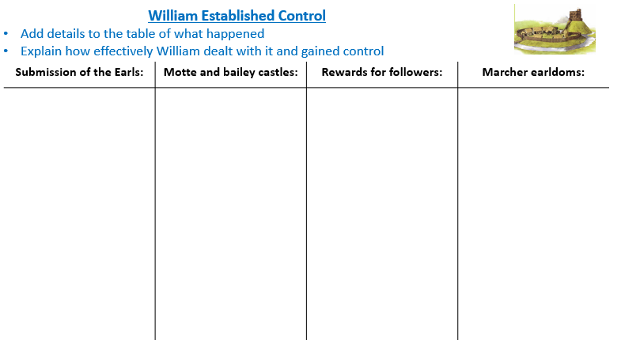
Q. What is the most important reason William was able to establish control? Why?
……………………………………………………………………………………………………………………………………………………………………………………………………………………………………
Revolt and Resistance after 1066
Task: Read and highlight the information on ‘The causes and outcomes of Anglo-Saxon resistance’ page 31 -32 -below and then complete the table- making key notes – page 32
The causes and outcomes of Anglo-Saxon resistance
The revolts of Edwin, Morcar and Edgar The Aethling
Revolt of Edwin and Morcar in 1068
Causes:
- Edwin resented the fact that William went back on his word about marrying his daughter
- William gave away land and his followers sought to expand their lands.
- Bad government - Odo and FitzOsbern made illegal land grabs and allowed soldiers to rape Anglo-Saxon women without punishment
- Morcar resented the fact his ealdom was reduced in size – parts had been given away to Tostig’s old thegn Copsi and to Maerlswein.
- William imposed a heavy geld tax in December 1066. In 1067, William returned to Normandy believing England was secure. He took a lot of English treasure with him.
Events:
- 1068 – Edwin and Morcar fled from William’s court – heading north and were joined by others who protested over William’s rule (e.g. Bleddyn, Lord of Pwys (Wales), Maerlswein, the Sherriff of Yorkshire, Earls Waltheof, Gospatric and Edgar Aethling)
- William went north building castles. He took control of Warwick and the Nottingham – building castles there.
- Edwin and Morcar went to Warrick and surrendered – meaning the rest of the revolt collapsed
Outcome: it failed
- William pardoned Edwin and Morcar, and they returned to being ‘guests’ at court, until 1071 when they escaped again.
- Edgar the Aethling fled to Scotland (protected by King Malcolm III of Scotland) and the rebels were not united.
- There were other revolts going on at the same time – William had some help from Anglo-Saxon troops.
Edgar The Aethling and the rebellions in The North in 1069
Causes: continued resentment and issues with William’s tyranny
- Rebels from Northumbria joined Edgar
- Edgar had the backing of Malcolm III of Scotland
- King Sweyn of Denmark sent a fleet of ships led by his brother Asbjorn – teaming up with the rebels
Events:
- Robert Cumin had been the new Earl of Northumbria but in January 1069 his soldiers were looting and burning their war North and burned Durham.
- A group of Northumbrians surprised and massacred him and his troops.
- February 1069 - There was an uprising in York
- Edgar came down from Scotland
- Norman sheriff and his garrison were attacked
- The survivors at York held out until William arrived and routed the rebels. He laid waste to York and built new castles.
- Easter – William returned south – entrusting York to Fitzosbern who was established in a new castle.
- September 1069 – Anglo-Danish attack on York - King Sweyn of Denmark sent a fleet to fight with Edgar and Northern Rebels and took over York after The Normans set fire to it. 3000 Normans were killed. The Danes retreated to the Lincolnshire coast.
- Anglo-Saxon’s in the north began guerrilla warfare, sheltered by locals.
- New rebellions – Devon, Shrewsbury and Chester
- As soon as William’s troops subdue the unrest in one region it starts in another
- The Danes bidded their time in the marshland
Outcome:
- William managed to buy off The Danes who returned to Denmark.
- He then embarked on a campaign to ‘Harry The North’ in destruction.
Hereward the Wake and rebellion at Ely 1070-71
Causes: 1070 - Another Danish fleet under King Sweyn arrived at The Isle of Ely in East Anglia.
- Sweyn made alliances with local people who used to be part of Danelaw including Hereward the Wake.
- Hereward had been a thegn under Edward whose lands had been stolen by Normans. He returned to Ely around 1068 from exile – he had lost lands to a new Norman lord.
- The Archbishop of Peterborough (possibly Hereward’s lord) was replaced by a Norman.
The Rebellion: Hereward The Wake and The Rebels were confident. Ely Cathedral was surrounded by marshland and only the rebels knew the way through.
- Morcar and his men came to Ely and joined Hereward to defend Ely
- William tried to cross the marsh with a wooden causeway but it collapsed and his soldiers drowned. He also paid a witch to curse the rebels
Result: Some monks betrayed Hereward and Ely Cathedral fell. Hereward disappeared. Morcar was captured. Hereward had hoped to save the treasures in the monastery (but the Danes took it).

The Harrying of The North 1069-1070
William’s reasons: Death of Robert Cumin. The rebels kept refusing to meet him in open battle. The Harrying of The North made it impossible for people to live there. The North clearly required different tactics to The South as The Danelaw resented Southern rule. He had to get rid of the threat of a Danish invasion and stop moving troops from one area to another.
Events: William killed everyone in rebelling areas. He burned houses, grain stores, crops and killed livestock. He destroyed farm equipment and sowed salt into the fields to prevent future crops growing.
Short-term impact: -100,000 dead. People resorted to cannibalism. -This massively reduced the chance of a future Danish invasion. Sweyn maybe chose Ely because Northumbria was no longer suitable.
Long term impact: There were no further uprisings in Northumbria. 60% of Yorkshire as listed as ‘vasta’ or wasteland and William couldn’t tax it. There were somewhere between 80,000 and 150,000 less people than in January 1066. -This massively reduced the chance of a future Danish invasion. Sweyn maybe chose Ely because Northumbria was no longer suitable.
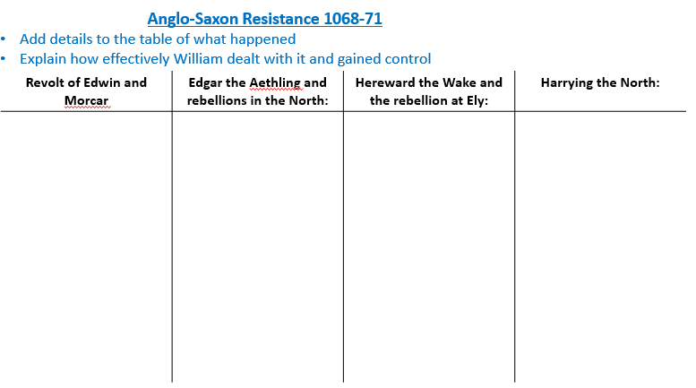
Q -Answer: Did William completely conquer England by 1071? Why? Why not? What is the most important reason?
………………………………………………………………………………………………………………… ………………………………………………………………………………………………………………………………………………………………………………………………………………………………………………………………………………………………………………………………………………………
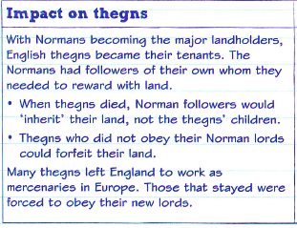
Changes in Land Ownership 1066-1087

How land was owned under Edward
- Bookland – lords were given a charter to show they owned the land.
- Leases – Land was loaned to someone for money. This could for a long time eg three generations.
How land was owned under William
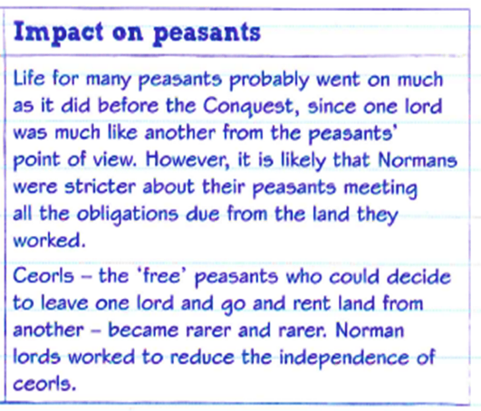
- There was only one landowner: The King. William owned all land. William made Saxons pay for their own land or granted it to his followers for free. Anyone who disobeyed him lost land.
- Of 190 tenants-in-chief, only two were Anglo-Saxon.
- A quarter of the land was held by The Church but The Normans held the most senior positions. The king’s royal estates made up 1/5 of the land.
- Only 5% of the land was still in Anglo-Saxon hands, typically in small estates.
- Half the land of the 190 tenants-in chief was held by just 11 men including William FitzOsbern, Odo of Bayeux and Robert of Mortain. They were all Norman nobles and William’s relatives.
How it was lost:
- Forfeit – William owned all the land, anyone who fought against him lost their land.
- New Earldoms – William created new blocks of land like The Marcher Earldoms from several old blocks.
- Land Grabs – Straightforward theft of land by Normans from Anglo-Saxons. Norman sheriffs were notorious for this sort of thing.
- Heirs – William made Normans ‘heirs’ to Anglo-Saxon lands.

Maintaining Royal Power
- Military Strength William mainly maintained power through his military strength. Anglo-Saxons would have respected great warriors and shown to many that he was favoured by God. Some Anglo-Saxon armies joined his armies against rebels.
- Royal Ceremonies – William made a point of being seen wearing his crown three times per year and swore to preserve Edward’s laws.
- Coinage and writs – William took control of minting coins with his Royal Seal on and used writs to control royal power.
- Journeys around England – William travelled around and met people to show his power was never far away.
- Owning the land – William was a much stronger king than Edward as he technically owned all land.

Remember that William still relied on oath-taking. He made every landholder in Britain swear an oath of allegiance to him in 1086 when he thought Vikings would invade again
Revolt of The Earls 1075
Causes:
- Roger De Breteuil (Earl of Hereford and son of FitzOsbern)– Objected to the fact that he was granted less land than his father and the fact that William had introduced his own sheriffs to The Marcher Earldoms
- Ralph de Gael (Earl of East Anglia)– Unknown but probably resented loss of power and wealth compared to his father. Married to Roger’s sister – a lot of the plotting happened at their wedding.
- Waltheof (Earl of Northumbria) – had taken part in other rebellions but was pardoned after submitting (last Saxon earl). Was the one who informed Lanfranc of the revolt which led to it failing. Maybe he was playing both sides but wanted to be on the winning side.
Events –
- Waltheof informed Archbishop Lanfranc about the revolt. Lanfranc tried to convince Roger not to act against William
- When Roger did not give up his plans, Lanfranc excommunicated him
- Bishop Wulfstan and the abbot of Evesham blocked Roger from taking his troops across the River Severn
- Anglo-Saxons also joined Normans in the east to prevent Ralph’s troops breaking out of East Anglia
- When the Danes arrived with 200 ships the revolt had ground to a halt – so too late. The Danes did not invade but raided and returned to Denmark.
Consequences:
- Roger was captured and imprisoned for life
- The Ralph escaped to Brittany, William failed to take Ralph’s castle in Normandy.
- Waltheof who had fled abroad was tricked into coming back,was executed.
Effects: Normans: William now had to be careful of his own earls’ ambition. Resentment of the power William held was at the heart of the rebellion. Anglo-Saxons: such as Bishop Wulfstan now seemed to support The Normans but this didn’t stop William eliminating Anglo-Saxon aristocrats. Vikings: The failure of the planned Danish invasion fleet to support the rebellion in 1075 was in fact the end of the Viking threat. When there was another threat in 1085, William launched The Domesday Book and took extra measures to boost his defences. This shows how seriously he took the threat of 1075

Q – How did William maintain his power after 1071?

……………………………………………………………………………………………………………………………………………………………………………………………………………………………………………………………………………………………………………………………………………………………………………………………………………………………………………………………………………………………………………………………………………………………………………………………
Choose a 12 mark question to answer – don’t forget your link and process words! Check out the word mat on page 4

A - Q2 - Explain why William I ordered the Harrying of the North.
You may use the following in your answer:
- The role of the Danes in the northern rebellions
- Edgar Aetheling
Advice:
- 3XPEE
- Make sure you are specific and explain in relation to the question
- You would have 20 minutes to answer this question
You must also include information of your own. (12)

Q2) Explain why William created the Marcher earldoms.
You may use the following in your answer:
- Protecting the borders
- Rewarding followers
You must also include information of your own. (12)

C -Q2) Explain why motte and bailey castles were built throughout England.
You may use the following in your answer:
- The Welsh Marches
- Norman knights
You must also include information of your own. (12)

D - Q2) Explain why the Revolt of the Earls in 1075 failed.
You may use the following in your answer:
- Ralph of Norfolk
- Mutilation as a punishment
- You must also include information of your own. (12)
……………………………………………………………………………………………………………………………………………………………………………………………………………………………………………………………………………………………………………………………………………………………………………………………………………………………………………………………………………………………………………………………………………………………………………………………………………………………………………………………………………………………………………………………………………………………………………………………………………………………………………………………………………………………………………………………………………………………………………………………………………………………………………………………………………………………………………………………………………………………………………………………………………………………………………………………………………………………………………………………………………………………………………………………………………………………………………………………………………………………………………………………………………………………………………………………………………………………………………………………………
………………………………………………………………………………………………………………………………………………………………………………………………………………………………………………………………………………………………………………………………………………………………………………………………………………………………………………………………………………………………………………………………………………………………………………………………………………………………………………………………………………………………………………
……………………………………………………………………………………………………………………………………………………………………………………………………………………………………………………………………………………………………………………………………………………………………………………………………………………………………………………………………………………………………………………………………………………………………………………………………………………………………………………………………………………………………………………………………………………………………………………………………………………………………………………………………………………………………………………………………………………………………………………………………………………………………………………………………………………………………………………………………………………………………………………………………………………………………………………………………………………………………………………………………………………………………………………………………………………………………………………………………………………………………………………………………………………………………………………………………………………………………………………………………………………………………………………………………………………………………………………………………………………………………………………………………………………………………….
Date
Lesson 4: Key Topic 3: Norman England, 1066-68
The Feudal system and the Church
LO: To be able to explain the nature of feudalism and the impact of reforms to the Church
Starter: Complete the Knowledge Quiz (no cheating!)
Q. | Question | Answer
1 | Why did William and his army not immediately march on London after the Battle of Hastings?
2 | What is the surrender of his remaining enemies in London known as?
3 | What was the biggest problem that faced William after he was crowned king of England?
4 | What type of castles was built by the Normans?
5 | What was the main purpose of the castles?
6 | In the immediate aftermath William didn’t change much; he kept Edwards laws and allowed earls to keep their lands, Why
7 | Why were the marches a problem William?
8 | How did he solve the problem?
9 | What did William do in 1067
10 | In summer 1067 where was a small rebellion that although was easily dealt with showed a sign of things to come?
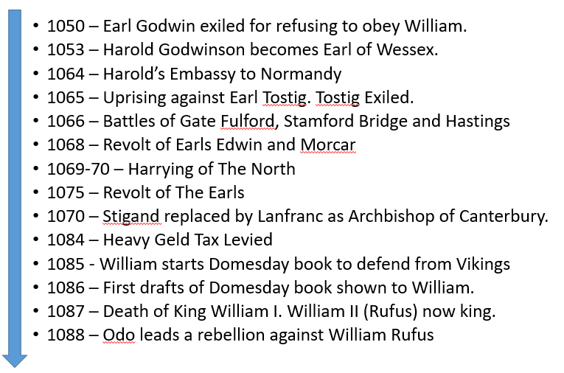
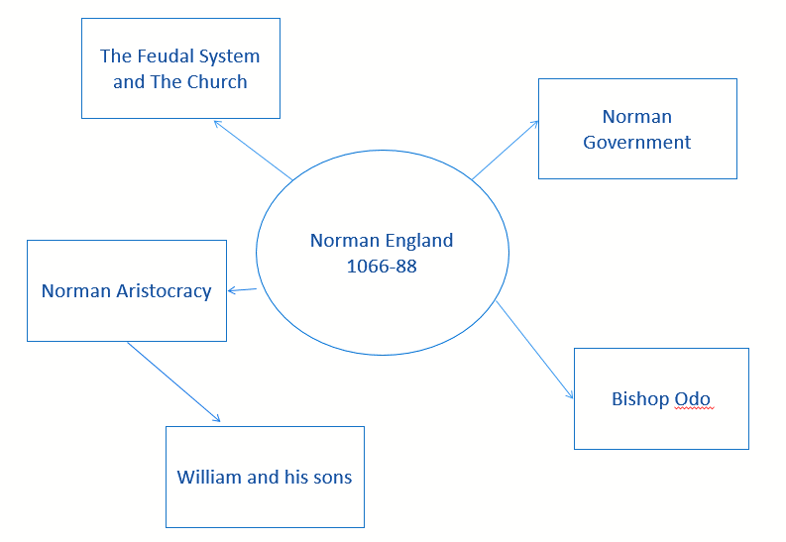
The Feudal System:
- When William became king, he established himself as the owner of all England’s land.
- His key allies became his tenants-in-chief, who received land direct from the king in return for their military service.
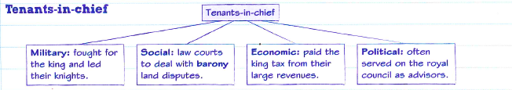
- They then granted land out to their followers in turn, creating a feudal hierarchy with the king at the top, with huge power to command and control the system.
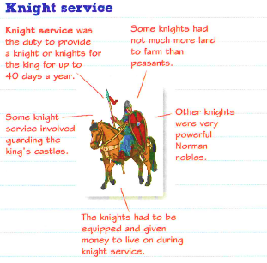

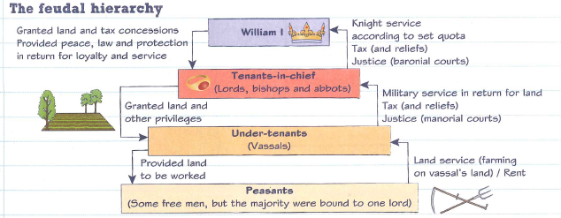

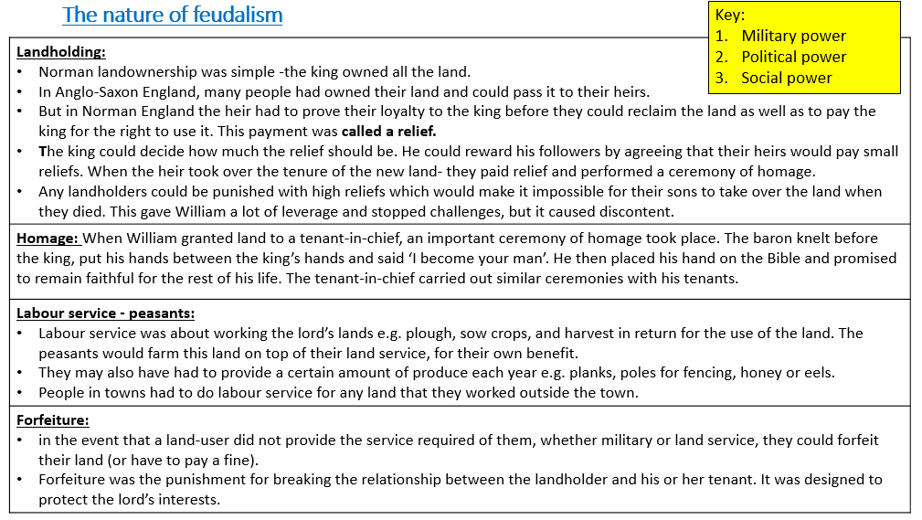
Q1A – 4 mark Questions – QA = 2 x PE – 5 mins

- Describe two features of feudalism. (4)
- Describe two features of knight service. (4)
- Describe two features of landholding. (4)
- Describe two key feature of the tenants-in-chief. (4)
- Describe two features of changes in land ownership during William I’s reign.
- Describe two features of William’s rewards to his Norman followers. (4)
- Describe two features of the rebellions of the North, 1069. (4)
- Describe two features of the revolt of the Earls, 1075. (4)
- Describe two features of Motte and Bailey castles. (4)
- Describe two features of earldoms in Anglo-Saxon England. (4)
- Describe two features of Hereward the Wake’s rebellion in 1070-71. (4)

……………………………………………………………………………………………………………………………………………………………………………………………………………………………………………………………………………………………………………………………………………………………………………………………………………………………………………………………………………………………………………………………………………………………………………………………………………………………………………………………………………………………………………………………………………………………………………………………………………………………………………………………………………………………………………………………………………………
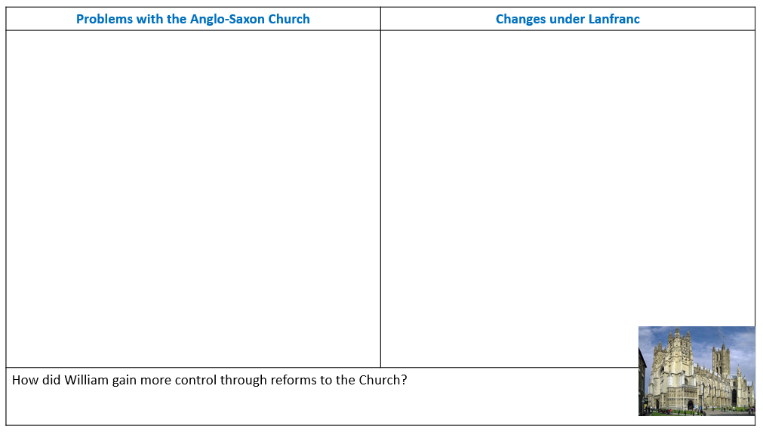
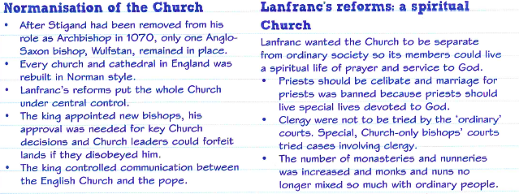
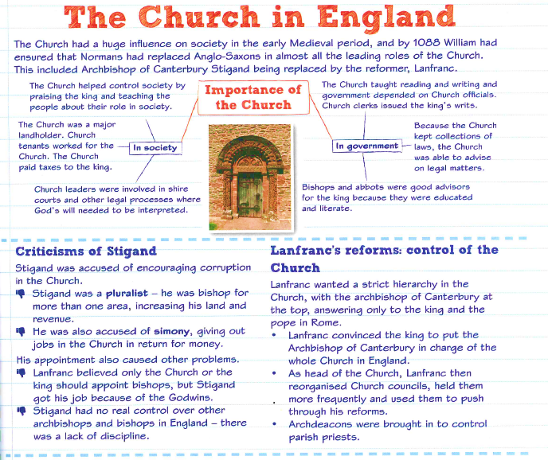
Task: Read the information on the Normanisation of the Church below and then complete the grid
Have a go at planning or answering these questions (there is lined paper at the back)
Qc - ‘The main consequence of the Normanisation of England was that the king became more powerful.’
How far do you agree? Explain your answer:
You may use the following in your answer:
- The feudal system
- Archbishop Lanfranc
You must also use information of your own. (16)

Qa) Describe two features of Lanfranc’s reforms of the English Church. (4 marks)

Qb) Explain why Lanfranc made changes to the Church in England.
You may use the following in your answer:
- Corruption
- The Pope
You must also use information of your own. (12 marks)

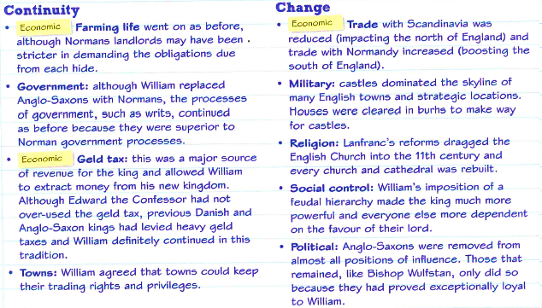
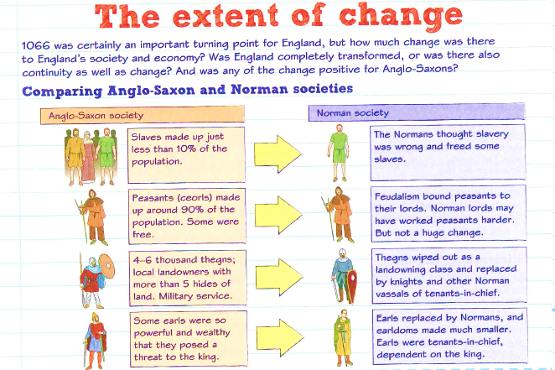

Q – How far did society change from Anglo-Saxon to Norman England?
………………………………………………………………………………………………………………………………………………………………………………………………………………………………………………………………………………………………………………………………………………………………………………………………………………………………………………………………………………………………………………………………………………………………………………………………………………………………………………………………………………………………………………
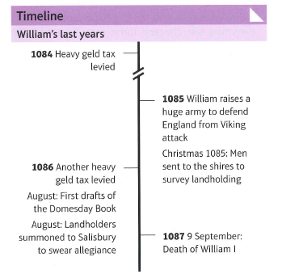
Date: Lesson 5: Norman Government and the Aristocracy
LO: To be able to explain the changes of government William brought in; the culture and language of the Norman aristocracy and the significance of Bishop Odo

Task: Read and highlight the information and then complete the Bingo sheet on page 47

The Norman Government
William used the opportunity of conquest to centralise power into his hands.
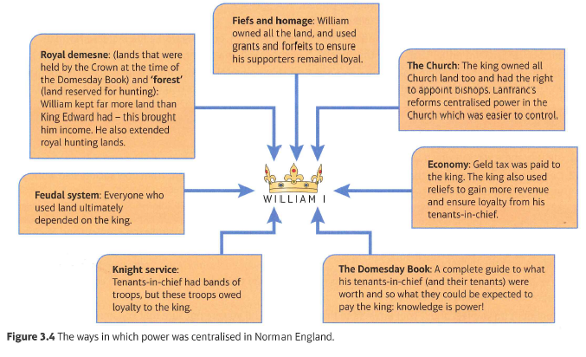
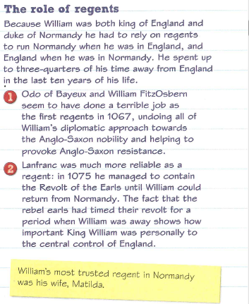
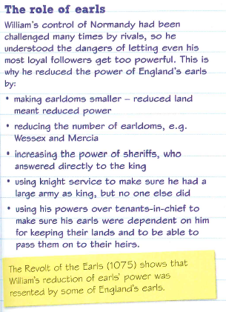

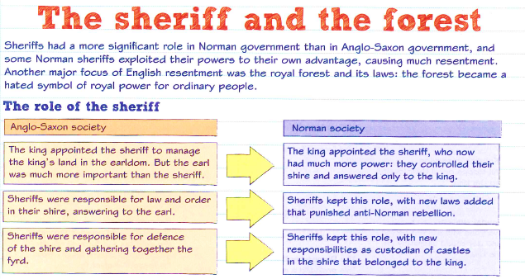
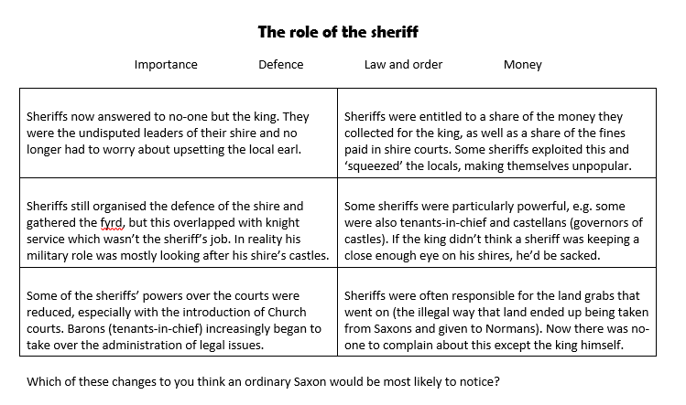
Code this:

The Forests:
- William loved hunting
- In Anglo-Saxon England and in Normandy the king could hunt across his own demesne
- The Conquest gave William the opportunity to extend his hunting ground!
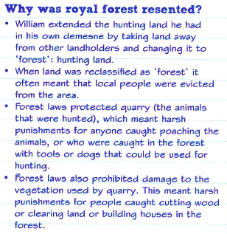
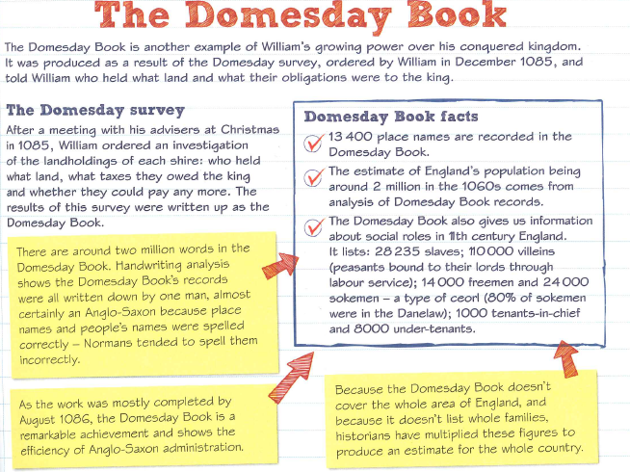
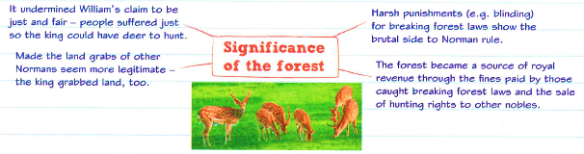

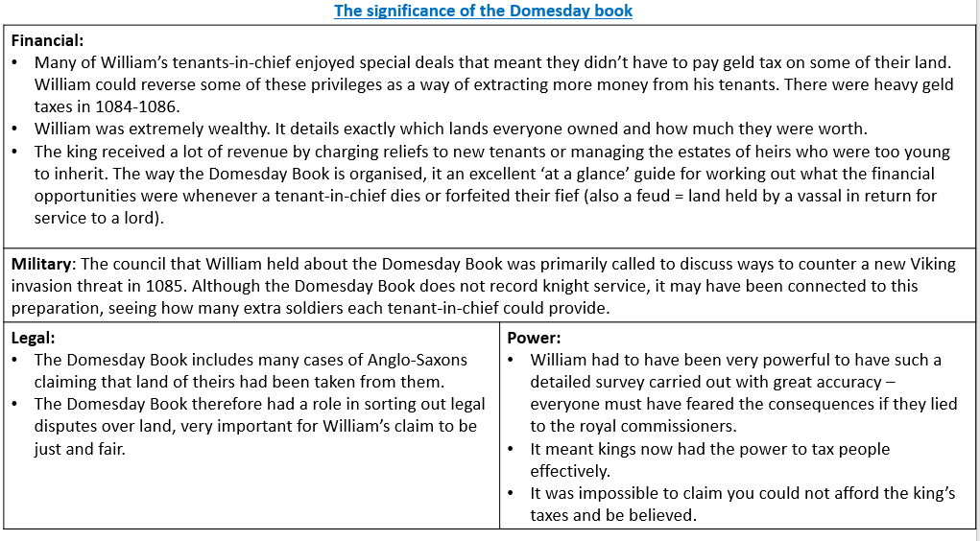

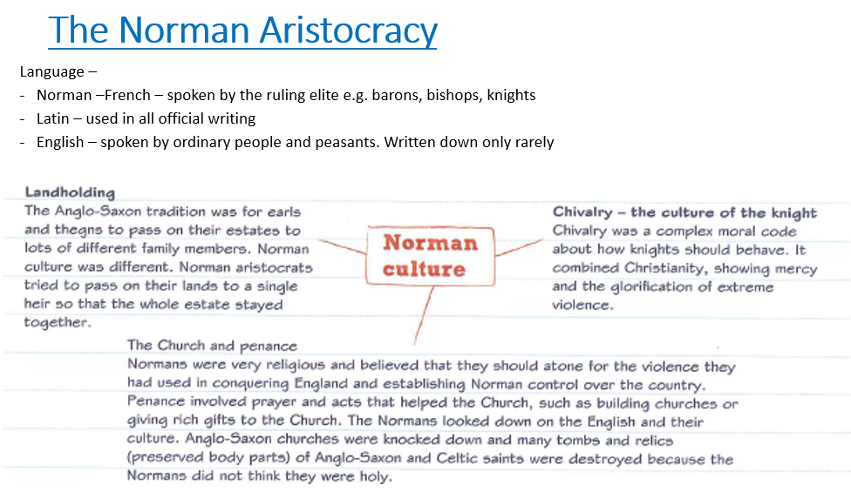

Bishop Odo
- Odo was William’s half brother – they had the same Mother, Herleva.
- In 1049, William made Odo Bishop of Bayeux, even though his reputation was very poor – he was greedy and immoral (Bayeux was an important Norman town).
- Odo was a major supporter of William’s invasion, contributing 100 ships to the fleet, and fought at the Battle of Hastings.
- William rewarded him with the earldom of Kent and gained control of many other estates to become the second largest landholder in England, after the king. The Domesday Book records him holding land in 22 counties.
- Odo was made co-regent of England (with William FitzOsbern) when King William returned to Normandy.
- 1076 – a 3 day enquiry was held following complaints to Lanfranc about land seizures by Odo. Odo is forced to return the land.
- 1079 – William sent Odo to Northumberland, following attacks from Scotland and the murder of the Archbishop of Durham – Odo laid waste to the region.
- 1082 – Odo fell out of favour with William and was imprisoned. He was not released until William’s death, after Odo’s brother manages to persuade William to show mercy. Historians don’t know why he got into trouble- probably due to his corrupt behaviour or tried to take the throne. Odo tried to take some of William’s knights out of England for a journey to Rome after he saw an opportunity to make himself Pope. This went against centralised power and knights service. No tenant-in-chief was allowed to put their own army together!
- 1088 – Odo led the barons in revolt against William II

Significance of Odo:
- William’s most trusted supports were his family members, they were richly rewarded.
- Loyalty was William’s priority.
- Odo and Earl William FitzOsbern seem to have wrecked the king’s attempts to gain Anglo-Saxon acceptance of his reign with their violent and oppressive actions.
- King William allowed Odo a lot of power; he was able to act as a ‘second king’.
- Odo went too far in his abuse of power (in the end), but probably only because he crossed Lanfranc: it isn’t likely that many Anglo-Saxons who lost land to Odo ever got it back. However it is significant that William was prepared to see the law enforced against a relative and a favourite.
- If Odo was imprisoned because of taking knights from William,that shows how seriously William took the idea that knights were loyal only to him, the king.
- The pope reprimanded William for imprisoning one of his bishops, Odo. William rejected the right of the pope to criticise what he did in his own kingdom.

In the exam you get a choice of two questions for QC
Q4c (i) ‘The main consequence of changes in government after 1066 was the king had more power than his Anglo-Saxon predecessors.’
- How far do you agree? Explain your answer:
- You may use the following in your answer:
- Castles
- the use of forfeiture
- You must also use information of your own. (16)

Q4C (II)‘The main significance of the Domesday Book was financial’.
- How far do you agree? Explain your answer:
- You may use the following in your answer:
- Invasion threats
- The geld tax
- You must also use information of your own. (16)

Bingo Sheet – first to complete a line of 3 correctly wins! Then we go for the whole table!
1 | Why was William physically at the centre of government and decisions taken? | 2 | Why were regents needed? | 3 | William gave his followers rewards. Was William too generous e.g. in rewarding his earls?
4 | Why were forests hated by the English? | 5 | Were the new sheriffs more powerful than the Anglo-Saxon shire reeves? | 6 | Why was the Domesday Survey carried out? What does the survey tell us about William’s power?
7 | Describe 2 features of Norman Aristocracy | 8 | Why was Odo significant to the Norman Conquest? | 9 | How and why did Odo go too far? What does it tell us about the type of leader William was?

Date: Lesson 6: William and his sons
LO: To be able to explain the reasons for and outcome of the disputed succession
Starter: Q4A) Describe two features of the career of Bishop Odo. (4)
Feature 1:
……………………………………………………………………………………………………………………………………………………………………………………………………………………………………
Feature 2:
……………………………………………………………………………………………………………………………………………………………………………………………………………………………………

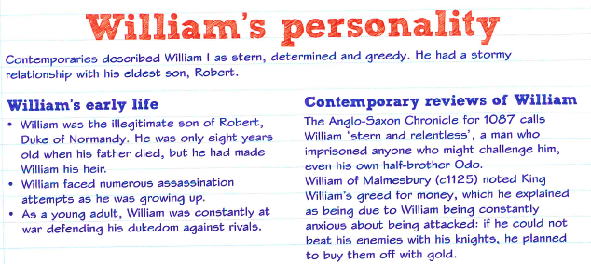

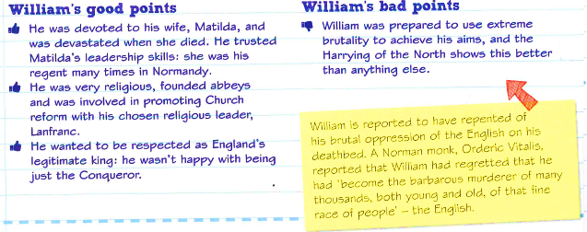

William’s Family
- Married Matilda around 1050.
- William and Matilda had 6 children.
- Matilda acted as regent in Normandy while William was in England in 1066 and on other occasions.
- Matilda died in 1083, four years before William.
- 9 September 1087 William the Conqueror dies at Rouen, Normandy
- 26 September 1087William II (Rufus) is crowned at Westminster Abbey
- After 1087 - As King of England William Rufus twice invaded Normandy to take it from his brother Robert.
- 1095 – Robert went on Crusade – at the Pope’s call. So William Rufus took control of Normandy for 3 years.
- 1100 – William Rufus died while hunting in the New Forest
- 1100- Henry became King (he did this quickly!).
- 1101 – Robert invades England – challenging his younger brother –he lost and agreed to recognise Henry as king in return for Henry’s territory in Normandy.
- 1105 - Henry and Robert fought over Normandy- as Henry went back on his agreement.
- September 1106 – Henry captures Robert and imprisons him for life. Henry ruled England and Normandy like his father.
- 1120 - Henry’s only son William died. Eventually he named his daughter Matilda as heir.
- Henry’s nephew Stephen challenged Matilda and became King of England in 1135

Task: Read the information below and complete the mind map on page 50 about Robert’s rebellion.
William, Robert and revolt!
Causes: Relationship between William and Robert was difficult – William often bullied him
- Robert has a close relationship with his mother Matilda
- Robert was nicknamed ‘Curthose’ – short or dumpy legs.
- Robert was a good warrior but William did not think he was ready to lead the Normans against their enemies (there were threats from the neighbours to Normandy). He thought he was lazy and weak-willed.
- In 1078, following a prank in which his younger brothers (William Rufus and Henry) by uriniating or throwing water on the heads of Robert and his friends. Robert started a real fight with his brothers that their father had to break up.
- Angry that William did not punish his brothers – Robert fled with his followers and tried to take William’s castle at Rouen.
The rebellion:
- Robert and his followers fled and William wanted them arrested (William continued to insult Robert).
- The fall out was good news for William’s enemies – the rulers of France and Flanders – who gave Robert knights and the castle at Gerberoi – to make it harder for William to defeat them!
- Robert and his men carried out raids in Normandy – forcing William to raise an army against him
- Matilda unknown to William sent money to Robert
- In 1079 – Robert and William fought against each other at Gerberoi. William besieged Robert in the castle.
- Robert ended up fighting William and winning. He knocked William off of his horse and ordered him to retreat – this was a huge humiliation for William – who had to be rescued by an Englishman in his army.
Consequences:
- Robert looked successful and William ‘over the hill’
- William looked weak and vulnerable
- The King of the Scots decided it was a good time to invade the North
- Enemies in France were attacking Normandy
- The revolt was not just against his father – Robert’s supporters were the sons of the senior Norman nobles (those that helped William conquer England)
- It showed that Robert wanted power before his father was ready to give it – which was a key problem for the kings and his nobles in this period!
Result:
Matilda organised a reconciliation between Robert and William at Easter 1080
While William was unhappy – Matilda and his nobles wanted peace – it could lead to their sons being killed in punishment. They needed their sons to inherit and rule their lands
- William gave in and restored Robert as his chosen heir to Normandy.
- To show unity Robert led William’s army to defeat the Scottish invaders. Robert also built the castle at Newcastle
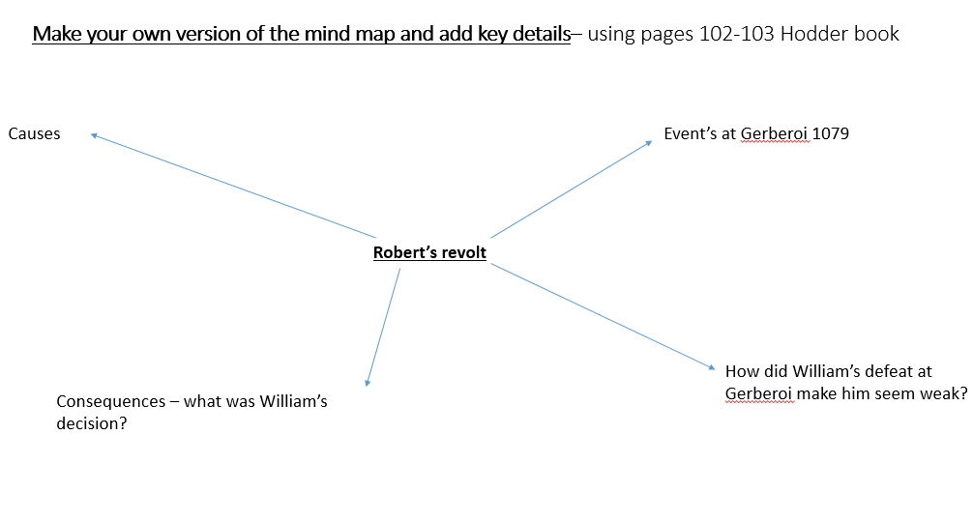

Extension:
Why did Robert rebel?..........................................................................................
……………………………………………………………………………………………………………

State one key event of the rebellion:………………………………………………………………………….

Why did William reach a peaceful settlement with Robert? ?........................................................
……………………………………………………………………………………………………………
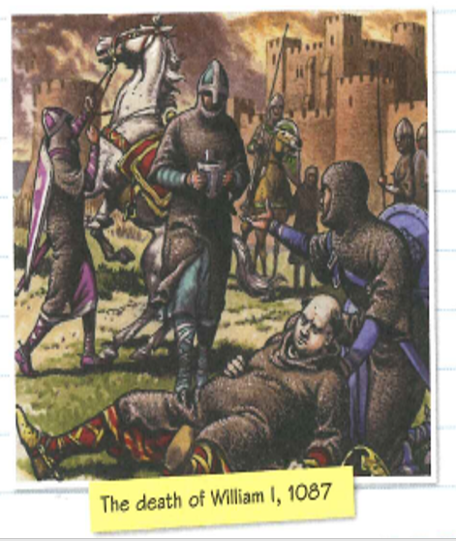
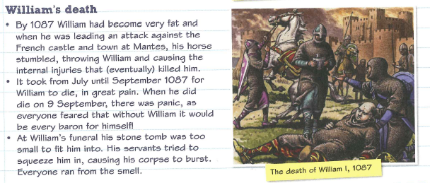
Reasons for the succession crisis | How did each reason lead to the crisis?
The relationships between members of William I’s family | - Robert was the eldest but quarrelled frequently with his father. Rufus and Henry took their father’s side.  - Therefore there was already mistrust between Robert and William but Robert remained ambitious. William preferred Rufus, who was also supported by Henry. William wanted him to have the wealthiest area.  - Both Robert and Rufus wanted to be King of England.
The nature of William’s death | - William died unexpectedly, away from England.  - Rufus and Henry were at his deathbed, but Robert was in exile again.  - Before he actually died, William gave Rufus a letter to take to Lanfranc instructing him to arrange Rufus’ coronation. He had a head start.
Customs about how land and kingdoms were inherited | Customs were clear in Normandy for land: eldest son inherited. However, this was the first time a Norman duke had been King of England too, so William was improvising.  William FitzOsbern had left his Norman lands to his eldest son and English lands to his second.
William I’s decisions about who inherited his land | - Keeping England and Normandy under his sole control was a huge achievement for William (Channel crossings, number of revolts on each side). He didn’t think his sons, especially Robert, could manage the same feat.  - Rufus was his favourite son, so he deserved the bigger prize of England.  - He helped him get a head start – the letter meant Lanfranc did crown Rufus king. Robert was presented with a fait accompli.  - William was full of repentance at the way he had gained the English crown. As much as he wanted his favourite son to inherit England – he said he would let God choose the next King of England.
Q – Why was there a succession crisis after William died? …………………………………………………………………………………………………………………
……………………………………………………………………………………………………………………………………………………………………………………………………………………………………
………………………………………………………………………………………………………………..
Task read about: William Rufus and the defeat of Robert and Odo 1087-88 on this page and then complete the table on page 53.
William Rufus made a good start when he was given the letter by his father (which recommended him to Lanfranc to be the next king)– he took control of the treasury in Winchester and was crowned king with Lanfranc’s support at Westminster in September 1087. Clearly Lanfranc was so powerful the Witan was not needed to authorise the succession! He became William II
What was the problem?
- Robert as the eldest son wanted to have both England and Normandy – according to Norman custom
- There was also the problem of loyalty and oaths of allegiance - most nobles would have only wanted one lord. If they had two different lords – one for their lands in England and one for their Norman ones – it would divide them and possibly cause conflict
- The nobles owed homage to both brothers – what would happen if they fought each other? The nobles had a dilemma
- In 1087 Odo had been freed by William on his death bed
Odo!
Odo said that the Norman nobles should choose between Robert and William Rufus and help one of them reunite England and Normandy.
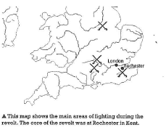
Odo suggested they should unite behind Robert and depose William Rufus- mostly because he knew Robert would be easier to handle and more likely to listen to Odo and other nobles (giving them more power). William Rufus – was much stronger and more idependently minded
The revolt!
- In 1088 Odo led a rebellion against William II (Rufus)
- Odo’s brother, Robert of Mortain, joined Odo – the brothers controlled large areas of the South of England, including some heavily fortified castles
- Other rebellions broke out in 1088 alongside the main revolt:
- Small rebellions by Roger Bigod in Norwich and the Sheriff of Leicester, Hugh de Grandmesnil
- Raids in Somerset and Wiltshire by Robert de Mowbray, Earl of Northumberland and in Gloucestershire by William of Eu
- Medium sized rebellions in the West, led by the Marcher Earls Roger de Montgomery and Roger de Lacey, which were put down by a force assembled by Bishop Wulfstan (as in 1075)
- The majority of the Norman aristocrats, the bishops and the English population were against the rebellion
- William II went straight to the heart of the rebellion and tackled Odo first!
- Odo and Robert of Mortain took refuge in Pevensey castle.
- William II besieged the castle for 6 weeks, using local fyrd troops to attach the castle and prevent supplies reaching the rebels inside
- William II capture both his uncles – althouth Odo escaped to Rochester
- Odo held out at Rochester – hoping Robert Curthose would come and support him (he was expected)
- Help never arrived and Odo was forced to surrender (lack of food and disease at Rochester Castle)
Consequences: William II was more popular -William had promised lower taxes, an end to the ‘forest’ and the restoration of the ;aws of Edward the Confessor. This was just what the English wanted. The nobles argued for a peaceful settlement with the rebels – which he did. Odo was exiled. William went back on all his promises!
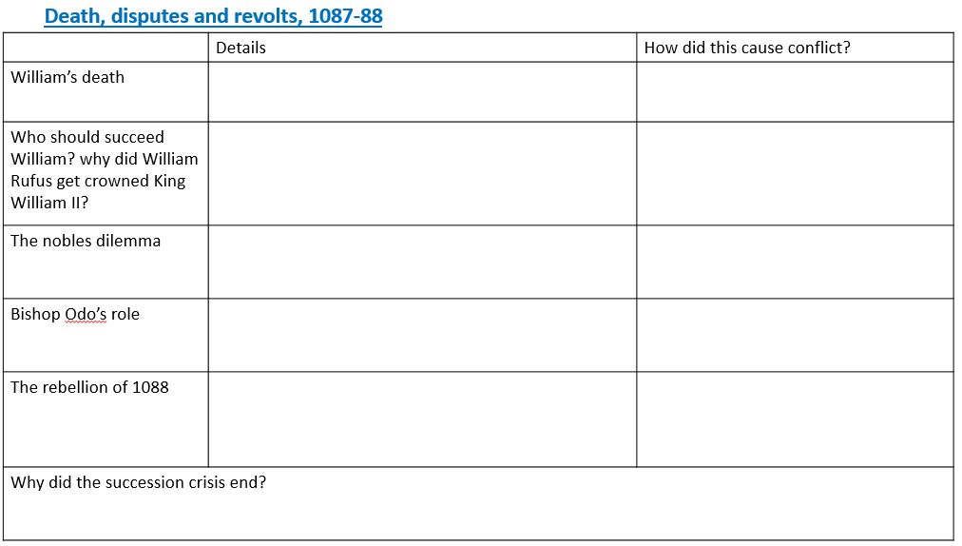

Date: Lesson 7/8: Exam Literacy
LO: To secure your exam literacy and how to strcutire the exam questions.

Starter: Revisit your knowledge audit – using a different colour pen – are you making progress in securing your knowledge?

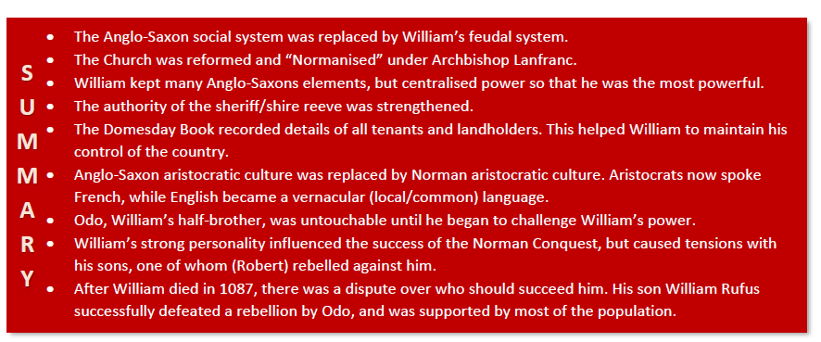

Task: Work through the exam question templates and practice planningg the structure for the questions.

You can always answer these in timed conditions and hand in for marking!

Question a:
- Describe two features of…. (4)
- 2 x PE
- 5 minutes

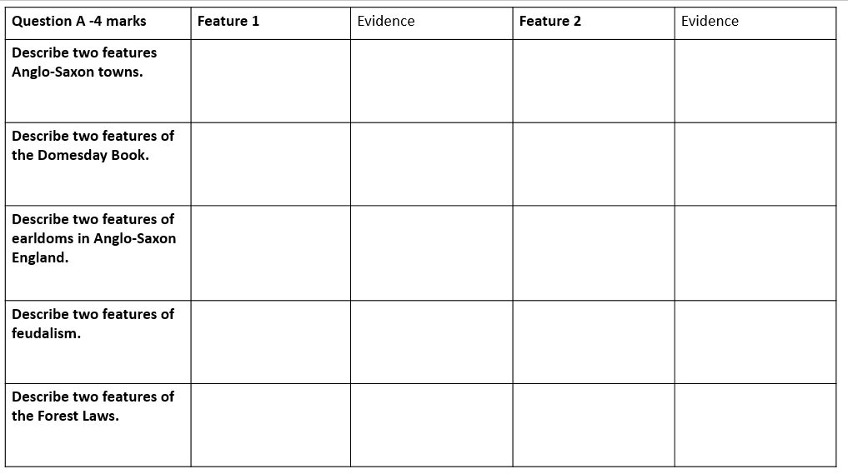
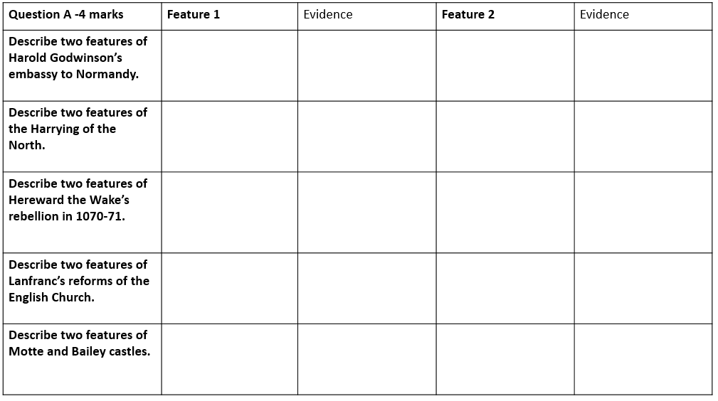
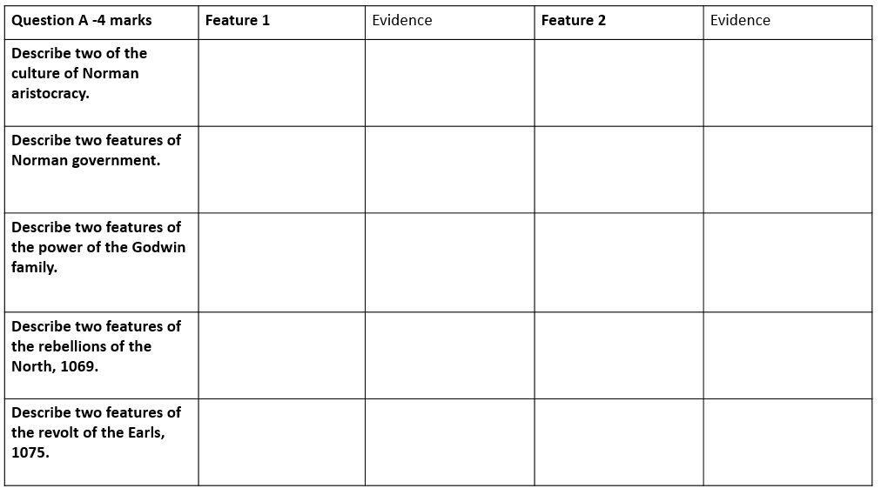
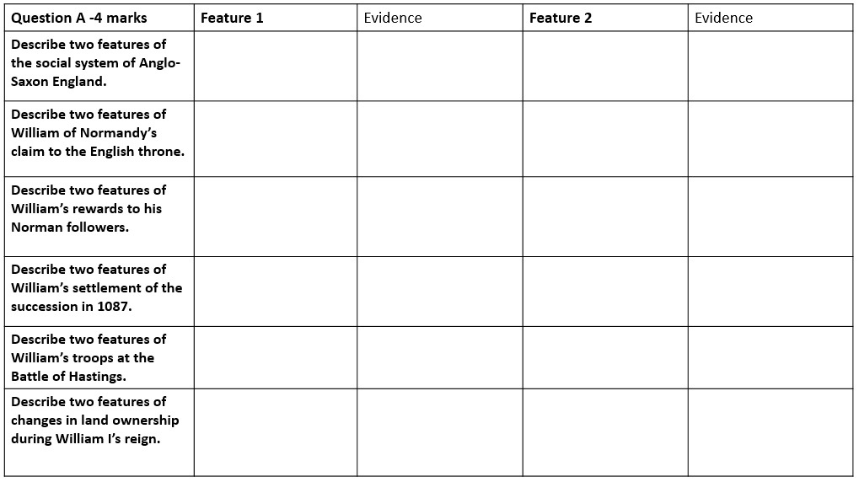
Question b:
(b) Explain why……. (12)
- You will be given two stimulus points but will also need to come up with at least one of your own
- Aim to give at least three explained reasons – 3xPEE
- Remember to link your explanation back to the question
- 20 minutes
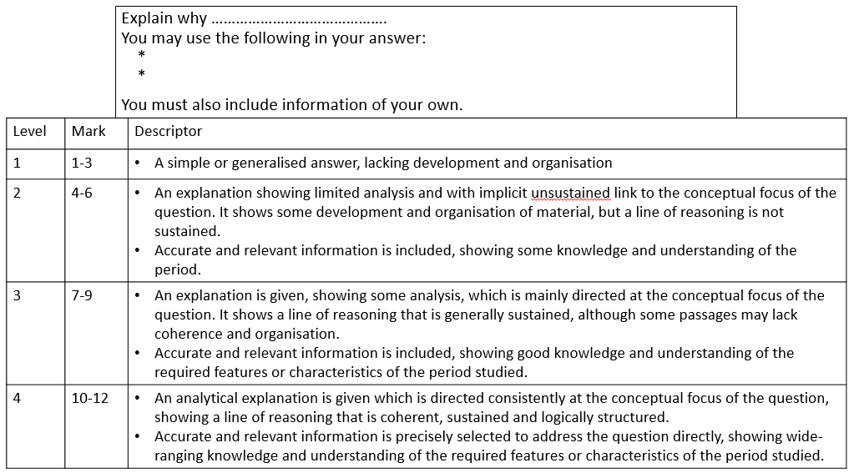

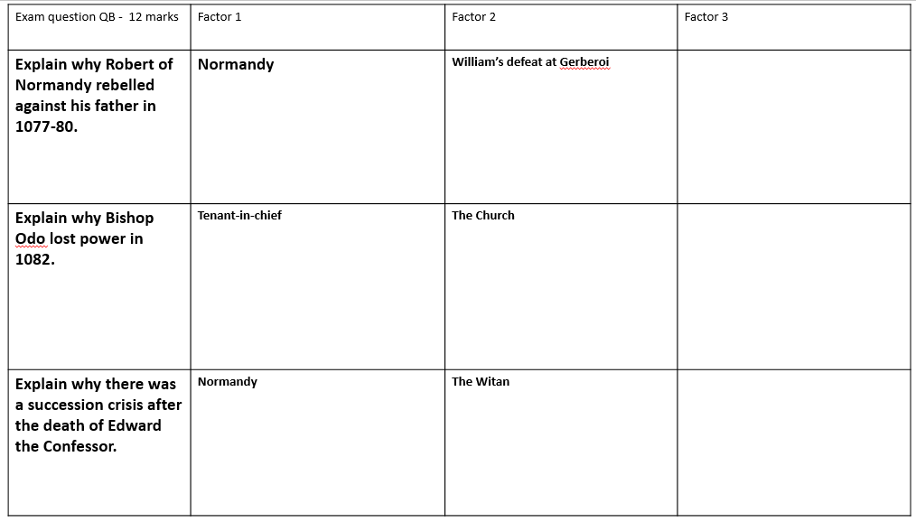
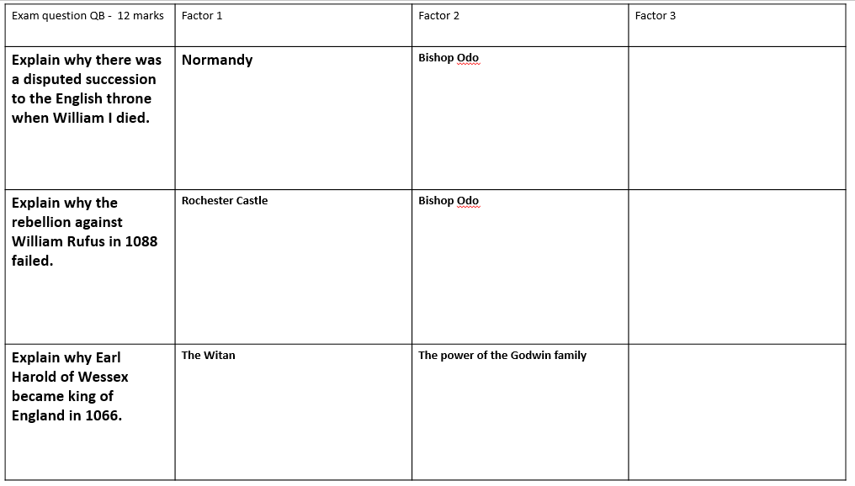
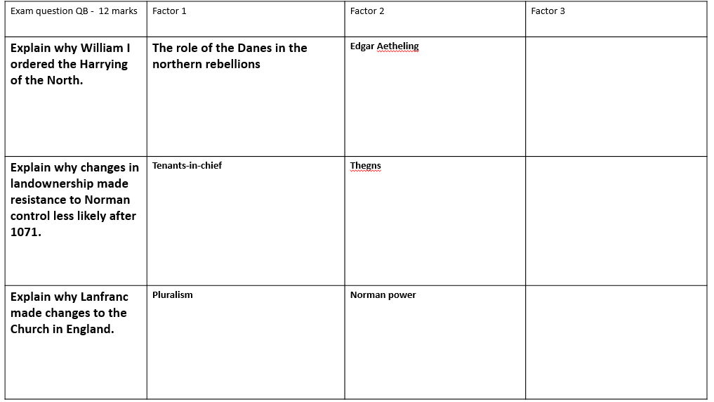
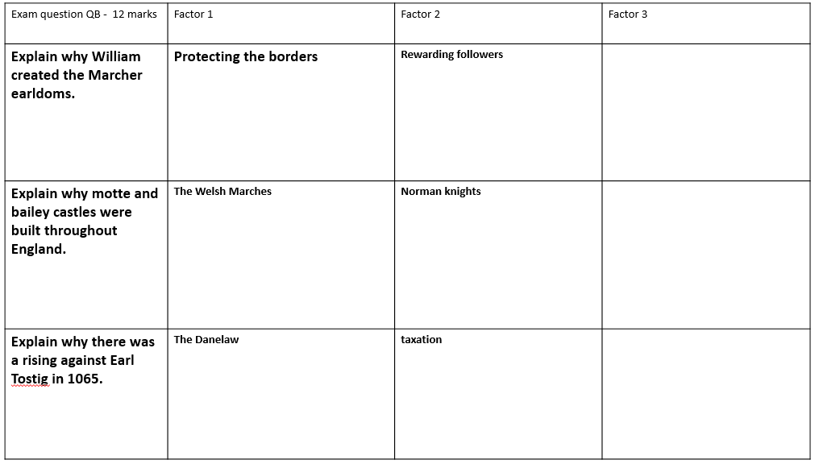
Question C – i and ii
- You get a choice of two questions – choose the one you can discuss the most factors!
- 16 marks
- 30 minutes
What you need:
- 3 PEEL paragraphs + a Judgement
- Either x2 paragraphs agreeing and x1 disagreeing Or x1 paragraph agreeing and x2 disagreeing.
- However you structure this question – you must have three factors – with evidence and specific arguments for reasons why (e.g. agree.disagree)
- You must have a sustained argument
- You must have a judgement at the end – that is supported by the strength of your argument in your paragraphs
Structure:
- Always start by AGREEING with the statement first. Address the factor in the statement – what truth is there in it?
- Signpost phrases will really help to focus your answer. See the structure strips.
- Conclusions should be developed and try to analysis. Lots of marks for this question!
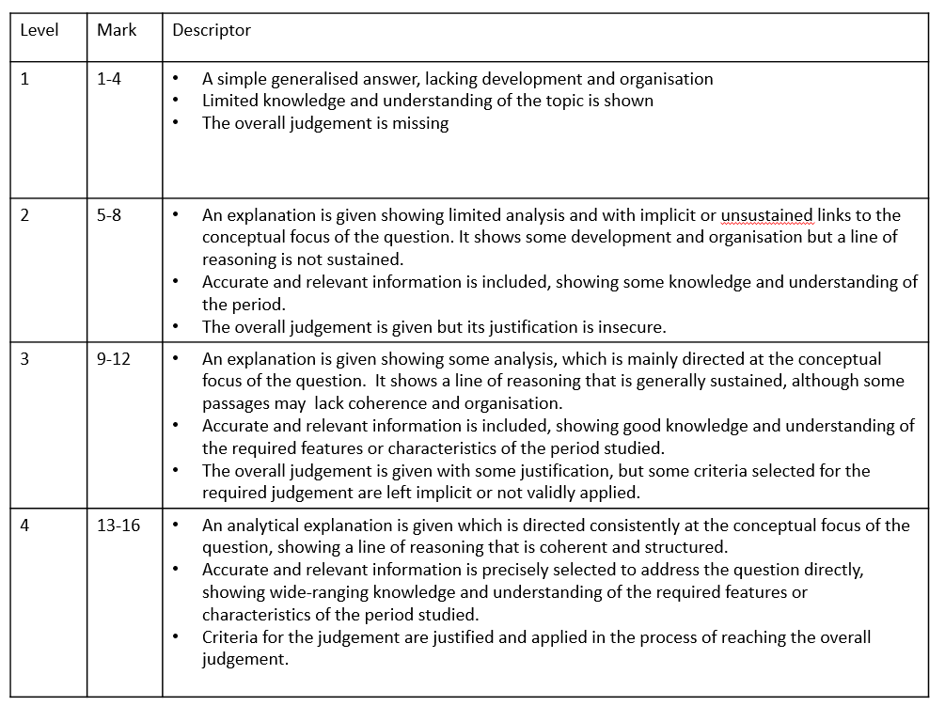
- Judgement – must say – how far you agree (e.g. significantly, somewhat, partially, not at all) and why? How important were the other factors you have discussed – consider their relative importance e.g. however ….factor was also important as….






