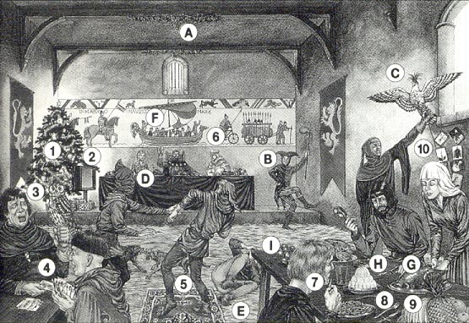

Christmas feast in a Medieval castle

- There would be no Christmas tree in the great hall. Christmas trees were not introduced until the early 1800s, Evergreen plants such as holIy and ivy (A) would have been used for decoration,

- There was no television, jesters (B), jugglers and musicians provided entertainment.

- A knight would have had a hawk, not an owl, sitting on his wrist. Trained hawks (C) were used hunt other birds such as pigeons and even swans

- There were no playing cards. After the feast, they played games such as Hoodman's Blind (D) which is similar to Blindman's Bluff.

- There were no rugs on the floors. Instead, they were strewn with straw and rushes (E),

- There were no bicycles. They would not be invented for hundreds of years. Tapestries (F) hung castle walls. This is the Bayeux Tapestry which tells the story of the Battle Hastings, In it you can see many examples of Norman transport

- They would not have chips at the time. The potato did arrive in England until the 1590s. Banquets would include various fish and meats (G) and even peacock if the king was visiting! Poor people lived mainly on vegetables such as peas and beans.

- They would not use forks at that time. They had knives and spoons (H) but mostly used their fingers.

- Tropical fruits such as pineapples and bananas were not known at the time. They grew apples (I) and grapes, and also made elaborate desserts sweetened with honey.

- The custom of giving Christmas cards or presents was not known at the time. Christmas was one of several holidays, along with May Day and Midsummer Eve, all celebrated with feasting, singing, and dancing.

