‘The Half Has Never Been Told’, Edward E. Baptist
Rachel: Slave Auctions
Rachel arrived in New Orleans in January 1819. After a long spell locked aboard a trading ship, she was taken to Maspero’s Coffee House. This was no Costa or Starbucks, it was a dark prison, filled with fumes from whisky and tobacco. Here Rachel and many others were sold.
First, she was examined by perspective buyers: her legs, her arms, teeth and gums. Women were often forced to strip naked, their bodies examined to see if they might bear children. Questions were asked: ‘What sort of work can you do? Have you ever run away?’ Disobedient slaves were worth less to masters seeking to turn a profit.
In January 1819, a healthy 18 year old male might reach $900-$1100 at auction (around $17,000 - $21,000 in today’s money). Rachel was sold for $800 to a man named William Fitz. The auctioneer’s hammer brought an end to her old life and signalled her transition to being little more than a pair of hands.
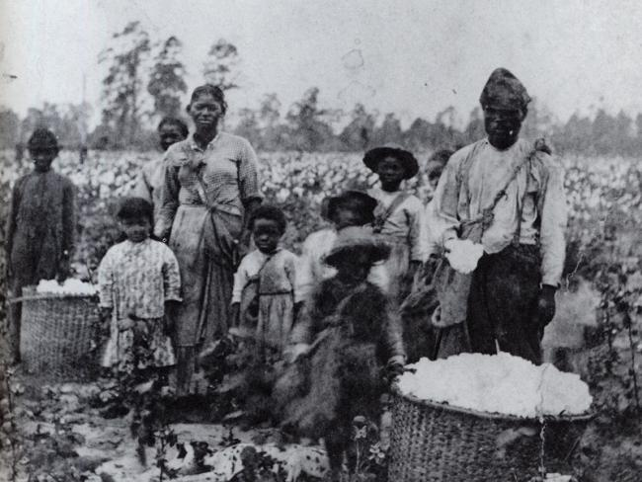

‘The Half Has Never Been Told’, Edward E. Baptist
Charles Ball - A new type of slavery
Charles Ball spent his youth on a plantation in Maryland working under the ‘task system’. Each slave was set a number of tasks to complete each day. One the tasks were complete, the slaves could use their spare time to tend to their own crops, go to church or relax. This all changed when Ball was sold and marched to a new plantation in Georgia, in the Deep South.
Here the ‘pushing system’ was being developed. The invention of the cotton gin allowed planters to process as much cotton as could be picked (harvested). The pushing system drove the pace of picking by putting the fastest pickers at the head of the line of slaves to set the pace. The overseer could then target the heads of the lines rather than having to monitor each slave.
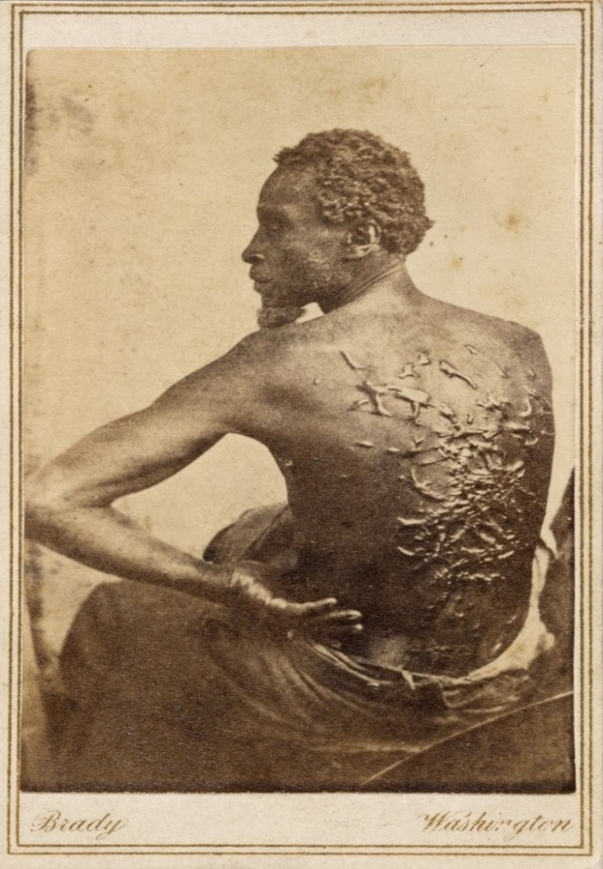
Ball and other cotton slaves worked from before dawn until after sundown, first planting, then weeding, and finally picking. Slaves had to train their fingers to work faster and faster to meet the demands. On his first day of picking, Ball harvested 17kg of cotton, weighed by the overseer at the end of the day. This set his minimum. Should Ball ever pick less than his 17kg he would be brutally punished.

‘The Half Has Never Been Told’, Edward E. Baptist

Joe Kilpatrick – building new lives
Joe Kilpatrick was stolen away from his wife and daughters, Lettice and Nelly, in the 1830s. He was sold to a different plantation in the Deep South where he had no family or friends. In these circumstances, enslaved people had to take a long view. They tried to build new ties and form new family connections on the plantations.
On his new plantation, Joe adopted an orphaned 5 year old named George. Together they made a new family as if they were blood relatives. It is impossible to know what stories Joe might have told young George in his cabin. However, when George had children of his own, years later, he named them Lettice and Nelly after the half-sisters he never knew. In this way, in some sense at least, Joe’s blood lived on in a new family.
