Wavell School-GCSE History
Paper 2: Cold War
Class Revision Booklet
Name:
Class:
Teachers name:
Classroom:
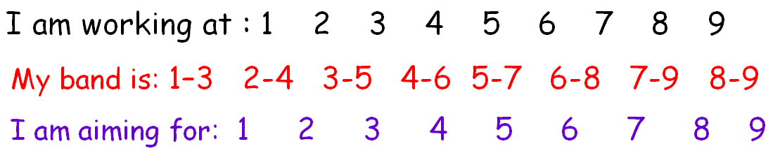

Paper 2 timings | Timing – Paper =1 hr 45 mins | With 25% Extra Time = Approx. 2hours 11 mins
Cold War booklet
Q1 – 2X 4 marks | -10 mins | -14 mins
Q2 – 8 marks | -15mins | -18 mins
Q3 – 2X 8 marks | -25 mins | -30 mins
Anglo-Saxon and Norman England booklet
Q1 – 4 marks | -5 mins | - 7 mins
Q2 – 12 marks | -20 mins | -25 mins
Q3i or 3ii – 16 marks | -30 mins | -37 mins

My Feedback:

Cold War keywords:
Abdicate: to step down from power
Aggressor: someone who starts a quarrel
Allies: countries working together
Bizonia: The joining of British and American sectors of West Germany
Blockade: a siege
Brinkmanship: pushing disagreements to the point where there is a risk of war
Capitalism: Western system of a free economy
Capitalists: believe that property and industry should be privately owned
Censorship: where the government controls what the newspapers/ radio etc. say
Co-existence: living together
Colonialism: economic, political and cultural control of another country
Communists: believe that industry should be state-owned
Congress: the American ‘parliament’
Containment: holding something in – stopping the USSR growing
Conventional: ordinary or normal e.g. conventional weapons = not nuclear, chemical or biological.
Currency: money
Democracy: where the people can elect their own government in free elections
De-Stalinisation: dismantling Stalin’s tyranny
Détente: a period of peace between two groups that were previously at war, or hostile to each other
Deterrent: the idea that having something in place puts someone off i.e. by having nuclear weapons each side tried not to attack the other
Dictator: a ruler who has total power
Doctrine: a belief or philosophy
Doves: during the Cold War, those who tried to find solutions without going to war
Economic aid: money given to a country to help build up its economy
Economic sanctions: measures taken to damage a country’s economy, usually involving a trade ban
Free city: a city with its own independent government
Glasnost: Russian for ‘openness’ or ‘transparency’
Hawks: during the Cold War, those who supported going to war were known as Hawks.
Interim: temporary or short term
Isolationism: staying apart and not getting involved in the affairs of others
London Poles: a group of politicians who left Poland after the German invasion in 1939 and formed a government in-exile, first in Paris and then London
MAD: Mutual Assured Destruction - the theory that a nuclear war would wipe out both sides.
Non-proliferation: stopping the spread of something, usually weapons or armaments
Nuclear weapons: atomic and hydrogen bombs and ICBMs – inter-continental ballistic missiles
Patriotic: loving your country
Perestroika: Russian for ‘reconstruction’.
Psychological: in the mind
Ratification: formal approval
Reparations: payments in goods or money, after a war, from the losing country to the victors - compensation
Satellite State: a nation that was once independent but is now under the control of another
Socialism: Communist countries sometimes refer to themselves as ‘socialist’. For example, the USSR was also known as the Soviet Socialist Republic
Soviet Union: the Union of Soviet Socialist Republics – the USSR – i.e. Communist Russia
Summit: meeting of the major world powers
Telex: an early form of fax, connecting typewriters down a telephone line
Trizonia: The joining of British, American and French sectors of West Germany
U2: was a spy plane
Ultimatum: a final demand, often backed up with a threat to take action
Veto – to forbid or refuse

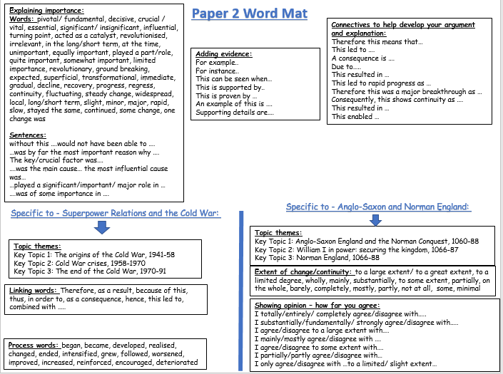

Knowledge Audit: Superpower relations and the Cold War, 1941-1991
Key topic 1: The origins of the Cold War, 1941-58 | Confident | Unsure | No idea
Early tension between East and West
The Grand Alliance. The outcomes of the Tehran, Yalta and Potsdam conferences.
The ideological differences between the superpowers and the attitudes of Stalin, Truman and Churchill.
The impact on US-soviet relations of the development of the atomic bomb, the long and Novikov telegrams and the creation of Soviet satellite states in Eastern Europe.
The development of the Cold War
The impact on US-Soviet relations of the Truman Doctrine and the Marshall Plan, 1947.
The significance of Cominform (1947), Comecon (1949) and the formation of NATO.
Berlin: its division into zones. The Berlin Crisis (blockade and airlift) and its impact. The formation of the Federal Republic of Germany and the German Democratic Republic.
The Cold War intensifies
The significance of the arms race and the formation of the Warsaw Pact.
Events in 1956 leading to the Hungarian Uprising, and Khrushchev’s response.
The international reaction to the Soviet invasion of Hungary.
Key Topic 2: Cold War crises, 1958-1970
Increased tension between East and West
The refugee problem in Berlin, Khrushchev’s Berlin ultimatum (1958), and the summit meetings of 1959-1961.
Soviet relations with Cuba, the Cuban Revolution and the refusal of the USA to recognise Castro’s government. The significance of the Bay of Pigs incident.
Opposition in Czechoslovakia to Soviet control: the Prague Spring.
Cold War Crises
The construction of the Berlin Wall, 1961.
The events of the Cuban Missile Crisis.
The Brezhnev Doctrine and the re-establishment of Soviet control in Czechoslovakia.
Reaction to the Crisis
Impact of the construction of the Berlin Wall on US-Soviet relations. Kennedy’s visit to Berlin in 1963.
The consequences of the Cuban Missiles Crisis: the ‘hotline’, the Limited Test Ban Treaty 1963; the Outer Space Treaty 1967, and the Nuclear Non-Proliferation Treaty 1968.
International reaction to Soviet measures in Czechoslovakia.
Key Topic 3: The end of the Cold War, 1970-91
Attempts to reduce tension between East and West
Détente in the 1970s, SALT 1, Helsinki, and SALT 2.
The significance of Reagan and Gorbachev’s changing attitudes.
Gorbachev’s ‘new thinking’ and the Intermediate-Range Nuclear Force (INF) Treaty 1987.
Flashpoints
The significance of the Soviet invasion of Afghanistan, the Carter Doctrine and the Olympic boycotts.
Reagan and the ‘Second Cold War’, the Strategic Defence Initiative.
The collapse of Soviet control in Eastern Europe
The impact of Gorbachev’s ‘new thinking’ on Eastern Europe: the loosening Soviet grip on Eastern Europe.
The significance of the fall of the Berlin Wall.
The collapse of the Soviet Union and its significance in bringing about the end of the Warsaw Pact.

Task: Write down your top 3 actions that you need to work on for the Germany unit and how you will do it:
1.
2.
3.
I can attend revision/catch-up/ homework help on………………………………………………………………………………………

The aim of this booklet is that you will complete all tasks and try to move onto the next task. There will be exam practice questions at the end of each lesson – you must try to get to these. Planning or answering the questions as directed – planning can go next to the question. There are lined pages at the back of the booklet.
You may not take these booklets home until your teacher says you can e.g. when the unit has been fully revised.
Exam Question Criteria
You will need to use linking and process words!
Section A: Cold War
- Question 1 – 2x 4 marks (10 mins) 2x developed PEE. The question wants you to explain the results of something. What difference did it make? Use phrases such as ‘as a result’, ‘as a consequence’ or ‘the effects of this was’.
- Question 2 – 8 marks (15 mins) – aim 3x factors (mini PEE – clear links and process words). The key to this question is to explain how one event leads to the next in a logical and structured way. To do this: As it is a narrative – you should write in chronological order. Put the events in the correct order and show how one event is connected to another. You need a beginning, middle and an end.
- Question 3 – 2x 8 marks (25 mins). 2x Developed PEE The question asks you to explain the importance of events and developments. Don’t just tell a story about the event – explain the importance e.g. the impact, what did the event affect or lead to? What difference did they make? Why do they matter?
Section B: Anglo-Saxon and Norman England.
- Question 4 (a) – 4 marks – 5 minutes. Describe two features of…. (2xPE)
Make a point and support with evidence. Do this twice.
- Question 4 (b) – 12 marks- 20 minutes. Explain why …. (3xPEE) You will be given two stimulus points but will also need to come up with at least one of your own. Aim to give at least three explained reasons
- Question 4 (c) – 16 marks – 30 minutes. How far do you agree? (choose (i) or (ii).
You will have a choice of two questions. This question will be worth half of the total marks so make sure you have kept 30 minutes to answer it. You must consider both sides of the argument. You must reach a judgement on how far you agree
Date: Lesson 1 Key Topic 1: The origins of the Cold War, 1941-58
Early tensions and the development of the Cold War
LO: To understand how relations declined between the west and the USSR during WWII and to be able to explain how Cold War tensions intensified.
Keyword:
Cold War - state of political tension and military rivalry between nations that stops short of full-scale war, especially that which existed between the United States and Soviet Union following World War II.
Starter:
What is the difference between capitalism and communism?
………………………………………………………………………..
…………………………………………………………………………
…………………………………………………………………………………………………………………
…………………………………………………………………………………………………………………
…………………………………………………………………………………………………………………
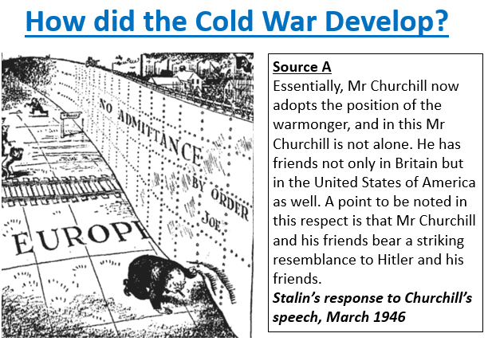

Task: Read through the table and complete the column – importance to international relations and score out of ten for tension. Score the events out of 10 for tension – 10 being the highest for tension
Reasons for importance: Relations between the USSR/USA
Relations between East and West Arms Race Development of the Cold War Relations within Europe Relations between the Satellite states/ Soviet Republic states
 | Details | Importance to international relations | Score
The Grand Alliance 1941 | It was created in 1941 to defeat the Nazis – it was a marriage of convenience between the USA, the USSR and Britain. Once Hitler was defeated relations became uneasy. They met at three international conferences between 1943 and 1945.
The Teheran Conference 1943 | The Big Three – Churchill, Stalin and Roosevelt met – they reached some firm and some agreements in principle.  Agreed: The USA and Britain agreed to open a second front to split German forces – Roosevelt agreed to keep Stalin happy. The USSR would declare war on Japan once Germany was defeated. Discussed Germany after the war – no formal agreement. Poland should be given land from Germany but give some to USSR  Didn’t agree: Churchill wanted to invade the Balkans – to stop Soviet advance. Stalin felt the West delayed opening a 2nd front. USA hated GB’s colonialism.
The Yalta Conference 1945 | The Big Three met again – the same things were agreed as at Teheran but there were some changes  Agreed: Germany (once defeated) would be reduced in size, demilitarised, and have to pay $20 bn in reparations. Plans were started on the division of Germany (Britain and the USA wanted all countries to choose their government). The Nazis were to be banned, criminals put on trial in an international court.  The United Nations to be set up (it met in April 1945) – Stalin not happy as USSR and France said the 16 Soviet republics could not have individual membership. The USSR would declare war on Japan 3 months after Germany was defeated (they would get the land Japan had taken returned). Poland would come under the ‘Soviet sphere of influence’. The future of governments in Eastern Europe to be decided in free elections.  Didn’t agree: While Roosevelt had good relations with both Stalin and Churchill, he and Churchill did not want a communist Poland and see communism spread. Stalin wanted a buffer from the West!
The Potsdam Conference 1945 | The Big Three met yet again – this time tensions were showing. They all agreed on democracy – but this meant different things to each leader. Roosevelt died and was replaced by Harry Truman – who was not willing to compromise (he also tested the atomic bomb – so trust was lost!)  Agreed: To set up a council of Foreign Ministers to organise the re-building of Europe. Ban the Nazi Party and prosecute surviving members (at Nuremberg), reduce the size of Germany, divide Germany into four zones (administered by the USA, USSR, Britain and France) – the aim being to reunite all under one government. Berlin as the capital was also being divided, the USSR was to take ¼ of the industrial equipment from the other three zones as it was the least developed – the USSR gave the other zones raw materials  Didn’t agree: The USSR wanted heavy reparations but the USA wanted to rebuild Germany. Truman was in Churchill’s words ‘bossy’ – Stalin refused to be pushed around. Truman objected to the control the USSR had over countries liberated from the Nazis.
The atomic bomb | Truman attempted to assert control at the Potsdam Conference – During the Potsdam conference Truman dropped the atomic bombs on Japan (on Hiroshima and Nagasaki), without informing the USSR. He refused to share the new technology. The USA had a nuclear monopoly for the next four years  Each country had to make sure it was not at a technological disadvantage – John Foster Dulles called it ‘brinkmanship’ | Stalin – determined to protect the USSR with a ‘buffer zone’ by making Eastern European countries communist.
Poland | Stalin had agreed to set up a government in Poland that included both communists and capitalists. But by the Potsdam Conference it was clear he had broken his word. Stalin wanted the elections to have a pro-communist government – GB supported the non-communist London Poles.
Greece | By 1946, Greece and Czechoslovakia were the only countries in eastern Europe that weren’t Communist. The German retreat in 1944 left two groups in Greece fighting each other – the monarchists and the communists. In 1945 British troops were sent in to help the monarchists. The USSR complained to the United Nations who did nothing a civil war erupted (the Soviets helped the communists). In February 1947, the British told Truman they could no longer afford to keep their soldiers in Greece. President Truman stepped in. The USA paid for the British soldiers in Greece.
Turkey | Truman noted that Turkey too was in danger from Soviet aggression, so Congress voted to give aid to Turkey as well. Part of the money was given in economic and humanitarian aid, but most was spent on military supplies and weapons.
The Long Telegram 1946 | Sent to Truman from Kennan, America’s ambassador in Moscow said:  - Stalin had given a speech calling for an end to capitalism  - There could be no peace with the USSR while it opposed capitalism  - The USSR was building up its military power  - The USA should seek to contain communism
Novikov’s Telegram 1946 | Sent to Stalin from Novikov, the Soviet ambassador to America said:  - America desired to dominate the world  - Following Roosevelt’s death, the US government was no longer interested in co-operation with the USSR  - The American public was being prepared for war with the USSR | Both telegrams effectively ended the Grand Alliance and set foreign policy for the USA and USSR going forward.
The Truman Doctrine  1947 | Even though the USSR was in no position to wage a war – Truman was worried Stalin would encourage communist revolutions across Europe. After WW2 countries like Britain, France, Italy, Greece and Turkey faced hardship – communism was appealing to many!  The Truman Doctrine said that: it was a choice of tyranny or democracy. The USA had a responsibility to fight for liberty. They would send troops and economic resources to help governments threatened by communism. $400 m was given in aid to Greece and Turkey and personnel were sent to the region.
The Marshall Plan 1947 | The USA agreed two approaches:  - Military force would be used to contain communism  - $13 billion was committed to rebuild shattered economies, encourage prosperity and weaken the attraction of communism  16 countries inc. Britain and France took aid. Stalin refused to allow ‘Soviet sphere of influence’ countries to accept aid. | Any lingering belief there was a Grand Alliance was gone.  Stalin’s suspicions reinforced.  Europe was in 2 economic and political camps.
Czechoslovakia 1948 | American attitudes to communism changed when the Communists took over the government of Czechoslovakia in a coup. In 1945 they had been ruled by a coalition government of left wing parties which, although included Communists, had been trying to pursue policies independent of Moscow. In 1946 the government was dominated by communists. The Communists came down hard in March 1948 – Anti-Soviet leaders were purged. One pro-American Minister – Jan Masaryk was found dead below his window– the Communists said he had jumped but the Americans suspected he had been pushed! | These events pushed the US Congress to accept the Marshall Plan
The Satellite States 1947-49 | There was a belief that the USA was buying influence over Europe – so he extended his control over Eastern Europe – creating satellite states. The USSR had agreed at Potsdam and Yalta to hold free elections – it was hoped they would choose communism in the elections the West insisted they had!  They USSR kept control by: making sure each state had a Communist Party with leaders who would obey Moscow, made people distrust each other so that they wouldn’t join forces against them, use the police and army to stamp out opposition, rationalised the economies of each country – so they were dependent on each other e.g. Poland did the ship building, Hungary – trucks etc.  The Satellite States: Yugoslavia, Albania, The Baltic States, East Germany, Bulgaria, Hungary, Poland, Romania and Czechoslovakia (although Yugoslavia left)
Cominform: (1947) | The Communist Information Bureau -Represented all Communist Parties internationally – and put them under USSR control. It had 9 members – USSR, Bulgaria, Czech., Hungary, Poland, Romania and Yugoslavia (expelled in 1948). The rejected the Marshall Plan – no Eastern European Country was allowed to take it and they encouraged strikes in Western Europe against it. Cominform ensured loyalty of the Eastern European Governments – ministers and employees were investigated and removed if not loyal. Had to follow orders from Moscow.
Comecon: 1949 | The Council for Mutual Economic Assistance was Stalin’s answer to the Marshall Plan. It aimed to prevent trade with the West and encourage economic development in the East – keeping the benefits in the Soviet ‘sphere’. Each state had a 5 year plan, nationalised industry and collectivised agriculture. It had 9 members – USSR, Bulgaria, Czech., Hungary, Poland, Romania, East Germany and Albania.
Task 2: Code the events on the table above:
- Events that show the breakdown of relations during WW2
- How Cold War tensions developed after WW2
- Soviet actions the made relations worse
- American actions that made relations worse

- Explain why you think tensions got worse.
……………………………………………………………………………………………………………………………………………………………………………………………………....................................................................................................................................................
- Explain how tensions worsened between the USA and USSR – why?
……………………………………………………………………………………………………………………………………………………………………………………………………....................................................................................................................................................
- How did Stalin take control over Eastern Europe?
……………………………………………………………………………………………………………………………………………………………………………………………………....................................................................................................................................................
3. Which statement would you agree with and why?
- Soviet actions the made relations worse B. American actions that made relations worse
Was anyone side more to blame? Is it that simple?
…………………………………………………………………………………………………………………
…………………………………………………………………………………………………………………
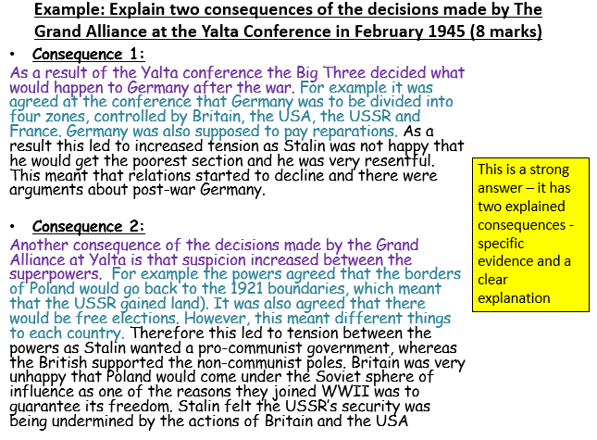
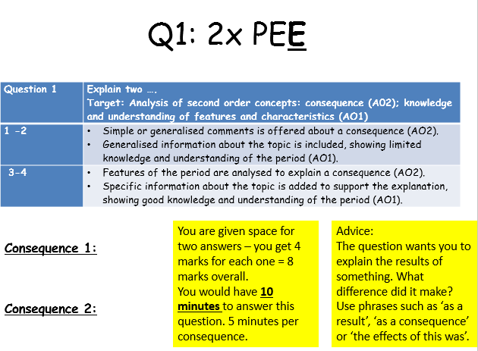
Q1 examples – choose the ones you would find hardest in the exam first
- Explain two consequences of the setting up of Cominform and Comecon. (8 marks)
- Explain two consequences of the Marshall Plan. (8 marks)
- Explain two consequences of the Potsdam Conference of July 1945. (8 marks)
- Explain two consequences of the Truman Doctrine. (8 marks)
- Explain two consequences of the Warsaw Pact (8 marks)

Consequence 1:
……………………………………………………………………………………………………………………………………………………………………………………………………………………………………………………………………………………………………………………………………………………………………………………………………………………………………………………………………………………………………………………………………………………………………………………………
Consequence 2:
……………………………………………………………………………………………………………………………………………………………………………………………………………………………………………………………………………………………………………………………………………………………………………………………………………………………………………………………………………………………………………………………………………………………………………………………

Date: Lesson 2 : The Berlin Airlift
LO: To understand the events of the Berlin Airlift. To consider the importance of these events in international relations and the deepening of the Cold War.
Starter:
- Read through the satellite states sheet
Key – Label
- Communists came to complete power in free elections
- Communists came to complete power by force
- Satellite state
- Directly part of The USSR

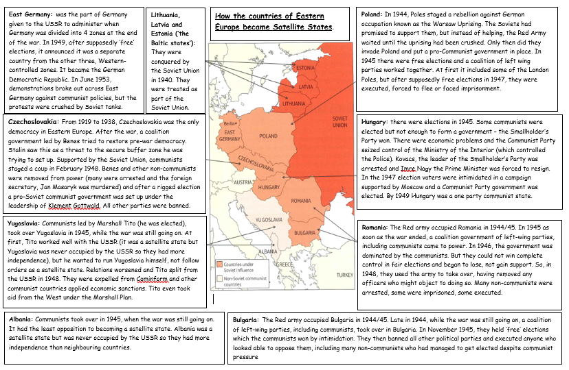
- How did the Soviets ensure control of these states?
………………………………………………………………………………………………………………………………………………………………………………………………………………………………….
3. What were the Soviet aims in doing this?
………………………………………………………………………………………………………………………………………………………………………………………………………………………………….
The creation of the Soviet satellite states:
- Twenty million Russians died during the Second World War, so Stalin said he wanted a buffer zone of friendly states around Russia to make sure that Russia could never be invaded again.
- Stalin was planning the takeover of Eastern Europe. As the Red Army drove the Nazis back, it occupied large areas of Eastern Europe. It was agreed that Eastern Europe could be a Soviet "sphere of influence".
- In the countries that the Red Army "liberated", communist-dominated governments took power.
- The Communists made sure that they controlled the army, set up a secret police force, and began to arrest their opponents.
- Non-Communists were gradually beaten, murdered, executed and terrified out of power.
- By 1949, all the governments of Eastern Europe, except Yugoslavia, were hard line Stalinist regimes.
- In 1946, in a speech at Fulton in the USA, Churchill declared that an Iron Curtain had come down across Europe, and that Soviet power was growing and had to be stopped.
- Stalin called Churchill's speech a "declaration of war".

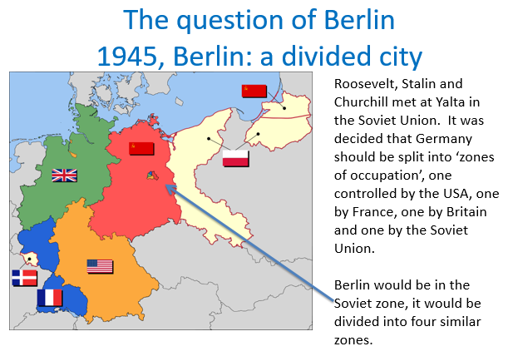

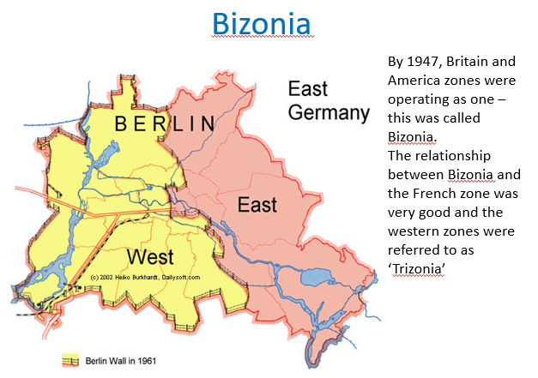

Task – The Berlin Airlift

- Highlight the Berlin Airlift sheet– the causes (before September 1948), events (September 1948-May 1949) and consequences (after May 1949)

- What was the most important reason why Stalin blockaded Berlin?

…………………………………………………………………………………………………………………………………………………………………………………………………………………………………..

- Why did Truman respond with the airlift?
…………………………………………………………………………………………………………………………………………………………………………………………………………………………………..

- What was the most important consequence of the airlift? Why? (7+ students attempt to link)
…………………………………………………………………………………………………………………………………………………………………………………………………………………………………..
…………………………………………………………………………………………………………………………………………………………………………………………………………………………………..
Berlin – The Air Lift  The end of the war:  - The future of Germany was intensely negotiated  - As they were unable to completely agree by the Potsdam Conference about the long term future of Germany, they agreed that Germany would be divided into 4 zones administered by the USA, Britain, the USSR and France. Berlin the capital although in the Soviet sector was also divided into 4 zones.  - By 1947, the British and American zones were effectively operating as one –called ‘Bizonia’. As the relationship with the French was also good – the 3 sectors became ‘Trizonia’. | Unfinished business!  - By 1948, however the Western Allies had started to develop western policy for West Germany (Trizonia).  - Britain, France and the USA agreed to set up an assembly to create a German constitution  - They also introduced a new currency the Deutschmark to give Trizonia economic unity.  Effectively creating a separate economic unit from the East. It acknowledged that there were in effect two Germanys.  - Stalin had not been consulted, feeling the USSR was being ‘ganged up on’. He believed it was a step to make the division of Germany permanent  - Stalin did not like the division as it allowed American influence over Germany, he did not want US troops stationed there and realised that Germany’s economic assets were in the west! He wanted to protect Soviet interests in Germany.
The Blockade – Stalin’s actions:  - Stalin knew that the Western-occupied zones of Berlin were vulnerable, as they were entirely surrounded by Soviet-occupied territory. There were only 2 agreed land and 2 agreed air routes across the Soviet zone into West Berlin. Stalin wanted to show a divided Germany would not work.  - In June 1948 the airlift – Stalin blockaded the land routes into Berlin so that the Allies could only airlift supplies in.  - He wanted to cut western Germany from the capital Berlin so that a new government could be set up to stop the west controlling the area.  - If successful = huge propaganda success. It was also a direct challenge to Truman. | The Western response – the Berlin Airlift:  - Stalin wanted to push the Western powers out of Berlin but it did not work!  - A war between the USSR and the USA seemed to be a real possibility – in fact it was the first military confrontation of the Cold War  - The Western Allies launched Operation Vittles – the airlift. They flew in food, coal and other necessities.  - Truman sent in Allied planes with supplies to West Berlin around the clock Initially, America committed 70 large cargo planes and airlifted between 600 and 700 tonnes of food and supplies every day.  - This increased to 1000 tonnes a day  - The British authorities created a similar system at its height  - This stopped the blockade from succeeding
Results  - In May 1949, nearly a year later, Stalin ended the blockade  - In May 1949 – West Germany became an independent state and was officially called the Federal Republic of Germany (FDR)  - In October 1949 East Germany was declared an independent state by the USSR and was called the German Democratic Republic (GDR).  - The Berlin Blockade was a propaganda success for the Americans  - It was a failure for the USSR  - It was very clear they could not work together! | - Soviet troops remained in East Germany and it became a satellite state. It was the first military confrontation of the Cold War  - Western Nations established an alliance to keep the ‘USA in and the USSR out’ – In April 1949 – NATO was established – if any country came under attack – all members of NATO would defend them (USA, GB, Belgium, Denmark, Canada, France, Iceland, Italy, Luxembourg, Netherlands, Norway, Greece (1952), West Germany (1955))  - In 1955 – Warsaw Pact formed (West Germany joining NATO was too provaocative)- military alliance that mirrored NATO (USSR, Albania (until 1968), Bulgaria, Czechoslovakia, East Germany, Hungary, Poland and Romania)  - The arms race continued to develop
Question 1: Explain two consequences of the Berlin Crisis of 1948-49
(8 marks)
Consequence 1:

Consequence 2:

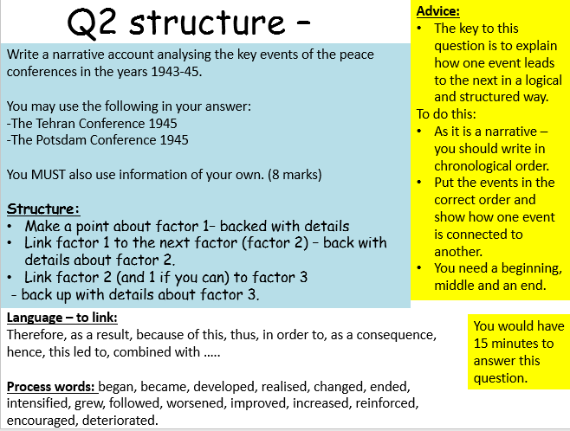

Date: Lesson 3:The Cold War intensifies
LO: To understand the increasing tension over the arms race and how and why the Soviets asserted their control over Hungary. To consider the importance of these events in international relations and the deepening of the Cold War.
Starter: Read through the arms race 1946-46– add in the advantages you think each side had.
USA | USSR
- 1945 – USA tests and drops the first atomic (A) bombs  - 1951 – US Strategic Air Command (SAC) develops a policy of constant readiness – SAC Commander Curtis Le May identifies 6,000 targets in the USSR in the event of a war  - 1952 – USA tests its first hydrogen (H) bomb – 1000 times more powerful than the atom bomb  - March 1954 – USA develops a H bomb small enough to be dropped from a bomber  - The USA’s warheads were more powerful but in 1955 the USSR tested a bomb called ‘Sakharov’s Third Idea – it was as powerful as America’s H-bombs  - 1955 – America developed B52 Stratofortress, an aeroplane with long-range flight capacity to bomb the USSR  - 1956 – US develops U-2 Spy plane  - 1958 – US puts a satellite into orbit  - 1958 – UK allowed US missiles bases  - 1959 – US develops sophisticated Atlas and Minuteman ICBM’s. They also develop Polaris missiles which can be fired from submarines  - By 1960, Britain and France had nuclear weapons and China was running a nuclear weapon development programme | - 1949 – USSR tests A bomb – causes huge concerns – US intelligence had predicted the USSR would not be able to do this until 1953  - 1953 – USSR tests its first H bomb  - Sept 1954 – USSR drops a test H-bomb from a bomber  - The USSR started to develop a similar aircraft called the TU20 Bear  - 1957 – USSR develops the first ICBM  - 1957 - USSR puts the space satellite ‘Sputnik’ into orbit around the earth. USSR now has the technology to launch rockets out of the Earth’s atmosphere and guide them to a target (USA shocked by this advancement)  - 1961 – Soviet Yuri Gagarin becomes the first man in space  - 1961 - USSR detonates the Tsar Bomba – the largest H-Bomb ever seen (it was 8m long and weighed 27 tons – it was 100 times more powerful than the Hiroshima/Nagasaki bombs. When tested it created a fireball 5 miles in diameter)
Advantages over the Soviets | Advantages over the Americans
Concerns about the Soviets military capacity  - They were concerned about the rate the USSR was building nuclear weapons and the size of them!  - The Tsar Bomba which was detonated in 1961, was the most powerful and therefore most destructive, bomb ever  - When the USSR landed a robotic spacecraft on the moon – Khrushchev boasted that the Americans were ‘sleeping under a Soviet Moon’ – many Americans believed the USSR capable of using the rockets to launch missiles at them | Concerns about Americas military capacity  - They were concerned that US missiles were closer to the USSR than its missiles were to the US  - The US had missiles bases in the UK (1958) and from 1961 in Italy and Turkey – these could easily be fixed on specific targets – they had a shorter range  - US B52 bombers were capable of dropping missiles on the USSR  - The USSR had no way to drop missiles accurately on the USA
New leaders
From 1953, both the USA and USSR had new leaders:
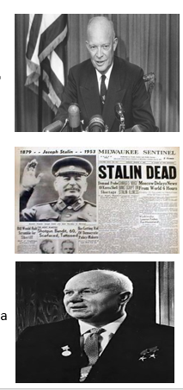
USA: Dwight Eisenhower – his campaign targeted communism and was anti-communist. He wanted to stop Soviet expansion. He was also aware of the danger of nuclear weapons.
USSR: Stalin died on 5th March 1953 and led to a power struggle. It was not until 1956 that Nikita Khrushchev emerged as the effective ruler.
At the Party Congress in that year, he openly criticised Stalin’s policies and suggested there should be peaceful co-existence with the West.
The change in leadership on both sides made people hopeful that tension would reduce as:
-the Korean War had come to an end
-both sides knew reducing arms spending was a good idea for their economies

Task:
During 1956 the people of Hungary began to protest about their lack of political freedom and problems created by fuel shortages and bad harvests.
- Highlight the sheet –
- causes (before the Soviets invaded
- events (what happened during the invasion)
- consequences (anything that happened AFTER the uprising was crushed).

Hungary under Stalin:  - Stalin claimed that Hungary had been liberated from the Nazis, however Cominform imposed an oppressive regime on them  - Land was redistributed to other Eastern European countries  - Hungarian oil, coal and wheat were shipped to Russia – depriving them of food  - Non-communist parties were abolished  - Russian officials controlled the government, the police and the army  - Cominform began a reign of terror – executing popular leaders and their supporters  - AVO’s – people lived in fear of the secret police  - There were thousands of Soviet troops in Hungary, there were even Russian street signs, schools and shops  - The standard of living in Hungary fell (it was a rich agricultural country) | Matyas Rakösi  - Appointed as Hungary’s dictator (1949-56) –  - He described himself as ‘Stalin’s best pupil’, the Hungarians named him ‘the butcher’.  - Rakösi developed ‘salami tactics’ for dealing with opponents ‘slice by slice’, meaning he got rid of opponents by dividing it bit by bit  - Rakösi imprisoned 387,000 and was responsible for more than 2000 deaths
‘De-Stalinisation’:
- Nikita Khrushchev took over Soviet rule when Stalin died in 1953. He seemed different from Stalin – he wanted to improve living standards of all
- Some political prisoners were released
- He relaxed the iron control of the Soviet Union
- Soviet troops were pulled out of Austria (there since WWII)
- At a Communist Party International in 1956, Khrushchev made an astonishing attack on Stalin (his ‘secret’ speech) – denouncing him as a tyrant, producing evidence of purges and as an enemy of the people
- A policy of De-Stalinisation came in
- He released more political prisoners
- He closed down Cominform
- He dismissed Stalin’s former Foreign Minister, Molotov
- But he did create the Warsaw Pact in 1955 – so some of Stalin’s policies stayed!!
Imre Nagy:
- Nagy replaced Rakösi as Prime Minister between 1953-55 but Rakösi was effectively in charge as the Secretary of the Communist Party. Nagy was thrown in prison for opposing him.
- People thought change would come with Khrushchev’s secret speech – it didn’t come and Rakösi was forced out of power in July 1956.
Protests:
- Bad harvests, and fuel and bread shortages, led to riot in Budapest on 23rd October 1956- fights broke out between students and police (a statue of Stalin was pulled down) – this conflict spread through Hungary.
- To calm the situation Khrushchev made Nagy Prime Minister and agreed to withdraw the Red Army from Hungary.
- On 31st October – Nagy announced reforms this included:
- The government was re-organised to include members of non-communist parties (ending the one party state)
- Hold free elections (they were bold as they thought the west would help)
- They asked the UN to recognise them as a neutral country (so if the USSR sent in troops the UN could assist)
- He released political prisoners and asked Khrushchev to remove troops from Hungary.
- Khrushchev may have given into these reforms but on 1st November Nagy announced that Hungary were leaving the Warsaw Pact. The USA encouraged them with offers of aid – but they would take only action short of military action to end communist governments.
Khrushchev and Nagy - The reforms split the Hungarian government and Janos Kadar (pro-Soviet) set up a rival government in eastern Hungary. The reforms also ended Hungary’s alliance with the USSR – Khrushchev saw the reforms as unacceptable – he could not allow Hungary to leave the Warsaw Pact as other members would follow! He had reports that there was widespread discontent with communism. Freedom could mean an end to the USSR!
Soviet Response  - On 4th November 1956, 200,000 Soviet troops and 1,000 tanks entered Hungary in support of Kadar’s government.  -The Soviets marched on Budapest and fought Nagy’s government for 2 weeks (Nagy’s supporters put up a fight and he begged the West for help) – 2,500 people were killed by the Soviets and 20,000 wounded. 200,000 fled to the West. 650 Soviet troops were killed and 1,250 wounded. Strikes and fighting continued into 1957 |  | International response  -Western powers protested but sent no help – they were too busy with the Suez crisis in the Middle East  -America offered food and medical aid worth $20m and allowed 80,000 Hungarian refugees to move to the USA.  -Eisenhower praised the bravery of the Hungarian people – encouraging them to fight on. But in many ways the failure reflected badly on the West.  -Warsaw Pact members knew they would not get any support  - Relations soured
Results – The Uprising was over.
-Nagy got protection from the Yugoslavian ambassador but was arrested trying to get to Yugoslavia, put on trial for treason and executed in 1958 – Khrushchev said this was ‘a lesson to the leaders of all socialist countries’
-Kadar was put in charge but he was controlled by the Soviets – his Fifteen Point Programme said that: He was re-establishing communist control of Hungary, Hungarian troops would be used to stop attacks on Soviet forces, Hungary would remain in the Warsaw Pact, Soviet troops would leave when the crisis was over.
-Kadar arrested 30,000 anti-communists and executed nearly 300– some economic reforms were made.
- Answer:
- 4-1 Students describe how the Hungarian Crisis shows how Soviet control of Eastern Europe had grown tighter
- 9-5 students explain how the Hungarian Crisis shows how Soviet control of Eastern Europe had grown tighter
………………………………………………………………………………………………………………………………………………………………………………………………………………………………………………………………………………………………………………………………………………………………………………………………………………………………………………………………………………………………………………………………………………………………………………………….
Extension: Why didn’t the USA come to Hungary’s assistance?

Question 1: Explain two consequences of the Hungarian Uprising in 1956. (8 marks)

Consequence 1:

Consequence 2:

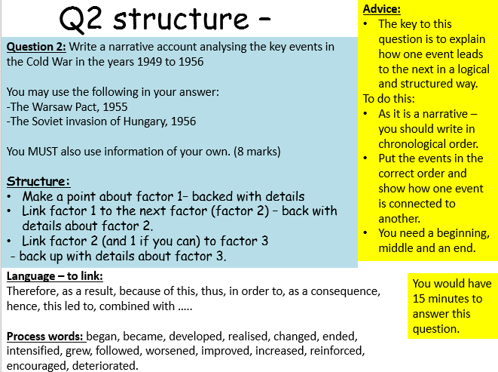

Date: Lesson 4:Topic 2: Cold War crises, 1958-70
Berlin: a divided city
L.O: To be able to explain the key causes, events and consequences of the Berlin Crisis.

In 1961 the Cold War reached a turning point with the construction of the Berlin Wall.
Starter:
Q. Why had the Cold War developed c1941-58?
……………………………………………………………………………………………………………………………………………………………………………………………………………………………………………………………………………………………………………………………………………………..
Keywords:
- Summit - A conference or meeting of leaders
Key people:
- Khrushchev – Soviet leader after Stalin 1953-64
- Eisenhower – American President 1952-60
- Kennedy – American President after Eisenhower 1960-63

The situation in Berlin
- Berlin had been a source of tension between the Western Allies and the Soviet Union since 1945.
- Capitalist West Berlin was surrounded by the Communist state of East Germany:
- The high standard of living enjoyed by the people of West Berlin contrasted sharply with that of the Communist half of the city – East Berlin. It was a continual reminder to the people in East Germany of their poor living conditions.
- It was estimated that 3 million people had crossed from East to West Berlin between 1946 and 1960. Many of these people were skilled workers and it seemed that the economic survival of East Germany was in doubt if this escape route remained open.
Stalemate and negotiation:
Due to the refugee problem- Khrushchev had real concerns and issued an ultimatum in Nov 1958 – he declared Berlin belonged officially to the USSR and that the USA had 6 months to withdraw troops. Eisenhower did not want to lose Berlin but he didn’t want to start a war – so it was agreed to hold an international meeting:
The conferences:
The Geneva Summit May 1959 – foreign representatives from the USA/USSR met – no solutions but agreed to a visit to the US by Khrushchev.
Camp David September 1959 – Eisenhower and Khrushchev met face to face – they spoke frankly, although not making any agreements agree to meet again. Khrushchev withdrew his ultimatum.
The Paris Summit May 1960 - it was a disaster – just before the conference – the USSR had shot down a US U2 spy plane. Khrushchev walked out of the conference when Eisenhower refused to apologise.
The Vienna Conference January 1961 – an discussion between Kennedy and Khrushchev about Berlin – neither side were willing to back down. Khrushchev saw Kennedy’s inexperience as weakness – so he pushed him over Berlin and re-introduced his ultimatum!

- Go through the tables and highlight –
- causes (before August 13th 1961 – why the wall was built),
- events (anything to do with the border being sealed/ wall being built)
- consequences (anything that happened as a result of the wall being built).
The Refugee problems  - East German government was extremely unpopular – there were a lot of restrictions, East Germany got less aid from the USSR and they were constantly monitored by the secret police.  - Many East Germans fled to West Germany – greater freedom and wealth (higher standard of living)  - 1949-61, 2.7 million East German refugees, many of whom were highly skilled escaped  - Berlin was the centre of the refugee problem because it was easy for East Germans to get from East Berlin to West Berlin |  | Khrushchev’s challenge  - The refugee problem was a propaganda disaster for Khrushchev because it proved that many people preferred the capitalist West to the communist East  - Large numbers were professionals and skilled craftsmen  - November 1958, Khrushchev declared that the whole of the city of Berlin officially belonged to East Germany  - He said Berlin should be  -demilitarised and Western had six months to withdraw  -Berlin should be a free city  - If not he would hand over control of all routes into Berlin to the East German government.  - Khrushchev’s plan was to prevent East Germans fleeing to the West and to humiliate America and force them to acknowledge East Germany as a legitimate country
Eisenhower’s response  - The Americans were uncertain about how to respond to Khrushchev’s ultimatum  - Eisenhower did not want to lose West Berlin, but neither did he want start a war  - It was agreed to hold an international meeting in order to discuss Berlin’s future | Four summits  - May 1959, Summit meeting in Geneva – USA and USSR – No agreement but it did lay the foundations for Khrushchev to visit the USA and speak face to face to Eisenhower  - September 1959 Khrushchev and Eisenhower met at a second summit meeting in Camp David, USA – No solution but they did agree to meet again AND Khrushchev agreed to withdraw his ultimatum  - May 1960, Paris Summit, - a disaster! Just before the conference the USSR had shot down an American spy plane over Russia and captured its pilot (Gary Powers). Khrushchev walked out when Eisenhower refused to apologise for the incident  - June 1961, Vienna Summit– neither side seemed willing to back down. Khrushchev saw Kennedy’s inexperience as an opportunity to exploit him (Kennedy had failed during the Bay of Pigs in Cuba). Confident that Kennedy would back down, Khrushchev again gave the USA a six month ultimatum to remove the troops from Berlin.
Kennedy prepares for war  - Kennedy refused to back down  - He started preparing America for war – committing the US government to an additional $3.2 billion of defence spending  - Kennedy also decided to spend $207 million on building nuclear fallout shelters  - A point of stalemate had been reached  - Khrushchev knew that the USSR could not win a nuclear war against the USA – America had almost 20 times more nuclear weapons (America’s weapons could reach the USSR – the USSR’s could not reach America) but he had to stop the ‘defectors’. Kennedy had called Khrushchev’s bluff, forcing him to back down |  |  | Building the Wall  - From 1961 – 20,000 East Germans were leaving a month. As tensions grew even more people tried to leave.  - Ulbricht the East German leader urged Khrushchev to close the border between east and west Berlin.  - Instead, to solve the refugee problem Khrushchev ordered the building of a wall separating East and West Berlin  - On the night of 12th August 1961, East German troops secretly erected a barbed wire fence around the whole of Berlin and Between East and West Berlin  - Berliners awoke to a divided city  - Soon work began on a concrete wall
The impact of the Berlin Wall - It stopped East Germans escaping to the West and therefore ended the refugee crisis. It allowed Khrushchev to avoid war with America while still appearing strong. It became a symbol of the division of Germany and the division of Europe |  | Kennedy’s visit to Berlin - Kennedy was unable to prevent the construction of the wall – however, in 1963 he toured West Berlin expressing his feelings of solidarity with its people  - Crowds of Berliners lined the streets cheering  - Kennedy said ‘All free men, wherever they live, are citizens of Berlin and therefore as a free man, I take pride in the words ‘Ich bin ein Berliner’
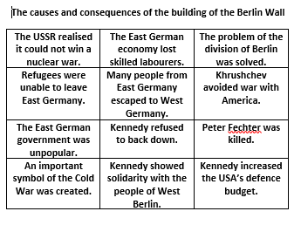
2)
- 9-5- Decide which is the most important cause and explain why. Then decide which is the most important consequence and explain why.
- 4-1 – Describe the most important cause and the most important consequence.
…………………………………………………………………………………………………………………………………………………………………………………………………………………………………………………………………………………………………………………………………………………………………………………………………………………………………………………………………………
- What impact did the wall have on the USA and USSR?
…………………………………………………………………………………………………………………………………………………………………………………………………………………………………………………………………………………………………………………………………………………………………………………………………………………………………………………………………………
Extension: How did the events change international relations? Refer to the causes, events and consequences surrounding the building of the wall (Link to other events as well).

Question 2: Write a narrative account analysing the key events of the ‘Berlin Crisis’ in the years 1958-61.
You may use the following in your answer:
- the Berlin Ultimatum, 1958
-the construction of the Berlin Wall
You MUST also use information of your own. (8 marks)
Structure:
- Make a point about factor 1– backed with details
- Link factor 1 to the next factor (factor 2) – back with details about factor 2.
- Link factor 2 (and 1 if you can) to factor 3
- back up with details about factor 3.
……………………………………………………………………………………………………………………………………………………………………………………………………………………………………………………………………………………………………………………………………………………………………………………………………………………………………………………………………………………………………………………………………………………………………………………………………………………………………………………………………………………………………………………………………………………………………………………………………………………………………………………………………………………………………………………………………………………………………………………………………………………………………………………………………………………………………………………………………………………………………………………………………………………………………………………………………………………………………………………………………………………………………………………………………………………………………………………………………………………………………………………………………………………………………………………………………………………………………………………………………
………………………………………………………………………………………………………………………………………………………………………………………………………………………………………………………………………………………………………………………………………………………………………………………………………………………………………………………………………………………………………………………………………………………………………………………………………………………………………………………………………………………………………………
……………………………………………………………………………………………………………………………………………………………………………………………………………………………………………………………………………………………………………………………………………………………………………………………………………………………………………………………………………………………………………………………………………………………………………………………
Date: Lesson 5: The Cuban Missile Crisis
L.O. To be able to explain the main causes, events and consequences of the Cuban Missile crisis
Starter:
Use the information in ‘The arms race’ to complete the second copy of the table, explaining why America was in a stronger position than it thought
America is worried that.... | But the real situation is that ....
... Sputnik 1 proves that the USSR has very powerful missiles.
... The USSR can land a spaceship on the moon, therefore it could put nuclear missiles in space.
... Khrushchev has said that the USSR is producing missiles as fast as it is producing sausages.
Keywords:
MAD – Mutually Assured Destruction
Brinkmanship - The practice, especially in international politics, of seeking advantage by creating the impression that one is willing and able to push a highly dangerous situation to the limit rather than concede.
Background:
The Cuban Revolution
- In 1959 Fidel Castro’s rebels overthrew corrupt pro-US government in Cuba under the leadership of Batista.
- Castro took over American property / businesses in Cuba.
- Castro tried to make a trade agreement with the USA to buy their sugar.
- The USA refused as they saw Castro as a Communist.
- Castro turned to the USSR, who were happy to make a deal – there was a secret clause saying that Cuba would receive arms
- The USA was concerned about a pro-Soviet regime.
The Bay of Pigs Incident
- President Kennedy who took over from Eisenhower in 1960 hatched a plan for the CIA to back a revolution to overthrow Castro’s government.
- Plan – to train and equip 1,400 Cuban exiles and put a US friendly government in place.
- They invaded the Bay of Pigs in April 1961
- Failure – they were badly trained, ill equipped and outnumbered by Castro’s troops.
- Castro found out about the invasion – 20,000 soldiers were ready
- The USA and exiles were wrong to think the people of Cuba would rise up to help them
- Castro showed images of wrecked plans – the USA’s involvement was undeniable – it was humiliating
- Castro declared himself communist and asked the USSR for help to defend Cuba. In September 1961 – Khrushchev said he would provide arms. Potentially using Cuba as a missiles base

Question 1: Explain two consequences of the Cuban Revolution of 1959. (8 marks)

Consequence 1:

Consequence 2:

Now the Crisis
Nuclear site spotted
- In return for buying Cuban goods, the UUSR got permission to build a nuclear missile site in Cuba.
- On 14th October 1962 a US U2 spy plane spotted the nuclear site being built.
Ex-com set up
- US President Kennedy set up ‘Ex-Comm’ a committee to decide what to do.
- On 22nd October, Kennedy ordered the US navy to blockade Cuba.
- He stated that any Soviet vessel that tried to break the blockade would be destroyed.
On the brink of war
- On 23rd October, the United Nations backed the US and ordered any missiles to be removed.
- Soviet ships were spotted heading towards Cuba.
- The world was on the brink of all out nuclear war.
Compromise:
- A series of telegrams and ultimatums were sent between the leaders
- On the 27th October Khrushchev secretly offered to pull out of Cuba if the USA pulled out of Turkey.
- Kennedy agreed and a day later Khrushchev ordered Soviet ships to turn around.
Consequences:
- Major propaganda victory for the USA – they looked to have ‘won’.
- As the compromise was secret, Khrushchev appeared to have backed down.
- Both sides began seeking ways of improving relations e.g. a ‘hotline’ was set up providing immediate contact.
- Limited Test Ban Treaty – August 1963 – agreed to ban testing nuclear weapons in space, in the sea and above ground – underground was still permitted.

Task – complete the table
 | USA | USSR | BOTH
Ways in which the outcome of the Cuban Missile Crisis was a success
Ways in which the outcome of the Cuban Missile Crisis was a failure

Extension: Write a paragraph that explains who gained most from the Cuban Missile Crisis. Make sure that you back up your point with detailed examples.

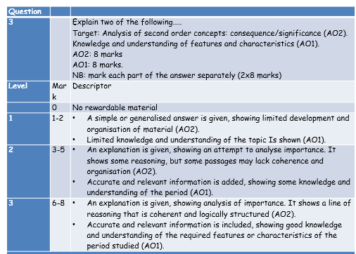
Question 3:
Question 3 – you need to answer two out of the three questions.
In the exam paper – you have two pages to answer – one for each question and you put a cross in the box for the one you are answering.
You get a total of 16 marks for this question.

Question 3: Explain two of the following:
-The importance of the Potsdam Conference (1945) for the development of the Cold War.
-The importance of the building of the Berlin Wall (1961) for the relations between the USA and the Soviet Union.
-The importance of the Cuban Missile Crisis (1962) for relations between the USA and the Soviet Union.
(16 marks)
Structure for each 8 mark part of the answer:
2xPEE
The main focus is the explanation
Start with a point about the importance – backed up and with a developed explanation (with supporting evidence).
Advice:
- The question asks you to explain the importance of events and developments.
- Don’t just tell a story about the event – explain the importance e.g. the impact, what did the event affect or lead to? What difference did they make? Why do they matter?
- Check the question carefully to ensure you are clear You would have 25 minutes to answer this question.
- =12.5 mins per part of the question.
- about what you are explaining.

Date: Lesson 6: Czechoslovakia
L.O. To be able to explain the causes, events and consequences of the Czech Crisis – The Prague Spring
Keywords:
Warsaw Pact – alliance between Eastern Block countries led by the Soviets.
NATO – alliance between Western countries (North Atlantic Treaty Organisation)

Starter:
What were the consequences of the Cuban Missiles Crisis? What did it mean to:
- International relations
- The development of the Cold War
……………………………………………………………………………………………………………………………………………………………………………………………………………………………………………………………………………………………………………………………………………………………………………………………………………………………………………………………………………………………………………………………………………………………………………………………
Task: Read through the notes:
- Underline anything you don’t understand.
- Highlight – causes, events and consequences
Czechoslovakian opposition to Soviet control  - A Soviet Satellite state  - Run by the brutal Secret Police  - Struggling economy  - The country still had not recovered after the war  - 5th January Dubcek became the Communist Party leader – the most powerful man in the country | Dubcek  - He was a committed Communist  - He wanted to create a popular form of Communism –‘Socialism with a human face’ – he wanted reforms  - He thought this would revitalise Czechoslovakian politics, economics and social life | The events of the Prague Spring  - Prague is the Czechoslovakian capital  - Dubcek introduced reforms:  - Relaxation of censorship  - Official toleration of criticism  - More power to regional governments  - More power to the Czech parliament  - ‘market socialism’ – the reintroduction of capitalist elements into the economy  - The reforms were widely well received. Some old communists didn’t like them. Soviet Union were angry
Brezhnev’s dilemma  - On the one hand Brezhnev regarded Dubcek as a friend  - Dubcek had made no attempt to leave the Warsaw Pact or damage the USSR  - Secret intelligence reports suggested that the reforms would weaken the Soviet union’s control  - He tried to persuade Dubcek to cancel the reforms – he refused  - August – Brezhnev ordered a full scale invasion | The Soviet invasion of Czechoslovakia  - 20 August -500,00 Warsaw Pact troops and Soviet tanks rolled into Czechoslovakia.  - Dubcek ordered the people not to react with violence  - Lots of non-violent civil disobedience e.g. students stood in front tanks waving banners  - Dubcek was arrested and taken to Moscow  - Dubcek was forced to sign the Moscow Protocol which committed Czechoslovakia to ‘protecting socialism’ by reintroducing censorship and removing political opposition | The Brezhnev Doctrine  - 26th October 1968-  - The Doctrine said that the USSR had the right to invade any country in Eastern Europe whose actions appeared to threaten the security of the whole Eastern Bloc  - Brezhnev argued that Dubcek’s actions threatened to undermine the Warsaw Pact and communist control in Eastern Europe – therefore the Soviet Union decided to invade
America’s response  - Brezhnev believed America would do nothing to help the Czech people  - America was already fighting a bloody war against Communism in Vietnam  - America publicly condemned the invasion, it offered no military support against it | Western European response  - Western European governments followed America’s lead – condemnation but no military help. There were protests  - the USSR vetoed UN action  - the USA were involved in a costly war with Vietnam and beginning to adopt a policy of détente with the USSR. Other countries say them as hypocrites – prepared to criticise but not take action. | Impact on relations with communists and Eastern Europe  - Western European Communist Parties surprisingly were outraged by the Soviet invasion – they therefore declared themselves independent of the Soviet Communist Party  - This created Soviet Communism in the East and Euro-Communism. The Soviet Union had lost authority and support  - The Soviet invasion led to discontent in Eastern Europe. Yugoslavia and Romania both condemned the invasions – relations were strained with Moscow  - Following 1968, Yugoslavia and Romania formed alliances with Communist China  - The governments of East Germany (Ulbricht) and Poland (Gomulka) welcomed the USSR’s actions  - The Suppression of the Prague Spring = Warsaw Pact members under more control

Q3 – this would be one option out of 2. How would you answer this?
Explain:
- The importance of the ‘Prague Spring’ for relations between the USA and the Soviet Union

Question 3: Explain two of the following:
- The importance of Kennedy’s 1963 speech for the future of Germany
- The importance of the ‘Bay of Pigs’ incident for the future of Cuba
- The importance of the ‘Prague Spring’ for relations between the USA and the Soviet Union
(16 marks)

- Question 1: Explain two consequences of the building of the Berlin Wall in 1961. (8 marks)
- Question 1: Explain two consequences of the Cuban Revolution of 1959. (8 marks)
- Question 1: Explain two consequences for international relations of the Soviet invasion of Czechoslovakia. (8 marks)
- Question 1: Explain two consequences of the Prague Spring on relations between the Soviet Union and Czechoslovakia. (8 marks)

Date: Lesson 7: Key Topic 3: The end of the Cold War, 1970-91
Détente and the Collapse of Détente
LO: To make judgements on changes in international relations during détente.
Starter: How and why did relations change after the Cuban Missiles Crisis?
…………………………………………………………………………………………………………………………………………………………………………………………
……………………………………………………………………………………………………………………………………………………………………………………….
What reaction did the USA and the west take towards the Czechoslovakian crisis (Prague Spring)?
…………………………………………………………………………………………………………………………………………………………………………………………
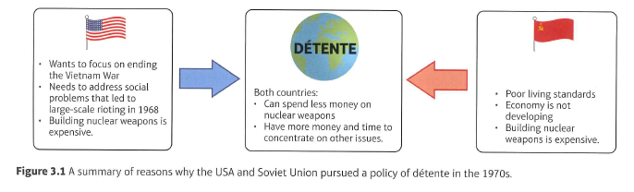
……………………………………………………………………………………………………………………………………………………………………………………….

Tasks – using the Edexcel Cold War book to help you
- Read through the table – complete the section on détente – what was the importance of the events
- Answer the questions on détente
- Read through and complete the section on the failure of détente and answer the questions
- Read through the section on the Second Cold War and complete the questions.

Extension:
9-5 students explain 4-1 describe
Who was to blame for the collapse of détente and why?
Détente
Why was there a period of Détente (the search for peace)?

Date | Event |  | What happened |  |  | Importance to international relations | Did relations improve or worsen (score 1 -10) 10 being great improvement
1967 | Outer Space Treaty |  | Added to the 1963 Nuclear Test Ban Treaty – stopped the arms race spreading into outer space – it pledged that no nuclear weapons would be placed in space by either superpower.
1968 | Nuclear Non-Proliferation Treaty |  | Agreed that neither super power would supply nuclear weapons to other states or help other states to develop nuclear weapons
1972 | SALT 1 |  | The Strategic Arms Limitation Treaty imposed limits on the nuclear capability of the USA and USSR. They would not produce any more strategic ballistic missiles (short-range/light weight). Both agreed that submarines carrying nuclear weapons would only be introduced when existing stocks of ICBMs became obsolete. The ABM (Anti-Ballistic Missile) Treaty was agreed – they could shoot down incoming missiles – only allowed two ABM systems each.  -The Basic Principles Agreement laid down rules for the conduct of nuclear warfare e.g. no warheads on the seabed
1972-79 | SALT 2 |  | SALT 1 was only temporary – negotiations for a more comprehensive treaty began in 1972. It was difficult as West Germany were worried they would be left undefended and right-wing American Congressmen thought détente had gone too far. In 1974 both sides agreed that they would reduce their stocks of nuclear warheads to 2250 (called the Vladivostok Agreement). Carter and Brezhnev signed SALT 2 in 1974. |  |  | Nov 1979 – Islamic militants captured the American embassy in Tehran – many Americans did not want détente.  Never ratified by Congress – due to Afghanistan.
1975 | Apollo-Soyuz Mission |  | A joint space mission – an America Apollo spacecraft and a Russian Soyuz spacecraft docked high above the earth.
1975 | The Helsinki Agreements |  | The conference met with representatives from 35 countries, all from Europe (except Andorra and Albania), USSR, USA and Canada. Agreed -  European borders: all country boundaries were accepted officially. Disputes to be settled peacefully (using UN), no interference with another country’s internal affairs, would inform each other of big military manoeuvers.  International Co-operation: economic co-operation through trade, setting the same standards in industry and joint projects, sharing scientific research, educational co-operation.  Human Rights: freedom of – speech, movement, religion and information
What does this period show about international relations?

How and why were they improving?

The collapse of détente
Date | Event |  | What happened |  | Importance to international relations |  | Did relations improve or worsen (score 1 -10) 10 being great improvement
1978 | Kabul Revolution |  | The Kabul Revolution was a dramatic overthrow of the government. The new government, based in Kabul was determined ‘to build socialism in Afghanistan’ – the new communist president, Mohammed Taraki became a Soviet ally. The new government was not stable – there were personal rivalries and disagreements. By Spring 1979 a civil war broke out between the government ad Islamic fighters – ‘Fighters of God’. President Taraki was forced to accept Hafizullah Amin, the head of the army, as prime minister – they were bitter rivals. In October 1979 – Taraki was assassinated and Amin claimed the presidency. The Afghan Communists appealed to Moscow for help. Although Amin was a communist, the USSR did not trust him – Soviet secret police reported that he was a US spy. He was also unpopular with a lot of Muslims and Brezhnev feared that they would take over the country |  | - The USSR was worried that after the civil war – Afghanistan would become an Islamic state and influence nearby Soviet Republics (the Soviets would lose influence)
Dec 1979 | Soviet Invasion of Afghanistan |  | In 1979, the Soviet Union invaded Afghanistan to try to prop up the communist government there, which was being attacked by Muslim Mujahidin fighters. On Christmas Day 1979 hundreds of Soviet tanks and tens of thousands of motorised infantry crossed the Soviet border into Afghanistan. They killed Amin along with many of his supporters, and Karmal was declared president (he held this post to 1986). By 1980, there were 125,000 Soviet troops in Afghanistan. The war lasted 10 years and around 1.5 million people died, including almost 15,000 Russian soldiers. It turned out to be a war against the mujahidin. |  | - This immediately caused a rift with America, which boycotted the 1980 Olympics.
 | The Carter Doctrine |  | President Carter was furious –He argued the USA could not allow the USSR to gain control of oil-rich Middle East. This meant the USA and Pakistan became involved in the rise of the mujahidin forces in Afghanistan. Carter’s actions:  - He formed an alliance with China and Israel to support Afghan rebels. The USA sent weapons (through the CIA) to the Mujahedeen via Pakistan (even though Carter had concerns about Pakistan’s human rights record!)  - He imposed economic sanctions – stopping virtually all trade with the USSR  - He ended diplomatic relations with the USSR |  | - End of détente  - SALT 2 Treaty was not ratified by the US Senate  - Carter increased defence spending by 5%
1980 | Western boycott of Moscow Olympics |  | Carter banned the US from competing in the 1980 Moscow Olympics – 60 countries including allies Canada, Japan, China, West Germany and Kenya did the same. The Americans set up an alternative games called the ‘Olympic Boycott Games’, which was held in Philadelphia American propaganda ridiculed Mischa Bear – Russia’s Olympic mascot, calling it Gulag Bear (Gulags = Soviet Prison Camps)
1984 | Soviet boycott of LA Olympics |  | In retaliation the USSR boycotted the Los Angeles 1984 Olympic Games – having their own Friendship Games)
Why did relations between the USSR and the USA worsen? Why did détente fail?

Reagan and the Second Cold War
Date | Event | What happened |  | Importance to international relations |  |  | Did relations improve or worsen (score 1 -10) 10 being great improvement
1983 | Reagan’s ‘Evil Empire’ speech | Reagan argued that the Cold War was a fight between good and evil (America fought with God’s blessing). He considered it America’s moral duty to invest in nuclear weapons to defend liberty. After 2 weeks in office Reagan increased weapons spending by $32,6 bn
 | Reagans response to the Soviet Invasion of Afghanistan | The USA hoped to bleed the USSR white. The Red Army’s attempt to wage a conventional war brought only hit and run raids on their convoys. By the end of 1982, 5,000 Red Army soldiers had been killed Reagan was willing to give the Mujahidin (whom Reagan called ‘Freedom Fighters’) whatever money and weapons they wanted – they used supply routes through Pakistan (who got something in return). The USA spent $2 bn dollars on this war. Some went to the Mujahidin but lots went to arm Pakistan in their continued rivalry with India  The Mujahidin flourished, recruits flocked to them from across the Muslim Middle East  Idealistic young Muslims (Osama Bin Laden for example) went to hear clerics speak about jihad (holy war) against the Communists and the West
1983 | Reagan proposes SDI | Brezhnev died in 1982 and was replaced by Yuri Andropov in 1983 – he went against Brezhnev’s hostile policies and called for a non-aggression pact between NATO and Warsaw Pact members  In 1983 Reagan revealed the 'Star Wars' and Strategic Defence Initiative - a space based anti–missile system - this would be an umbrella of protection for the US and put an end to MAD. America would have the advantage.  The idea behind SDI was to create a shield of lasers which would detect and destroy any in-coming missiles from outer space – this was a futuristic plan though!
1983 | The Soviet response to SDI | The Soviets could not compete in the development of new space-based weapons. Soviet troops were put on automatic alert. Andrei Gromyko, the Soviet Foreign Minister warned ‘problem number one for the world is to avoid nuclear war’.
Why did relations between the USSR and the USA worsen?

Date: Lesson 8: The end of the Cold War
LO: To be able to explain why the Cold War ended and the Soviet Union collapsed

Starter:
- How did SDI affect the relationship between the USA and the USSR?
- Stick in and label the cards – would Gorbachev have improved or weakened relations with the West?
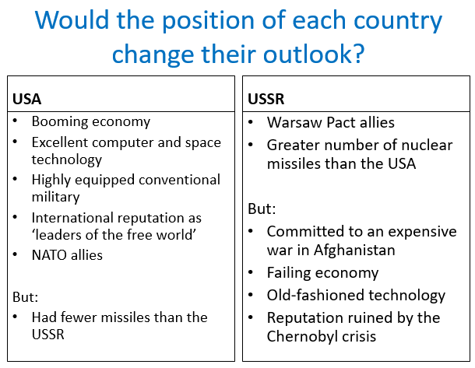
Keywords: Perestroika: Means restructuring Glasnost: means openness
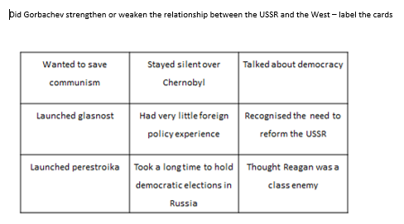
Task 1: Why did relations between the superpowers improve?
1) Using the sheet ‘Reagan and Gorbachev’
Highlight –
- Reagan hindered relations R-
- Reagan improved relations R+
- Gorbachev hindered relations G-
- Gorbachev improved relations G+
- Gorbachev and Reagan worked together to improve relations R/G
2) Explain the reasons why the relationship between the USA and the USSR changed.

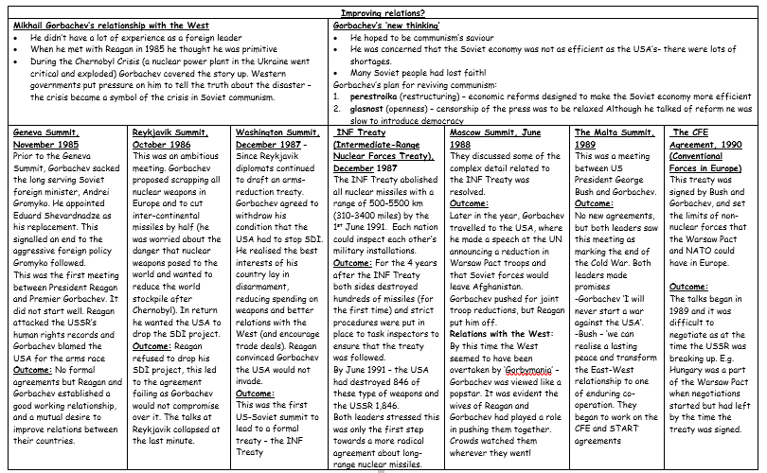
Task 2: Why did Eastern Europe break-up and the Berlin Wall fall?
Using the sheet ‘The Break up of Eastern Europe’
Highlight –
- Causes
- Events
- Consequences
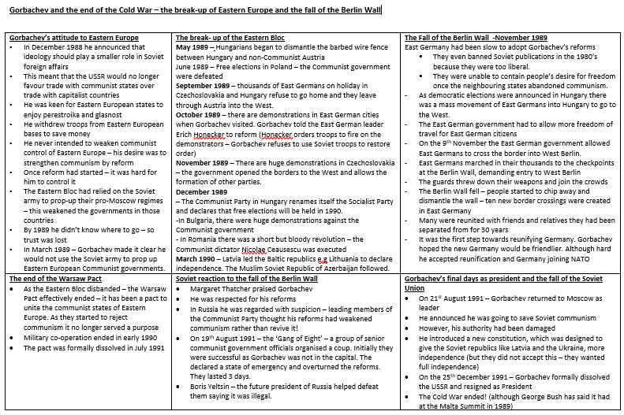

2) Explain why Gorbachev’s attempts to reform communism caused the downfall of the Soviet Union
Question 3: Explain two of the following:
- The importance of the nuclear arms race for the relations between the USA and the Soviet Union
- The importance of the Soviet invasion of Afghanistan for relations between the USA and the Soviet Union
- The importance of Ronald Reagan for relations between the USA and the Soviet Union
(16 marks)

Q1 – 2XPEE
Question 1: Explain two consequences of Nixon and Brezhnev’s Moscow meeting in 1972. (8 marks)
Question 1: Explain two consequences of the Soviet invasions of Afghanistan. (8 marks)
Question 1: Explain two consequences for relations between the USA and the Soviet Union of Reagan becoming president. (8 marks)
Question 1: Explain two consequences of Mikhail Gorbachev’s decision to abandon the Brezhnev Doctrine (8 marks)
Question 1: Explain two consequences of Gorbachev coming to power in the Soviet Union. (8 marks)
Question 1: Explain two consequences of Gorbachev’s ‘new thinking’ on eastern Europe. (8 marks)

Q2 – 8 MARKS – 3 X developed factors – write chronologically showing the links and developments between events
- Question 2: Write a narrative account analysing the key events of détente in the years 1970-79
You may use the following in your answer:
- SALT 1, 1972
-The Helsinki Accords, 1975
You MUST also use information of your own. (8 marks)

2. Question 2: Write a narrative account analysing the key events in the Soviet Union and eastern Europe in the years 1989-91.
- You may use the following in your answer:
-The impact of ‘new thinking’
- -The fall of the Berlin Wall
- You MUST also use information of your own. (8 marks)

3. Question 2: Write a narrative account analysing the key events leading to the break-up of the Warsaw Pact in the years 1985-91.
- You may use the following in your answer:
- Gorbachev became leader of the Soviet Union in 1985
- -the fall of the Berlin Wall in 1989
- You MUST also use information of your own. (8 marks)

4. Question 2: Write a narrative account analysing the main developments in the collapse of the Berlin Wall during 1989.
- You may use the following in your answer:
-The impact of Sinatra Doctrine
- -Developments in East Germany
- You MUST also use information of your own. (8 marks)

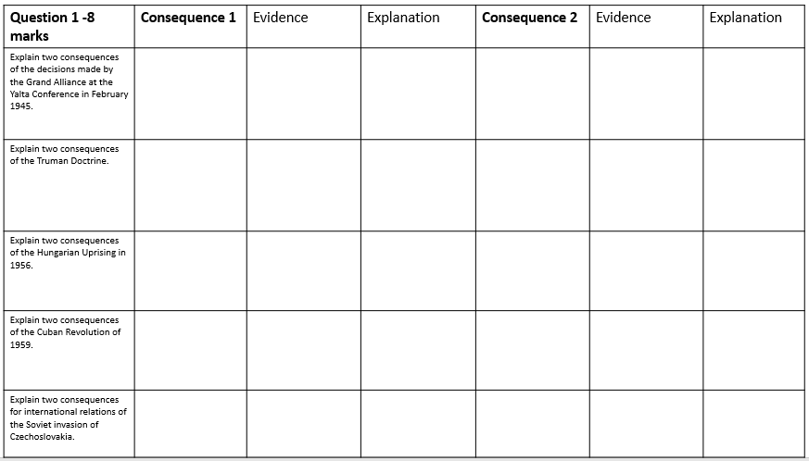
Date: Lesson 9: To work on exam literacy – the Cold War
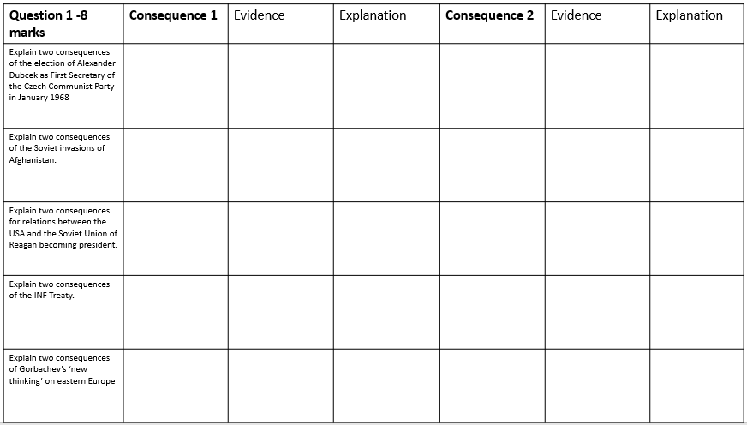
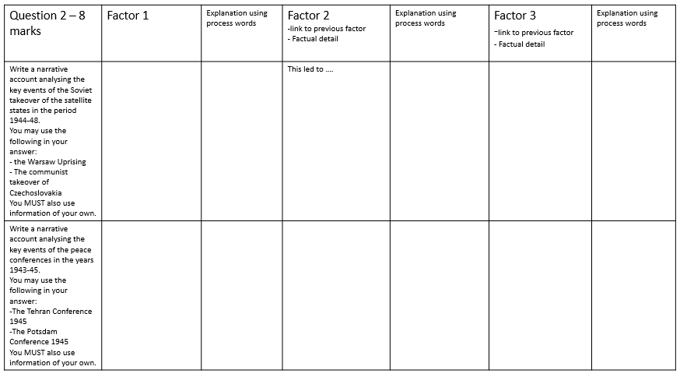
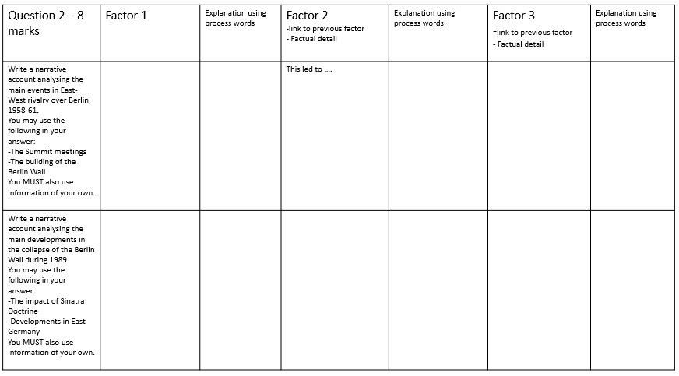
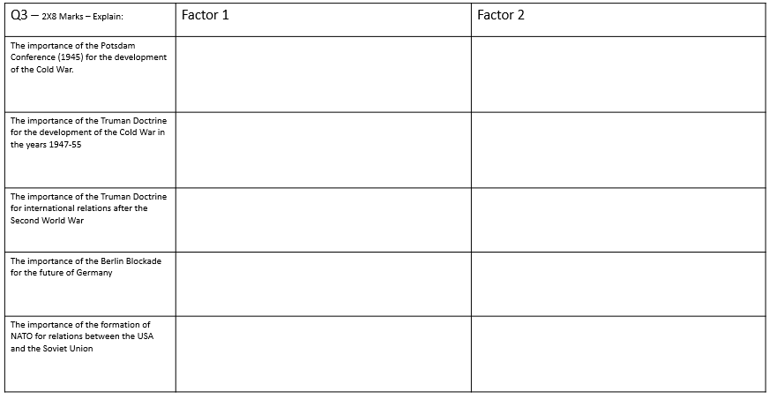
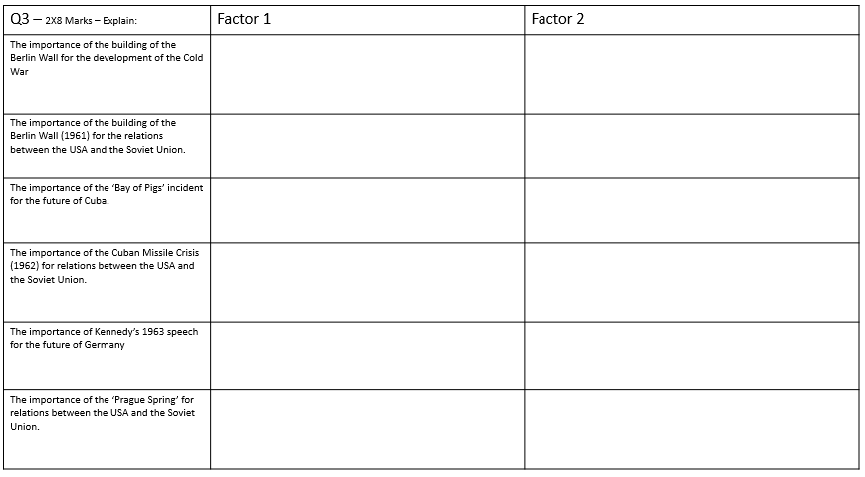
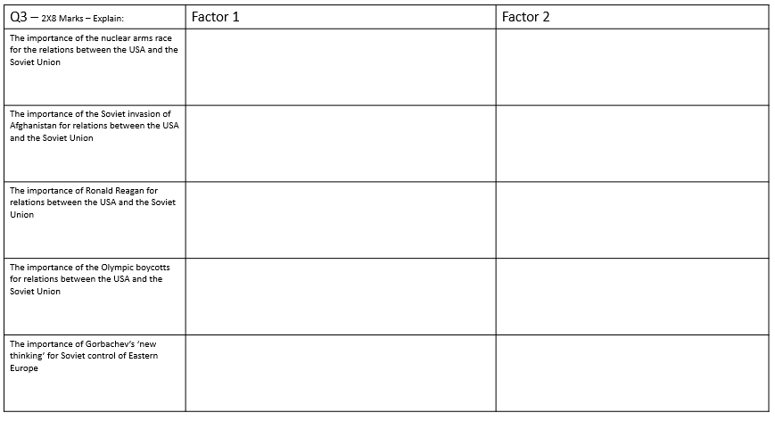
……………………………………………………………………………………………………………………………………………………………………………………………………………………………………………………………………………………………………………………………………………………………………………………………………………………………………………………………………………………………………………………………………………………………………………………………………………………………………………………………………………………………………………………………………………………………………………………………………………………………………………………………………………………………………………………………………………………………………………………………………………………………………………………………………………………………………………………………………………………………………………………………………………………………………………………………………………………………………………………………………………………………………………………………………………………………………………………………………………………………………………………………………………………………………………………………………………………………………………………………………
………………………………………………………………………………………………………………………………………………………………………………………………………………………………………………………………………………………………………………………………………………………………………………………………………………………………………………………………………………………………………………………………………………………………………………………………………………………………………………………………………………………………………………
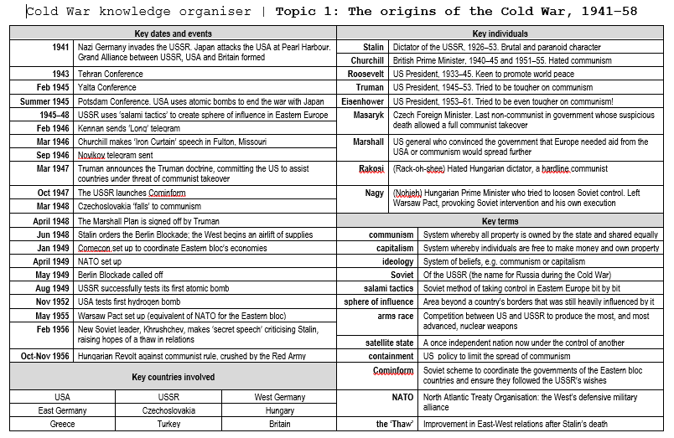
…………………………………………………………………………………………………………………………………………………………………………………………………………………………………………………………………………………………………………………………………………………………………………………………………………………………………………………………………………………………………………………………………………………………………………………………………………………………………………………………………………………………………………………………………………………………………………………………………………………………………………………………………………………………………………………………………………………………………………………………………………………………………………………………………………………………………………………………………………………………………………………………………………………………………………………………………………………………………………………………………………………………………………………………………………………………………………………………………………………………………………………………………………………………………………………………………………………………………………………………………………………………………………………………………………………………………………………………………………………………………………………………………………………………………………………………………………………………………………………………………………………………………………………………………………………………………………………………………………………………………………………………………………………………………………………………………
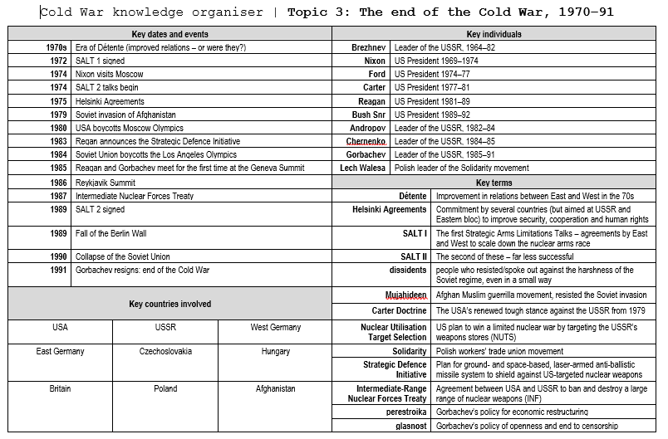
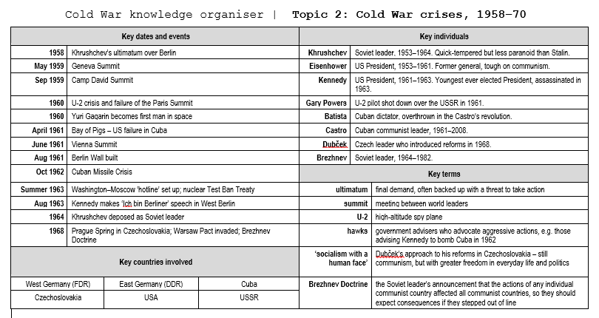
Who was involved in which event?
Event | American President | Soviet Leader | Other
WW2 | Roosevelt 1932-45  Truman – 1945 - 1952 | Stalin  1924-53 | Churchill – British PM from 1940-45  Atlee – British PM from 1945 - 51
The Berlin Blockade 1948-49 | Truman | Stalin
Hungarian Uprising 1956 | Eisenhower | Khrushchev | Hungarian Leaders  - Matyas Rakosi – hard-line communist leader of Hungary – forced to retire as very unpopular  - Imre Nagy – took over from Rakosi and introduced reforms - he wanted to leave the Warsaw Pact  - Janos Kadar – Khrushchev replaced Nagy with him – he treated anti-communists harshly and introduced some economic reforms
The U2 Spy Plan Incident  1960 | Eisenhower | Khrushchev
Bay of Pigs 1961 | Kennedy | Khrushchev | Batista – Dictator of Cuba (pro-American)  Fidel Castro – Communist leader of Cuba who overthrew Batista
The Building of the Berlin Wall 1961 | Kennedy | Khrushchev
Cuban Missiles Crisis 1962 | Kennedy | Khrushchev | Fidel Castro - Cuba
The Prague Spring  1968 | Lyndon B. Johnson and From 1969 Richard Nixon | Brezhnev | Dubcek – took over from Nototny as the Communist Czechoslovakian leader (‘socialism with a human face’)  Ulbricht – East German Leader and Gomulka – Polish Leader – both feared the spread of the Prague Spring
Détente – | Nixon | Brezhnev | SALT 1 and SALT 2
Afghanistan 1978-1980 | Carter | Brezhnev | Taraki – new communist president of Afghanistan after the Kabal Revolution  Amin – head of the Afghan army – claimed the presidency after Taraki’s assassination.  Karmal – Soviet troops replaced Amin with Afghani communist Karmal.
The Second Cold War 1979-85 | Reagan | Brezhnev  Andropov  Gorbachev
Chernobyl 1986 | Reagan | Gorbachev
Conciliation  1986-1991 | Reagan  Bush | Gorbachev | Geneva Summit, Reykjavik Summit, INF – Gorbachev/Reagan  Malta Summit, CFE Agreement and Start 1 – Gorbachev/Bush
Fall of the Soviet Union | Bush | Gorbachev  Yeltsin | West German Chancellor – Helmut Kohl  Yeltsin became the leader of the Russian Republic in May 1990. Gorbachev announced the end of the USSR in Dec 1991.

