Little question: Was the Peasant’s Revolt a threat to Richard II’s power?
LO: to understand the consequences of the Peasant’s Revolt and evaluate the impact on Richard II’s reign
BACKGROUND INFORMATION:
Although the Black Death had brought a better standard of living for some peasants, they still led miserable lives.
During the new King Richard II's first years as king, government was in the hands of a series of regency councils, influenced by Richard's. England then faced various problems, most notably the Hundred Years' War. Peasants still hated the Statute of Labourers: the law arranged by the rich to keep the peasants’ wages low and kept them tied to one lord. Some peasants took advantage of the lower population and would move from village to village looking for the highest wages.
If these peasants were caught they would be returned to their own village where they would be punished. As a result, peasants became angry and bitter and in 1360 poorer priests began to complain about rich leaders of the church.

TASK ONE: Reading the sources, answer the following questions for each source:
- What did Wat Tyler do?
- What did the Mayor do?
- What did the king’s men do?
- Is this source reliable/trustworthy? Why?
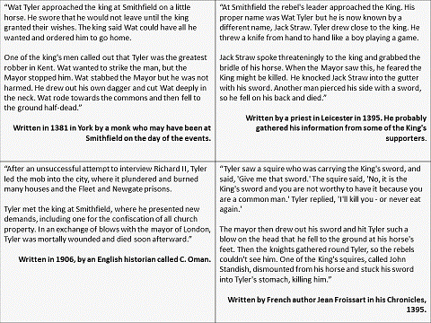

The story of the Peasant’s Revolt:
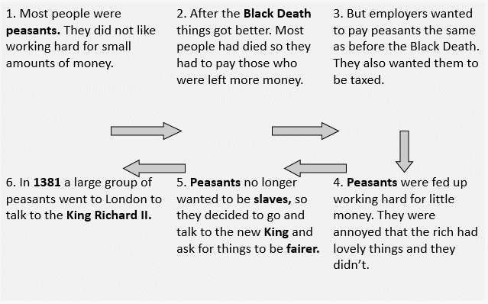
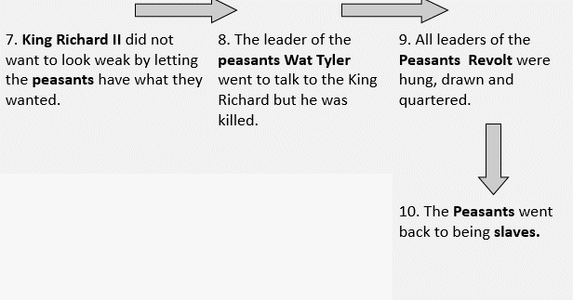
TASK TWO: Summarise the Peasant’s Revolt in your own words, using a maximum of 150 words.
________________________________________________________________________________________________________________________________________________________________________________________________________________________________________________________________________________________________________________________________________________________________________________________________________________________________________________________________________________________________________________________________________________________________________________________________________________________________________________________________________________________________________________________________________________________________________________________

TASK THREE: Imagine you are either one of the peasants or King Richard II. You need to write a letter, leaflet or create a speech explaining your view of the Peasant’s Revolt.

