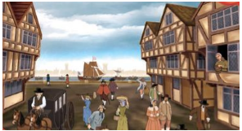
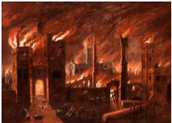
Year 7 Learning Task
Fearsome Fire

Your learning task for the four lessons is to investigate the Great Fire of London 1666.

Lesson | TASK TO BE COMPLETED
1 | Research the Great Fire of London. Use the websites below to help. However, try to use other resources to complete your research. Reference books for example. Your research should be collected together in the form of bullet pointed information – not a collection of copy and paste  http://www.historylearningsite.co.uk/great_fire_of_london_of_1666.htm http://www.bbc.co.uk/history/british/civil_war_revolution/launch_ani_fire_london.shtml http://www.fireoflondon.org.uk/  http://www.historyonthenet.com/Stuarts/great_fire.htm
2 | Produce a storyboard to tell the story of the Great Fire of London. This should have at least squares and should include both information boxes and images.  The story begins on a Sunday night in 1666. The fire started on Pudding Lane in a bakery owned by Thomas Farriner…
3 | Samuel Pepys wrote about the Great Fire of London in his diary. His diary became very famous as it gives us a contemporary account of what happened. Read through his entries using the website below. Use this and your research to write four diary entries about the fire as if you had been alive at the time. This can be done using ICT or by hand. Really think about what you would be experience, sights, sounds, smells and emotions.  http://www.pepys.info/fire.html
4 | Source Analysis Using the uploaded resource p 106/107 read through Source A and look closely at Source B . Describe two key features of London in 1666. (Two characteristics you would expect to see at this time if you were in London.) Your research from lesson and 1 and 2 should help you do this.  Follow the steps on p107 to help answer question 2. For question three think about what other types of sources you could use to find out about the fire. You have already used one in a previous lessons.

