Topic: Mughal India and the British Empire
Enquiry Question: Were the British a force of good in India?
Life in Mughal India
LO: To make a judgement about what life was like in Mughal India

STARTER: What do you already know about India?
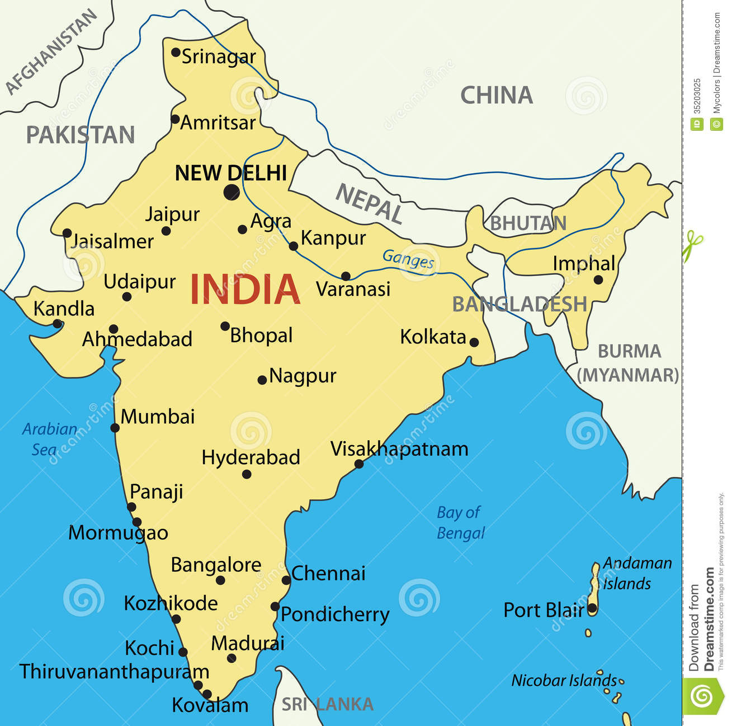
- ___________________________________
- ___________________________________
- ___________________________________
- ___________________________________
- ___________________________________
- ___________________________________
- ___________________________________
- ___________________________________
- ___________________________________
- ___________________________________

- In the 16th Century most of India was conquered by a family of princes called the Mughals
- They came from lands that are now part of Afghanistan and Uzbekistan
- Mughal means “Mongol”. Babur, the Asian invader who founded the empire, was descended from Mongol warlords.
- The Mughals were Muslims who ruled a country with a large Hindu majority.
- However, for much of their empire they allowed Hindus to reach senior government or military positions.

The Mughals brought a lot of change to India:
- Centralised government that brought together many smaller kingdoms
- Delegated government with respect for human rights
- Persian art and culture
- Persian language mixed with Arabic and Hindi to create Urdu
- Periods of great religious tolerance
- New styles of architecture (e.g. the Taj Mahal)
- A system of education that took account of pupils' needs and culture

Who was Babur?
TASK – Read the information and answer the questions.

Babur is considered to be the founder of the Indian Mughal Empire, although it was his grandson (Akbar) who developed it. Babur was born in 1483. He became ruler of Ferghana at the age of 11. Known as the 'Tiger', he was ambitious and determined to recapture land from rival princes. His attempts resulted in failure, however, and he ended up losing Ferghana - so he turned to India instead.

India was vulnerable to Babur because it was very weak at the time with a lot of internal conflicts. At that time North India was ruled by the Lodi Sultans, a dynasty that was weak because of lots of arguments and threatened by Afghan chieftains. Babur also had a large, well organised army with impressive tactics and weapons.

In 1526 Babur defeated the Sultan Ibrahim Lodi at the Battle of Panipat. Although he was outnumbered, Babur's army was experienced and equipped with new, superior artillery, including field cannons. Ibrahim's army was chaotic because of internal tensions and their weapons and tactics were out of date. Babur's victory at Panipat was the beginning of the Mughal Empire. Ibrahim was killed and three days later Babur occupied the capital, Delhi.

Although he had won, Babur's first real problem was his own followers - they were ready to go home. He encouraged his army and pushed them through to defeat Rajput chieftains at the Battle of Khanwa in 1527.

Babur had won his Empire, but it was chaotic with no real settled administration or organisation. He fell in very early on in his reign; his strength began to fail and he died in 1530, after only four years in power. He named his son, Humayun, as his heir.

- Why did Babur decide to invade India? ___________________________________________________________
________________________________________________________________________________________________________________________________________________________________________________________
- Why was his invasion a success? ________________________________________________________________
________________________________________________________________________________________________________________________________________________________________________________________
- What issues did he face after his invasion was a success? ____________________________________________
________________________________________________________________________________________________________________________________________________________________________________________
- What was the problem with Babur’s empire? ______________________________________________________
________________________________________________________________________________________________________________________________________________________________________________________

Akbar the Great, Emperor of the Mughal Empire in India
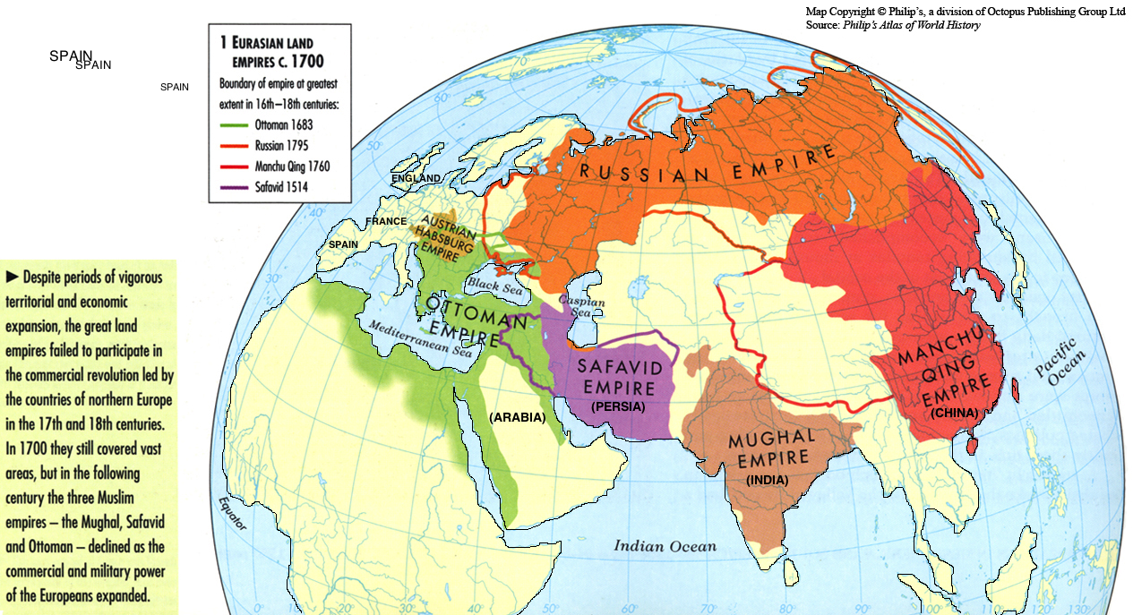
Source: Philips Atlas of World History

TASK: Read the information (highlight the key parts) and answer the question.
…Rather than learning only from Muslim scholars in his court, Akbar stated that he mingled with "learned men of all religions”…
…Akbar also went to great lengths to integrate non-Muslims into the Mughal empire…he did not forcefully convert Hindus to Islam, but accommodated their religious demands by securing their freedom of public prayer, and allowing Hindus to build and repair their temples. Granting Hindus the ability to freely worship baffled many critics, including his own son Salim, who once asked his father why he had allowed Hindu ministers to spend money on building a temple. Akbar responded to Salim: "My son, I love my own religion... [but] the Hindu [m]inister also loves his religion. If he wants to spend money on his religion, what right do I have to prevent him...Does he not have the right to love the thing that is his very own?"
Ensuring equality for all his subjects was one of Akbar's paramount concerns. In abolishing the jizya, or poll tax on non-Muslims, and allowing for conversions to and from Islam, Akbar set an example: one did not have to be Muslim to be treated fairly in the Mughal empire.…
Akbar the Great's tolerance of other religions is also noticeable in his marriages to women of various faiths, most noteably Jodha Bai, a Hindu daughter of the House of Jaipur. Akbar also took a Christian wife, Maria Zamani Begum, who had her own chapel in one of Akbar's palaces….

Source: Craig Considine. “Finding Tolerance in Akbar, The Philosopher-King”. HuffingtonPost, 2013.

TASK: What were the two most important impacts of Akbar’s rule in India? Explain using PEE.
_______________________________________________________________________________________________
_______________________________________________________________________________________________
_______________________________________________________________________________________________
_______________________________________________________________________________________________
_______________________________________________________________________________________________
_______________________________________________________________________________________________
_______________________________________________________________________________________________
_______________________________________________________________________________________________
_______________________________________________________________________________________________
_______________________________________________________________________________________________
_______________________________________________________________________________________________
_______________________________________________________________________________________________
_______________________________________________________________________________________________
_______________________________________________________________________________________________
_______________________________________________________________________________________________

