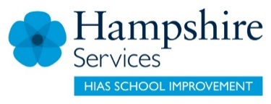
Medium term plan - Enquiry Question: |  |  |  | Year Group
Substantive concepts |  | Historical concept/ process | Misconceptions to overcome | SEN provision
Public health, Government, sanitation, settlement, prehistoric, |  | Continuity and change within and across periods  Key terms: change, continuity, progress, regress, pace, extent, trends and turning points | Not everyone benefitted from Roman public toilets e.g. those in rural areas or poorer parts of town.
Historical concept/ process |  |  | Specified knowledge content
Hampshire Age Related Expectations: Change and continuity for Y7  - explain why some things that have changed whilst others remained the same within and across periods, giving the immediate reasons for and results of change and continuity  - use the terms change and continuity appropriately  - explain that some changes happened quickly; others happened slowly  - explains that some things can get worse over time as well as getting better  - Can make a judgment.  We will also challenge students to:  - analyse the pace and extent of change and its different effects on different people and places at different times using terms like progress, regress, pace, extent, trends and turning points |  |  | - Explore what Skara Brae reveals about Neolithic attempts to deal with sewage.
Sequence of lessons  Enquiry outcome | Lesson 1:  Lesson 2:  Lesson 3:  Lesson 4:  (End product/student task that allows students to answer the enquiry question/demonstrate their understanding.)
Opportunities for:
1. modelling, deliberate practice and formative feedback before assessment
2. SMSC + Brit Values
Assessment points:
© Hampshire County Council

