Dear colleagues
This is the first of what we hope will be a monthly Secondary History e-newsletter circulated by email at the beginning of each month. I hope that it will be helpful way for us to keep in contact during these unprecedented times. The idea is to alert you to some new resources as they come on stream via the Hampshire History Moodle Home Study area. These home study resources are open access and free. Please remember that the Hampshire History Moodle site, managed by Barbara, History Centre Manager, will be kept up to date with news and interesting information. Keep in touch with us further, as there may be online courses available in the summer term.
If you would like to receive these monthly newsletters, please simply reply with a yes please and I will forward it to Barbara in the History Curriculum centre.
The existential significance of history education in these times
Our students are living through a historic moment in our nation and in our world’s history when our future seems very uncertain which must be very disorientating. Students will be feeling more isolated by recent social distancing measures yet at the same time these events show our world as a smaller, more interconnected place than ever. We know that a person’s historical consciousness influences their attitudes, perceptions, perspective and actions. Helping our students to develop a broad and evidentially grounded historical framework at a large and small scale will help students orientate themselves within our global history and gain a new perspective on these events and possible futures, including positive outcomes. This, for example may be a good time to look at how past societies or the world working together has overcome adversity or threats to our health such as smallpox or infection. Medicine and scientific understanding has come a long way since the days of the Black Death and the quarantining we can see making a difference in slowing the spread of the virus today was practiced successfully by the village of Eyam. Their sacrifice saved thousands of lives by preventing further spread of the virus in Derbyshire. Teaching the impressive history of China including its Golden Age during the Tang, Song and Ming dynasties may help to dispel negative misconceptions about the Chinese and help to combat the growing racism against the Chinese since the start of this new virus. That is why some of the websites, home study enquiries and guided reading tasks have a global perspective such as the website Meanwhile Elsewhere with worksheets to get you started on creating a home study enquiry like this one on the Song Dynasty while the Normans ruled England.

The purpose of history education in the public sphere
The national curriculum and GCSEs aim to teach students several forms of knowledge. Educating students with the form of knowledge, which constitutes the discipline of history includes teaching them about two different types of knowledge: firstly, a chronological framework of substantive knowledge including possible narratives and first order concepts such as Empire and democracy; secondly (and equally) the disciplinary knowledge that tests the origin and validity of previously established historical information, differing historical interpretations and attributions of historical significance and finally the organising second order concepts including cause and consequence, change and continuity and similarity and difference. Students should learn to talk and work like historians. They should follow lines of historical enquiry and learn to investigate, evaluate, debate, analyse and argue. The obvious immediate challenge for us as educators is how to help students develop these kinds of knowledge through home study. We must guard against setting purely task focussed worksheets that result in a superficial understanding of the topic and history, although this is not easy. Here are some ideas below!!

New resources for KS3 and KS4
Already on the open History Moodle area is a list of useful websites to support our teaching and preparation of historical enquiries. In addition, there are a whole range of student Home Study enquiries and workbooks to help you set meaningful work on the national curriculum and GCSE studies and helps them to broaden their knowledge world history. The History Steering Group and other colleagues have been generously donating their resources and will be developing more to share as school closures continue. This super example is from Rachel Woodward at Wavell School.
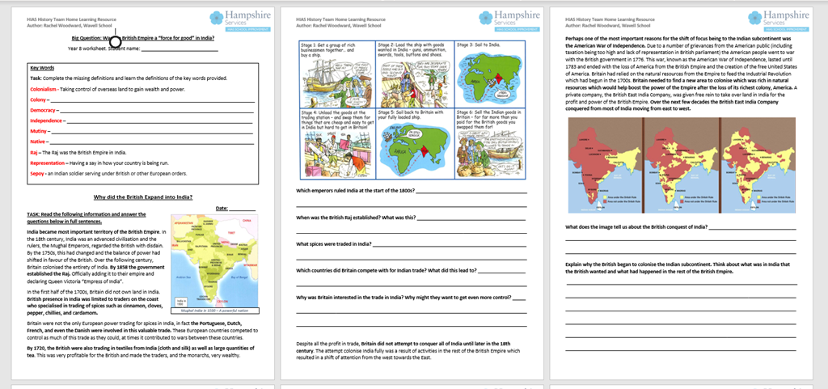

The next resources to be added are a series of guided reading activities that Stuart Farley from Upper Shirley High has developed. They are an excellent example of how we can introduce more scholarship into our curriculum, expose students to the work of historians, support their reading of more complex texts and broaden students’ horizons. The example in the following image asks students to engage with Peter Frankopan’s groundbreaking history book, Silk Roads’ that is changing our narrative on world history.
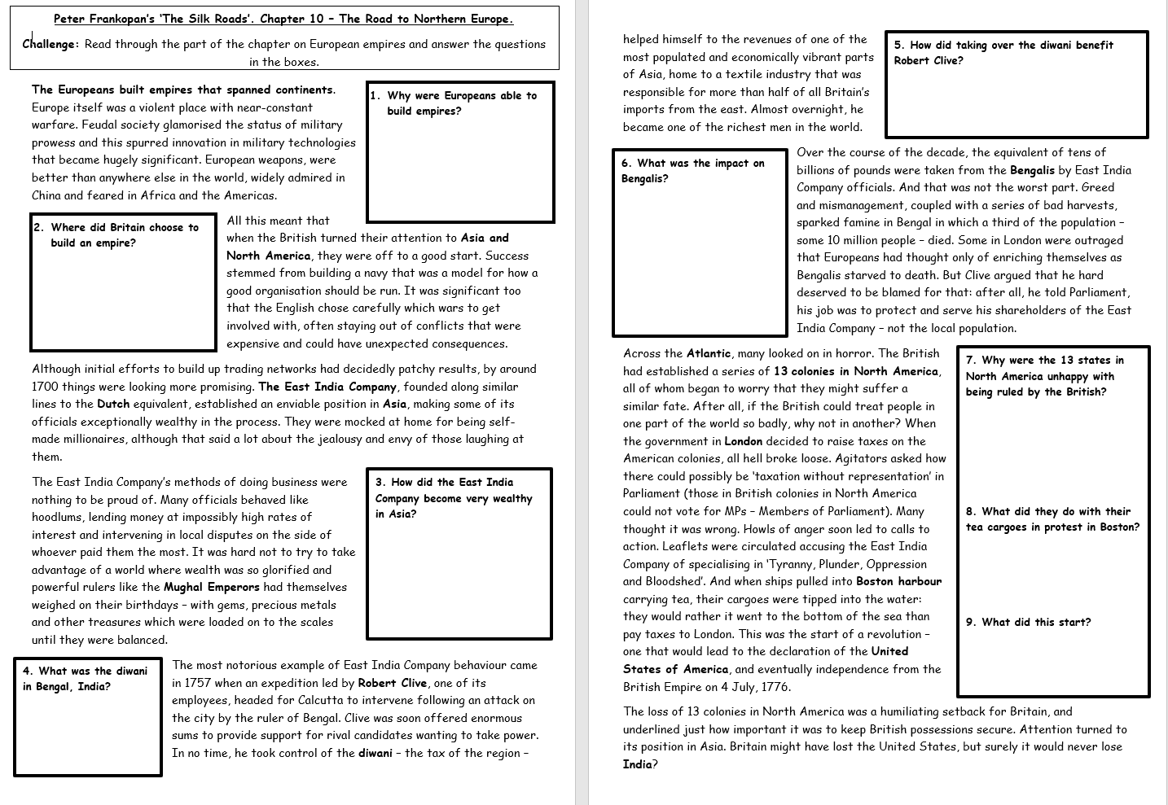
GCSE
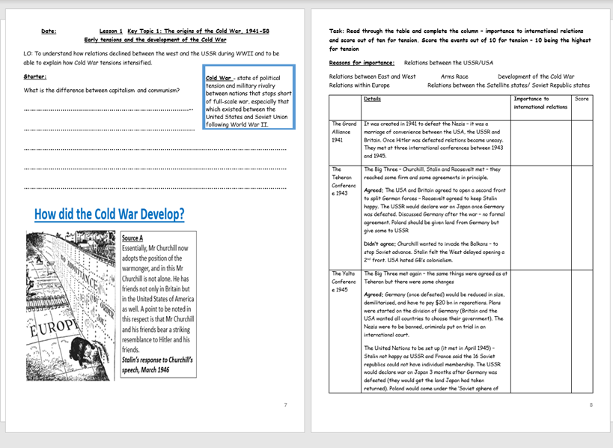
In the GCSE section of the home study area on the history Moodle you will find GCSE work books on various GCSE topics like these pages from the Cold War booklet from Wavell School. Please could you send your examples to add to this site.

Year 11
We need to think more creatively for our Year 11s for whom GCSE exams are no longer happening but who need work which will prepare them for further study such as history A level. For those not doing History A Level there is a chance to broaden their horizons out of the straight jacket of a GCSE syllabus and help them study areas of self- interest. If anyone is developing such resources, please get in touch with me so we can share examples on the open Moodle to inspire others.
Subject knowledge professional development opportunity for teachers
As well as preparing study resources for our students, I will continue to develop new resources for the Moodle plus History pages and hope to offer CPD opportunities to your history teams as we continue to work remotely in this fast changing situation. I know many of you will be working on developing/improving your history curriculum.
This may also be an opportunity to develop your history curriculum and boost our own subject knowledge. To this end I will also be putting onto the Home Study area a list of really useful links to TV programmes, academic websites and other elements that you might enjoy investigating. I hope these are both interesting and useful.
Keep in touch
Meanwhile, please keep in touch with me.
I would be available to work with you 1:1 in the coming term to ensure your curriculum is in place for September, including adapting it to help current year groups ‘catch up’ on missed curriculum. This could be an ideal opportunity to develop new ideas too. Email me for more details as well as how we hope it is going to be possible for the Secondary History Challenge Group and other CPD opportunities to continue remotely in the coming term.
Share resources
We are so fortunate to have such a wonderful opportunity to network and receive support in our Hampshire History and IOW Community. I would like the open access ‘Home Study area to be a place where you share resources you have developed. Please don’t hesitate to send me things for sharing there. This is especially important now, when supporting one another in educating our history students well is really needed. Some of you may already have received the call to action, Operation Resource. Thank you very much to those who have already responded.
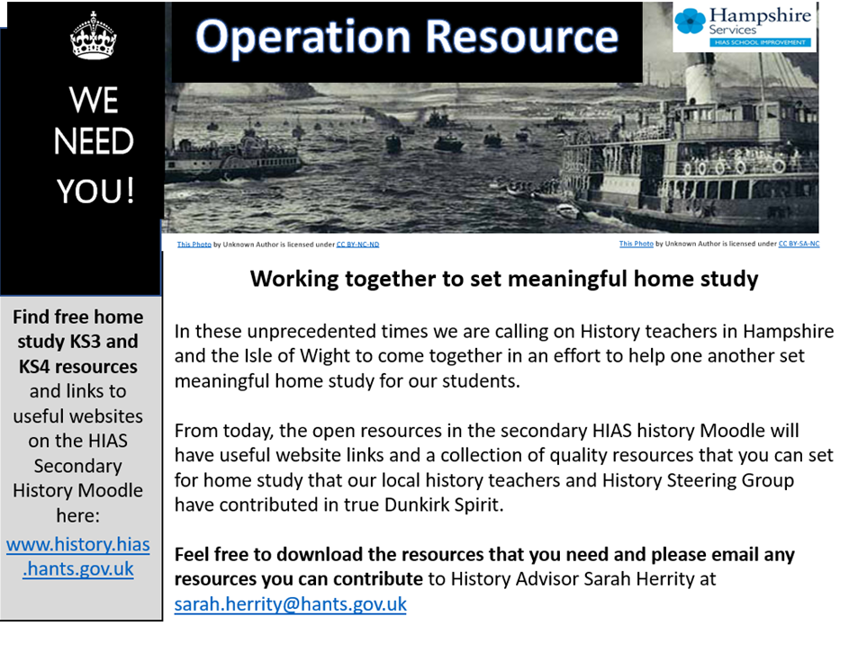
Warmest wishes, stay safe and stay well.
Sarah

Sarah Herrity
HIAS County Adviser for Secondary History
Email: sarah.herrity@hants.gov.uk

Barbara McFadyen
County History Centre Manager
Email: barbara.mcfadyen@hants.gov.uk

