HIAS HISTORY CENTRE RESOURCE

Student glossary

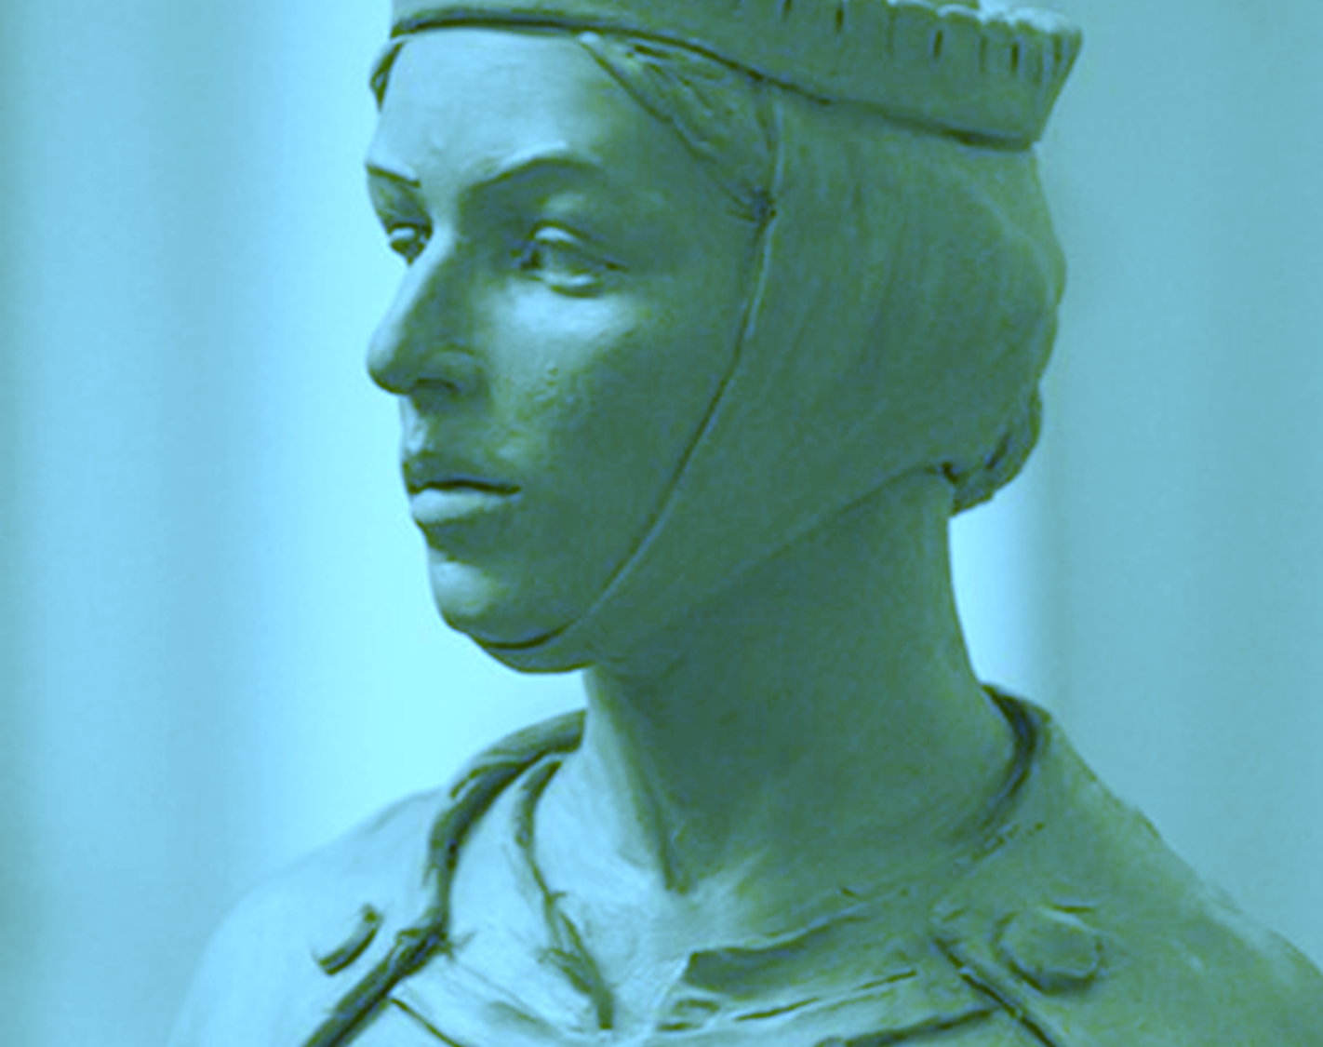
Teaching resource to support the enquiry:
What does the life of Licoricia of Winchester reveal about how medieval society treated its Jewish community?
S Herrity
[November 2021]
Final version
© Hampshire County Council

Overview

This document contains

A glossary of key terms to support students’ access to these resources and build their vocabulary and understanding of the medieval period

Points to consider when using this resource

There may be other terms and their contextual definition that some of your students will need explaining.

Students may need explanation and exemplification of these terms in the context of medieval history.

Consider whether any of the terms need images to accompany them to build students’ understanding.

You might want to consider providing students with only the terms that are relevant to the resource that is currently being used to avoid cognitive overload and make finding the needed definition easier.

Glossary

A
Archa – a chest with three locks in royal castles, used to hold records of debts owed to Jews. These debts were then recorded on documents called Rolls. This helped the king enforce repayment. Sometimes the archa chests were attacked and destroyed by mobs of people who wanted to get rid of evidence of their debts.
Archa town – 27 towns where Jews were allowed to live in the second half the thirteenth century (1200-1299). This was because the king wanted to make sure that his Jews lived where there was an archa or chest to lock away Jewish documents.
Accusation – a claim that someone has done something wrong.
Anti-Semitism – hatred or prejudice towards Jews for religious or racial reasons.
B
Baron – a man who was given land and power by the king in return for service to the king. He was a powerful man in medieval society that ruled an area for the king, with the help of knights.
Business – a job or organisation that makes money by selling goods or services.
C
Captured – taken prisoner.
Cathedral – the main church in an area, usually a larger building.
Chirograph – a record of the debt or money that has been borrowed. This was a document that had sections cut in a wavy pattern so that copies would match to check they were authentic. One copy was kept locked in an archa chest by the king.
Christian – a medieval Christian followed the teachings of the Roman Catholic Church led by the Pope. They believed Jesus Christ was the son of God and the only way they could get to heaven was if the Roman Catholic Church let them. Most people in England and Europe were Christians.
Citizens – someone who is allowed to live in the town, city or country and has rights.
Coin clipping – this was a crime. Money could be made from clipping off tiny bits of metal from coins which could be melted down into silver plates or sold to silversmiths. Both Christians and Jews were accused of this crime in the medieval period. Ten times as many Christians were accused as Jews. Records show that a lot of accusations were false and there are references to coin clippers being planted to make people look like they were guilty. The punishment was harsh. You would be imprisoned and your property taken by the government. Later those accused and sometimes their families would be executed.
Community – a group of people living in the same place with something in common.
Cosmopolitan – including people from many countries.
Compulsory – something you must do, required by a rule or a law.
Convert – to change something, in this case your religion. The church tried converting Jews into followers of Christianity.
Crusade – a religious war. In the medieval period there were a number of Christian crusades to try to capture the city of Jerusalem from Muslim invaders. Jerusalem was a holy city to Jews, Christians and Muslims.
D
Debt – an amount of money that has been borrowed or is owed.
Dehumanised – treated as though you are not a human being.
Demand – something you ask for or expect, giving people no choice to say no.
Document– some writing or a record.
E
Educated – has been taught or has studied knowledge.
Equality – having the same rights and rules, being treated equally.
Exiled – being banned from your country.
Expulsion – being banished or banned from your country.
F
False accusation – when someone is wrongly blamed for something.
Financier – someone whose job is organising money or finance for people to borrow or invest. Jewish financiers developed new ideas like mortgages.
Friary – a building where friars lived who were a kind of monk who wanted to serve society.
G
Great Hall – a medieval Great Hall was the main room in a castle or manor house. It was where meals were eaten, meetings took place and it also acted like a court room where decisions on the law were made.
H Hostile – unfriendly, to show dislike, against
I
Imprisoned – put into prison.
Interest – extra money charged for money that is borrowed.

J
Judaism – the beliefs or religion of Jewish people.

L
Linen – a type of material used in medieval clothing for example.
Liquidation – ending a business and selling everything you can to make money.
Loans – lending people something, usually money, expecting them to give it back.
M
Mark – a medieval coin that was worth a lot of money. It was worth 13 shillings and 8 pence. A medieval knight would have earned around 2 shillings a day.
Mathematician – someone who is an expert in maths.
Merchant – someone who buys and sells goods to make money.

Minority – a smaller group of people that have different religion, race, background or culture to most other people and can be treated badly because of this.
Mob – a large crowd who are out of control, who can be violent.
Mortgage – a loan of money to help you buy a home which you pay back over time with interest. If you stop paying the loan back the lender takes the home.
Monastery – a building where a group of monks or nuns lived. Male monks and female nuns were people who lived and worked away from society to dedicate their lives to God. Medieval monasteries were Christian.
Multilingual – can speak more than one language.
N
Non-Christian - not a Christian. In the medieval period this could be a Jew or a Muslim.
O
Official records – information written down for the government to keep.
Oppressive – unfairly harsh or mean, causing suffering.
Occupation – what you do for a job.

P
Papal Bull – papal means by the pope. A papal bull is a letter or statement to the public usually to let people know what he believes and what churches should do about rules and rights.
Pilgrimage – a special religious journey.
Policy – a way of doing things decided by the government or other organisation.
Pope – the leader of the Roman Catholic Church. The leaders of the churches in England and Europe were led by the Pope.
Poverty – not having enough for what you need eg money, food, shelter.
Profession – your job especially one for which you have trained or studied.
Property – things that belong to you.
Prosperous – being successful or becoming wealthy.
R
Rabbis – religious leaders and teachers of the Jewish religion.
Relations – how people get on in their relationship.
Religious – about beliefs or a religion.
Respect – being treated well, being careful of people’s feelings or admiring them.
Royal writing office – wrote official documents for the king and government.
S
Scholar – someone who studies to become an expert. Medieval scholars studied documents, many translating, explaining and copying the Bible. Others became experts in areas like history, geography, mathematics and medicine. Some studied astrology which used the position of stars and planets to try to work out information about future events.
Scribe – someone who has the job of writing legal documents or records.
Sermon – a talk by a religious leader or teacher.
Spared – decided not to kill or hurt someone.
Statue – a model of a person or animal that is made for people to look at, for example a sculpture.
Statute – law or rule of an organisation.

T
Tallage – a demand for money from the king that could come at any time. It was a type of tax that did not need the usual permission of parliament. It comes from the French phrase meaning taking a cut.
Tally stick – a stick to record money you owe in a debt or tallage demand. The stick had notches for payments made. It was split into halves so the lender and person borrowing had a copy.
Tax – an amount of money you were forced to pay the king or government based on the size your land, property, income or trade.
Trade – buying and selling goods and services.
Trade fair – like a big market where lots of businesses come together to buy and sell goods.
U
Usury – charging interest on a loan which meant people had to pay more money back than they borrowed. This was seen as a sin by the medieval church and the pope banned Christians from charging interest on loans. There were Christian, Jewish, Italian and French financiers who charged interest on loans.
V
Vermin – wild animals or pests that cause harm.
W
Wages – money you earn from your work.
Widow – a woman whose husband has died.
Historical significance – the importance that historians or society give to people or events in history using the kind of criteria below:
remembered today – do people still talk about, know about, celebrate or criticise this person today?
remarkable for the time – did people notice this person at the time, did they do anything unusual or noticeable at the time?
resulted in change – did anything they did result in important changes for others at the time or later in history?
resonant – does their story seem to reflect current issues or people’s experiences today?
revealing – does their story reveal more about a time in history

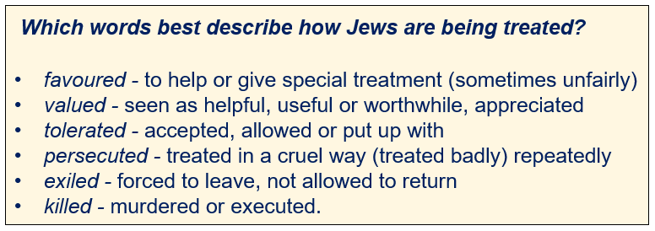
Which words that best describe the king’s policy towards the Jews?

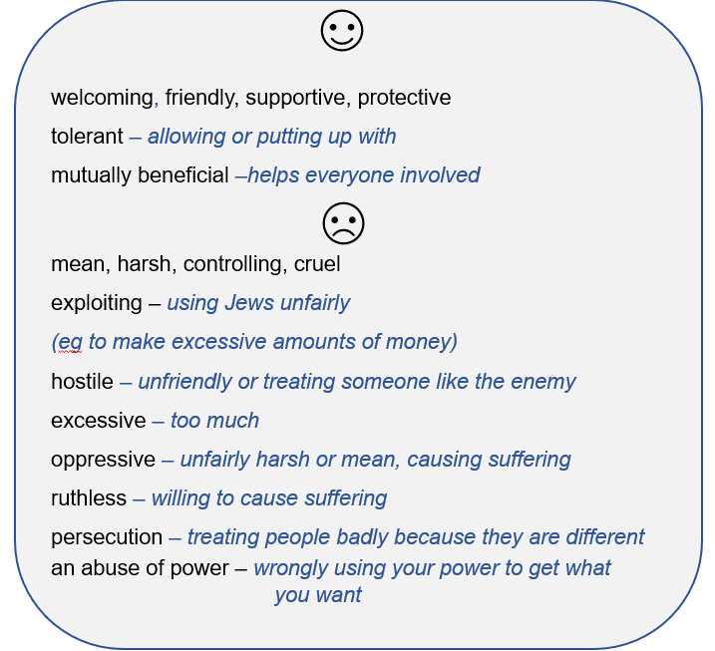

Terms and conditions

Copyright notice
This publication is copyright of Hampshire County Council © 2021. All rights reserved.
Any redistribution or reproduction of part or all of the contents in any form is prohibited other than the following:
You are welcome to:
- download this resource
- save this resource on your computer
- print as many copies as you would like to use in your school.
You may not:
- claim this resource as your own
- sell or in any way profit from this resource
- store or distribute this resource on any other website or another location where others are able to electronically retrieve it
- email this resource to anyone outside your school or transmit it in any other fashion
- amend this electronic resource as it has been approved for use in secondary schools by HIAS and Licoricia.org.

