Big Question: What impact did WWI have on Britain and the wider world?
Little Question – What terms did Germany have to agree to after WW1?
LO: To know how Germany were punished by WWI. To be able to consider how the WWI leaders reached agreements.
After World War One, Germany was not in a good position. Having surrendered to the Allies and signed the Armistice, the decision now had to be made about what to do with the country in a post-war Europe. This meant deciding what the real peace terms were going to be and deciding how Europe would rebuild after the devastation of war itself.
TASK – Use the mind map below to plot what you think the Allies might want at the end of World War One. Consider: Germany, France, Britain, Belgium USA, rest of Europe!

What the Allies might want at the end of World War One.

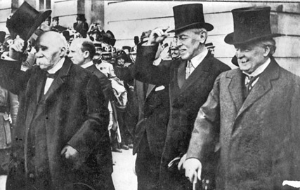

Each country in Europe wanted many different things, but it was three major powers that were able to make the final decision on Germany after 1918: Britain, France and America.
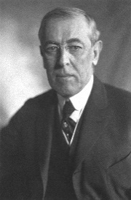  America – Woodrow Wilson | - He wanted a better world after WW1 to make it safer for democracy.  - Thought that peace should be fair for everyone.  - Had a 14 point plan, including making a “League of Nations” to help prevent war.  - Wanted more international co-operation.
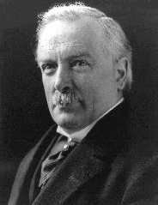  Britain – David Lloyd George | - Wanted everyone to compromise on peace.  - Had promised Parliament he’d make Germany pay, but he didn’t want to push them too far.  - Needed to protect the British Empire.  - He didn’t want to create more anger in Germany – that might start another war.
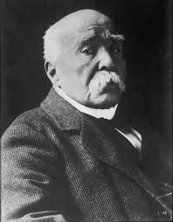  France – Georges Clemenceau | - Blamed Germany completely for the war starting.  - Wanted revenge above all else.  - Said that Germany should pay for all the war damage (reparations).  - Wanted land that used to belong to France to be independent of Germany (e.g. Rhineland).  - He wanted Germany to be weak and crippled after the war.

TASK – Answer the questions.
1. What do you think is going to happen with Germany based on this information? Why?
_______________________________________________________________________________________________________________________________________________________________________________________________________________
2. Why do you think France was so determined to have revenge on Germany?
_______________________________________________________________________________________________________________________________________________________________________________________________________________
3. How do you think Germany is going to react to the situation?
_______________________________________________________________________________________________________________________________________________________________________________________________________________

Terms of the Treaty of Versailles – Read the information and fill in the final column.
 | Specific Terms of the Treaty of Versailles | What do you think the German reaction to these terms would be?
Blame | Article 231 was enforced on Germany. This meant they had to accept the blame for starting the war.
Reparations | Germany was ordered to pay £6.6 million in reparations to other countries in Europe, including France. | The German economy was already struggling: paying reparations meant that they were going to struggle to recover from the war.
Armaments – military restrictions | Germany was now limited to the following:  - 100,000 men in their army.  - No conscription (forcing people to join the army by law).  - No submarines, armoured vehicles or aircrafts.  - 6 battleships.
Territorial losses (land) | Germany lost its overseas Empire – their colonies were taken by the League of Nations, so essentially Britain and France controlled them.  They lost land near Poland and were not allowed to unite with Austria (who were also German-speaking).
League of Nations | Germany was not allowed to become a member of the League of Nations.

Source A – Cartoon entitled “Peace and Future Cannon Fodder”.
Task – Analyse the cartoon by answering the questions.
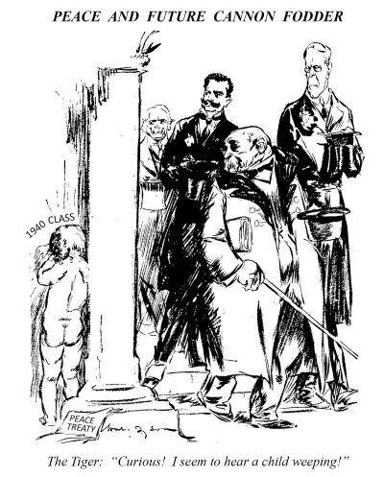
What is this referring to?
____________________________
Who does the child represent?
______________
How can you tell?
______________

Who are these three people?
1. ____________
2. ____________
3. ____________
Who do you think ‘the Tiger’ refers to?
__________________________________________________________________

What is the message of this cartoon (what is it trying to say to us?) How can you tell?
_________________________________________________________________________________________________________________________________________________________________________________________________________________________________________________________________________________________________________________________________________________________

Source B – Cartoon depicting Germany being spoon-fed peace-terms by the Council of Four. The caption states "You've got to swallow it (the pill) whether you like it or not".
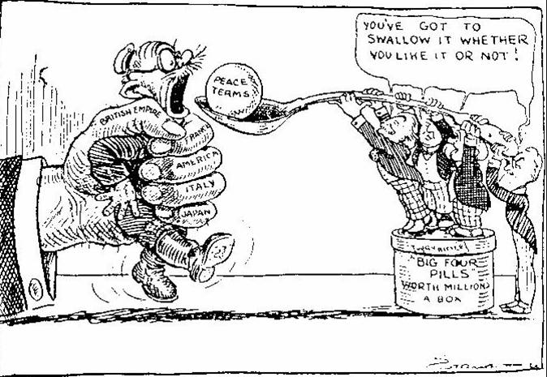
Task – answer the questions
- What is the message of this cartoon (what is it trying to say to us?) How can you tell?
_______________________________________________________________________________________________________________________________________________________________________________________________________________________________________________________________________________________________________________________________________________
- Do you think that this source is reliable (trustworthy)? Why do you think this way?
_______________________________________________________________________________________________________________________________________________________________________________________________________________________________________________________________________________________________________________________________________________

