Date:
Big Question: Why did WW2 break out?
LQ: ‘Was appeasement justified?’
Appeasement was the policy that Britain followed in the 1930s. They hoped to avoid a war.
Nowadays, when we use the word 'appeasement', we take it to mean: 'giving in to a bully'. Consequently, many people have criticised Chamberlain for appeasing Hitler.
This is not quite fair, because in the 1930s, the word 'appeasement' meant what we would today call 'negotiation'; Chamberlain, tried to negotiate peace with Hitler.
There were many reasons why Britain 'appeased' Hitler in the 1930s. Historians have ascribed every possible motive to Chamberlain - sheer abject cowardice, that he was duped by Hitler, that it was a noble attempt to prevent bloodshed, that he was buying time for Britain to re-arm... and many others!

Q1: What is appeasement?
……………………………………………………………………………………………………………………………………………………………………………………………………………………………………

Watch this clip:
https://www.youtube.com/watch?v=Hzomi4RNtiE

Read the information
As the League of Nations crumbled, politicians turned to a new way to keep the peace - appeasement. This was the policy of giving Hitler what he wanted to stop him from going to war. It was based on the idea that what Hitler wanted was reasonable and, when his reasonable demands had been satisfied, he would stop.
Although historians recognise appeasement in the actions of Britain and France before 1938, the Sudeten Crisis of 1938 is the key example of appeasement in action. Neville Chamberlain was the British prime minister who believed in appeasement

12-13 September 1938 - Hitler encourages Konrad Henlein, leader of the Sudeten Nazis, to rebel, and demands a union with Germany. When the Czech government declares martial law, Hitler threatens war.
15 September 1938 - Chamberlain goes to see Hitler at Berchtesgaden. Without consulting Czechoslovakia, he promises to give Hitler all the areas where more than 50 per cent of the population is German. Then he persuades France to agree.
22-23 September 1938 - Chamberlain goes to Bad Godesberg to tell Hitler about the decision, but Hitler now demands ALL the Sudetenland. Chamberlain refuses - it looks like war. Chamberlain calls the crisis 'a quarrel in a faraway country, between people of whom we know nothing'.
30 September 1938 - At Munich, France and Britain agree to give Hitler the Sudetenland. Chamberlain waves 'a piece of paper' with Hitler's statement that he does not want to go to war. German troops march into the Sudetenland and are welcomed as heroes.

On 15 March 1939, Hitler’s troops marched into the rest of Czechoslovakia.
- It was now clear to many people that Hitler’s next target would be Poland.
- Chamberlain promised Poland that Britain would support them if Germany invaded, which the Nazis did on 1 September 1939 and Britain and France finally declared war.
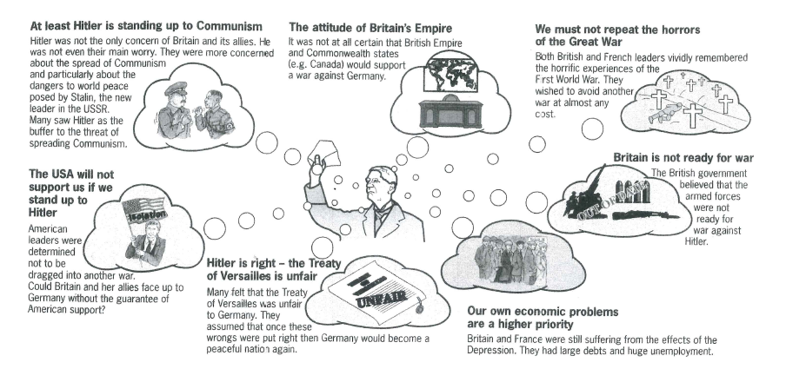
Arguments for appeasement:
Task: What is the main reason why the British and the Neville Chamberlain the Prime Minister thought Appeasement was a good idea? …………………………………………………………………………………………………………………………………………………………………………………………………………………………………………………………………………………………………………………………………………………………………………………………………………………………………………………………………………………………………………………………………………………………………………………………………………………………………………………………………………………………………………………………………………………………………………………………………………………………………………………………………………………………………………………………………………………………………………………………………………………………………………………………………………………………………………………………………………………………………………………………………………………………………………………………………………………………………………………………………………………………………………………………………………………………….
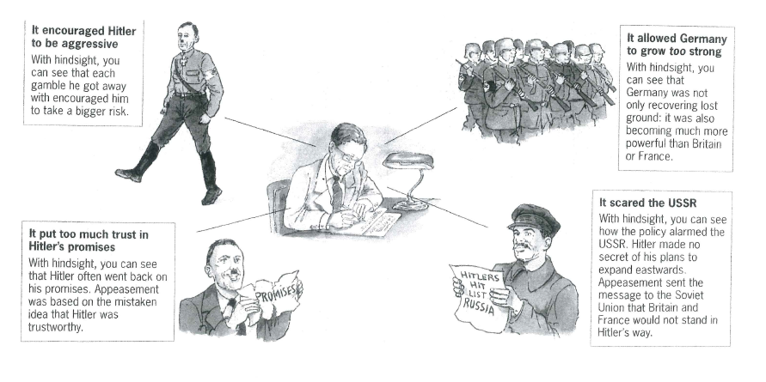
Arguments against Appeasement
Task: Many people like Winston Churchill thought appeasement was a bad idea? Why? …………………………………………………………………………………………………………………………………………………………………………………………………………………………………………………………………………………………………………………………………………………………………………………………………………………………………………………………………………………………………………………………………………………………………………………………………………………………………………………………………………………………………………………………………………………………………………………………………………………………………………………………………………………………………………………………………………………………………………………………………………………………………………………………………………………………………………………………………………………………………………………………………………………………………………………………………………………………………………………………………………………………………………………………………………………………….

Task: Explain your opinion (PEEL) – do you agree/disagree – how far. ‘Was appeasement justified?’
………………………………………………………………………………………………………………………………………………………………………………………………………………………………………………………………………………………………………………………………………………………………………………………………………………………………………………………………………………………………………………………………………………………………………………………………………………………………………………………………………………………………………………………………………………………………………………………………………………………………………………………………………………………………………………………………………………………………………………………………………………………………………………………………………………………………………………………………………………………………………………………………………………………………………………………………………………………………………………………………………………………………………………………………………………………………

