Date……………..
Big Question: Why did WW2 break out?
Little Question: What is the most important reason why war broke out?
LO: To reach a judgement about the most important reason why WW2 happened.

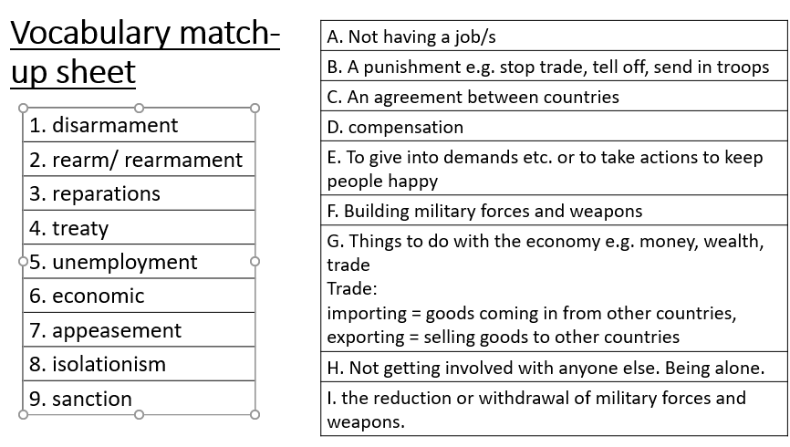
Starter:

Watch the video clip
https://www.youtube.com/watch?v=Q78COTwT7nE

Task: Complete the table - When filling in the last column- think about:
- The Treaty of Versailles and the breaking of it
- Hitler’s Actions
- The failure of the League of Nations
- Appeasement
- The USA’s lack of help
- Britain did not take action
- France did not take action
- Members of the League acted against it e.g. Germany, Britain, France, Italy and Japan

Timeline of events in the build up to WW2
Date | Event | Details | Why did this lead to war?
1919 | Treaty of Versailles | The treaty was signed, punishing Germany for WWI, it was very unpopular. They were not allowed to attend the talks. The economic terms such as having to pay £6,600 million in reparations and losses of key lands such as the Saar (coalfields) caused hardship in Germany and they were bankrupt. Germany were angry at the loss of land, people and the limitations on their armed forces. They were not allowed troops in the Rhineland, to unite with Austria and could not be in the League of Nations (they were allowed in in 1926 when relations improved)
1919 | USA adopted a policy of isolationism | The United States attempted to stay out of world issues with a policy of isolationism. They were not members of the League of Nations as they did not want to become the world’s policeman! This meant Britain and France were the strongest countries in the League – they had huge economic problems themselves!
1929 | Wall Street Crash | The American stock market on Wall Street Crashed – meaning that the value of companies in the USA declined. This meant that they could not trade with other nations and they recalled their loans to countries like Germany. The period 1929-33 is generally called the Great Depression as many countries suffered huge economic difficulties. Most countries only looked after themselves.
1931 | Japan invaded Manchuria (an area of China) | Japan was growing rapidly. However, as an island nation they did not have the land or the natural resources to sustain their growth. Japan began to look to grow their empire in order to gain new resources. They had relied on trading with the USA. They invaded Manchuria in 1931 and China asked the League for help. The League were slow to act (took a year to produce a report), they told Japan to give the land back. Japan (a member of the League) ignored what they said and left the League and began taking over the rest of China. The League was powerless without the USA (Japan’s main trading partner) to back them up!
1933 | Hitler came to power in Germany | Hitler persuaded many people to vote for him as there was chaos in Germany during the Great Depression- there was a lot of unemployment and the government couldn’t tackle the problems. Unemployment grew to 6 million!  Hitler had 3 main aims: he wanted the land Germany lost back, join all German speaking people in Europe together and to make Germany bigger by taking land from weaker nations (e.g. the Slavic nations of Eastern Europe), to create more living space for Germans (this was called Lebensraum).
1933 | Hitler and rearmament | Three days after Hitler came to power he began to increase Germany’s armed forces. This is known as rearmament. Britain and France did nothing to stop him. They thought it was reasonable considering the problems created by the Depression to be able to defend themselves. Other countries were not willing to disarm themselves!
1935 | Italy invaded Abyssinia | Mussolini invaded Abyssinia. The League banned arms (weapons sales), loans and some goods stopped being sold to Italy. Imports from Italy were banned. They worried about banning oil sales as they did not think the USA would support and go along with this sanction – so they took months to decide.  Britain and France were afraid to stop Italy using the Suez Canal. They also started a secret deal with Mussolini to give him most of the land. It got into the news and made the League look weak and ineffective.  The USA – kept selling oil to the Italians anyway. So the best sanction of taking away oil did not work.  By this time it is clear the League can do very little – Britain and France start to negotiate outside of the League. Italy ignored the League.
1936 | Rhineland | Hitler sent his troops into the area of Germany known as the Rhineland – despite what the Treaty of Versailles said! His soldiers were under strict orders to retreat if they were attacked. Britain and France did nothing to stop him.
1938 | Anschluss | Hitler’s troops marched into Austria – the country of his birth. He forced an election and united Germany and Austria – this was against the Treaty of Versailles. Again – Britain and France did nothing.
 | Appeasement | After World War 1, the nations of Europe were weary and did not want another war. When countries such as Italy and Germany became aggressive and began to take over their neighbours and build up their armies, countries such as Britain and France hoped to keep peace through "appeasement." This meant that they tried to make Germany and Hitler happy rather than try to stop him. They hoped that by meeting his demands he would be satisfied and there wouldn't be any war. Unfortunately, the policy of appeasement backfired. It only made Hitler bolder. It also gave him time to build up his army.  Britain and France thought Hitler would protect Europe from Russia and communism.
1938 | The Czechoslovakian Crisis and the Munich Agreement | Hitler announced he wanted control of an area of Czechoslovakia (the Sudetenland) that contained many German speakers. The British Prime Minister Chamberlain and the French leader visited Hitler (with the help of Mussolini) in Munich. As part of their appeasement policy, Britain and France agreed to let Hitler have part of Czechoslovakia (the Sudetenland) in the Munich Agreement. Czechoslovakia had no say in the deal. The Czechoslovakians called the agreement the "Munich Betrayal."
1939 | Invasion of Czechoslovakia | Hitler invaded all of Czechoslovakia and exposed his promises as lies.
1939 | Nazi Soviet Pact | Stalin wanted to avoid a war and was concerned as although he joined the League in 1934, it wasn’t working by then. Britain and France would not make alliances as they were concerned about the fact Russia was communist and they didn’t trust him so he didn’t think they were reliable allies against Hitler. Hitler also did not want to fight a war on two fronts. Therefore Hitler and Stalin promised not to attack each other and privately agreed to divide Poland between them. This was a shocking change (Hitler hated communism) and worried Britain and France
1939 | Poland | Chamberlain realised he had been tricked over Czechoslovakia – made a pact with Poland, promising to help Poland in Hitler attacked them
1939 | Invasion of Poland | On 1st September German troops invaded Poland. Two days later Britain and France declared war on Germany.

Task:

Decide where each factor in the white box should go – how important was it in starting WW2?

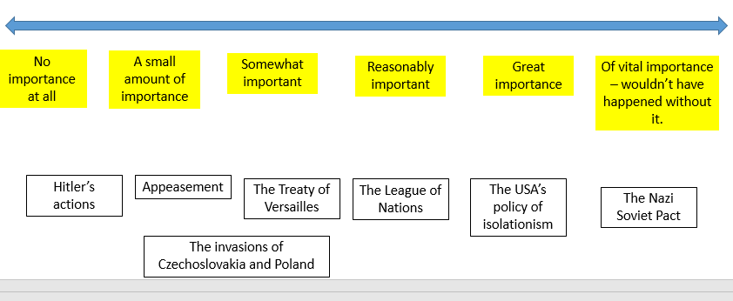

Answer: What was the most important cause of World War II?
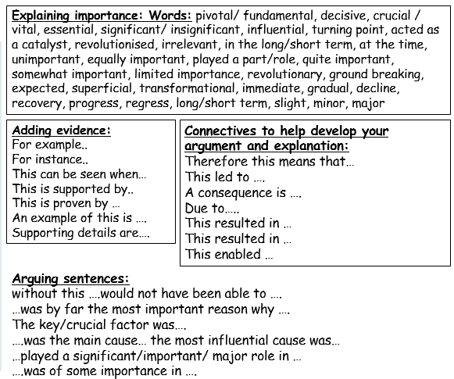
Structure:
- Point
- Evidence
- Explain
- Link

…………………………………………………………………………………………
…………………………………………………………………………………………
………………………………………………………………………………………..
………………………………………………………………………………………..
…………………………………………………………………………………………
…………………………………………………………………………………………
………………………………………………………………………………………………………………………………………………………………………………………………………………………………………………………………………………………………………………………………………………………………………………………………………………………………………………………………………………………………………………………………………………………………………………………………………………………………………………………………………………………………………………………………………………………………………………………………………………………………………………………………………………………………………………………………………………………………………………………………………………………………………………

