How is the “Scramble for Africa” significant?
Year 8 worksheet Student name: _________________
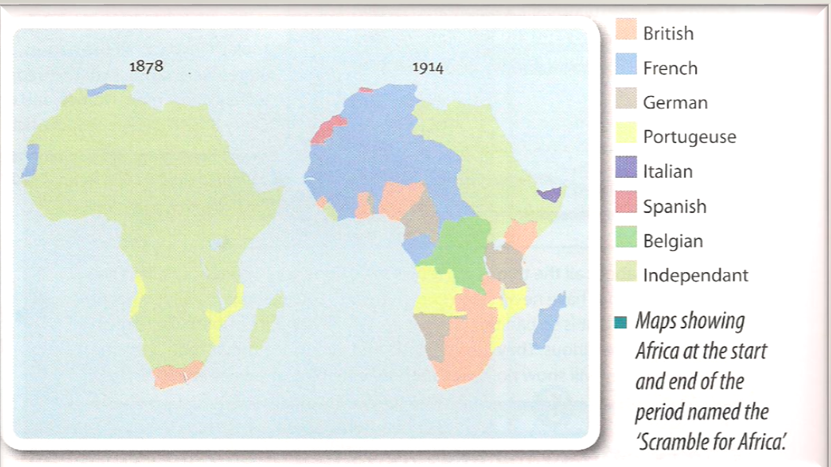

What does the name the “Scramble for Africa” make you think about European colonialism in Africa?
____________________________________________________________________________________________________________________________________________________________________________________________________________________________________________________________________________________________________________
The Scramble for Africa
Between 1881 and 1914 European countries went from ruling just 10% of Africa to over 90%, with only Ethiopia and Liberia maintaining independent self-rule.
The Europeans were unconcerned with the thoughts or opinions of the natives; they held conferences about who should get which parts of Africa to try to prevent war between European countries.
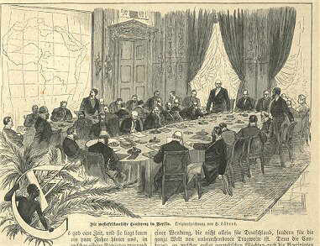
The Berlin Conference
The Berlin Conference of 1884 was a meeting of the major European powers trying to avoid possible wars by partitioning up Africa and deciding who should get which areas peacefully.
13 different European nations were present at the talks, as well as representatives of the United States of America, although there were no Africans present and their opinions, wants, and needs were barely considered.

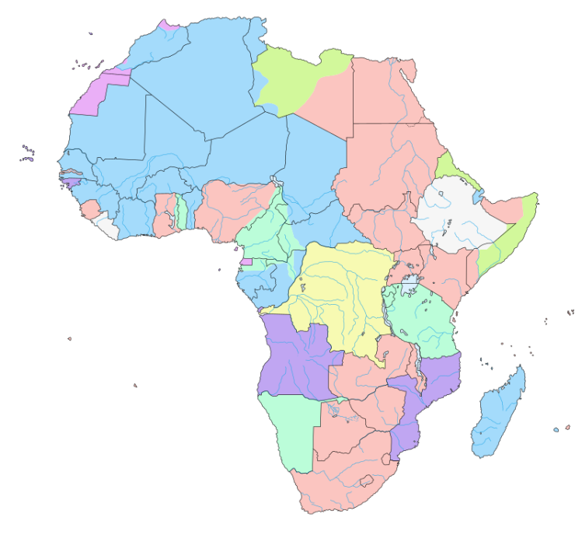
At the conference there were a number of key decisions made, including specific parts of Africa being given to specific nations, and the decision was made to rapidly colonize all of Africa. Within 10 years only 5 independent countries still existed, by 1914 this had dropped to only 2.
Despite the lack of concern for the African people one of the key points decided on in the conference was the complete abolition (end) of slavery in all nations participating in the conference, as well as its prevention in any part of Africa. The Europeans claimed that in this way they were bringing an end to the “savage practices” of the native Africans.

What happened at the Berlin Conference? ____________________________________________________ _______________________________________________________________________________________
What changed for Africans because of the Conference? _________________________________________ _______________________________________________________________________________________
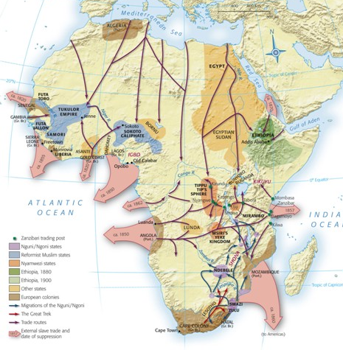
Africa and Trade
African Trade
The map shows trade routes in Africa before the Europeans arrived. These trade routes were wealthy; many of them had access to gold, spices, and other valuable materials.

In order to maximize their profits many European countries set up trade posts on the African coast and near major rivers. Eventually, these grew larger and more powerful until the European countries eventually annexed (took over) the land around them to keep all the trade and wealth for themselves.

Africa had been a very important part of major trade routes for centuries. During the 16th and 17th centuries Europeans had made a lot of money from trading with the West African countries, mostly trading manufactured European goods for slaves which were transported to other European colonies to grow expensive cash crops such as sugar and tobacco.

The Europeans realized that if they took control of the trade routes themselves they would be able to take all the profits and increase their own power. To do this they had to send armies and explorers into Africa, which was initially very dangerous. Many explorers got lost in vast African forests, were killed by the Natives, or were unable to find what they were looking for but despite this they gained huge fame and notoriety back home in Britain and the rest of Europe.

What items did the British and other Europeans want to take control of? Why? _____________________
_______________________________________________________________________________________
How did some Europeans get famous because of the search for trade routes? ______________________
___________________________________________________________________________
Resistance to Europeans
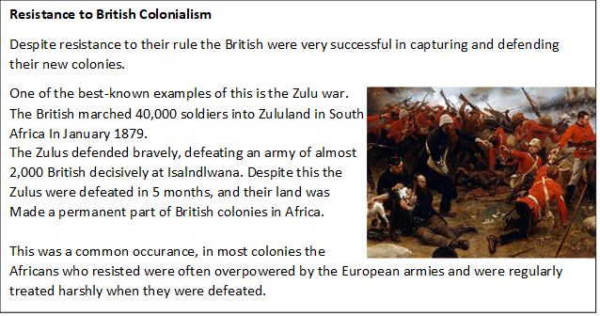

Successful Resistance to Colonialism
Some Africans were more successful in defending against European invasion.
Samory Touré was able to create the large Mandinka empire in West Africa between the 1860s and 1890s. For over 30 years he resisted the French invasions by making his own guns, moved his capital city, and played the British and French off against each other to hold on to his own power. For many African kingdoms the only way to defend themselves was to ask for help from another European country, in the long run this eventually led to their conquest anyway.
In 1896 the Ethiopian Emperor Menelik II led his army to defeat the invading Italian army of more than 25 thousand men at the battle of Adwa. By determinedly defending their mountain kingdom the Ethiopians were able to be one of only 2 countries not governed by Europeans at the start of WW1 in 1914.
Which Emperors were successful at fighting off the Europeans? __________________________________ _______________________________________________________________________________________

Why was resistance to the invading Europeans so difficult for the African kingdoms? _________________ ______________________________________________________________________________________________________________________________________________________________________________

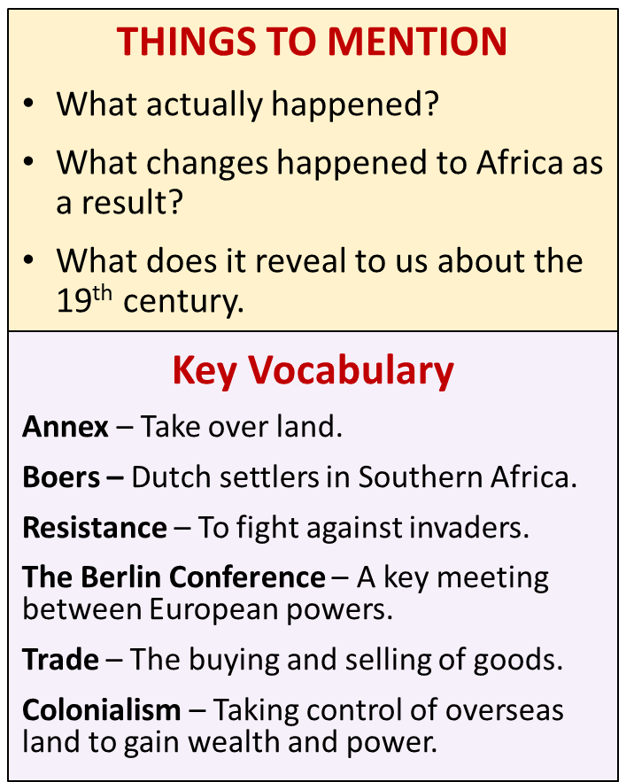
What was the Scramble for Africa and why was it significant? Explain your answer using PEE.
__________________________________________________________
__________________________________________________________
__________________________________________________________
__________________________________________________________
__________________________________________________________
____________________________________________________________________________________________________________________________________________________________________________________________________________________________________________________________________________________________________________________________________________________________________________________________________________________________________________________________________________________________________________________________________________________________________________________________________________________________________________________________________________________________________________________________________________________________________________________________________________________________________________________________________________________________________________________________________________________________________________________________________________________________________________________________________________________

