Big Question: Was the British Empire a “force for good” in India?
Year 8 worksheet. Student name: _____________________________
Key Words
Task: Complete the missing definitions and learn the definitions of the key words provided.
Colonialism - Taking control of overseas land to gain wealth and power.
Colony – _____________________________________________________________________________
Democracy – _________________________________________________________________________
Independence – ______________________________________________________________________
Mutiny – ____________________________________________________________________________
Native – _____________________________________________________________________________
Raj – The Raj was the British Empire in India.
Representation – Having a say in how your country is being run.
Sepoy - an Indian soldier serving under British or other European orders.

Why did the British Expand into India?
Date: __________
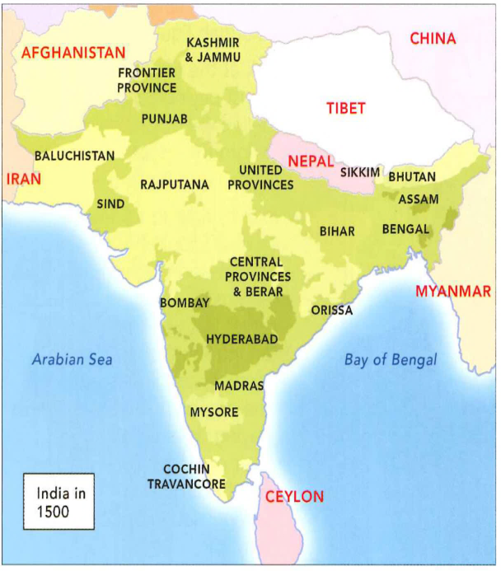
TASK: Read the following information and answer the questions below in full sentences.
India became most important territory of the British Empire. In the 18th century, India was an advanced civilisation and the rulers, the Mughal Emperors, regarded the British with disdain. By the 1750s, this had changed and the balance of power had shifted in favour of the British. Over the following century, Britain colonised the entirety of India. By 1858 the government established the Raj. Officially adding it to their empire and declaring Queen Victoria “Empress of India”.
In the first half of the 1700s, Britain did not own land in India. British presence in India was limited to traders on the coast who specialised in trading of spices such as cinnamon, cloves, pepper, chillies, and cardamom.
Mughal India in 1500 – A powerful nation
Britain were not the only European power trading for spices in India, in fact the Portuguese, Dutch, French, and even the Danish were involved in this valuable trade. These European countries competed to control as much of this trade as they could, at times it contributed to wars between these countries.
By 1720, the British were also trading in textiles from India (cloth and silk) as well as large quantities of tea. This was very profitable for the British and made the traders, and the monarchs, very wealthy.

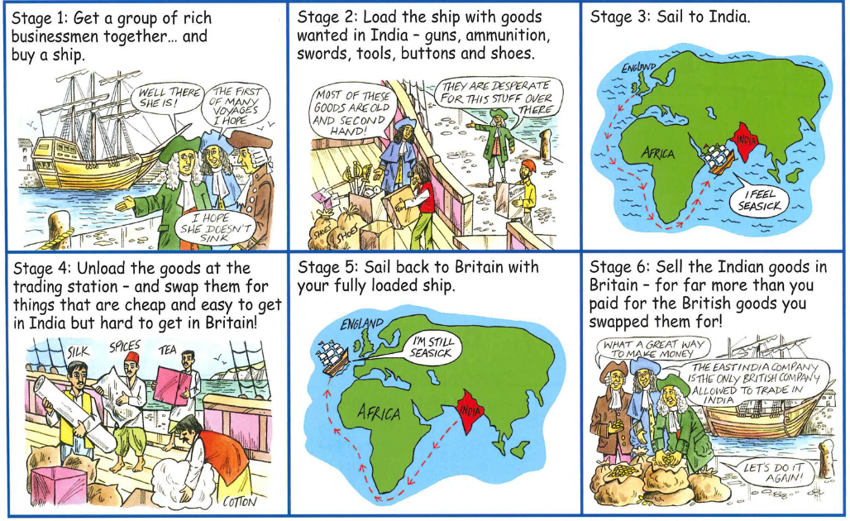

Which emperors ruled India at the start of the 1800s? __________________________________________
_______________________________________________________________________________________
When was the British Raj established? What was this? _________________________________________
_______________________________________________________________________________________
What spices were traded in India? __________________________________________________________
_______________________________________________________________________________________
Which countries did Britain compete with for Indian trade? What did this lead to? __________________
_______________________________________________________________________________________
Why was Britain interested in the trade in India? Why might they want to get even more control? _____
_______________________________________________________________________________________
_______________________________________________________________________________________

Despite all the profit in trade, Britain did not attempt to conquer all of India until later in the 18th century. The attempt colonise India fully was a result of activities in the rest of the British Empire which resulted in a shift of attention from the west towards the East.

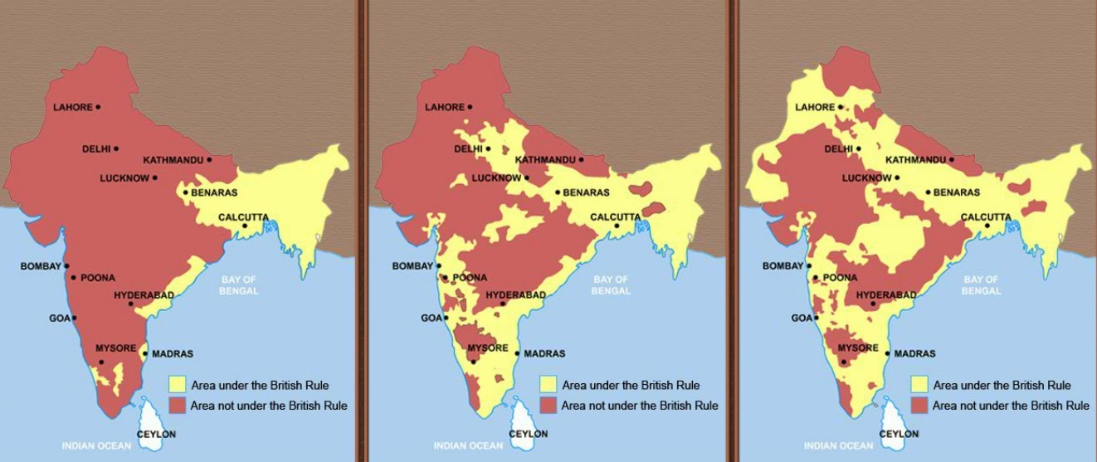
Perhaps one of the most important reasons for the shift of focus being to the Indian subcontinent was the American War of Independence. Due to a number of grievances from the American public (including taxation being too high and lack of representation in British parliament) the American people went to war with the British government in 1776. This war, known as the American War of Independence, lasted until 1783 and ended with the loss of America from the British Empire and the creation of the free United States of America. Britain had relied on the natural resources from the Empire to feed the Industrial Revolution which had begun in the 1700s. Britain needed to find a new area to colonise which was rich in natural resources which would help boost the power of the Empire after the loss of its richest colony, America. A private company, the British East India Company, was given free rein to take over land in India for the profit and power of the British Empire. Over the next few decades the British East India Company conquered from most of India moving from east to west.

What does the image tell us about the British conquest of India? _________________________________
_______________________________________________________________________________________
_______________________________________________________________________________________
Explain why the British began to colonise the Indian subcontinent. Think about what was in India that the British wanted and what had happened in the rest of the British Empire.
_______________________________________________________________________________________
_______________________________________________________________________________________
_______________________________________________________________________________________
_______________________________________________________________________________________
_______________________________________________________________________________________
_______________________________________________________________________________________

How did Mughal India rise and then fall?
Year 8 worksheet. Student name: _____________________________ Date: __________

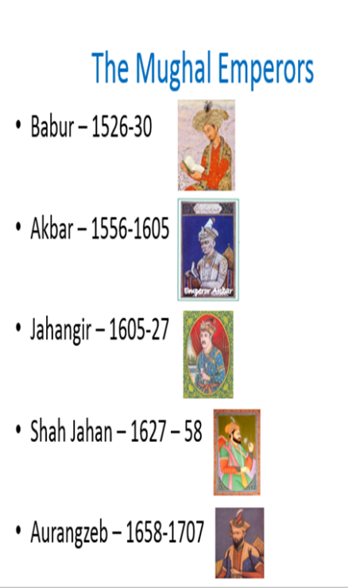
The Mughals ruled India for about 150 years during the 16th and 17th centuries.
The Mughals failed because they made little, if any, effort to drag India out of the Middle Ages. Akbar, the greatest of the Mughal emperors, was the only exception. He was a man of extraordinary vision; a Muslim who took a keen interest in the Hindu and Christian faiths and devised what was, to all intents and purposes, his own religion.
However, the Mughals were unable to create a peaceful transition from one ruler to another.
This meant that under Aurangzeb, Hindu temples were demolished and the hated Jizya – a poll tax on all who were not Muslims – re-imposed. This led to the demise of the Empire.
While this was going on the European countries like Britain started to take advantage of the division and took over large areas of land.

Timeline of Mughal India
- The Mughal Empire, in India, was founded by Babur 1526-30, a Central Asian ruler. He expanded his territory around Asia and strengthened the empire within India.
- Babur’s son, Humayun (1530-1556), who was driven out of India and into Persia by rebels, showing that things were not stable. Humayun made a triumphant return from Persia in 1555.
- Akbar created a modern government, and supported cultural developments. Akbar allowed free expression of religion.
- Under Akbar, the empire's economy became strong and stable and he traded with Europe. They bought were gold/silver, silk, precious stones, drugs, china goods, and European wines. They sold cotton cloth to Europe, spices, sugar, textiles etc.
- Akbar's son, Jahangir (1605-1627), ruled the empire at its peak, but he was addicted to opium (a drug) and didn’t rule very well.
- Jahangir did increase the size Mughal Empire, got rid of opponents and released lots of prisoners.
- During the reign of Jahangir's son, Shah Jahan (1627-1658), Mughal architecture became well known and was very impressive such as the most famous Mughal monument, the Taj Mahal. These new buildings were a great blend of Islamic, Persian, and Indian architecture. This cost a lot of money though and people hated paying more tax.
- During Aurangzeb’s (Shah Jahan’s son) reign (1658-1707) he expanded the empire to include almost the whole of South Asia.
- Aurangzeb was a strict Muslim and picked on the followers of India’s other religions (Hindus and Sikhs). As wars broke out all over India, the Mughals started to lose control over India.
- In the 12 years after Aurangzeb’s death in 1707, there were 10 emperors – they were weak and the princes stopped sending as much tax to the emperors.

- During the reign of Muhammad Shah (1719-1739), the empire began to break up, and the Mughals lost lots of land in India. The princes started to break away to form independent kingdoms.
- Many European’s like the Dutch, French and British realised that by helping certain princes (giving them weapons and soldiers etc.) they could turn the wars anyway they wanted. When their new ally beat their enemy, the Europeans would demand rewards like land and goods. If they fell out with the prince they just took his land from him – so the Europeans gained land in India.
- In 1739, Nader Shah, a Persian leader, invaded the Mughal Empire, and defeated Muhammad Shah during the Battle of Karnal in less than three hours. His army took a lot of the northern regions of the empire.
- Nader's Indian campaign alerted, the British East India Company to the weakness of the Mughal Empire and the possibility of expanding the territory they controlled.
- By the 1750s the East India Company had its own army to protect their trade goods. In 1757 they won a victory at the Battle of Plassey and they took over Bengal in India.
- By the 1780s Britain had a lot of influence over all of the rulers of the southeast coast of India. They also ruled Bengal. Bengal's large population and wealthy princes offered many opportunities for the British East India Company to trade spices and textiles and they built up their wealth and their military power there.
- As the East India Company took over more and more of India, it appointed Governor-Generals to rule.
TASK
Akbar is considered the greatest Mughal emperor. How did his reign benefit India? __________________
_______________________________________________________________________________________
_______________________________________________________________________________________
Why did Aurengzeb begin to lose control of India? _____________________________________________ _______________________________________________________________________________________
_______________________________________________________________________________________
What battle led to the British beginning to take over India from Bengal? ___________________________
What were the main reasons why the empire rose and grew? ____________________________________ _______________________________________________________________________________________
When was it the strongest? ________________________________________________________________
_______________________________________________________________________________________
What were the main reasons why the empire declined? ________________________________________
_______________________________________________________________________________________
What is the most important reason why it weakened? _________________________________________
_______________________________________________________________________________________

How were the British able to colonise India?
Year 8 worksheet. Student name: _____________________________ Date: __________
The British presence in India began through trade. Men like Robert Clive, of the British East India Company, combined military prowess with a ruthless ambition, and became fabulously wealthy. With wealth came power, and traders took control of huge swathes of India.
http://www.bbc.co.uk/education/clips/zjy7pv4
Watch the clip
Who were the East India Company? _________________________________________________________
_______________________________________________________________________________________
In 1738, Nadir Shah, the leader of Iran, invaded India and defeated the Mughals. The Mughal rulers were badly defeated and that signalled to the world that India was very weak. The East India Company immediately made use of the weakness. The timing was key. | India had plenty of infighting; it was clearly not a unified Empire. For instance, Tipu Sultan, who offered ferocious resistance against the British was undermined by his own people. | British troops were well organized and used superior tactical & strategic skills to defeat any opposition in India
- The French, who often competed with Britain for colonies in Spain, Portugal and the United Province, were distracted by the French revolution and later the defeat of Napoleon in 1815. | - By the 18th century, India was in crisis. Aurangzeb's rule was quite bitter for non-Muslims and the Hindus were tired of Islamic rule. This gave rise to many Hindu Kings (such as the Marathas). The East India Company rightly used this period to increase the divisions with their divide and rule policy. | India had a very weak navy. Unlike islands like Britain or Japan, India didn't have a strong incentive to build a strong navy. Naval superiority helped the British to gain and build the critical ports of India (Bombay, Madras, Calcutta) and build the empire from there.
- Britain was entering the age of Industrial Revolution at around the same time (1750) when Indian empires were weakened. The economic strength from the Industrial Revolution gave the Britain an upper hand. | By the 1750s, Britain had become much more religiously tolerant. Under King George II, there was a strong government, with William Pitt the Younger as Prime Minister. | Britain had a hunger to expand its empire. Not only did Robert Clive secure the Indian continent for Britain at the Battle of Plassey (1757), but also General Wolfe captured Quebec in Canada in 1759. In addition, the East India Company already knew India well enough (through trade links) to know that there would be disorganised opposition – it was an easy target.
How did they take control of India? _________________________________________________________ _______________________________________________________________________________________
Label the information cards from 1-9 in order of importance in explaining why the British were able to conquer India from the Mughal Empire.

Which factor did you choose as the most important? Explain why ________________________________
_______________________________________________________________________________________
_______________________________________________________________________________________
_______________________________________________________________________________________
_______________________________________________________________________________________
_______________________________________________________________________________________
_______________________________________________________________________________________
_______________________________________________________________________________________
Which factor did you choose as the least important? Explain why ________________________________
_______________________________________________________________________________________
_______________________________________________________________________________________
_______________________________________________________________________________________
_______________________________________________________________________________________
_______________________________________________________________________________________
_______________________________________________________________________________________
_______________________________________________________________________________________

Think back to what you know about the Mughal Empire and its popularity. How do you think the British will change India? Do you think they will be more or less popular? Explain why.
_______________________________________________________________________________________
_______________________________________________________________________________________
_______________________________________________________________________________________
_______________________________________________________________________________________
_______________________________________________________________________________________
_______________________________________________________________________________________
______________________________________________________________________________________________________________________________________________________________________________

Why did the Sepoys mutiny in 1857?
Year 8 worksheet. Student name: _____________________________ Date: __________

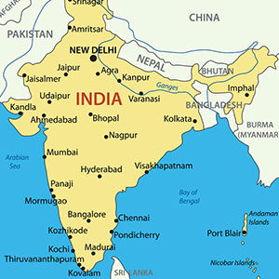
In 1857 there was a major rebellion in northern India by Hindu and Muslim sepoys. Some historians consider this a national uprising against British rule.
The British responded harshly, ending the rebellion in just 2 years with few casualties of their own.
Britain committed atrocities during this rebellion that affected rule in India until the end of British rule.
People often say that a new rifle used by the British army caused the mutiny.
There was a rumour that the rifle used cartridges lined with cow or pig fat. In order to use the cartridges you had to literally bite the bullet out of them.
Areas most affected
This would have been offensive to both Muslims (who don’t eat anything from a pig) and Hindus (who consider cows sacred)
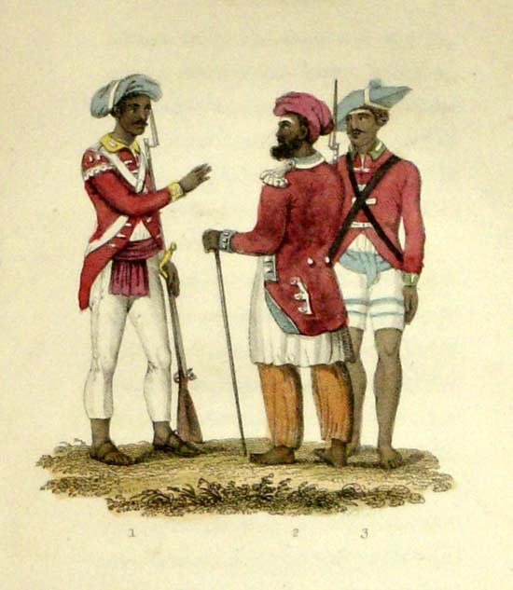
Causes of the Indian Mutiny
In 1857, the British East India Company faced an enormous rebellion in India. It began among the Indian troops in the army (the Sepoys), who rebelled for many reasons.
Firstly, the East India Company and many British rulers in India did not seem to respect the traditional Indian values and way of life. They started to introduce new laws, new technology and tried to force Christianity upon the Indian people.
Also, the British wanted to conquer more lands in India. To conquer these lands, the British used the Sepoy army. The Sepoys found themselves fighting against fellow Indians. They didn’t have much reason to feel loyal to their British commanders.
Indian soldiers in the British army, known as Sepoys
In the lands that they controlled, the British demanded high taxes and rents of ordinary Indians. This meant that millions of Indians died in terrible famines. Millions more had their land taken off them.
The British were accused of using violence and torture to keep control and collect the taxes. An investigation was set up to see if this was true. However, during the three months of the investigation people with complaints about the British were not allowed to leave their homes.

The final spark came with the introduction of the Lee Enfield Rifle to the army. Loading it involved biting the end off of the cartridge, which was supposedly lubricated with beef and pork fat. Hindus saw cows as sacred and Muslims saw pigs as unclean. Soldiers refused to use the rifle.
The Sepoy rebellion spread quickly. It involved many battles. It took fierce fighting and over a year for the British to regain control. Anyone suspected of being involved in the rebellion was treated harshly: many were tied to cannons and blown to pieces.
The Victorians played down the importance of the rebellion. They called it a ‘mutiny’ (a rebellion limited to the army). Modern historians see the rebellion as very important and the start of Indian resistance to British rule.
Read the information
Make a list of all the evidence that the Sepoy mutiny was caused by these 3 categories.
Religious causes | Economic causes | Social causes
e.g. - The introduction of the Lee Enfield Rifle, the ammo was supposedly coated with animal fat.

After two years of fighting, the ‘Indian Mutiny’ was eventually over. The ‘Mutiny’ had failed. Hundreds of thousands of Indians had died – most of them civilians.
The Government of India Act was passed in 1858, ending the rule of the East India Company. India was now officially property of Queen Victoria. Power passed to a new India Department and a British viceroy.
The number of British soldiers in India was increased.
“The rumour that the new rifle cartridges used animal grease
was the most important cause of the Sepoy Mutiny.”
TASK:
How far do you agree with the statement about the mutiny?
POINT
I agree/don’t agree with the statement because...
EVIDENCE
Evidence that supports the statement is...
Evidence that disagrees with the statement is...
EXPLAIN
This shows that the main cause of the mutiny was...
Write a paragraph that includes evidence that SUPPORTS and DISAGREES with the statement.

Causes of the ‘Indian Mutiny’
- The Sepoys believed the new rifle cartridges contained animal grease.
- Fear that traditional Indian religions would be replaced by Christianity.
- Soldiers were unhappy fighting for the British against Indians.
- British trade was ruining Indian trade.
- No Indians were employed in senior jobs such as judges or army officers.
- The British did not respect or understand Indian ways.
- The British simply wanted to build an empire to increase power. They thought they were superior to the Indians and treated them terribly.

_______________________________________________________________________________________
_______________________________________________________________________________________
_______________________________________________________________________________________
_______________________________________________________________________________________
_______________________________________________________________________________________
_______________________________________________________________________________________
_______________________________________________________________________________________
_______________________________________________________________________________________
_______________________________________________________________________________________
_______________________________________________________________________________________
_______________________________________________________________________________________
_______________________________________________________________________________________
_______________________________________________________________________________________
_______________________________________________________________________________________
_______________________________________________________________________________________

Does Britain “owe” India?
Year 8 worksheet. Student name: _____________________________ Date: __________
What does Shashi Tharoor think India deserves from Britain?

_____________________________________________________________________________________________
As far as I am concerned, the ability to acknowledge your wrong that has been done, to simply say sorry will go a far, far, far, longer way than some percentage of GDP in the form of aid.
What is required it seems to me is accepting the principle that reparations are owed. Personally, I will be quite happy if it was one pound a year for the next 200 years after the last 200 years of Britain in India.
- Shashi Tharoor (2015)

Why do you think some people agree with Tharoor?

________________________________________________________________________________________________________________________________________________________________________

Over the 200 years of British rule had a massive impact on India.
Read the information on how Britain impacted India during the rule of the Empire and write the headings and a few notes in this table. (Information on the next page)
Good for India | Bad for India

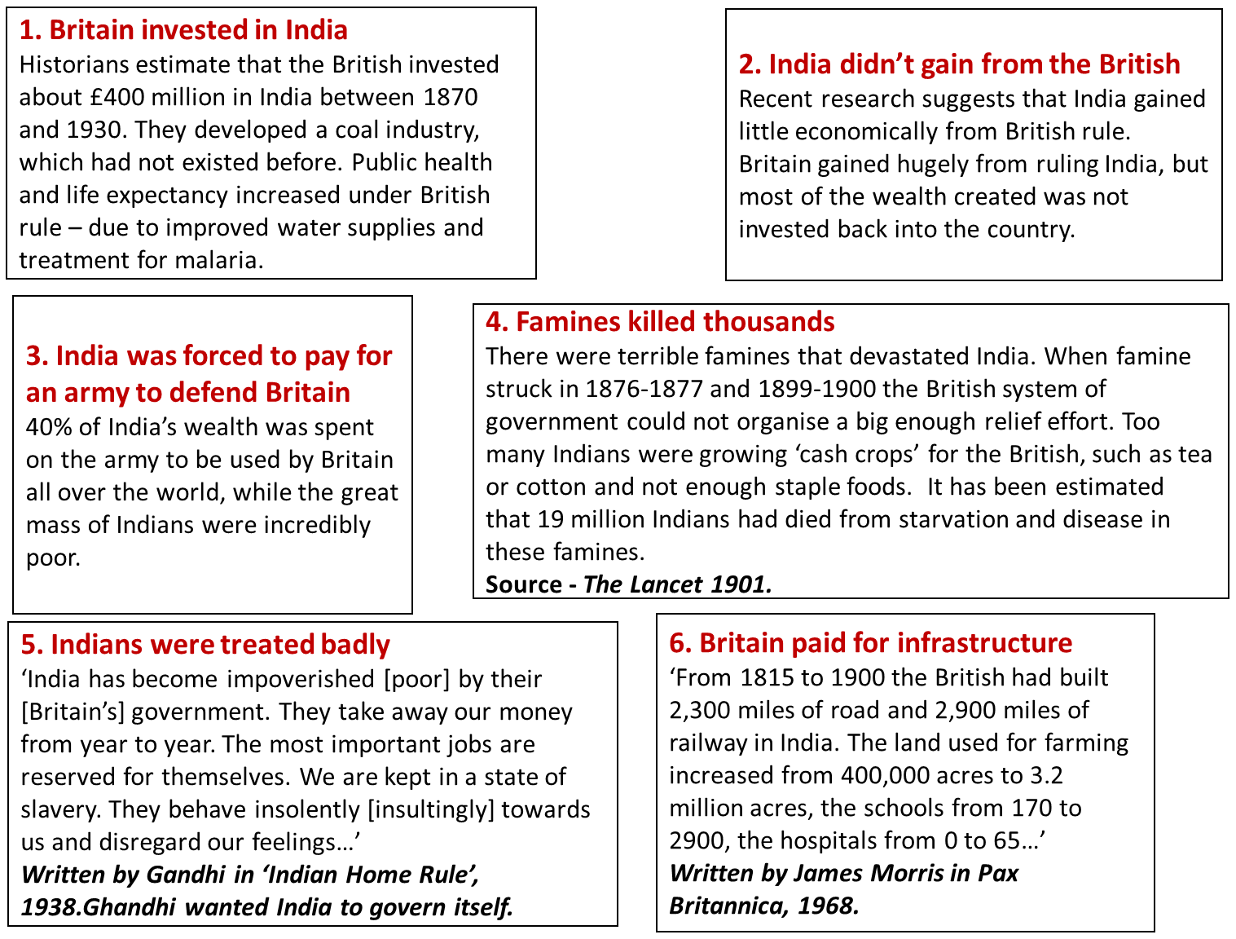
Source A – Niall Ferguson, Empire, 2003
“the colonial burden [of Britain] as measured by the trade surplus of the colony - amounted to little more than 1 per cent of Indian net domestic product a year between 1868 and 1930. That was a lot less than the Dutch 'drained' from their Indonesian empire, which amounted to between 7 and 10 per cent of Indonesian net domestic produce in the same period.
And on the other side of the balance sheet were the immense British investments in Indian infrastructure, irrigation and industry. By the 1880s the British had invested £270 million in India, not much less than one-fifth of their entire investment overseas. ... The British increased the area of irrigated (farmed) land by a factor of eight, so that by the end of the Raj a quarter of all land was irrigated, compared with just 5 per cent of it under the Mughals.
They created an Indian coal industry from scratch which by 1914 produced nearly 16 million tons a year. They increased the number of jute spindles by a factor of ten. There were also marked improvements in public health, which increased the Indian average life expectancy by eleven years.”

Read Source A and answer the questions.

How does Niall Ferguson say Britain improved India? ____________________________________________
_______________________________________________________________________________________
How much money did the British invest in India? _______________________________________________ _______________________________________________________________________________________
Source B – Shashi Tharoor, Inglorious Empire, 2016
“The India that the British East India Company conquered was no primitive of barren land, but the glittering jewel of the medieval world. At the beginning of the eighteenth-century India’s share of the world economy was 23 per cent, as large as all of Europe put together. By the time the British departed India, it had dropped to just over 3 per cent.
The East India Company presided over the destinies of more than 200 million people, determining their economic, social and political life, reshaping society and education, introducing railways and financing the inauguration of the Industrial Revolution in Britain. In power Britain were in a word, ruthless. They stopped paying for textiles and silk in pounds brought from Britain, preferring to pay from taxes extracted from Bengal, and pushing prices still lower. Many Indian textile weavers were forced into other jobs to support themselves.
The construction of Indian railways is often pointed to as one of the ways British colonialism benefited India, ignoring the obvious fact that many countries also built railways without having to go to the trouble and expense of being colonized to do so. The India railways system was a big colonial scam. The government guaranteed returns of 5% net per year, unavailable on any other investments. This was only possible because the government made up the shortfall from India, rather than its own taxes. As a result, each mile of Indian railways construction cost 18,000 against the equivalent £2,000 in the United States, with the Indian population paying the difference. All the losses were borne by the Indian people, all the gains pocketed by the British trader.”

Read source B and answer the questions

How does Shashi Tharoor say life got worse in India whilst the British ruled it? ______________________
_______________________________________________________________________________________
How does Tharoor say the British didn’t care about the Indians? _________________________________ _______________________________________________________________________________________
Was British rule good for India? Explain why using your knowledge and sources A and B to support your answer.
_______________________________________________________________________________________
_______________________________________________________________________________________
_______________________________________________________________________________________
_______________________________________________________________________________________
_______________________________________________________________________________________
_______________________________________________________________________________________
_______________________________________________________________________________________
_______________________________________________________________________________________
_______________________________________________________________________________________

