BQ: How significant was the British Empire for Britain?
LQ: What can the Highland Clearances reveal about the British Empire?
LO: To categorise Scottish emigration factors and compare this experience with that of Ireland.
Background information:
- In 1603 James VI of Scotland became King of England (James I) – he was the heir to Elizabeth I.
- He moved his court to London – after that the King of England was also the King of Scotland
- The Scottish supported King Charles I and tried to help his son Charles II get the throne (they were Catholics and did not want the Protestant parliament in charge). It didn’t work but eventually Charles II got the throne!
- On the 16th January 1707 the Act of Union was signed. The Scottish parliament was dissolved and England and Scotland became one country.
- The battle of Culloden (1746) was the last battle fought between Scotland and England.
- The English put down the Jacobites who supported Charles Edward Stewart (Bonnie Prince Charlie) claims for the throne.
- From 1750 to 1860 the Highlands experienced a large decrease in population.
- There were a number of factors involved in the “clearance” of these highland regions.

TASK ONE: Read the information on the worksheet and highlight whether the factors are push or pull using your key.
The Highlanders  Before 1755 over half the people of Scotland lived in the Highlands.  Most Highlanders spoke Gaelic, a language similar to Irish and were members of large organised clans.  Their culture and traditions were different from those of people in Lowland Scotland. Lowlanders in Scotland were more likely to support the English and be loyal to the British Empire.  Some in Britain were worried that the Highlanders would continue to support rebels against the British Monarchs, as they had in 1746 before the Battle of Culloden. | The Battle of Culloden  In 1746 a large army of Scottish Highlanders rebelled against British rule, led by Charles Edward Stewart, “Bonnie Prince Charlie”, who believed he should be king instead of George II. In the battle, the Highlanders were crushed.  After this battle the British made attacks on Highland civilians, executing clansmen and stealing their livestock of sheep and goats. This was intended to prevent the Highlanders ever rebelling again.  The British also passed laws banning important parts of Highland culture to encourage Highlanders to move to the lowlands and integrate with the British Empire.
Emigration within Britain  The Industrial Revolution was underway in English cities such as London, Liverpool, Manchester, Newcastle.  Imports from the British colonies around the world meant a constant supply of raw materials were coming in, and there was greater demand from an increasing population. So more workers were needed, providing the Scots with greater chances of employment. | Chieftains wanting sheep farms  They had farmed in the Highlands for generations and made money from selling vegetables from their crofts. Life had stayed the same for years.  The chieftains and the English landlords instead wanted to use this land for grazing sheep, as it would make more money. The only problem was they did not want to pay the clans for their land; they decided to take it instead, some chieftains forced Highlanders off their land to make room for the sheep.  Scottish clans living in the Highlands felt betrayed by their clan chieftains.
Agricultural Problems  Farming in the Highlands had always been more difficult than in the Lowlands. Despite this population had been growing for centuries.  During the 19th century there were a number of food shortages, most notably the Highland Potato Famine between 1846 and 1857, similar to the famine in Ireland.  Many landlords refused to help their tenants, preferring the land to be freed up so they could use it for profit. Many thousands were dying. As a result many poor Highlanders chose to leave for large Lowland cities, or even abroad, looking for work and food. | British Policies  In order to prevent the Highlanders rebelling again the British decided to weaken the clans as much as possible.  Many clans were forced to start living on land unsuitable for farming. This led to starvation and many leaving the country.  Highlanders were forced to sign contracts of loyalty to the English. Many were tricked into living on terrible land because they couldn’t understand the English in these contracts.  If Highlanders protested or refused to do as they were told the British, or even the clan leaders, would burn their houses down leaving them with nowhere to stay.

Emigration to America  Tickets to America were very cheap and many saw that as a more attractive prospect than living in the Highlands. Once the British passed laws preventing them from living their traditional lives (bagpipes and tartan were banned by the British!) and the clan leaders moved them out of their villages many stopped feeling any sort of attachment to the Highlands.  The job opportunities and chance to improve one’s lifestyle in Canada and North America were often advertised in Scottish towns. Thousands left for America and the promise of a better life. | Emigration to Australia  When Australia needed workers many Scots received ‘assisted immigration’, so the cost of passage on a ship was either paid for or massively reduced.  Between 1852 and 1857, the Highland Emigration Society responded to the Scottish potato blight by sending about 4910 Highlanders, to Australia. The society aimed ‘to promote measures for aiding persons in some parts of the Highlands, who desire to emigrate to the British Colonies, but who are prevented by the want of sufficient means’. Queen Victoria, help to fund the emigration by giving £300, and Prince Albert, also contributed £105.

Key
Push Factors
Pull Factors

Task 2:
The main reason for people leaving Scotland was Push/Pull factors (circle chosen option). These factors are more important for explaining why Scottish people left because ……………………………………………………….
…………………………………………………………………………………………………………………………………………………………...…….……………………………………………………………………………………………………………………………………………………...............
…………………………………………………………………………………………………………………………………………………………..........
…………………………………………………………………………………………………………………………………………………………..........
…………………………………………………………………………………………………………………………………………………………..........
…………………………………………………………………………………………………………………………………………………………..........
…………………………………………………………………………………………………………………………………………………………..........
…………………………………………………………………………………………………………………………………………………………..........
…………………………………………………………………………………………………………………………………………………………...
…………………………………………………………………………………………………………………………………………………………...
…………………………………………………………………………………………………………………………………………………………...

TASK THREE: Answer the following:
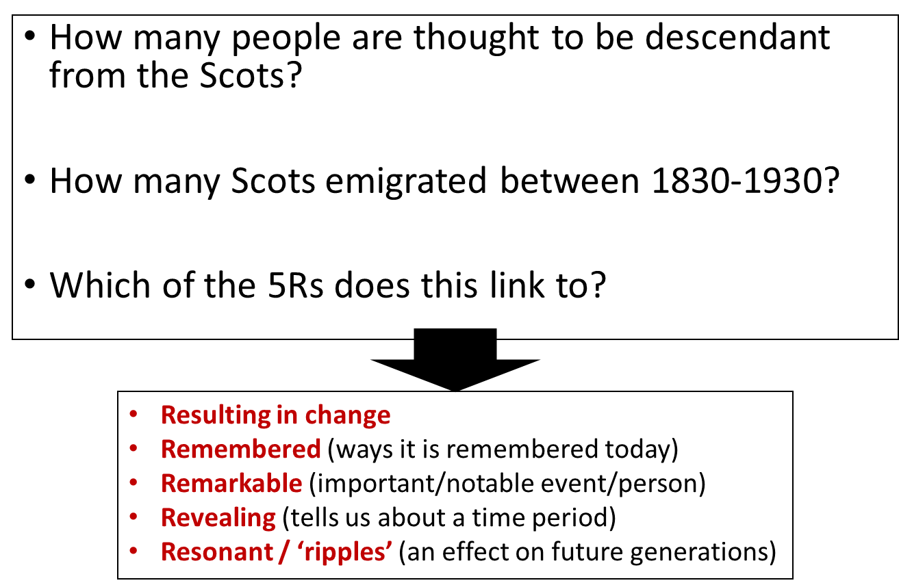
- Although there were no military revolts – people still protested.
- In 1885 – the post of Secretary Scotland was made available – this meant that someone was in charge of administering central government functions in Scotland.
- This stopped most protests.
- In 1928 the Scottish National Party was created.
- A vote for devolution kept the union in 1979.
- In 1997 – Scotland were given the right to set up their own parliament and raise their own taxes.
- The Scottish National Party has lots of support – a vote on devolution in 2014 kept the union between Scotland and England.
TASK FOUR: Answer the question in PEE: Who was treated worse by Britain throughout the 1800s, the Irish or Scottish?
________________________________________________________________________________________________________________________________________________________________________________________________________________________________________________________________________________________________________________________________________________________________________________________________________________________________________________________________________________________________________________________________________________________________________________________________________________________________________________________________________________________________________________________________________________________________________________________________________________________________________________________________________________________________________________________________________________________________________________________________________________________

