BQ: How significant was the British Empire for Britain?
LQ: Why did the Irish leave Ireland?
LO: To explain the push and pull factors causing people to emigrate from Ireland in the 1840s make links between them.

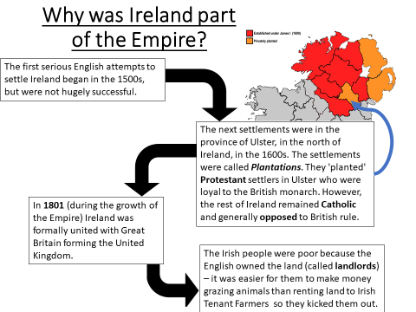

Between 1845 and 1850 1 million Irish left the country, mostly going to Britain and the USA.
In order to work out why these people left we need to know why people migrate from one place to another.
We can categorize these reasons as push and pull factors.
Push Factor
A factor which explains why people decide to leave somewhere, usually because they strongly dislike it.
Pull Factor
A factor which explains why people would want to move to somewhere, usually because they strongly want it.

TASK TWO: For each factor, place it in the box you think it most belongs in.
Push (pushing people out) | Pull (pulling people away)

- Community: There were large communities of Irish people living in big cities in North America including Toronto and Ontario in Canada, and Boston and New York. They provided food and money for Irish people arriving in their cities.
- Food Supply: The British Government imported grain from Canada to help the starving. But rather than giving the grain away, the government sold it. Irish peasants could rarely afford this.
- Potatoes: More than one-third of Irish people ate nothing but potatoes. From 1845 to 1849 the potato crop was destroyed by a fungus. Between 1.1 million and 1.5 million Irish people died of famine.
- Land: Most of the land in Ireland was owned by a small number of people. The large majority of Irish people had little chance of owning more than a tiny plot of land.
- Work: Lancashire and Yorkshire in England were attractive places to move because there was plenty of work in the factories and fields thanks to the Industrial Revolution.
- Transport: Transport on ships (known as ‘coffin ships’) to America was very cheap. In the 1840s it cost just half a penny to travel from Cork to London.
- Government: In 1846 the British government tried to help the starving people in Ireland by providing work such as mending roads through public work schemes. In February 1847 the government set up around 600 soup kitchens but in late 1847 they were closed.
- Landlords: Some landlords were kind to their starving tenants giving them food and not making them pay their rents. Other landlords were not so kind, throwing their tenants out of their houses in what is known as ‘eviction’.
- Railways: Railways were being built across Britain and America in the 1840s. There was plenty of work for railways labourers, who became known as ‘navvies’.
- Youth: Young people in particular could find work in America and could send money back to Ireland to help their relatives.

TASK THREE: Decide which of these push and pull factors was the most important and explain why. Think about which factors are LINKED and how.
__________________________________________________________________________________________________________________________________________________________________________________________________________________________________________________________________________________________________________________________________________________________________________________________________________________________________________________________________________________________________________________________________________________________________________________________

TASK FOUR: Explain: What do these sources show us about the British Empire’s treatment of the Irish?
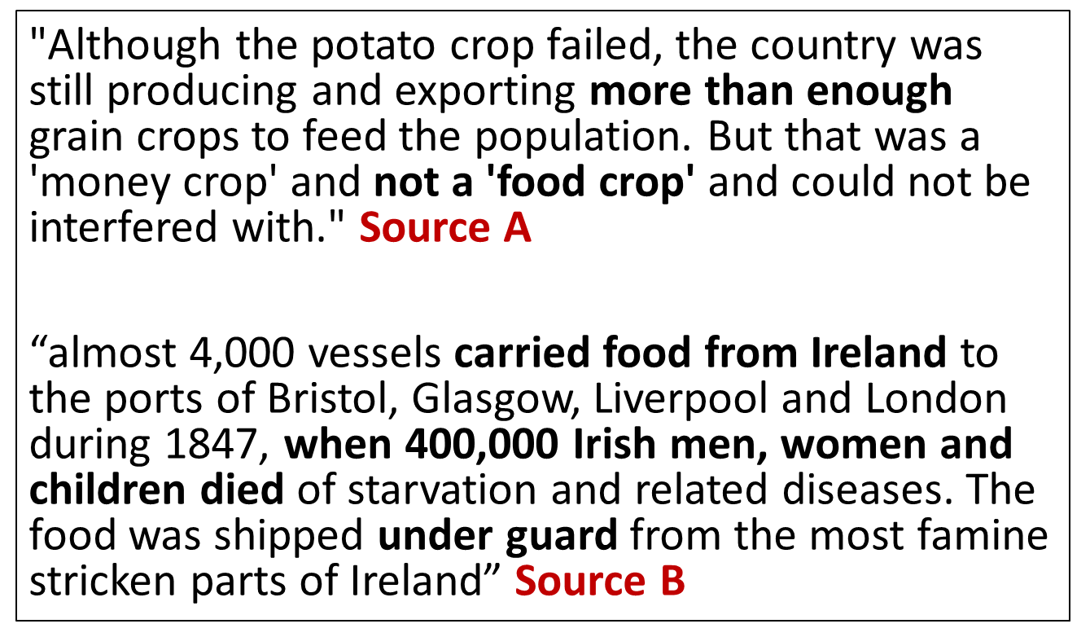
____________________________________________________________________________________________________________________________________________________________________________________________________________________________________________________________________________________________________________________________________________________________________________________________________________________________________________________________________________________________________________________________________________________________________________________________________________________________________________________________________________________________________________________________________________________________________________________________________________________________________________________________________________________________________________________________________________________________________________________________________________________________________________________________________________________________________________________________________________________________________________________
BACKGROUND – The end of Britain in Ireland – Read and highlight:
- By the 1880s Irish resistance to British rule was becoming more effective, mainly because it was using democratic methods.
- The Irish Home Rule Party campaigned for Home Rule for Ireland. This meant Ireland would still be part of the British Empire, but it would have its own Parliament.
- The vast majority of Irish Catholics and some wealthy Protestants (who thought they would run an Irish Parliament) supported Home Rule - they thought an Irish Parliament would treat them better than a Parliament based in London.
- There were a large number of people in Ireland who wanted to keep the Union between Britain and Ireland. Most of these Unionists lived in Ulster.

- Many British MPs felt that if Ireland got Home Rule then the rest of the British Empire would fall apart. If they gave Ireland Home Rule, why should they not give India Home Rule too? The requests failed!
- At the end of WW1 Sinn Fein won all the election seats outside of Ulster.
- The IRA Irish Republican Army – IRA – started to fight the British
- Eventually a treaty was drawn up – the south of Ireland (mostly Catholic) was to be a Dominion like Canada
- Ireland became a republic in 1949 and Northern Ireland remains part of the United Kingdom.

TASK FIVE: Answer the following:
- Why did the Irish choose to leave Ireland? _____________________________________________________
________________________________________________________________________________________________________________________________________________________________________________
- What drew the Irish to move to America? ______________________________________________________
________________________________________________________________________________________________________________________________________________________________________________
- In what ways might historians consider the Irish Famine ‘Significant’? (Think about the 5 Rs) _____________
________________________________________________________________________________________________________________________________________________________________________________________________________________________________________________________________________

