Big question: How powerful were medieval monarchs?
LO: to review medieval monarchs and begin to make a judgement on the changes in their power
STARTER: Who are the kings we have looked at so far? How did their power change during their reigns?
- _______________
- _______________
- _______________
- _______________
- _______________
- _______________
- _______________
TASK ONE: Match up the key words to the definition.
A. Monarch | 1. Belonging by rank, title, or birth to the aristocracy.
B. Heir | 2. Having a different religion to the king or queen.
C. Pope | 3. A very large, usually stone, building used for Christian worship.
D. Heresy | 4. Tax levied on every adult, no matter how much they earned.
E. Poll tax | 5. Document that the barons forced John to sign giving him new rules.
F. Cathedral | 6. A king or queen.
G. Noble | 7. The leader of the Roman Catholic Church.
H. Magna Carta | 8. Next in line to the throne; to be king or queen after the current ruler.

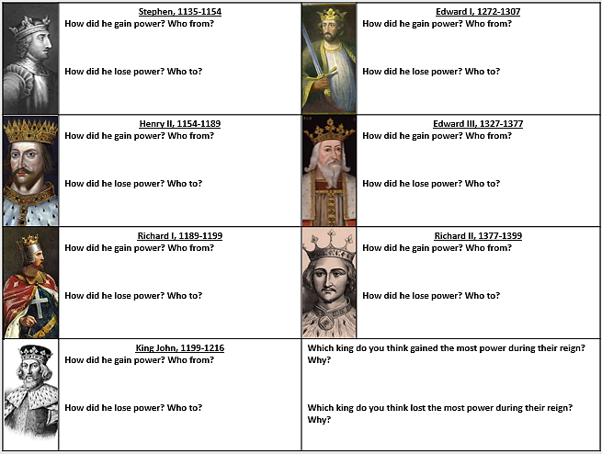
TASK TWO: Using links on SMHW, notes from homework / books (if you have them) fill in the overview sheet.
TASK THREE: Use the topic toolbox to revise the monarchs. Complete one of the tasks at the bottom.
History: Monarchs in Control: Topic toolbox

Monarchs in Control key words
1 | Monarch | The king or the queen
2 | Democracy | Government by the whole population e.g. people voting for who is in charge
3 | Feudal system | The way in which people received land in return for some sort of work
4 | Heresy | Beliefs which are not allowed by the Church
The Medieval church
5 | In the Medieval period nearly everyone belonged to the Catholic Church.
6 | It was made up of the Pope (the leader); Archbishops and Bishops (local leader, rich and powerful, advised kings) and Priests (poor, worked very hard).
7 | The church didn’t just control people’s land, money and behaviour: it also tried to control their beliefs as well.
Monarchs of England
8 | Stephen claimed the throne instead of Matilda. He was captured, but was traded for her brother in law. He stayed king until he died.
9 | Henry II fell out with his Archbishop, Thomas Beckett, which ended with Beckett being killed.
10 | Richard I went on many crusades and spent most of his time outside of England. He said he would have sold London if someone had offered him enough money.
11 | John I signed a document called the Magna Carta because of the demands of his barons. This gave the barons more power. He is remembered very negatively.
12 | Edward I took over the running of the country from a young age and was hugely successful in battle, often called a bully. He conquered Wales and put down a Scottish rebellion.
13 | Edward III succeeded in some war with France, but suffered from being very unpopular due to the Black Death and new laws limiting workers’ wages.
14 | Richard II took the throne at age 9 and was king during the Peasant’s Revolt, where the peasants marched on London because of the new Poll Tax.
15 | People believed the plague was caused by bad air (‘miasma’), witches poisoning them and from God being upset with them.

What can you do for a topic toolbox homework? You need to revise by completing one of the tasks and bringing it in.
You only need to do one of these tasks. Try each one and reflect on how will you did in the facts test just after it. Some methods might work better for you than others! Bring in your work.
- Look, cover, write, check – read the fact, cover it up, write it out, then check if you were right. If you didn’t get it all right (including spelling!) look, cover and write it again.
- Create a quiz with the information.
- Make a mind-map, especially if the information has different categories.
- Get a parent or guardian to test you. If you do this, they must write in your book and sign it, stating who they are (Dad, Gran, etc), how many you got right, how many times they tested you.

