Big Question: How did extremism spread across the world?
Little Question: What is extremism and what does it mean?
LO: to understand and explain the nature of extremism and how it developed globally after World War One
TASK – Consider: what happened at the end of World War One that might create issues in Europe?
- ________________________________________
- ________________________________________
- ________________________________________
- ________________________________________
- ________________________________________
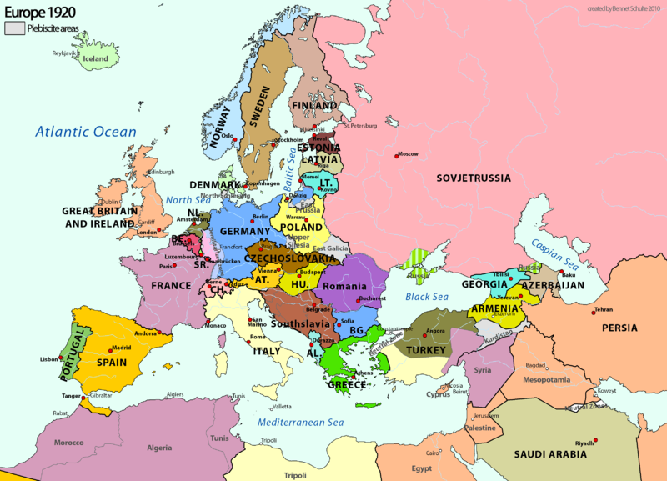
- ________________________________________

After World War One there were many issues in Europe. Many countries were struggling to recover from their war debt (the cost of war had been very high) and the mortality rate was at a level that had never been seen in any kind of warfare up to that point. People were struggling, and this led to many political, social and economic issues.
As a result of this, many extremist groups began to develop due to dissatisfaction with how their governments were running their countries.

Two major extremist groups that developed globally:
Fascism | Communism
- Fascism is a form of government that is a type of one-party dictatorship.  - They aim is to prepare the nation for armed conflict, and to respond to economic difficulties.  - It puts nation and often race above the individual.  - It stands for a centralised government headed by a dictator.  - Historically, fascist governments tend to be autocratic, militaristic, and racist. | - Communism is a political and economic ideology that positions itself in opposition to capitalism.  - Communists want a classless system (no upper/middle/lower classes).  - They want means of production to be owned by everyone.  - Says everyone should contribute to society based on their ability.  - Argues the state should control everything and should share it with everyone equally.

Key words:
- Dictator – form of government where one person or political party has the power to do whatever they want. The ruler is called a dictator.
- Centralised government – form of government is one in which all power is held by a single authority or by a group of people.
- Autocratic – a single person has all legal and political power, and makes all decisions by himself or herself.
- Militaristic – a view on society that says society should be like the military.
- One-party - form of government where the country is ruled by a single political party, meaning only one political party exists and the forming of other political parties is forbidden.
- Capitalism - economic and political system in which a country's trade and industry are controlled by private owners for profit, rather than by the state.
- Means of production - the facilities and resources for producing goods (e.g. raw materials, facilities, machinery and tools).
Task – What are the differences between Fascism and Communism?
____________________________________________________________________________________________________________________________________________________________________________________________________________________________________________________________________________________
Task: What countries do you already associate with these ideologies?
_____________________________________________________________________
__________________________________________________________________________________________________________________________________________
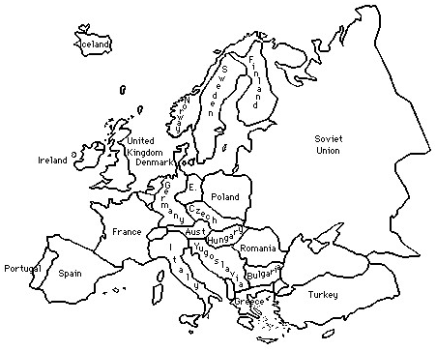
Task – using the information below, colour-code or label the map with which ideology you think became most prominent in that country.
- Soviet Union/Russia – Had a communist revolution in 1917, removing the Tsar and replacing him with a communist government. Ended in 1991.
- Germany – Had a communist uprising in 1919, led by a group called the Spartacists, which ultimately failed. In 1933 the fascist leader, Adolf Hitler, became Chancellor and, later, dictator (Fuhrer). Ended in 1915.
- Italy – Benito Mussolini took power in Italy and made it into a fascist dictatorship. Ended 1947.
- Austria – Hitler unified with Austria in 1938, bringing it under his dictatorship.
- Portugal – Had many fascist aspects, but their leader, Antonio Salazar, said they were not fascist in ideology. Ended around 1968.
- Romania – had many regimes that were inspired by or took ideas from fascism. Ended 1941.
- Poland – Originally invaded by Hitler, it was later controlled by the Soviet Union. It became one of the Soviet Union’s states and part of their ‘Eastern Bloc’ (a group of countries controlled by/managed by the Soviet Union). Became independent in 1993.
- Hungary - Originally invaded by Hitler, it was later controlled by the Soviet Union. It became one of the Soviet Union’s states and part of their ‘Eastern Bloc’. Ended 1991.
- Czechoslovakia – Became one of the Soviet Union’s states and part of their ‘Eastern Bloc’. Ended 1993.
- Spain – When Francisco Franco took control of Spain in 1936 he transformed it into something close to a fascist dictatorship. Ended 1975.

What do you think the consequences of these changes in Europe might be?
Consider: what might happen to the relations between different countries? Is peace guaranteed? What do you already know is going to happen in the future?
_____________________________________________________________________________________________________________________________________________________________________________________________________________________________________________________________________________________________________________________________________________________________________________________________________________________________________________________________________________________________________________________________________________________________________________________________________________________________________________

