Wavell School-GCSE History
Paper 1: Medicine Through Time
Class Revision Booklet

Name:
Class:
Teachers name:
Classroom:

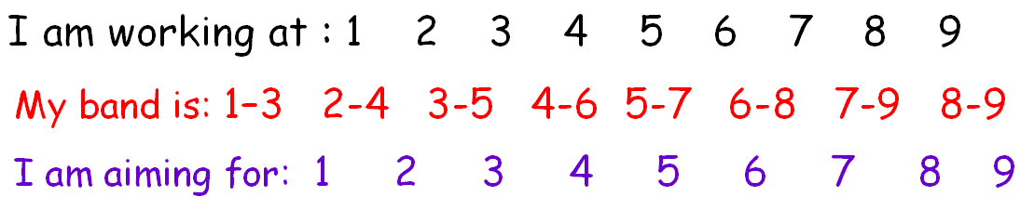
Medicine | Timing – Paper =1 hr 15 mins | With 25% Extra Time = Approx. 1hr 34mins
Q1 – 4 marks | -5 mins | -7 mins
Q2A – 8marks | -15 mins | -18 mns
Q2B – 4 marks | -5mins | -7 mins
Q3 - 4 marks | -5 mins | -7 mins
Q4 – 12 marks | -15 mins | -18 mins
Q5/6 – 16 marks (+4 SPaG) | -30 mins | -37 mins

My Mock Feedback and my Cold War/Anglo-Saxon assessment feedback:

Keywords

Medicine in Medieval England c.1250-c.1500
Miasma – Smells from decomposing material which were believed to cause disease
Four Humours – The Ancient Greeks believed the body contained four Humours of liquid; blood, phlegm, black bile and yellow bile
Physicians – A doctor of medicine who was trained at university
Apothecary – A pharmacist or chemist
Barber Surgeon - One of the most common medical practitioners of medieval Europe
Amputation – The removal of a limb by surgery
Privies – Toilets, usually public toilets outside of houses
Superstition – An unreasonable belief based on ignorance or sometimes fears
Pestilence – A fatal epidemic disease, also known as the plague
Blood-letting - the surgical removal of some of a patient's blood for therapeutic purposes
Purging - rid someone of an unwanted feeling, memory, or condition
Purifying the air – Ways that medieval people made the miasma disappear
Respect for tradition - due regard for long-standing feelings, wishes or customs
Bubonic Plague - the Black Death; a form of plague in humans,
Pneumonic Plague - a contagious bacterial disease - infection of the lungs
Buboes - a swollen inflamed lymph node in the armpit or groin
Epidemic – A widespread outbreak of disease
Flagellants - a person who subjects themselves or others to flogging
The Medical Renaissance in England c.1500-c.1700 Key words
Anatomy – The science of understanding the structure and make-up of the body
Physiology – The study of how the body works
Ligature – A thread used to tie a blood vessel during an operation
Cauterisation burning a part of a body to remove or close off a part of it e.g. blood vessels
Blood vessels - a tubular structure carrying blood through the tissues and organs; a vein, artery, or capillary
Diagnosis - identification of the nature of an illness /problem by examination of the symptoms
Printing Press - a machine for printing text or pictures
Circulation – the movement of blood around the body
Medicine in eighteenth and nineteenth-century Britain, c.1700-c.1900
Anaesthetics – A drug or drugs given to produce unconsciousness before and during surgery
Antiseptics – Chemicals used to destroy bacteria and prevent infection
Vaccinations – The injection into the body of killed or weakened organisms to give the body resistance against disease
Antibodies – A substance produced in the body to counter infections
Smallpox – A dangerous disease causing fever
Chloroform – A liquid whose vapour acts as an anaesthetic and produces unconsciousness
Tuberculosis - an infectious bacterial disease characterised by the growth of nodules (tubercles) in the tissues, especially the lungs
Typhoid - an infectious bacterial fever with an eruption of red spots on the chest and abdomen and severe intestinal irritation
Contagion – The passing of disease from one person to another
Inoculation – Putting a low dose of a disease into the body to help it fight against a more serious attack of the disease
Cesspit – A place for collecting and storing sewage
Dispensary – A place where medicines are given out
Voluntary hospitals – Hospitals supported by charitable donations
Workhouses – Accommodation for the poor who could no longer pay for or look after themselves.
Poor Law Unions – Local organisations set up to take care of the poor and unemployed
Sterilise – To destroy all living micro-organisms from surfaces and surgical instruments
Gangrene – the infection of dead tissue causing, in the case of gas gangrene, foul-smelling gas
Germ theory – The theory that germs cause disease, often by infection through air
Microbe – another name for a bacterium or micro-organism
c1900-present: Medicine in modern Britain
Penicillin – The first antibiotic drug produced from the mould of penicillium to treat infections
Anthrax – An infectious disease mostly affecting animals but occasionally people
Antibiotic – A drug made from bacteria that kills other bacteria and so cures an infection or illness
Bacteria – A tiny living organism, too small to be seen by the naked eye, which causes disease
Infection – The formation of disease-causing germs or micro-organisms
Septicaemia – Blood poisoning caused by the spread of bacteria from an infected area
Biochemistry - the branch of science concerned with the chemical processes and substances which occur within living organisms.
Polio – A contagious illness that can cause paralysis and death
Passive smoking- the involuntary inhaling of smoke
Immunotherapy – A method of treating disease by stimulating the body’s immune system to work more effectively
Radiotherapy – Treatment of a disease, such as cancer, by use of radium
Chemotherapy – Treatment of a disease, such as cancer, by the use of chemicals
Quarantined – Separated from the rest of the local population because of illness
The British Sector of the Western Front, 1914-18 surgery and treatment
Salient - most noticeable or important
Billets – Accommodation for soldiers
Trench foot - a painful condition of the feet caused by long immersion in cold water or mud and marked by blackening and death of surface tissue
Contagious - (of a disease) spread from one person or organism to another, typically by direct contact
Dysentery – A severe infection causing frequent, fluid bowel movements
Base Hospitals - a military hospital situated at some distance from the area of active operations during a war
Stretcher bearers - a person who helps to carry the sick or injured on stretchers, especially in time of war or at the scene of an accident
Triage – The system of splitting the wounded into groups according to who needs the most urgent attention
Tetanus – A disease in which muscles go rigid or into spasm which can lead to death
RAP – Regimental Aid Post
CCS – Casualty Clearing Station
VAD – Volunteer Aid Detachment
FANY – First Aid Nursing Yeomanry
RAMC – Royal Army Medical Corps
Aseptic surgery – Removal of germs from the operating theatre and as a result, strict hygiene soon became part of the operating theatre routine
Blood transfusions - an injection of a volume of blood, previously taken from a healthy person, into a patient.

Medicine Knowledge Audit - How confident are you? | Confident | Unsure | Not at all
C1250-c1500: Medicine in medieval England
Ideas about the cause of disease and illness:
- Supernatural and religious explanations of disease
- Rational explanations: the Theory of the Four Humours and the miasma theory; the continuing influence in England of Hippocrates and Galen.
Approaches to prevention and treatment:
How they connect to ideas about disease and illness -religious actions, bloodletting, purging, purifying the air and the use of remedies.
Approaches to prevention and treatment:
New and traditional approaches to hospital care in the 13th Century.
The role of – the physician, apothecary and barber surgeon in treatment.
Care provided within the community and hospitals.
Case study: Dealing with the Black Death, 1348-49: approaches to treatment and attempts to prevent its spread.
C1500-c1700: The Medical Renaissance in England
Ideas about the cause of disease and illness:
Continuity and change in the explanations of the cause and illness. A scientific approach, including the work of Thomas Sydenham in improving diagnosis. The influence of the printing press and the work of the Royal Society on the transmission of ideas.
Approaches to prevention and treatment:
Continuity in approaches to prevention, treatment and care in the community and in hospitals.
Change in care and treatment: improvements in medical training and the influence in England of the work of Vesalius.
Case study: Key individual: William Harvey and the discovery of the circulation of the blood.
Case study: Dealing with the Great Plague in London, 1665: approaches to treatment and attempts to prevent its spread.
C1700-1900: Medicine in 18th and 19th century Britain
Ideas about the cause of disease and illness:
Continuity and change in explanations of the cause of disease and illness. The influence in Britain of Pasteur’s Germ Theory and Koch’s work on microbes.
Approaches to prevention and treatment:
The extent of change in care and treatment: improvements in hospital care and the influence of Nightingale. The impact of anaesthetics and antiseptics on surgery.
New approaches to prevention: the development and use of vaccinations and the Public Health Act in 1875.
Case study: Key individual: Jenner and the development of a vaccination.
Case study: Fighting Cholera in London, 1854; attempts to prevent its spread; the significance of Snow and the Broad Street Pump.
C1900-present: Medicine in modern Britain
Ideas about the cause of disease and illness:
Advances in understanding the cause of illness and disease: the influence of genetic and lifestyle factors on health.
Improvements in diagnosis: the impact of the availability of blood tests, scans and monitors.
Approaches to prevention and treatment:
The extent of change in care and treatment. The impact of the NHS and science and technology: improved access to care; advances in medicines, including magic bullets and antibiotics; high-tech medical and surgical treatments in hospitals.
New approaches to prevention: mass vaccinations and government lifestyle campaigns.
Case study: Key Individuals: Fleming, Florey and Chain’s development of penicillin
Case study: The fight against lung cancer in the twenty-first century: the use of science and technology in diagnosis and treatment; government action.
The British Sector on the Western Front 1914-18
The context of the British sector of Western Front and the theatre of the war in Flanders and northern France: the Ypres salient, the Somme, Arras and Cambrai.
The trench system – its construction and organisation, including frontline and support trenches.
The use of mines at Hill 60 near Ypres and the expansion of tunnels, caves and quarries at Aras.
Significant for medical treatment of the nature of the terrain and problems of the transport and communications infrastructure.
Conditions requiring medical treatment on the Western Front, including the problems of ill health arising from the trench environment.
The nature of wounds from rifles and explosives.
The problem of shrapnel, wound infection and increased numbers of head injuries.
The effects of gas attacks.
The work of the RAMC and FANY.
The system of transport: stretcher bearers, horse and motor ambulances.
The stages of the treatment areas: aid post and field ambulance, dressing station, casualty clearing station, base hospital. The underground hospital at Arras.
The significance of the Western Front for experiments in surgery and medicine: new techniques in the treatment of wounds and infection, the Thomas splint, the use of mobile x-ray units, the creation of a blood bank for the Battle of Cambrai.
The historical context of medicine in the early twentieth century: the understanding of infection and moves towards aseptic surgery.
The development of x-rays;
Blood transfusions and developments in the storage of blood.

Task: Write down your top 3 actions that you need to work on for the Medicine unit and how you will do it:
1.
2.
3.
I can attend revision/catch-up/ homework help on………………………………………………………………………………………………………………………

The aim of this booklet is that you will complete all tasks and try to move onto the next task. There will be exam practice questions at the end of each lesson – you must try to get to these. Planning or answering the questions as directed – planning can go next to the question. There are lined pages at the back of the booklet.
You may not take these booklets home until your teacher says you can e.g. when the unit has been fully revised.

Exam Question Criteria
Section A: The Historic Environment: The British sector of the Western Front, 1914-18.
Q1 – 2 marks –- You will be asked to describe two features– 2xPE
Q2a – 8 marks –Argue the usefulness of 2 sources for the specific enquiry. For each - analyse the - C – content, O – own knowledge and P - Provenance (nature, origin and purpose) – argue usefulness, reliability, typicality etc.
Q2b – 4 marks – - Make a point per criteria given e.g. the detail in the source you would follow up, the question you would ask, the type of source you could use to find out more information, your explanation of how this information would help answer the question.
Section B: Medicine through time, c1250-present
Q3 – 4 marks - You need a developed PEE paragraph. P – identify the big point of similarity/difference. E – use evidence –providing examples specific to each period. E – Explain meaning
Q4 – 12 marks - You need 3 xPEE. You must have at least one factor of your own.
Q5/6 – 16 marks +4 SpaG marks –– you choose either question 5 or 6. You need to argue for and against the statement – making sure you weight your argument towards your overall judgement. You need 3Xfactors of developed PEE/l each arguing specific reasons for your argument. Your judgement must say how far you agree with the statement – why? How important are other reasons? Are they linked?

Lesson 1: Medieval Medicine Date ……………………………………….
L.O. To revise Medicine in Medieval England c.1250-c1500.
Starter:
- What did people think caused disease in the Middle Ages?

- How did they treat disease in the Middle Ages?

- How did they prevent disease in the Middle Ages?

Task: You will complete the table on page 7 using the notes below and the Edexcel textbook
Ideas about the cause of disease and illness:
- Astrology – people believed in the supernatural and were sure that the alignment of planets and stars would cause disease
- Punishment from God – the Church used religion to explain disease
- Miasma – harmful fumes could cause disease
- The Four Humours – the imbalance of blood, phlegm, black bile and yellow bile could cause illness
Key individuals:
Hippocrates: A leading physician from Ancient Greece. Created the Theory of the Four Humours after carefully observing and recording the symptoms of his patients.
Galen : A doctor in Ancient Rome. Developed the Theory of Opposites.
Approaches to prevention and treatment
Rational –
Bloodletting
Purging - Cupping
Herbal remedies
Purifying the air with posies
Regimen Sanitatis
Religious –
- Pilgrimages
- Prayer
- flagellation

Care of the sick:
- Physician – trained for 7 years, studied blood and urine, suggested treatments. Rarely treated a patient.
- Apothecary – mixed herbal remedies.
- Barber surgeon – performed simple surgery using a sharp knife such as bloodletting and pulling teeth.
- Hospitals – increased throughout this time. Owned by the church and run by monks and nuns. Provided rest and prayer rather than treatment.
- Home – women cared for relatives and also acted as midwives. Sometimes local wise women would be involved.

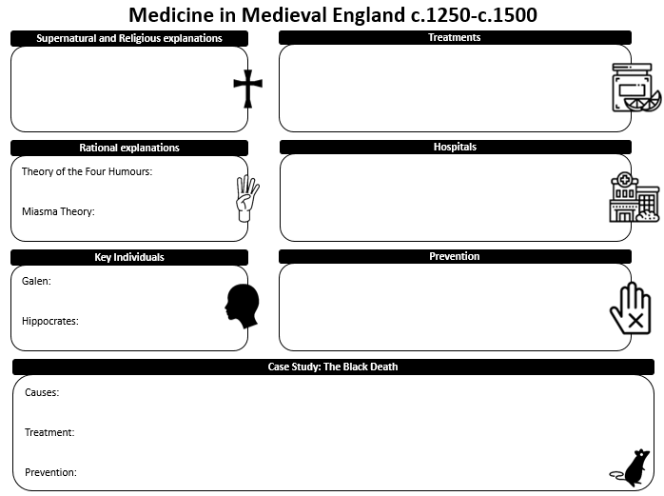
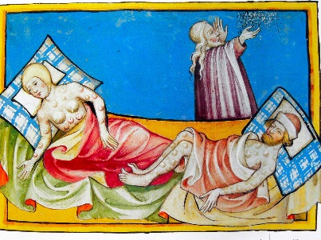
Case study – The Black Death 1348-9
Beliefs about causes –
- Sent by God as a punishment for sins
- An unusual alignment of the planets
- Imbalance of the four humours
- Miasma (perhaps from a volcano or earthquake)
Approaches to treatment –
- Prayer, confession of sins, donations, holy charms
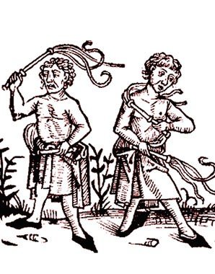
- Bloodletting, purging, treatments based on the four humours
- Sniffing herbs, lighting fires
- Lancing buboes
Prevention –
- The authorities quarantined houses
- The reduction of waste on the streets
- Rakers cleared animal dung
- Flagellants asked God for forgiveness
- The King ordered processions to church at least once a day

Exam questions:
- Explain one way in which people’s reactions to the plague were similar in the 14th and 17th centuries. (4)

- Explain one way in which ideas about treatment of disease were different in the 13th and 17th centuries. (4)

- Explain one way in which treatments for illness were similar in the 14th and 17th centuries. (4)

- Explain one way in which people’s reactions to epidemics of disease were similar in the 17th and 19th centuries. (4)

- Explain one way in which people’s reactions to epidemics of disease were different in the 17th and 19th centuries. (4)

- Explain one way in which ideas about the causes of disease were different in the 17th and 19th centuries. (4)

- Explain one way in which ideas about the causes of disease were similar in the 17th and 19th centuries. (4)

12 mark question structure:

1st PEEL paragraph
In 1 sentence, sum up what this paragraph is about. One reason why there was …
Give specific evidence to support this.
Explain why – Link to the question focus giving reasons
2nd PEEL paragraph
In 1 sentence, sum up what this paragraph is about. Another reason why there was …
Give specific evidence to support this.
Explain why – Link to the question focus giving reasons
3rd PEEL paragraph
In 1 sentence, sum up what this paragraph is about. A final reason why there was …
Give specific evidence to support this.
Explain why – Link to the question focus giving reasons

Q. Explain why there was continuity in ideas about the cause of disease during the period c1250-c1500. You may use the following in your answer:
- the Church
- a lack of scientific understanding
You must also use information of your own. (12)

Q. Explain why there was little change in the care provided by hospitals in the period c1250-c1500.
You may use the following in your answer:
- St Bartholomew’s Hospital in Smithfield
- people left money for new hospitals in their wills
You must also use information of your own. (12)

Q5/6) ‘Hospital treatment in England in the period from 1250 to 1500 was very rare.’ How far do you agree? Explain your answer. You may use the following in your answer:
- charity hospitals
- care in the home
You must also use information of your own. 16 marks plus 4 marks for SPaG = 20 marks.

Lesson 2: Renaissance Date………………………………………………………
L.O. To revise medicine in Renaissance England c1500-c1700.

Recall quiz 1 c1250-1500: Medicine in medieval England
- Give two reasons why people believed God sent diseases.

- Name two important classical medical thinkers.

- What were the Four Humours?

- What had to happen to the Four Humours to cause disease?

- Name two other things people in the period c1250-c1500 believed caused disease.

- What was theriaca?

- What was the name for advice on how to maintain a healthy lifestyle?

- What was the main job of the apothecary?

- Roughly how many hospitals were there in England in 1500?

- How many people died during the first outbreak of the plague in England?

Task: Explain the meaning of the following key terms:
- Anatomy

- Dissection

- Syphillis

- Renaissance

Information:
Ideas about the causes of disease and illness – new ideas began to replace old beliefs as Protestantism spread across Europe and the Catholic Church was less able to control medicine.

Continuity
- Miasma Theory continued and became more widespread during epidemics
- The influence of the Church during epidemics e.g. the Great Plague – religious causes were still influential
- Supernatural – astrology was less popular but during epidemics people continued to wear charms as protection from evil spirits
Change
- The decline in the influence of the church
- Most people no longer believed that God sent disease as a punishment
- The Theory of the Four Humours had been discredited – physicians no longer used it but patients did as they understood it
- Physicians now knew that urine was not linked to ill health so did not use it to diagnose

4 important developments
Animacules  A new idea that tiny animals were the cause of illness after the invention of more powerful microscopes. The images however remained unclear. | Thomas Sydenham  He believed in closely observing patients, writing detailed descriptions and then looking for remedies to treat the disease. He moved medicine away from a reliance on books and particularly the work of Hippocrates and Galen.
The influence of the printing press  The printing press was invented in the fifteenth century which meant that medical information could spread more quickly – this also contributed to the decline of the church.  Physicians were now able to publish books which criticised Galen. | The Royal Society  The Royal Society was founded in 1660 to discuss new ideas in medicine, science and astronomy. It made it possible for scientists and physicians to study each other’s work. The society also sponsored scientists and the publication of their work.

Approaches to prevention and treatment
Continuity
- Bloodletting, purging and sweating
- Herbal remedies
- The practice of regimen sanitatis
- The removal of bad air
- Treatment of the sick by apothecaries and surgeons by those who could afford it
- Women cared for those who did not go to hospital
Change
- People started to believe in transference
- People began looking for chemical cures rather than relying on herbs and bloodletting
- Ideas that the weather conditions were the cause of disease became more popular so people would relocate to avoid disease
- Hospitals began to treat people with wounds and curable diseases such as fevers
- Hospitals that specialised in one particular disease were new in this period. These became known as pest houses, plague houses of pox houses.

Transference – the belief that an illness could be transferred to something else e.g. if you rubbed an object on a boil the disease would transfer to the object.

Changes in care and treatment
Improvements in medical training
- Physicians trained at universities
- Dissection was legalised but it was difficult to get fresh corpses
- Physicians were inspired to challenge Galen
- The printing press made books more widely available including the works of Vesalius and Harvey
- Wars were fought with new technology which led to wounds requiring more surgery
- The increase in available chemical led to new ingredients for apothecaries

Key individuals
Vesalius:
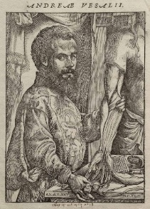
Discovery: Vesalius found 300 mistakes in the anatomical work of Galen, including:
- The human lower jawbone has one bone not two
- The human breastbone has three parts, not seven
- Men do not have one fewer pair of ribs than women
- The human liver does not have five separate lobes
Published On the Fabric of the Human Body
Impact
- Anatomy became central to the study of medicine and doctors were encouraged to carry out dissections for themselves
- Vesalius’ work was heavily copied and appeared in other medical texts
- His work inspired other anatomists
- Vesalius caused a lot of controversy because he challenged the ideas of Galen.

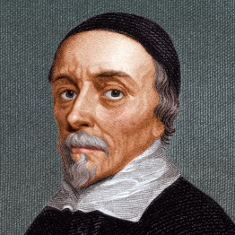
Harvey:
Discovery
- Dissected corpses and cut open cold-blooded animals because they had a slower heartbeat and this enabled their blood to be observed while they were still alive
- His research proved that arteries and veins were linked together in one system
- His theory was that blood must pass from arteries to veins through tiny passages invisible to the naked eye (capillaries)
- He corrected Galen and showed that only the veins carried blood and that the heart acted as a pump
Impact
- His discovery encouraged other scientists to experiment on actual bodies
- His discovery had little practical use in medical treatment and led to little change
- Some openly criticised Harvey because he did not have a powerful enough microscope to prove that capillaries existed. People said that he was mad.

Case study – The Great Plague 1665
Ideas about cause
- Astrology and the alignment of planets
- Punishment from God
- Imbalance of the Four Humours
- Miasma – caused by foul smelling rubbish
- Person to person
Prevention and treatment
- Prayer
- Quarantine – up to 28 days, painting a cross on the door with the words ‘Lord have mercy upon us’
- Carrying a pomander
- Fasting
- Plague doctors
- Local authority actions:
- Banning public meetings, funeral and fairs
- Closing theatres
- Cleaning streets
- Burning barrels of tar
- Killing cats and dogs
- Appointing searchers to monitor the spread of disease and clear victims bodies

Exam questions:
- Explain one way in which people’s reactions to the plague were similar in the 14th and 17th centuries. (4)

- Explain one way in which ideas about treatment of disease were different in the 13th and 17th centuries. (4)

- Explain one way in which treatments for illness were similar in the 14th and 17th centuries. (4)

- Explain one way in which people’s reactions to epidemics of disease were similar in the 17th and 19th centuries. (4)
- Explain one way in which people’s reactions to epidemics of disease were different in the 17th and 19th centuries. (4)
- Explain one way in which ideas about the causes of disease were different in the 17th and 19th centuries. (4)
- Explain one way in which ideas about the causes of disease were similar in the 17th and 19th centuries. (4)

12 mark exam questions:
EQ. Explain why some changes took place in medical knowledge during the period c1500-c1700.
You may use the following in your answer:
- The Church
- Lack of scientific understanding
You must also use information of your own. 12 marks

Structure:
- PEE Paragraph – The Church
- PEE Paragraph – lack of scientific understanding
- PEE Paragraph – one other factor that you choose

EQ. Explain why there was continuity in the way disease was treated in the period c1500-c1700.
You may use the following information in your answer:
- The Great Plague
- Attitudes in society
You must also use information of your own. 12 marks
Structure:
- PEE Paragraph – The Great Plague
- PEE Paragraph – Attitudes in society
- PEE Paragraph – one other factor that you choose

16 mark questions:
Q – ‘Harvey’s discovery of the circulation of the blood was a major breakthrough in medical knowledge during the period c1500-c1700.’ How far do you agree? Explain your answer. 16 marks (+4 SPaG)
You may use the following information in your answer:
- Harvey’s discovery of circulation of blood
- Vesalius dissections of the human body
You must use information of your own.

Q -‘There was little progress in medicine in Britain during the Renaissance period c1500-c1700.
How far do you agree? Explain your answer.
You may use the following information in your answer:
- The work of William Harvey
- Bloodletting and purging
You must use information of your own.

Lesson 3: c1700-1900 Date………………………..
L.O. To revise medicine in England c1700-c1900.
Starter:
- Explain one way in which people’s reactions to the plague were similar in the 14th and 17th centuries. (4)
- Explain one way in which ideas about treatment of disease were different in the 13th and 17th centuries. (4)
- Explain one way in which treatments for illness were similar in the 14th and 17th centuries. (4)

…………………………………………………………………………………………………………………………………………………………………………………………………………….
…………………………………………………………………………………………………………………………………………………………………………………………………………….
…………………………………………………………………………………………………………………………………………………………………………………………………………….
…………………………………………………………………………………………………………………………………………………………………………………………………………….
……………………………………………………………………………………………………………………………………………………………………………………………………………
Ideas about the cause of disease and illness
- Ideas about the cause of disease had not changed by the eighteenth century and people still believed in the Theory of the Four Humours and miasma, but this theory was losing popularity.
- Scientific thinking led to a change in medical understanding at the end of this period when the Germ Theory was developed.
- Spontaneous Generation – microscopes had improved so that scientists could see microbes on decaying matter. This led some scientists to develop the theory of spontaneous generation. They argued that the microbes were a product of the decay, rather than the cause of it, and they spread by miasma.

Task: Complete the revision mats using the Edexcel Book and your own knowledge:

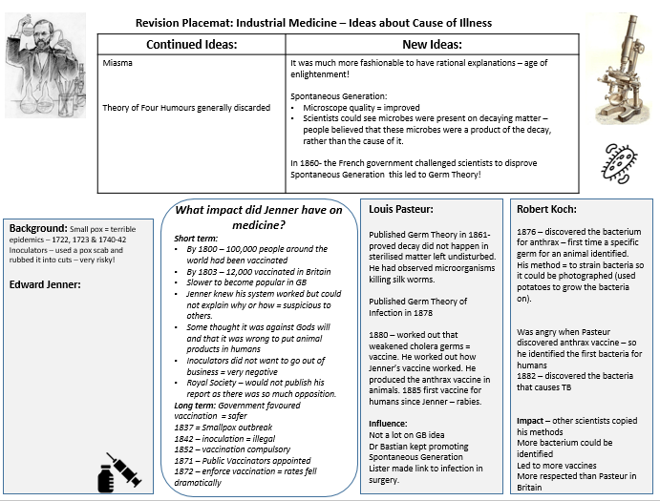
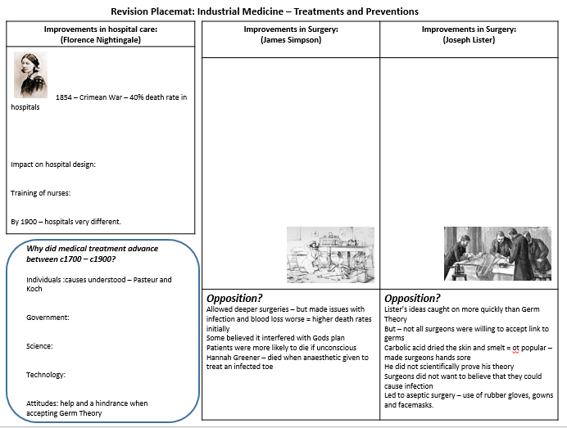
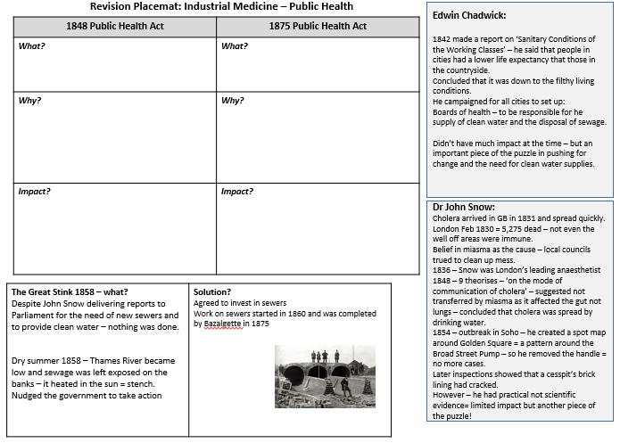
Exam questions:
- Explain one way in which people’s reactions to the plague were similar in the 14th and 17th centuries. (4)
- Explain one way in which ideas about treatment of disease were different in the 13th and 17th centuries. (4)
- Explain one way in which treatments for illness were similar in the 14th and 17th centuries. (4)
- Explain one way in which people’s reactions to epidemics of disease were similar in the 17th and 19th centuries. (4)

- Explain one way in which people’s reactions to epidemics of disease were different in the 17th and 19th centuries. (4)

- Explain one way in which ideas about the causes of disease were different in the 17th and 19th centuries. (4)

- Explain one way in which ideas about the causes of disease were similar in the 17th and 19th centuries. (4)

12 mark questions

Q. Explain why there was rapid change in surgical treatments in the period 1700-1900.
You may use the following information in your answer:
- chloroform
- Joseph Lister
- You must also use information of your own. 12 marks

Explain why there were changes in understanding of the cause of disease during the period 1700-1900.
You may use the following information in your answer:
- Koch
- Snow
You must also use information of your own. 12 marks

16 mark questions

Q.‘Jenner’s vaccination against smallpox was a major breakthrough in the prevention of disease in Britain during the period c1700-c1900.’
How far do you agree? Explain your answer.
You may use the following in your answer:
- cowpox
- Germ Theory
You must also use information of your own.

Q.‘There was rapid change in ideas about the causes of illness and disease in the period c1700-c1900.’
How far do you agree? Explain your answer.
You may use the following in your answer:
- Spontaneous generation
- Louis Pasteur
- You must also use information of your own.

Lesson 4 12 and 16 mark exam technique Date ………………………………………..
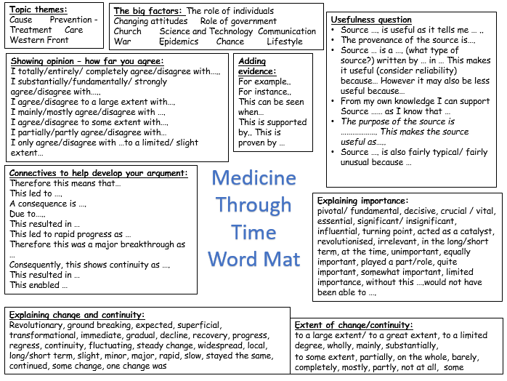
LO: To work on exam literacy
Question 4 (12 marks) 15 mins
You need 3 x PEE (and a J – if you have time). You must have at least one factor of your own.
Level | Mark | Descriptor
 | 0 | No rewardable material
1 | 1-3 | A simple or generalised answer is given, lacking development and organisation (AO2) Limited knowledge and understanding of the topic is shown (AO1)
2 | 4-6 | An explanation is given, showing limited analysis and with implicit or unsustained links to the conceptual focus of the question. It shows some development and organisation of material, but a line of reasoning is not sustained. (AO2) Accurate and relevant information is included, showing some knowledge and understanding of the period (AO1) Maximum 5 marks for Level 2 answers that do not go beyond aspects prompted by the stimulus points.
3 | 7-9 | An explanation is given, showing some analysis, which is mainly directed at the conceptual focus of the question. It shows a line of reasoning that is generally sustained, although some passages may lack coherence and organisation. (AO2) Accurate and relevant information is included, showing good knowledge and understanding of the required features or characteristics of the period studied (AO1). Maximum 8 marks for Level 3 answers that do not go beyond aspects prompted by the stimulus points.
4 | 10-12 | An analytical explanation is given which is directed consistently at the conceptual focus of the question, showing a line of reasoning that is coherent, sustained and logically structured. (AO2)  Accurate and relevant information is precisely selected to address the question directly, showing wide-ranging knowledge and understanding of the required features or characteristics of the period studied. (AO1). No access to Level 4 for answers which do not go beyond aspects prompted by the stimulus points.

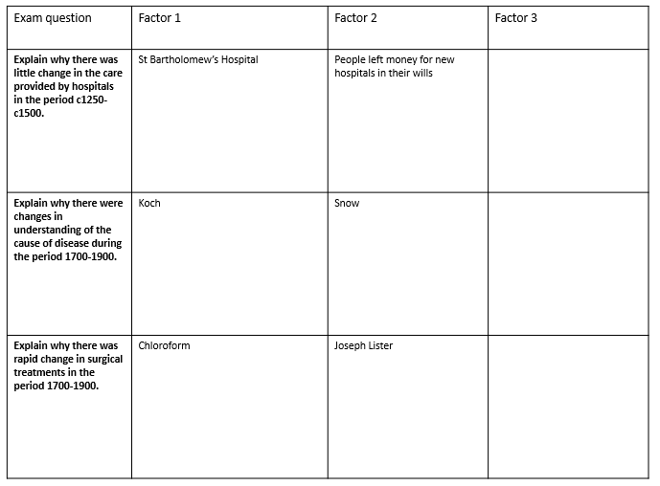
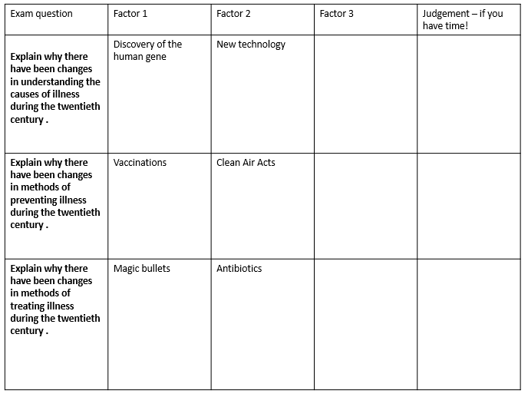
Question 5/6 – 20 mark question (includes 2 SPaG marks)
In the exam you get a choice of which one to answer – make sure you cross the right box!
You need 3 factors – e.g. developed PEE/L
Make a clear point – which factor? Do you agree or disagree?
Argue in relation to the statement.
Say what happened but also give specific reasons for agree/disagree arguments
Come to a judgement about the statement – explain why you agree or disagree. How important were the other factors?
Structure
Paragraph 1 – Evaluate the extent - of the first factor
Paragraph 2 - Evaluate the extent - of the second factor
Paragraph 3 – Evaluate a factor of your own
Paragraph 4 – Your final conclusion – how far you agree with the statement and the reason why
You need to have clear criteria for reaching a judgement:
- If you are judging the importance of an individual or discovery you could analyse and evaluate the immediate impact, the short-term impact and the long-term impact.
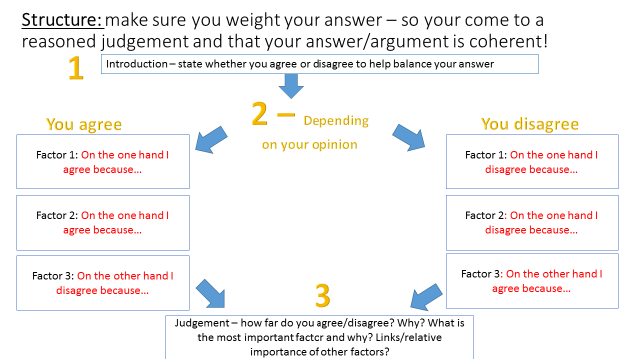
- If you are judging the extent of change you could analyse and evaluate how many people benefitted (e.g. did everyone benefit or was it just the rich or those living in a certain area) or how quickly the medicine or an area of medicine progressed (were there immediate benefits? Were they long lasting and permanent?)
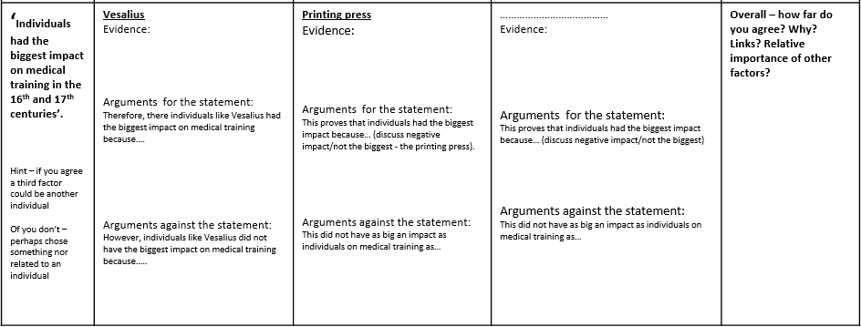
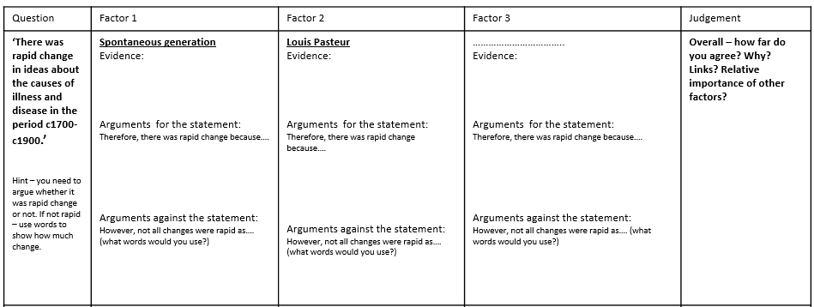

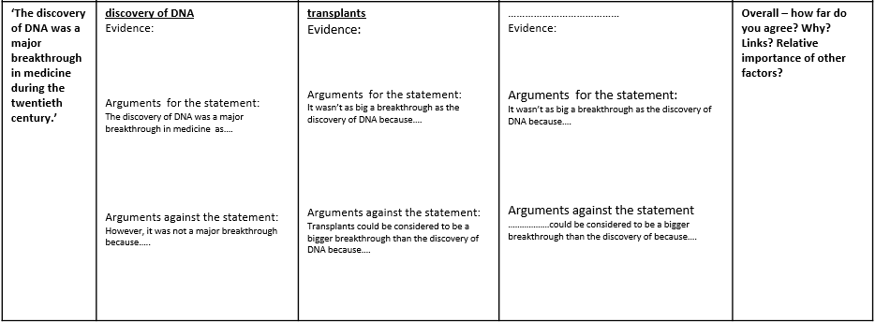
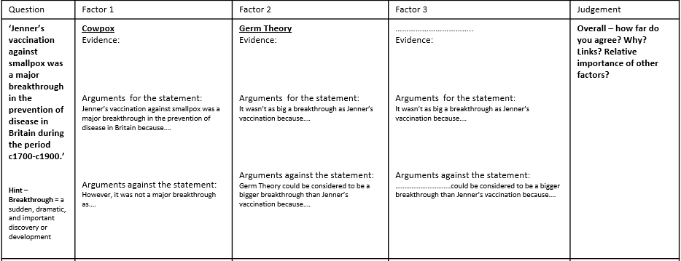

Lesson 5: Modern Medicine Date ……………………………
L.O. To revise Medicine 1900-present.

Starter: answer one of the following questions
- Explain one way in which people’s reactions to epidemics of disease were similar in the 17th and 19th centuries. (4)
- Explain one way in which people’s reactions to epidemics of disease were different in the 17th and 19th centuries. (4)
- Explain one way in which ideas about the causes of disease were different in the 17th and 19th centuries. (4)
- Explain one way in which ideas about the causes of disease were similar in the 17th and 19th centuries. (4)
……………………………………………………………………………………………………………………………………………………………………………………………………………………………………………………………………………………………………………………………………………………………………………………………………………………………………………………………………………………………………………………………………………………………………………………………
Ideas about the cause of disease and illness
By 1900 it was clear to scientists that microbes did not cause all disease and illness. The causes of hereditary diseases were still unknown. The puzzle of hereditary diseases was solved in 1953 when DNA was discovered.
The influence of lifestyle factors on health
Our understanding of how lifestyle is linked to disease and illness has improved:
- Smoking is linked to a range of diseases including high blood pressure, cancers and heart disease
- Diet has a huge impact on our health and we are advised to maintain a healthy food intake e.g. too much sugar can lead to diabetes
- Drinking too much alcohol can lead to liver disease
- Unprotected sex can lead to the spread of certain diseases
Improvements in diagnosis
The development of technology has enabled doctors to understand and diagnose illness and disease more quickly and accurately e.g.
- X-Ray – sees inside the human body without cutting it open –
- ECG – electrocardiograms that measure the hearts activity
- Blood pressure monitor – measures blood pressure
- CT and MRI scans – diagnose internal damage, tumours and other growths

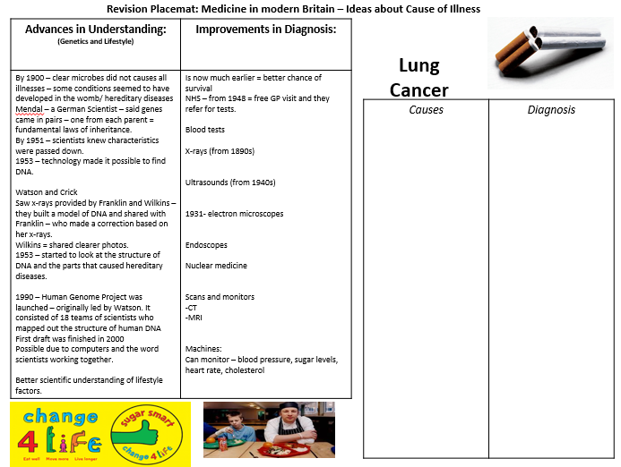
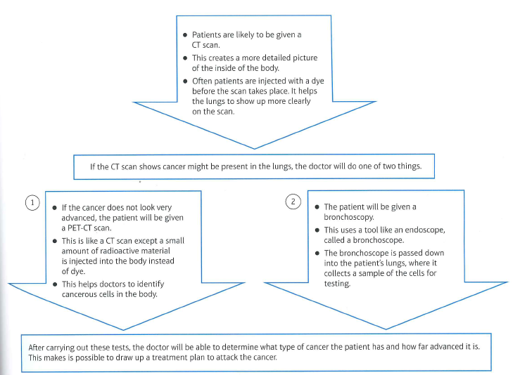
Diagnosis of lung cancer
Timeline - Penicillin
1928 – Fleming identifies penicillin in his lab (mould had killed his germs)
1929- Fleming published his findings and writes articles about his work.
1939 – Florey and Chain revive Fleming’s research after reading an article by Fleming.
1940 – Florey and Chain successfully treat mice with penicillin.
1941 – Florey and Chain trial penicillin on a human, with some success.
1942 – US and British governments co-operate to fund production of penicillin.
1942 – US pharmaceutical companies begin mass producing penicillin.
1944 – enough penicillin to treat all allied forces wounded in the D-Day invasion of Europe.
1945 – Dorothy Crowfoot Hodgkin, a scientist at Oxford University, identifies the chemical structure of penicillin.
1957 – Chemist John.C.Sheehan creates a chemical copy of penicillin. This allows for the drug to be changed in order to target different diseases.

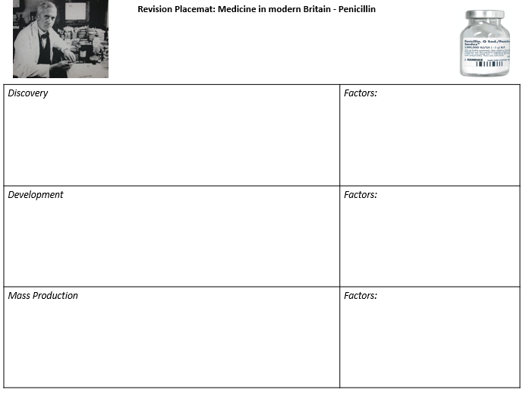
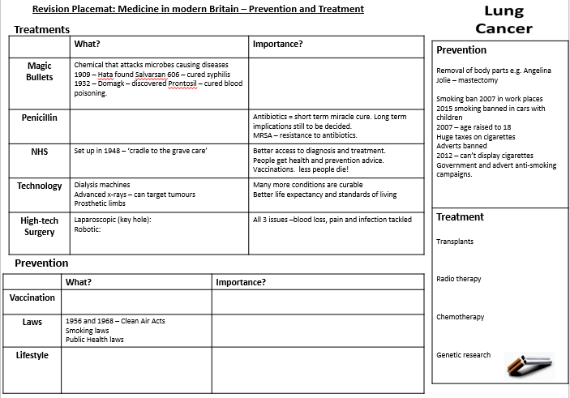
12 mark questions
Q. Explain why there have been changes in understanding the causes of illness during the twentieth century .
You may use the following information in your answer:
- discovery of the human gene
- new technology
You must also use information of your own. 12 marks
Structure:
- PEE Paragraph – discovery of the human gene
- PEE Paragraph – new technology
- PEE Paragraph – one other factor that you choose

Q. Explain why there have been changes in methods of treating illness during the twentieth century .
You may use the following information in your answer:
- magic bullet
- antibiotics
You must also use information of your own. 12 marks

Structure:
- PEE Paragraph – magic bullet
- PEE Paragraph – antibiotics
- PEE Paragraph – one other factor that you choose

Lesson 6 Western Front Date…………..
L.O. To revise The British sector of the Western Front, 1914-18: injuries, treatment and the trenches.
Starter:
- List the types of medical problems and possible injuries that soldiers faced in the trenches.

- How were the wounded transported?

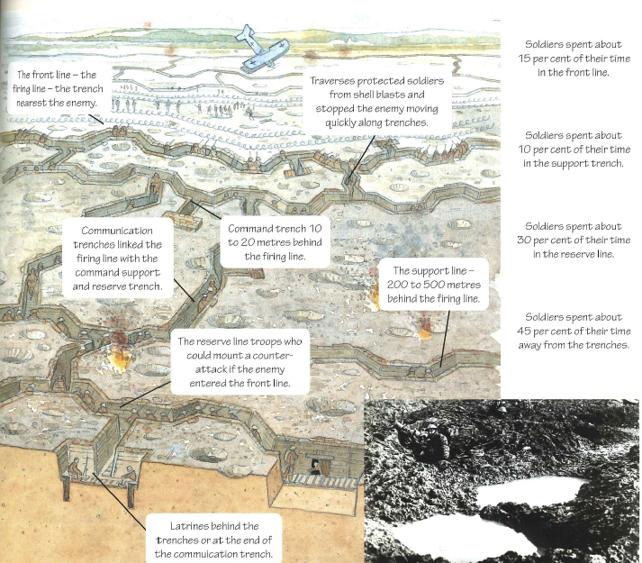
Context of the Western Front:
The Ypres Salient  - The scene of many battles during the First World War – it was on the way to the Channel ports of Calais and Dunkirk. The Germans wanted to capture these ports to cut off supplies to the British army. The Ypres Salient was vulnerable because the Germans had the advantageous position on higher ground. The German army could see the Allied movements and build strong defences.  - Tunnelling and mines were used by the British at Hill 60, a man-made hill captured by the Germans to regain control in April 1915.  - The Battle of Ypres took place between October and November 1914.  - The second Battle of Ypres – April to May 1915 saw the first use of chlorine gas by the Germans.  - The third Battle of Ypres took place in July-Nov 1917. |  |  |  |  | The Somme  - The Battle of the Somme lasted from July to November 1916 and took place along the River Somme.  - It is remembered for its high casualty rate. On the first day of the battle the British army suffered nearly 60,000 casualties and 20,000 dead.  - In total there were over 400,000 Allied casualties. This put pressure on the medical services on the Western Front.
Arras  - The Battle of Arras took place in April 1917.  - Before the battle, Allied soldiers had dug a network of tunnels below Arras. The tunnelling was made easy by the chalky ground. New tunnels joined with existing tunnels, caves and quarries. Rooms were created with running water and electricity. There was also a hospital. |  |  |  |  | Cambrai  - The Battle of Cambrai took place in October 1917. During this battle over 450 large-scale tanks were used by the Allies to launch a surprise assault on the German front line. Unfortunately the tanks did not have enough infantry support. The British lost the ground they had taken.
 | illness | Cause | Symptoms | Treatment and prevention |  | Impact
 | Trench Fever | Transmitted by body lice | Flu-like symptoms: high temperature, headaches, shivering and aching muscles | Treatment – drugs were trialled such as quinine and salvarsan.  Prevention – clothes were disinfected with repellent gel  Delousing stations were set up |  | Affected nearly half a million men on the Western Front
 | Trench Foot | Soldiers stood in mud and waterlogged trenches | Tight boots added to the problem because they restricted blood flow. Later gangrene would set in. | Treatment – soldiers were advised to keep their feet clean and dry. Worst cases led to amputation  Prevention – changing socks  Rubbing whale oil in to protect them |  | Winter of 1914 and 1915, over 20,000 Allied men were affected
 | Shell Shock | Stressful conditions of war | Tiredness, nightmares, headaches, uncontrollable shaking and a mental breakdown. | Treatment – mainly consisted of rest. Some soldiers received treatment back in Britain. |  | Est.80,000 experienced shell-shock. Some men were accused of cowardice. Punishment could be being shot.

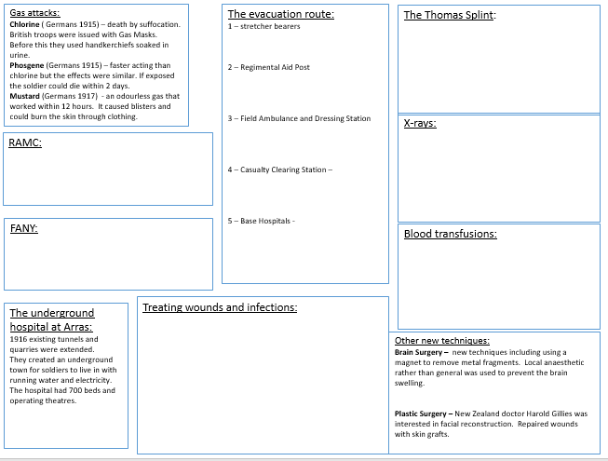
Q1 – 2XPE 5 mins: Topic | Key Features | Evidence
The Trench System | 1.  2. | 1.  2.
Stretcher bearers | 1.  2. | 1.  2.
Ambulances | 1.  2. | 1.  2.
Trench Foot | 1.  2. | 1.  2.
Gas attacks | 1.  2. | 1.  2.
RAMC | 1.  2. | 1.  2.
FANY | 1.  2. | 1.  2.
Dressing stations | 1.  2. | 1.  2.
Casualty Clearing Stations | 1.  2. | 1.  2.
Base Hospitals | 1.  2. | 1.  2.
The underground hospital at Arras | 1.  2. | 1.  2.
The Thomas splint | 1.  2. | 1.  2.
Blood transfusions | 1.  2. | 1.  2.
The Blood Bank at Cambrai | 1.  2. | 1.  2.
Plastic surgery | 1.  2. | 1.  2.

Lesson 7 Western Front Date …………………..
LO: To revise exam technique for the British section of the Western Front.

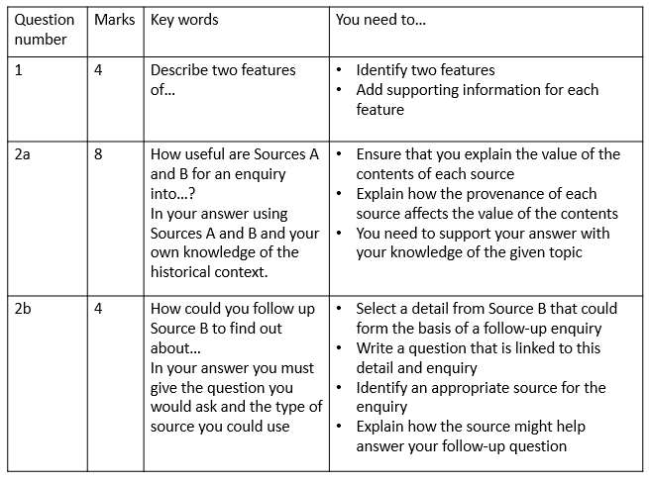

Task: Complete any of the Q1s from last lesson

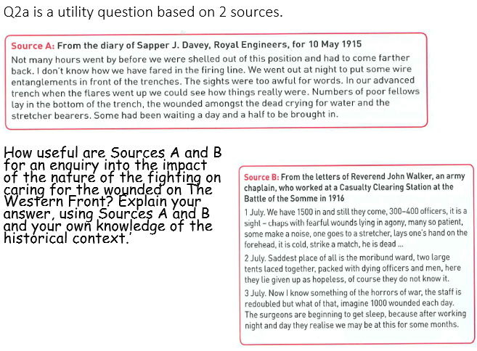
Structure:
- C – Content – what does the source say that is useful in relation to the enquiry?
- O- Own knowledge – what do you know about the context of the time?
- P – provenance – how do the nature, origin o purpose effect the usefulness of the source? Does it make it reliable? Typical? Comprehensive? (you only need one aspect of provenance)

Sentence starts you could use..
C - Source ……. is useful as it tells me … (try and keep it specific to the effect the fighting had on caring for the wounded). My evidence for this is…
O - From my own knowledge I know that ……………(add something from your own knowledge that isn’t included in the source). This makes the source useful as …………
P - Source ……… is a …. (what) which means it is useful as……
It was written by … in … This makes it useful as …………..…
The source is reliable/typical as …………………….
Overall the source is …………..useful for the enquiry.

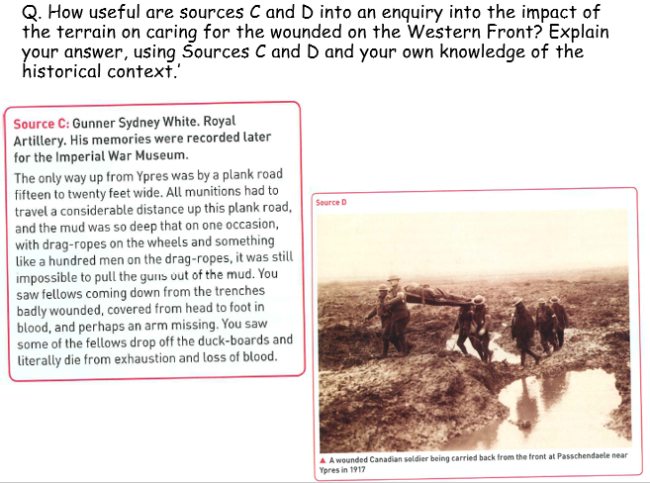

Q2b is an analysis question that asks you to use sources – you have to explain a follow-up enquiry and the source that you would use.
Type of Source | What can be learnt from this type of source
National Army Service Records for individual soldiers. | Dates of service; Where soldiers fought; Record of wounds, treatments and hospitals admitted to, discharge records, death record
pension record cards (currently being digitised) | Details of war related wounds, sickness and injuries and post-war medical board results
National newspaper reports | Battles, number of injuries, deaths etc recorded, eye-witness accounts, government statistics – should be fair but may be one-sided. Propaganda often published as fact. Censorship relaxed during war.
Government reports on aspects of the war | Departmental overview of aspects of the war – spending on munitions etc.
Medical articles by doctors and nurses who took part in the war  e.g. British Medical Journal | Although BMJ is produced for medical professionals it provides an insight in the medical care of soldiers e.g. articles like ‘Head injuries in War’, ‘Some notes on Trench Fever’  Recollections of the work undertaken – injuries of soldiers, conditions, chain of evacuation, new techniques and technology etc
Personal accounts of medical treatments by soldiers, doctors, nurses or others who were involved e.g. letters, diaries | Often emotive accounts – detailing feelings and thoughts as well as facts. Only give one person’s view of events or a snapshot of what was happening at one particular time or place in the war
Photographs | Show images of what is happening at that exact moment in time although could be staged and not necessarily typical of conditions across the Western Front or throughout the war
Hospital records | Date of admittance, records of injuries and care given, discharge notes, death records, new techniques attempted
Army statistics | Numbers fighting in each battle, killed or injured
Orders of Battle (ORBATS) | Documents produced by the military to show the hierarchical structure, command organisation and disposition of units for engagements of the British Military
Military Hospitals Admissions and Discharge Registers WW1 Collection | Records of soldiers' admission to, or discharge from, hospital in the First World War.
Questions that sources may be able to answer:
- What kinds of wounds did soldiers suffer from?
- What kinds of weapons caused particular injuries?
- what kind of illnesses did soldiers suffer from in the trenches?
- What did the army do to address health problems for soldiers at the Western Front?
- Did surgical techniques improve during war time?
- What pressures were medical staff under?
- Who was providing the medical care?
- What work was done by nurses?
- How successful were new techniques e.g. blood transfusions, mobile x-ray machines, Thomas Splints?
- Did transport from the front line to CCS increase death rates?
- What problems did the transportation of injured soldiers create?
- How did attitudes towards shell shock (NYD.N.) change during the war?




