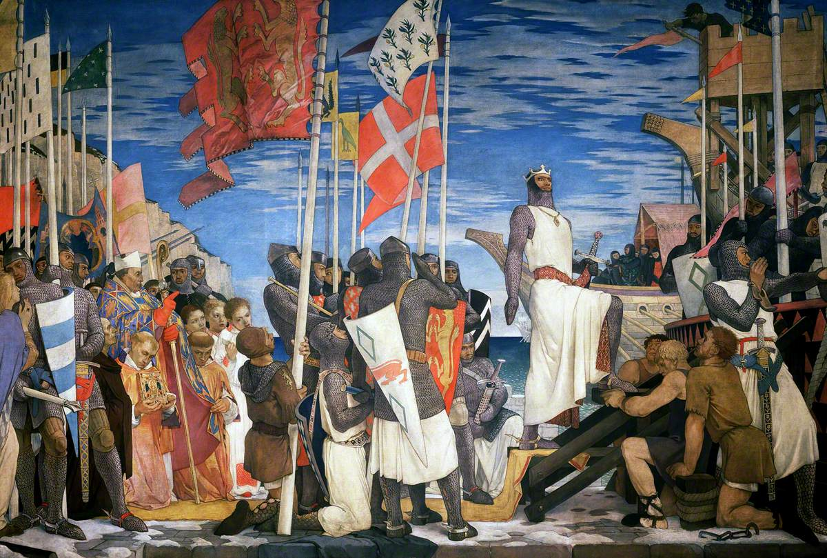

**Wavell School KS3 History (Year 7)**

**Islam and the Crusades workbook**

Name:

Class:

Teachers name:

Classroom:

**Topic contents**:

* Key words
* Introduction to Islam
* What do Muslims believe?
* The impact of Islamic civilisation on the wider world
* Why did the Crusades start?
* Were the Crusades a success for the Europeans?

Photo credit: Parliamentary Art Collection

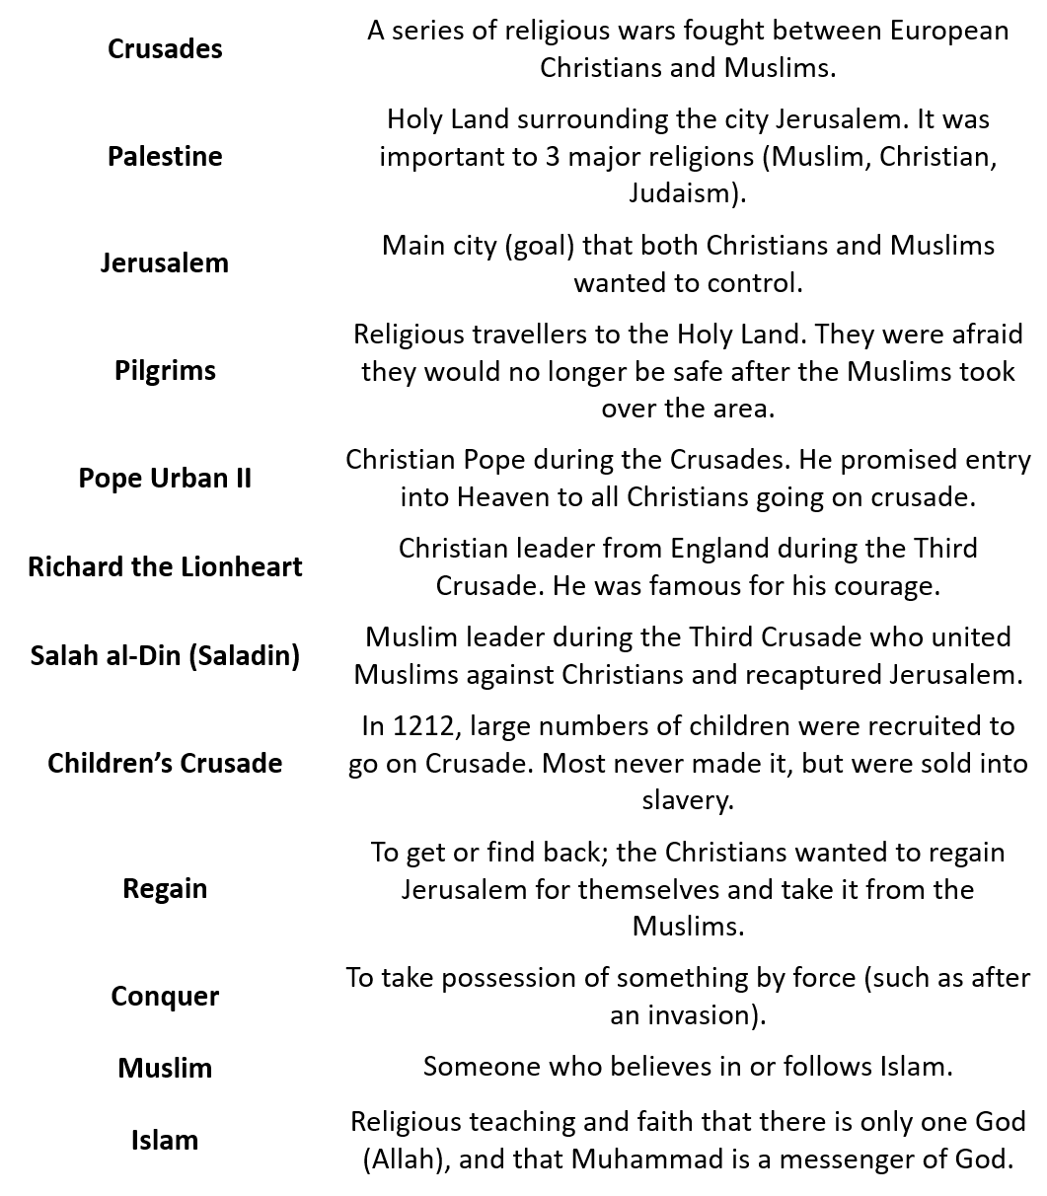

**Key Words**

Date: ______________________________

**An introduction to Islam**

**LO: To be able to explain what Islam is and why it spread in the early medieval period.**

* 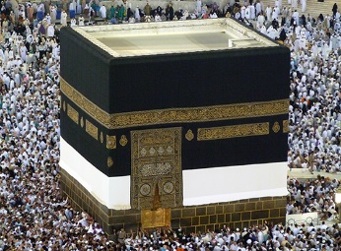The Middle East was made up of large empires such as the **Byzantine** and **Persian**.
* Islam took the world by surprise.
* The coastal areas were part of a well-known trade route, but it was far from the centres of power.

**TASK:** Read the information below and use it to complete the map on the next page.

* **Europe:** was made up of lots of **small weak** countries, which were **always at war**. **France and Spain** were quite rich and were Christian countries, but the people hated their rulers.
* **Constantinople**: was the **capital** of what was left of the **Roman Empire** (called the Byzantine Empire). It had rich lands but it was weak and was **always at war with Persia**. The official religion was Christianity in the Greek Orthodox tradition.
* **Persia**: was a **very rich empire** but it was **quite weak**. Persia was always at war with Constantinople. The Persians were **Zoroastrians**, a religion which believed that a **new** **good leader**, sent from **God**, would come to the world in **628.**
* **Yemen**: had quite **rich farmland**, but in 600 was ruled by the **Persian Empire**. There was **a mix of religions** in the Yemen.
* **Abyssinia**: was a small **mountain kingdom** in Africa. It was quite **rich** and the religion was **Christian**.
* **The Hejaz:** was part of a trading route from the Byzantine Empire (what was left of the Roman Empire) through Yemen to the Far East (India and China). It was a desert with oases (an oasis is a water-hole) spread here and there. The **people were poor** and the **different tribes were always fighting**.
* The people of the **Hejaz** also believed that some places were **holy**. One holy place was **Mecca**, where a **black meteorite** had fallen to earth. It was kept in a building called the **Kaaba**, along with **360 idols**. The **Quarish tribe** was very important among the Arab tribes because they looked after the Kaaba.

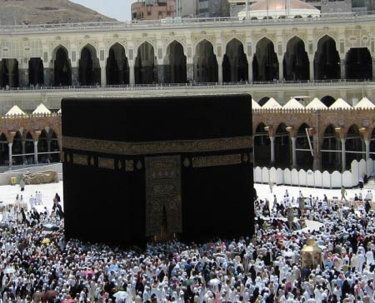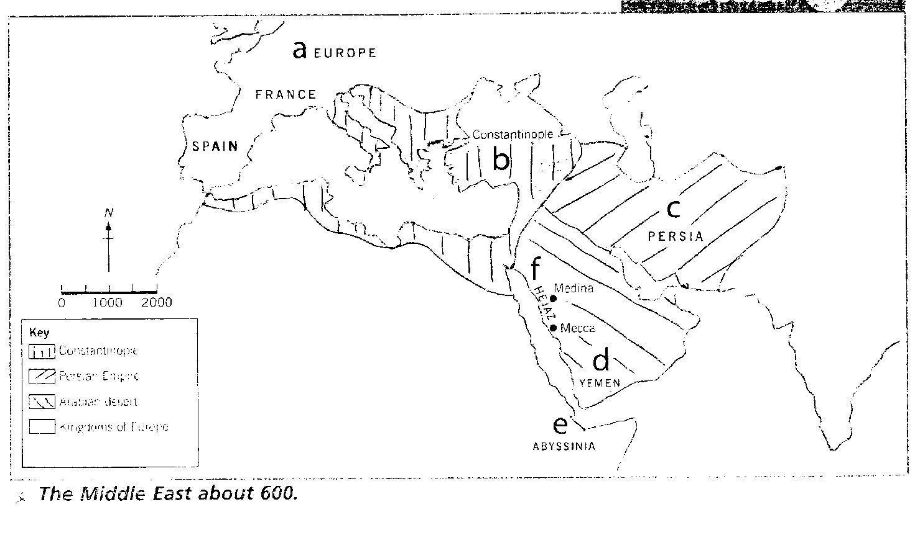

**F. The Hejaz:**

The Hejaz is a desert, with now and again a water hole (called an ‘oasis’).

1) The people were ________.

2) The different __________ were always fighting.

3) The people of the _________ also believed that some places were ________. One holy place was ________, where a black ________ had fallen to ________. It was kept in a building called the ________ , along with _________ idols. The ________ tribe were very important among the Arab tribes because they looked after the Kaaba.

**B. Constantinople:**

1) It was the__________ of the old R____ E_____.

2) Weak. Always at _____ with _______.

The Kaaba

**E. Abyssinia:**

1) Their religion was ___________.

2) It was quite_______

3) Small ________

________ in Africa.

**D. Yemen:**

1) There was a ______ of _________.

2) Quite _______ _____________.

3) In 600 the Yemen was ruled by the ______________.

**C. Persia:**

1) The Persians were ___________, a ________ which believed a new good ________, sent from _____, would come to the world in _____.

2) A ________ _______ empire.

3) It was quite ________.

**A. Europe:**

1) They were always___________.

2) _________ and ________ were quite _______.

3) Lots of s_____ _______ countries.

**What do Muslims believe?**

The Five Pillars of Islam are five fundamental functions in Islam, believed compulsory by believers and will be the base of Muslim life.

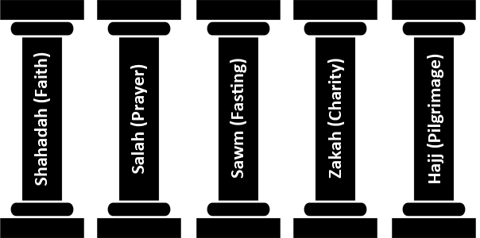

* **Shahadah** is a declaration of faith and trust that says that there's one God (Allah) and Muhammad is God's messenger.
* **Salah** includes five daily prayers based on the Sunna (the way of life).
* **Sawm** is taking part in fasting (not eating) at particular times. This includes the month of Ramadan. It is meant to seek nearness and also to search for forgiveness from God, to express their gratitude to and reliance on him, atone for their past sins, and also to remind them about the needy.
* **Zakah** means charity or alms-giving, which is the practice of charitable giving based on how much money you have. It is obligatory for all Muslims who can do so.
* **Hajj** is a pilgrimage that happens throughout the Islamic month of Dhu al-Hijjah (the twelfth and final month) into the holy city of Mecca. Every able-bodied Muslim is obliged to make the pilgrimage to Mecca at least once in their life.

**Muslims also have several key beliefs:**

* Belief in Allah as the one and only God.
* Belief in angels and the holy books.
* Belief in the prophets (e.g. Abraham, Moses, David, Jesus). Muhammad was the final prophet and was God’s messenger.
* Belief in the day of Judgement – when the life of every human will be assessed to decide if they go to heaven or hell.
* Belief in predestination – Allah has knowledge of everything that will happen, but this does not stop humans from making free choices.

**TASK: Sum up the key beliefs of Muslims using words and pictures.**

**You cannot draw Allah, however, as this would be considered offensive to Muslims!**

**Date: _________________________________**

**The impact of Islamic civilisation on the wider world**

**LO: To consider how important Baghdad and the Islamic scholars were in improving knowledge. To explore what impact the Islamic civilisation had on the Medieval world.**

Starter:

1. What is a civilisation? ________________________________________________
2. What was life like in Medieval England? ___________________________________  
   ________________________________________________________________________________________________________________________________
3. What kind of inventions and discoveries do you think would have been important in medieval times? ____________________________________________________  
   ________________________________________________________________________________________________________________________________  
     
   **Task: Read the information and answer the questions in each box.**

|  |  |
| --- | --- |
| **Arabic Numerals** – The Arabs led the world in mathematics in the Middle Ages. In the ninth century, the Persian mathematician, Al-Khwarizmi introduced a clear numbering system. People in Europe used Roman numerals and it was not until the introduction of the printing press in the fifteenth century that Arabic numbers caught on.  Arabic numbering is an example of just one idea that spread from the Arab world to Europe in the Middle Ages.   1. What nationality was Al-Khwarizmi?   ________________________   1. What numerals did people use before Arab ones?   ________________________   1. When did Arab numbers catch on?   ________________________ | **The Astrolabe** – The astrolabe was first written about by the Greeks and the Romans. They understood that it was possible to tell the time and work out direction and location when travelling by measuring distances from the planets and the stars.  The astrolabe was first used in the Arab world in the eighth century. Muslims found it useful because it told them the prayer times and also the direction of Mecca. Europeans began to buy astrolabes in the eleventh century. In the 13th century it was used by travellers and sailors.   1. Who wrote about the astrolabe first?   ________________________   1. How did they use it for travel?   ________________________   1. What century did it start being used by sailors?   ________________________ |

|  |  |
| --- | --- |
| **Mathematics –** The Arab mathematician Omar Khayyam had a great influence on European mathematics. He set out rules for algebra and equations that influenced Italian mathematicians five hundred years later.  In 1074 Omar calculated that every year lasted 365.24219858156 days. His calculations were used by Europeans when they drew up a new calendar four hundred years later.  Omar even used mathematics to suggest that the universe did not revolve around the earth. He tried to show that the earth turned on its axis.   1. What parts of mathematics did Omar Khayyam set out rules for?   ________________________   1. How long did he say a year lasted?   ________________________   1. What did he try to show about the earth?   ________________________ | **Medical advice –** Ibn Sina became known as the ‘doctor of doctors’. He wrote a huge book of advice to doctors, known as the ‘Canon’.  The Canon was used to train doctors in Europe from the twelfth to the seventeenth century. Ibn Sina gave advice on many aspects of medicine, from treating cancer to the need for a healthy diet.   1. What was Ibn Sina known as?   **________________________**   1. What centuries was the Canon used from?   **________________________**   1. What aspects of medicine did he give advice on?   **__________________________________ __________________________________** |

**Further questions:**

1. How important do you think each development was? Why?
   1. Arabic Numerals – _____________________________________________  
      ___________________________________________________________
   2. Astrolabe – __________________________________________________  
      ___________________________________________________________
   3. Mathematics – ________________________________________________  
      ___________________________________________________________
   4. Medical advice – ______________________________________________  
      ___________________________________________________________
2. Which of the four developments do you think was the most important? Why?  
   ________________________________________________________________________________________________________________________________________________________________________________________________________________________________________________________________________________________________________________________________________________________________________________________________
3. **Explain:** What was the impact of the Arab world on Europe in the medieval period? Use PEE.

______________________________________________________________________________________________________________________________________________________________________________________________________________________________________________________________________________________________________________________________________________________________________________________________________________________________________________________________________________________________________________________________________________________________________________________________________________________________________________________________________________________________________________________________________________________________________________

**TASK:** Create some revision material on the topic you think was most important for next year’s Year 7. It can be a flash card, leaflet, poster, etc – but it must be informative, give detail and explain why it is important! Use the space below or your own sheet of paper.

**The Crusades**

**Why did the Crusades start?**

**LO: To categorise the causes of the crusades and make a judgement on the most important reason for the start of the crusades**

STARTER: What is a Crusade? (Think back to our lesson on Richard I!)

____________________________________________________________________________________________________________________________________________________________________________________________________________________________________________________________________________________

At the start of the Middle Ages the Christians in northern Europe knew very little about Muslims and their advanced civilisation – the called them ‘Saracens’ and wrongly believed that they were all dark, long-haired tent-dwellers who followed strange religious beliefs.

Medieval Muslims knew a lot about Christians living in the Mediterranean but not much about those in northern Europe (Franks) – also thinking of them as primitive!

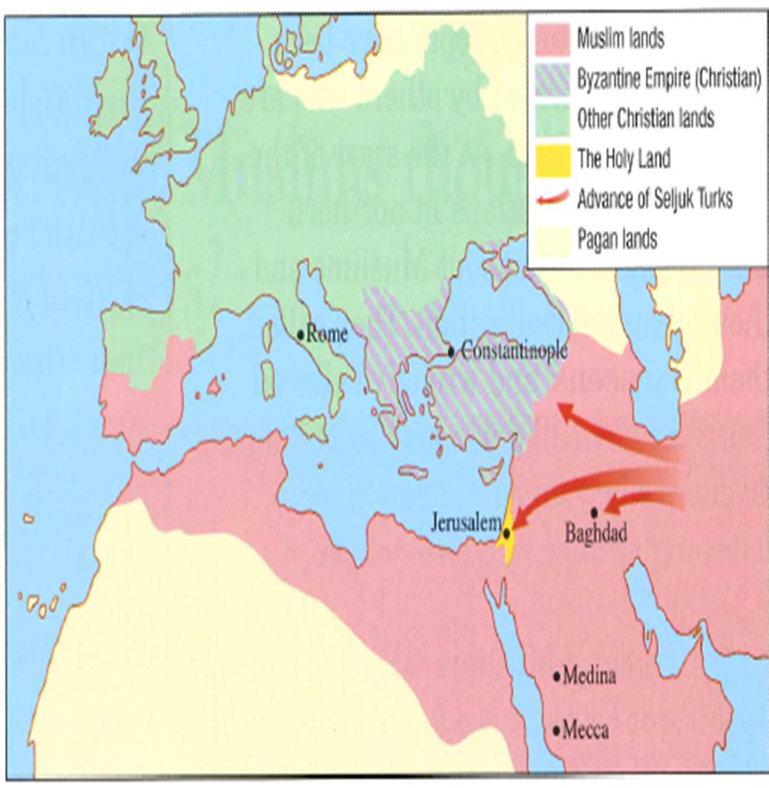

Why was the Holy Land so important?

* **Jews** - their holiest site, the Temple of Solomon, was there.
* **Christians** - it was where Jesus was killed and buried.
* **Muslims** - it was where Mohammed left Earth to go to Heaven.

Why do you think people might have gone on Crusade? Make a **hypothesis**.

_________________________________________________________________________________________________________________________________________________________________________________________________________________________________

TASK – Read this source from Pope Urban II and answer the questions in the boxes about why the Crusades began.

5. What is the source about? (What is the source trying to say?)

**__________________________________________________________________________________________________________________________________________________________________________________________________________________________________________________________________________________________________________________________________________________________________________________**

1. Who said this?

_____________________

2. Who were they?

_____________________

3. Why are they important to Christians?

_____________________

_____________________

_____________________

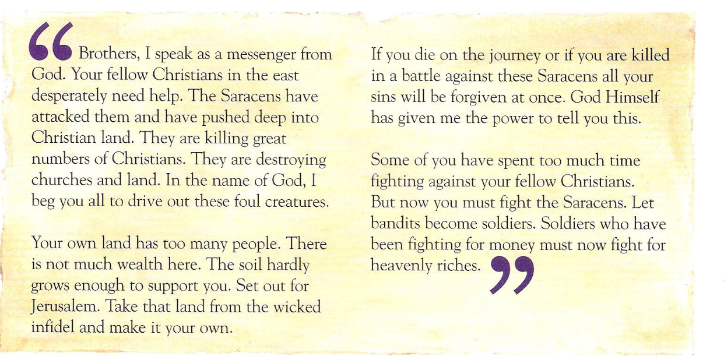

**Key Words:**

**Crusade:** A war for the Holy Land between Muslims and Christians during the Medieval period

**Saracens:** A medieval word for Muslims

**Foul:** disgusting, horrible

**Infidel:** people who do not believe in Christianity.

**Bandits:** people who rob or steal

**Pope:** A person who is the leader of the Catholic Church.

4. What reasons does the source give for people going on a Crusade?

* **___________________________________________________________**
* **___________________________________________________________**
* **___________________________________________________________**
* **___________________________________________________________**
* **___________________________________________________________**
* **___________________________________________________________**
* **___________________________________________________________**

What does the source suggest is the **main reason** people went on Crusade? How do you know?  
____________________________________________________________________________________________________________________________________________________________________________________________________________________________________________________________________________________________________________

TASK – Match up the other reasons for going on Crusade with the correct heading.

|  |
| --- |
| Religion |
| Money |
| Power |

|  |
| --- |
| There would be the opportunity to get treasure and riches. |
| It was promised your sins would be forgiven if you went on Crusade. |
| You could gain a heroic reputation at home. |
| To make sure that Christians had access to the Holy Land. |
| Successful Crusaders could be given land or new titles. |
| The Holy Land was rich and prosperous. |
| The Pope said that people should be going on Crusade. |

Using the information you have looked at and the source, answer this question:

**Why did people go on Crusades?** Use evidence to support your argument. ____________________________________________________________________________________________________________________________________________________________________________________________________________________________________________________________________________________________________________________________________________________________________________________________________________________________________________________________________________________________________________________________________________________________________________________________________________________________________________________________________________________________________________________________________________________________________________________________________________________________________________________________________________________________________________________________________

Date: __________________________

**The Crusades**

**Were the Crusades a success for the Europeans?**

**LO: To be able to explain how successful the crusades were and to come to a judgement about the consequences**

Starter:

1. What is the difference between a Christian and a Muslim in terms of beliefs? ____________  
   ______________________________________________________________________
2. Why was Jerusalem so important to both sides? __________________________________  
   ______________________________________________________________________
3. Why did European people join up to fight the crusades? ____________________________  
   ____________________________________________________________________________________________________________________________________________

**Refresher:**

* In the Middle Ages, the Muslim world **stretched from India to Spain**, including Jerusalem and the Holy Land. It was **scientifically and culturally ahead** of the Christian countries of Western Europe.
* By 1070, more and more Turkish nomads were settling in the Christian Byzantine Empire and the **Byzantines felt threatened by this**. Then, from 1087 onwards, Turks **stopped Christian pilgrims from entering Jerusalem**.
* For Jews, Christians and Muslims, **Jerusalem was and still is a holy city**.
* In fact for **Medieval Christians it was the centre of their world spiritually** and geographically according to their maps.

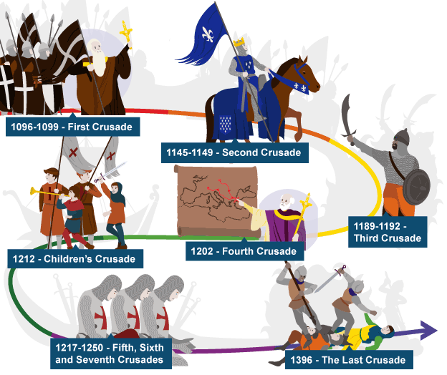

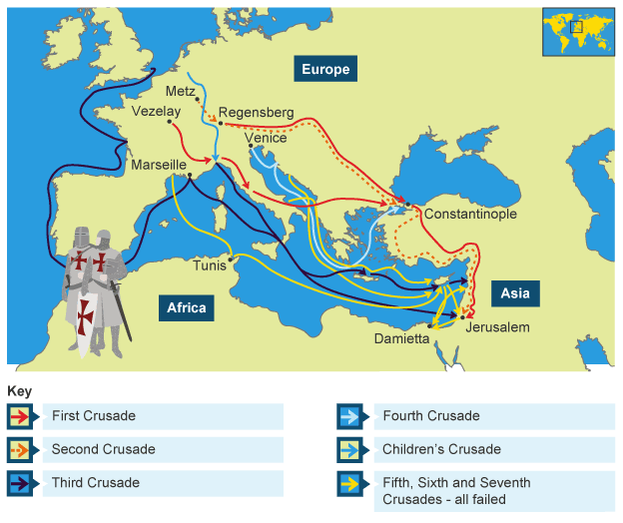

**Look at this map of the Crusades and answer the questions.**

1. How many Crusades were there in total?   
__________________________________________________________________

2. How successful do you think the Crusades were based on this number and map? ______  
____________________________________________________________________________________________________________________________________

3. What countries did the Crusades start in?  
___________________________________________________________________________________________________

4. What questions might you ask about this map?



**Look at this map of the Crusades and answer the questions.**

1. How many Crusades were there in total?   
__________________________________________________________________

2. How successful do you think the Crusades were based on this number and map? ______  
____________________________________________________________________________________________________________________________________

3. What countries did the Crusades start in?  
___________________________________________________________________________________________________

4. What questions might you ask about this map?



**TASK** – Read the information on the impact of the Crusades and answer the questions.

While the Crusades **resulted in defeat for Europeans** and a **Muslim victory**, many argue that they successfully made the reach of Christianity and Western civilization far greater. The Roman **Catholic Church experienced an increase in wealth** (money), and the **power of the Pope** grew after the Crusades ended.

**Trade and transportation also improved** throughout Europe as a result of the Crusades. The wars created a constant **demand for supplies and transportation**, which resulted in ship-building and the creation of various supplies.

After the Crusades, there was far **more interest in travel and learning** throughout Europe, which some historians believe may have paved the way for the Renaissance (a period of new thinking, art and culture in Europe).

Among followers of Islam, however, the Crusaders were regarded as **immoral, bloody and savage**. The ruthless and widespread **massacre of Muslims, Jews and other non-Christians** resulted in **bitter resentment** that persisted for many years. Even today, some Muslims derisively refer to the West’s involvement in the Middle East as a “crusade.”

1. What things improved after the Crusades?

1. __________________
2. __________________
3. __________________
4. __________________
5. __________________

2. How do the followers of Islam view the Crusades?  
_________________________________________________________________________________________________________________________________________________________________________________________________________________________________  
  
3. What do you think was the biggest impact of the Crusades on Europe? Why?  
_________________________________________________________________________________________________________________________________________________________________________________________________________________________________

4. What do you think the crusades did to relations between Europe and the Middle Eastern Muslims?  
_________________________________________________________________________________________________________________________________________________________________________________________________________________________________

5. Do you think that the Europeans were right in their judgement that the Muslims were barbarians?  
_________________________________________________________________________________________________________________________________________________________________________________________________________________________________