Two types of Historical concepts   
Guidance written by Chris Trevor, [christrevor@histgeog.org.uk](mailto:christrevor@histgeog.org.uk) Please do not share beyond your school.  
  
The perfect history lesson should include the development of disciplinary knowledge, substantive knowledge and methods of enquiry. Teachers should refer to these whenever appropriate! More on concepts and enquiry can be found on History Association website (This is always my go- to source for support on History as it contains articles on podcasts etc.) [**https://www.history.org.uk/**](https://www.history.org.uk/)

1. **Disciplinary knowledge and concepts:** These are listed in the National Curriculum (2014) for History under the Aims (bullet point 4). “*understand historical concepts such as continuity and change, cause and consequence, similarity, difference and significance, and use them to make connections, draw contrasts, analyse trends, frame historically-valid questions and create their own structured accounts, including written narratives and analyses.”* Disciplinary knowledge is sometimes referred to as second-order concepts or procedural knowledge. A more child-friendly term could be “the BIG IDEAS of history” which are essential to history teaching and learning at all ages.   
   Suzie Townsend explained disciplinary knowledge and concepts in an excellent article in the Historical Association’s journal “Primary History” *“This is how historians debate history. It is therefore a question of considering why something happens (causation) why it might be important (significance) and how it can be viewed in different ways (interpretation). It is also about understanding continuity and change and giving children a sense of period so that they can have some understanding of what life was like at a different period of time.”*

For the full article – see “Primary History” issue 86, “Back to basics: What does a good History lesson look like?” [**https://www.history.org.uk/publications/resource/9950/back-to-basics-what-does-a-good-history-lesson-lo**](https://www.history.org.uk/publications/resource/9950/back-to-basics-what-does-a-good-history-lesson-lo).

1. **Substantive knowledge and concepts:** Substantive knowledge is the facts about people and events, which you can’t teach history without this content. However, historical facts in isolation mean very little unless they are put in context. The History National Curriculum (2014) gave a few examples of substantive concepts or **golden threads** (if you want a child friendly term), which they referred to as “abstract terms.” *“Gain and deploy a historically grounded understanding of abstract terms such as ‘empire’, ‘civilisation’, ‘parliament’ and ‘peasantry’*” It would have been helpful if they had given more advice on these, but I think they wanted schools to decide on their own choices, according to their own setting and curriculum vision/ focus. Some organisations refer to these as “curriculum concepts” as they run through their whole curriculum. E.g. some of these concepts could be similar to some of your chosen substantive concepts for Geography as they are equally important for History e.g. settlements, trade and diversity etc. In his session at the Historical Association National Conference 2023, Michael Maddison, the previous Ofsted Lead for History declared *“Local History is a golden thread”.* He also stated *“Migration should run through your curriculum!”* There is an excellent scheme of work for year 6 on Migration [**www.history.org.uk/primary/resource/9985/scheme-of-work-journeys-the-story-of-migration**](http://www.history.org.uk/primary/resource/9985/scheme-of-work-journeys-the-story-of-migration)

Substantive concepts help us to group, explain and make sense of historical facts and information Substantive knowledge is also about how these facts are linked together, making connections across and within time periods, within chronological frameworks. Suzie Townend stated: *“Substantive knowledge is also about exploring key concepts such as power, empire, democracy and trade. Children will need to understand these concepts if they are to make sense of what they are learning.”*

You don’t have to change your curriculum to facilitate the development of these concepts. Instead, work as a whole staff to map out where teachers in each year group, could naturally develop these concepts in the units or themes which currently taught, in order to ensure they are taught and developed in age - appropriate ways, to build understanding for future learning in other years/key stages.

You could make big versions of these tables on large Flip Chart pieces of paper and work as a staff to decide how and where is appropriate to develop the disciplinary concepts in the units you already teach across the school. Discuss where the N.C. **disciplinary concepts** will be developed across the school.

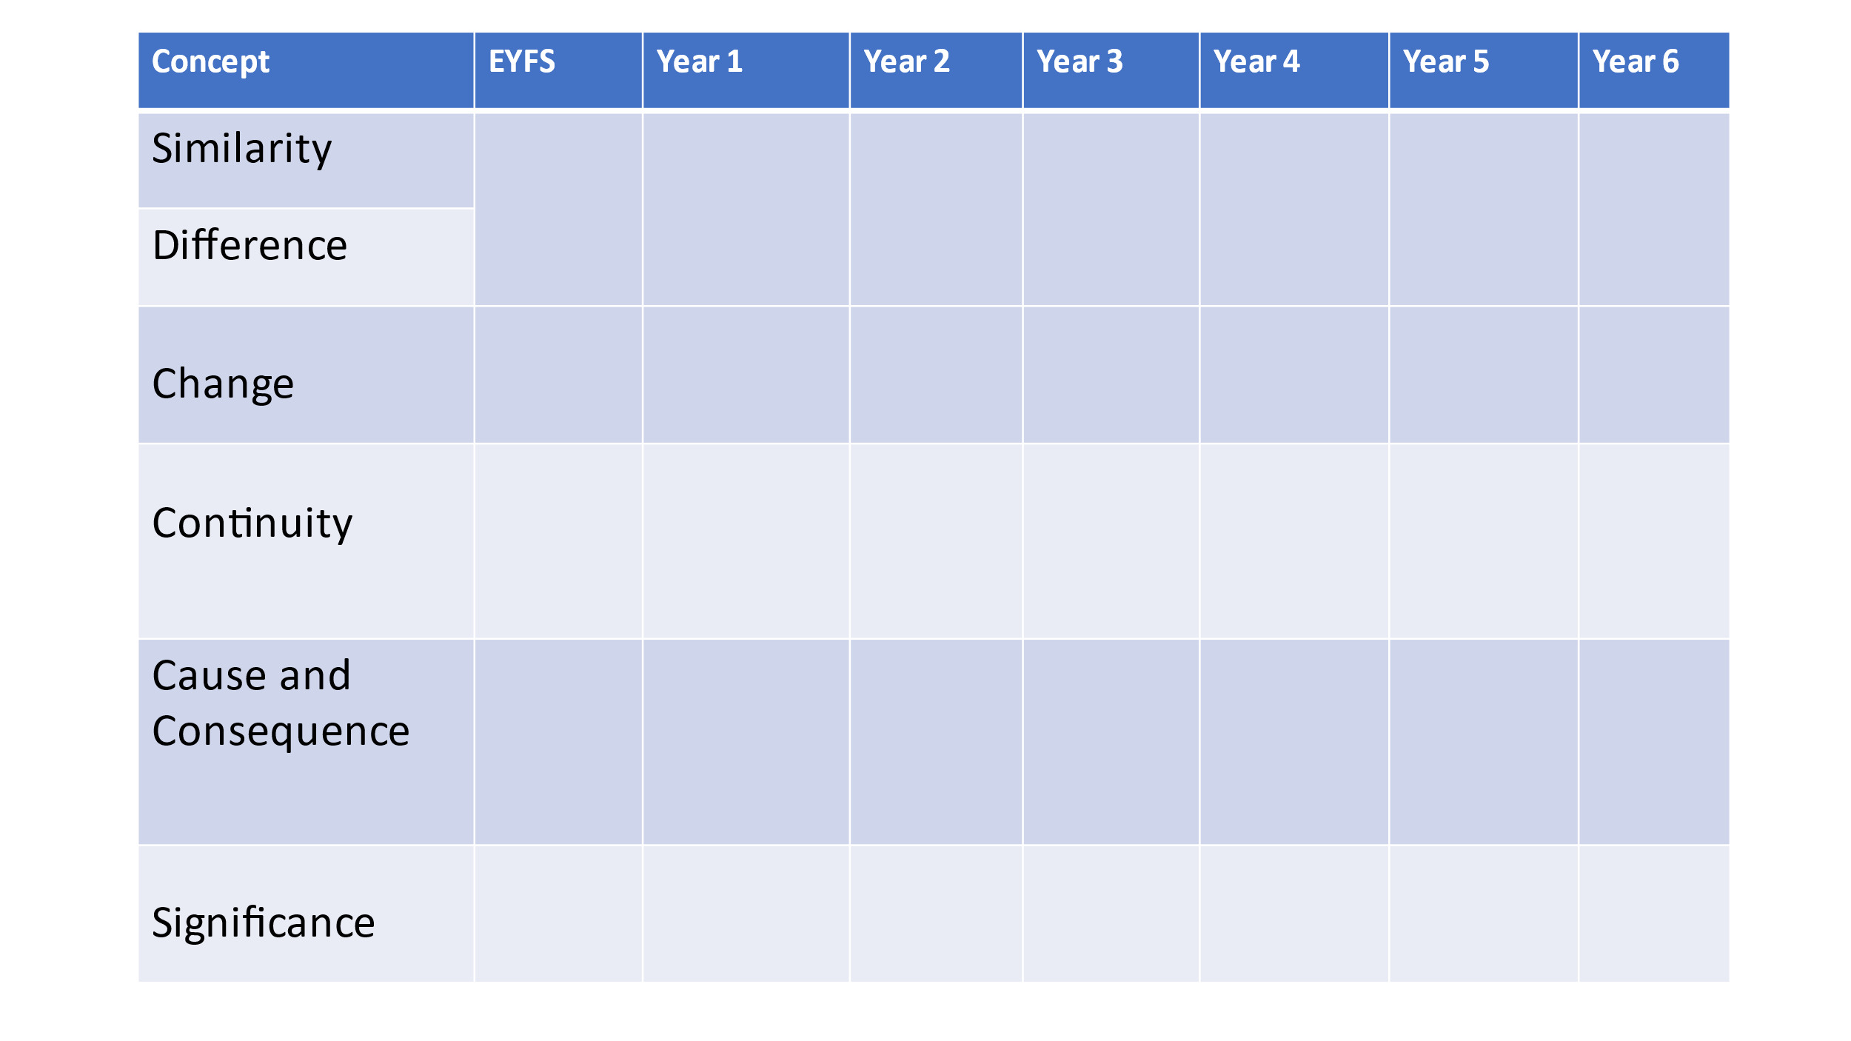Then think where your few chosen **substantive concepts/ golden threads** can be developed in the themes which you already teach. Where will you pick up the same “threads” and to develop further understanding for aspects of history, which children will meet in subsequent years? Again – this is best done as a whole school task, so all teachers can use the grid to build on prior learning and think how to support future learning. The following are just possible examples: You can discuss and select your own.

