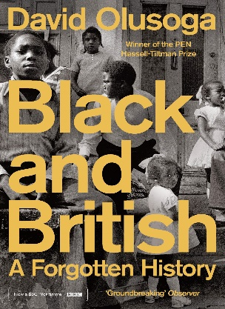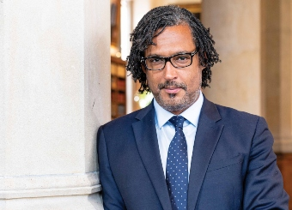

1. **What does Olusoga say England engaged with between 1608 and 1807?**

**Y8 HWK 2:**  **Reading the work of historians.**

David Olusoga

*‘Black and British, A Forgotten History’*

**4. How does he argue cities like these benefited?**

**3. Which cities does he argue benefitted most from the slave trade?**

**2. Select 2 pieces of evidence which Olusoga uses to argue Britain became the dominant slave-trading nation:**

**1)**

**2)**

‘Between 1618, when Richard Jobson recoiled at the mere suggestion that he or any Englishman would engage in the buying and selling of other human beings, and the passing, in 1807 of the Act of the Abolition of Slave Trade, Britain became the dominant slave-trading nation in the North Atlantic. Half of all the Africans who were carried into slavery over the course of the eighteenth century were transported in the holds of British ships. Some estimates put the total shipped by the British at around three and a half million. It took around eleven thousand separate slave trading expeditions to complete such a vast forced migration, a movement of people that remained without precedent until the twentieth century.

The wealth generated through the slave trade and the sale of the tropical goods that their labour produced transformed cities like Bristol, Liverpool and Glasgow into boom towns; frenetic centres of global commerce, investment, conspicuous consumption and philanthropic endeavour.’

|  |  |
| --- | --- |
| Add 5 challenging words in the text | Look them up and write a definition. |
| 1. **Abolition** |  |
|  |  |
|  |  |
|  |  |
|  |  |

**Own research:** What was the Transatlantic Slave Trade?

**Extra challenge:** Find 5 facts about the history of slavery or the Transatlantic Slave Trade