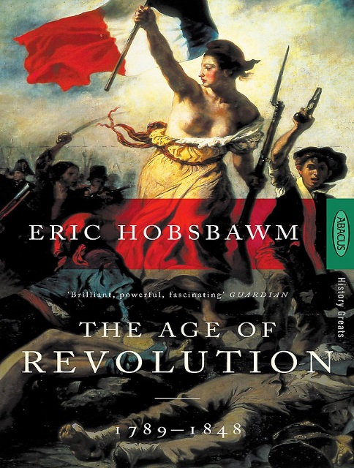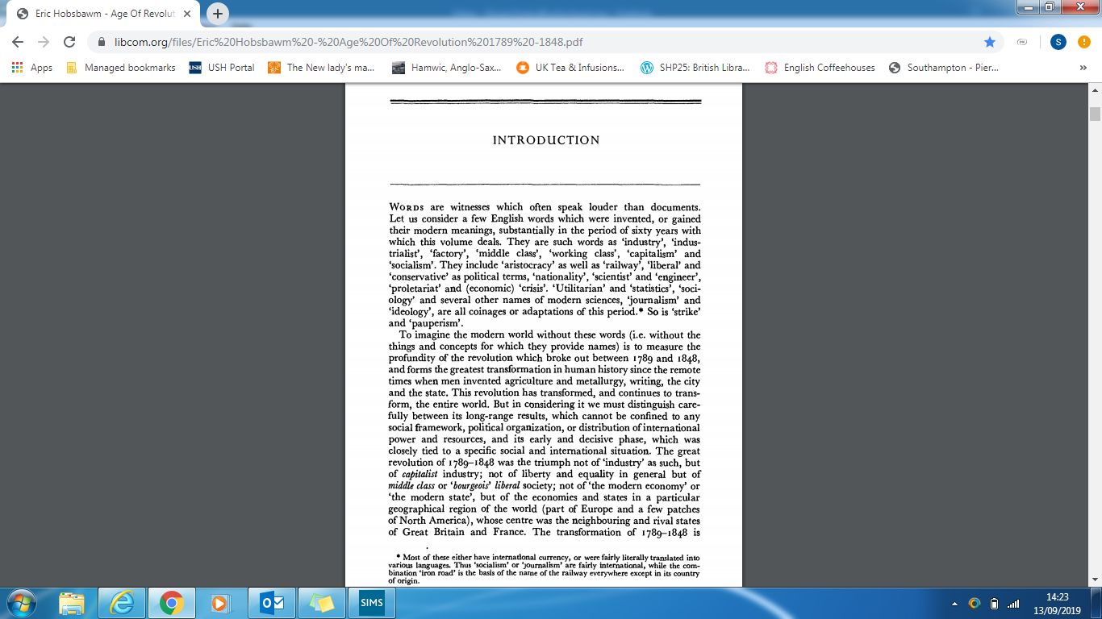

**Y8 HWK 1:**  **Reading the work of historians.**

Eric Hobsbawn.

*The Age of Revolution, 1789 – 1848.*

**HWK Challenge** (write your answers on the next page**):**

1. Look up the title of Hobsbawm’s famous book. **What was the ‘Age of Revolution’?**
2. Read through the first paragraph. Hobsbawm introduces a few English words ‘which were invented or gained modern meanings’ during the Age of Revolution. **Choose at least 5 words, look them up and write the definition for each.**
3. What types of changes happened as a result of the Age of Revolution? **Use the definitions for your words to sum up how the world changed.**
4. **Extra challenge:** Hobsbawm is an academic historian so do not worry if you don’t understand all of paragraph 2. It will take a lot of practice to read at this level. In this paragraph he is arguing why the Age of Revolution was so important. **Find** **one quote which shows how he does this.**

|  |  |
| --- | --- |
| New words from ‘The Age of Revolution’ | Definition |
|  |  |
|  |  |
|  |  |
|  |  |
|  |  |

**Extra challenge:** One quote Hobsbawm uses to argue the Age of Revolution was important is:

Sum up how your words reveal the world changed during the Age of Revolution.

The Age of Revolution is…