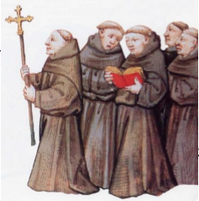

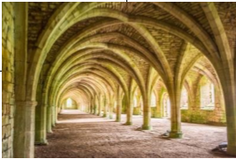
Year 7 Learning Task
Life of a Monk

Your learning task for the four lessons is to investigate the day in the life of a Medieval Monk.

Lesson | TASK TO BE COMPLETED
1 | Research Life as a Medieval Monk. Use the websites below to help. However, try to use other resources to complete your research. Reference books for example. Your research should be collected together in the form of bullet pointed information – not a collection of copy and paste.  https://www.ducksters.com/history/middle_ages_monastery.php  https://www.bbc.co.uk/bitesize/guides/znjnb9q/revision/3 https://www.ancient.eu/article/1293/the-daily-life-of-medieval-monks http://www.lordsandladies.org/daily-life-monk-middle-ages.htm https://schoolhistory.co.uk/notes/medieval-monasteries https://www.youtube.com/watch?v=ewbjWSAVDLI https://www.youtube.com/watch?v=ikicnfBQEcw
2 | Using the research that students have carried out they will need to create a storyboard about the day in the life of a medieval monk. They will need to consider both their monk’s role in the church is along with which order they belong to.
3 and 4 | Using this information will need to create a survival guide booklet for a newly arrived medieval monk. It will need to cover every aspect of life as a medieval monk. It will need to be detailed, neat and well laid out. Remember the novice will know nothing about life as a medieval monk so it will be your duty to show them how to behave.

