Did the Black Death make English nobles less powerful?
LO: to investigate and judge if the Black Death led to a loss of power for English nobility
STARTER:
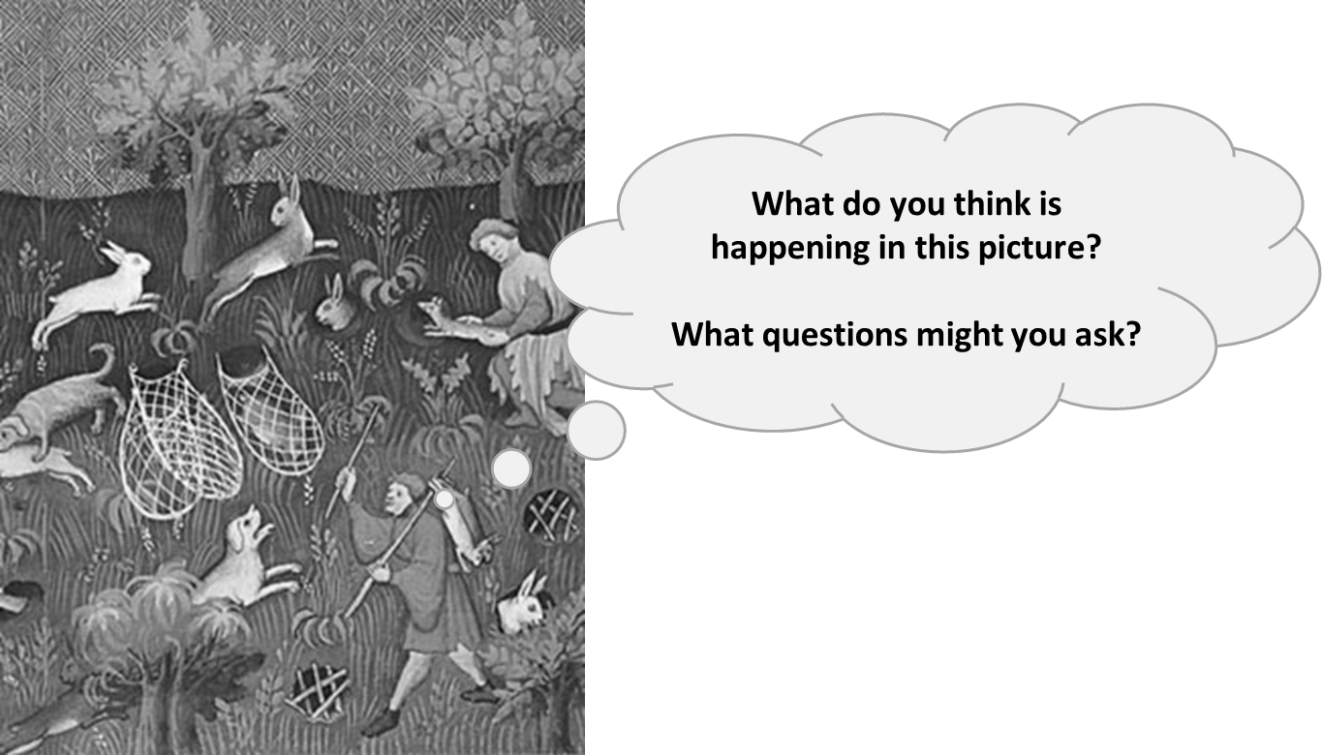
_____________________________________________________________________________________________________________________________________________________________________________________________________________

TASK ONE: Fill out the mind map with ideas of what you already know / remember about the Black Death in England.

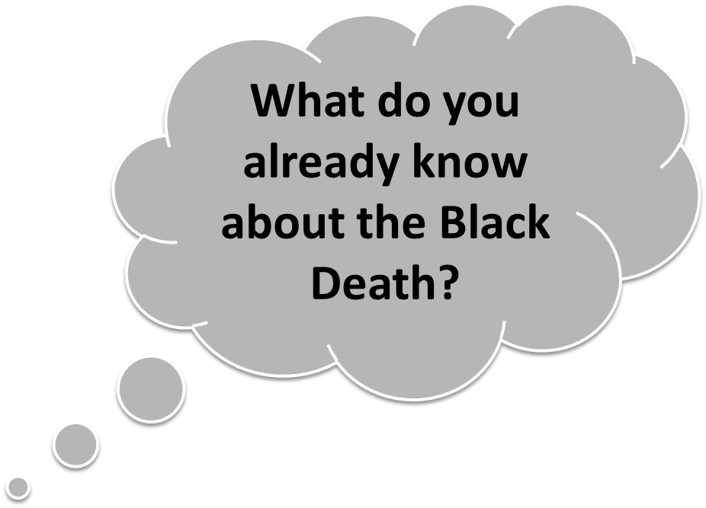

TASK TWO: Read the following information and use it to fill out the table.
Group | How did the Black Death change things? | Was it a positive or negative change? | How big was the impact? Why?
Peasants

The Nobles
The King

Information one - Peasants:
All the deaths as a result of the Plague meant that the surviving peasants in England and Western Europe benefitted. They were now able to travel to find work as so many people had died – leaving farms needing new farmers. Land was plentiful, wages high, and it was possible to move about and rise higher in life. Younger sons and women especially benefited. The upper classes attempted to stop these changes by putting in new laws. These regulated what people (particularly of the peasant class) could wear, so that nobles could ensure that peasants did not begin to dress and act as a richer person with their new money. Another tactic was to fix prices and wages so that peasants could not demand more. In England, a new law (Statute of Labourers 1351) was enforced, meaning no peasant could ask for more wages than in 1346.
Information two – Nobles:
Things began to change after the Black Death struck England. The Black Death left the nobles' land with shortages of workers, meaning there were not enough farmers to harvest the crops in autumn. Nobles had to sell freedom to their peasants in order to earn money, which made them less powerful as a result. This also led to the nobles becoming more equal to the peasants - peasants were now working harder for themselves and earning more money, meaning they were more able to gather money for themselves. Rich merchant nobles, however, sold their goods outside of the usual rules and helped them start to make an even bigger profit, allowing them to keep some of their power.
Information three – King:
Three of Edward's children, his daughter Joan and young sons, Thomas and William, who had been born in 1347 and 1348, died during the outbreak of bubonic plague in 1348. Edward had to deal with the economic issues caused by the Black Death. Attempts to control wages by introducing the Statute of Labourers Act made him unpopular with the people. Edward became even more unpopular – the laws against raising working wages, his war with France and the impact of the Black Death (seen as a punishment from God) meant that the people in England were unhappy with the way that he was ruling.

TASK THREE:
Read this historian’s interpretation and answer the following:
- What is he saying about the Black Death in England? _____________________________________________
________________________________________________________________________________________________________________________________________________________________________________
- Do you have evidence that supports his view? __________________________________________________
________________________________________________________________________________________________________________________________________________________________________________
- Do you have evidence that does not support his view? ___________________________________________
________________________________________________________________________________________________________________________________________________________________________________
- Do you agree with his interpretation? Why? ____________________________________________________
________________________________________________________________________________________________________________________________________________________________________________
“Inevitably it had an enormous impact on European society and greatly affected the dynamics of change and development from the medieval to Early Modern period. A historical turning point, as well as a vast human tragedy, the Black Death of 1346-53 is unparalleled in human history.”
Ole J. Benedictow, ‘The Black Death: The Greatest Catastrophe Ever’, History Today magazine

