Wavell School KS3 History (Year 7)
Tudor England workbook

Name:
Class:
Teachers name:
Classroom:

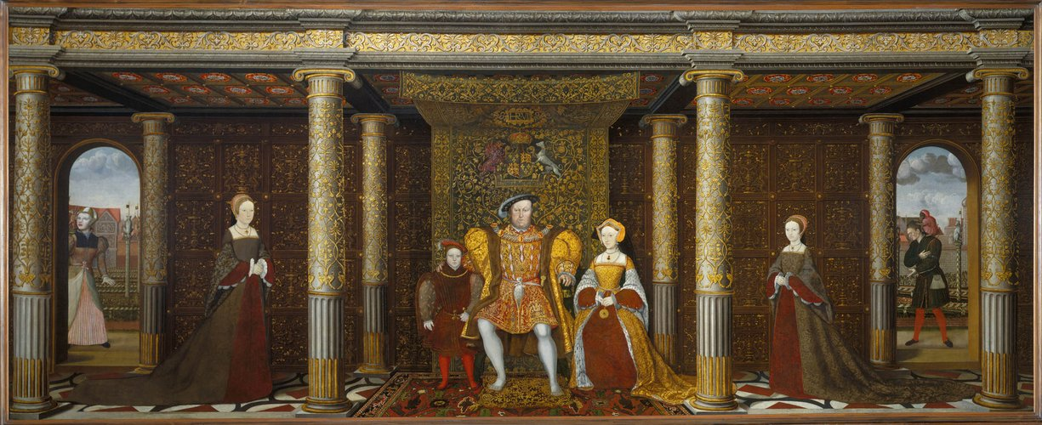
Picture from the Royal Collection Trust
Topic contents:

Date: _______________________
Who reigned before the Tudors?
LO: To recognise the Plantagenet dynasty and how they lost power in England.
TASK – Using the information on the next page fill in the blanks on the family tree.
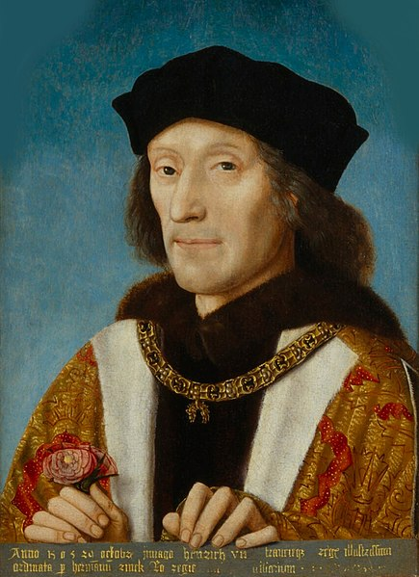
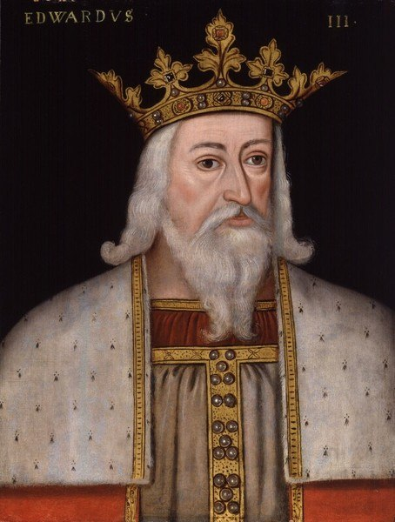
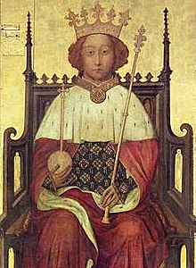
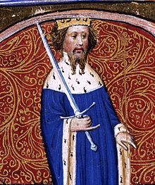
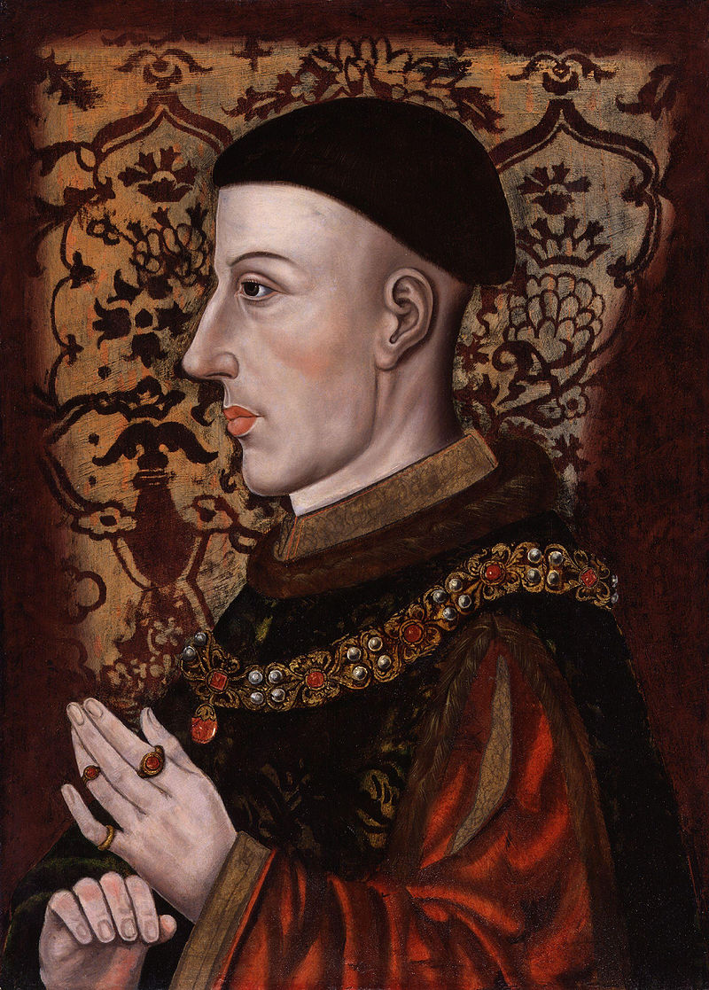
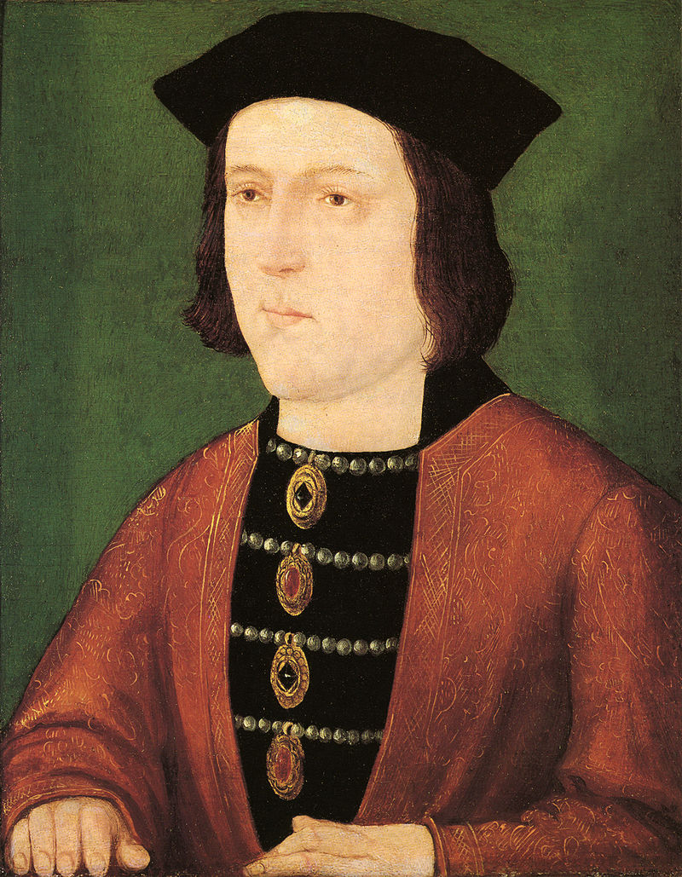
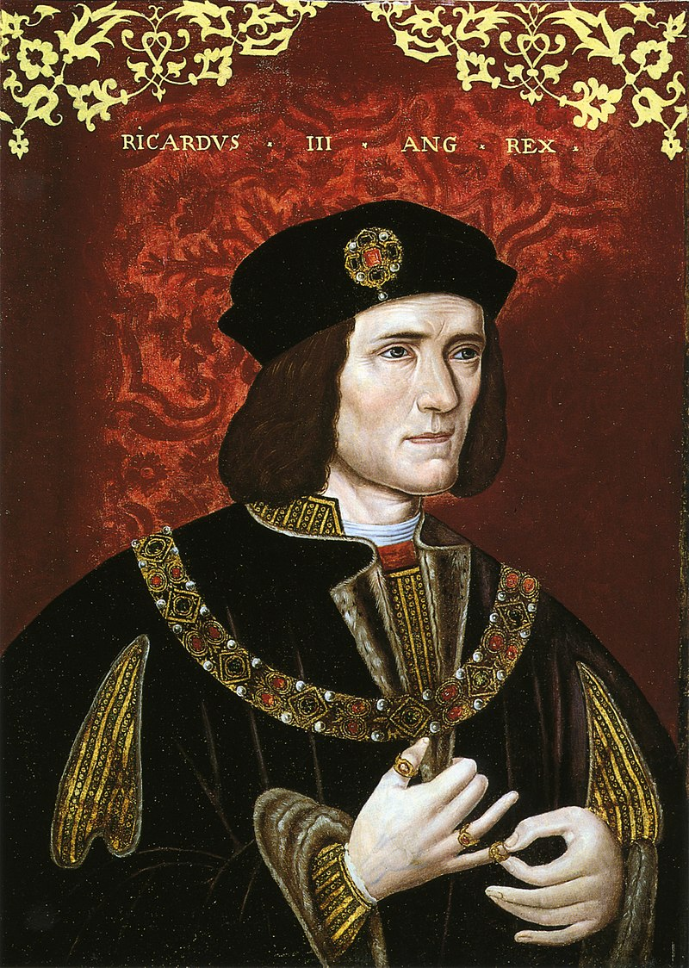
1327-1377
Edward, the Black Prince
John of Gaunt, Duke of Lancaster
Lionel, Duke of Clarence
Edmund, Duke of York
1377-1399
1399-1413
John Beaufort, Earl of Somerset (illegitimate)
1399-1413
Margaret Beaufort, Countess of Richmond and Derby
Richard, third Earl of Cambridge
Richard, third Duke of York
1461-1470 & 1471-1483
1483-1485
1485-1509

List of Kings and their Dates:
- Henry V – 1399-1413
- Edward IV – 1461-1470 & 1471
- Edward III – 1327-1377
- Richard III – 1483-1485
- Richard II – 1377-1399
- Henry IV – 1399-1413
- Henry VII – 1485-1509
Date: ________________________________
The Tudors
Who were the Tudors?
To recognise and identify the key events during the Tudor Period
TASK – Complete the key words word search.
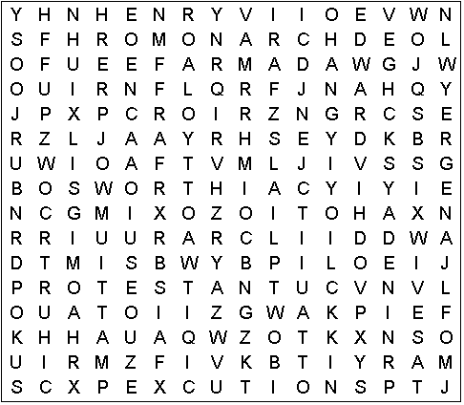
REFORMATION ELIZABETH I
PROTESTANT HENRY VIII EXECUTIONS HENRY VII EDWARD VI JANE GREY BOSWORTH SIX WIVES NINE DAYS CATHOLIC MONARCH ARMADA
MARY I

How did the Tudors become the reigning royal family?

