Big Question: Why did WW2 break out in 1939?
Little Question – How successful was the League of Nations?
LO: To be able to explain what the League of Nations was. To reach a judgement about how successful it was at stopping WW2
This will take you two lessons
Background: Towards the end of WWI, President Woodrow Wilson of America has called for the setting up of a world Parliament. This was to be a place where nations could meet together and settle arguments instead of going to war. After the war the League of Nations were formed in 1919.
The aims of the League were:
- To protect the independence of countries which belonged to the League. This was done by arranging help if a country was attacked. It was called Collective Security.
- To help countries which had disagreements to talk about their problems instead of going to war.
- To make sure that former German Colonies were governed fairly and prepared for independence.
- To encourage nations to keep fewer weapons.
- To help improve living and working conditions of all people.

QA) What do you think the most important aim of the League was? Why?
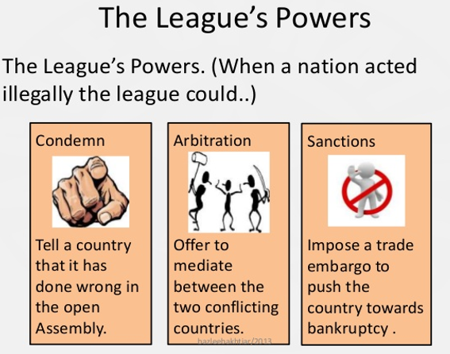
……………………………………………………………………………………………………………………………………………………………………................................................................
- Even though the League of Nations was mainly the idea of the President of USA, Woodrow Wilson, US Congress (parliament) decided the USA would not join because many Americans did not want to get involved in any more world affairs.
- Without America – Britain and France were the strongest countries in the League but they had been weakened by WWI.
- Germany was not allowed to join because of WWI (until 1926).
- Soviet Union (Russia) was not allowed to join because of their revolution in 1917 which meant the country was now run by Communist (joined in 1934).

Problems:
- The League did not have its own army and relied on members to provide troops (unpopular after WWI and cost money)
- Many countries had economic problems after WWI and during the Great Depression so were unwilling to issue economic sanctions (i.e. stop trade)
- The USA did not support the League’s decisions – some countries may have listened to them more.
- Most countries wanted to avoid a war and keep allies e.g. Mussolini and Hitler were seen as better than Communist Russia and would help stop it spreading to other countries!
- The leading countries in the League e.g. Britain, France, Italy and Japan had the power of veto – this meant if one country disagreed over an action that the League should take. They had to start the talks again.
QB) What strengths and weaknesses do you think the League had?
……………………………………………………………………………………………………………………………………………………………………………………………………………………………………

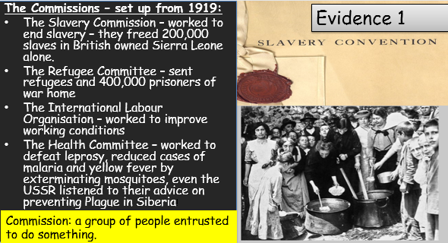
How successful was the League?

Q1a) What work did the Commissions do to help the world?
……………………………………………………………………………………………………………………………………………………………………………………………………………………………………
Q1b) How successful was the League?
……………………………………………………………………………………………………………………………………………………………………………………………………………………………………

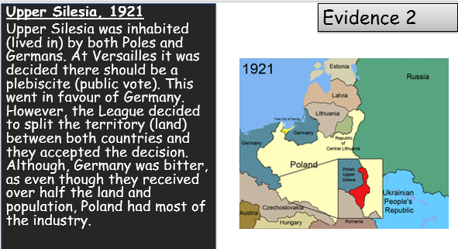

Q2a) What was the problem in Upper Silesia?
……………………………………………………………………………………………………………………………………………………………………………………………………………………………………
Q2b) What impact did the League have? How did the League solve the problem?
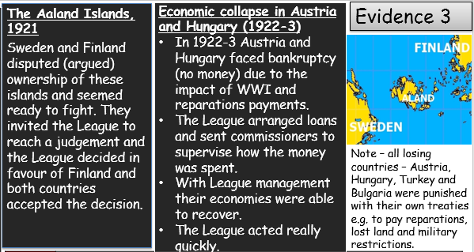
……………………………………………………………………………………………………………………………………………………………………………………………………………………………………

Q3a) What was the problems were there in the Aaland Islands, Austria and Hungary?
………………………………………………………………………………………………………………………………………………………………………………………………………………………………………………………………………………………………………………………………………………………
Q3b) What impact did the League have? How did the League solve the problem?
……………………………………………………………………………………………………………………………………………………………………………………………………………………………………
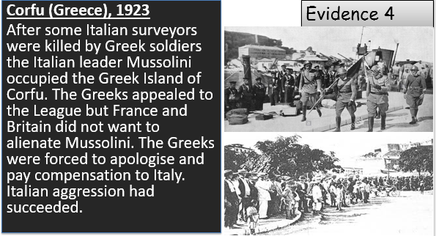

Q4a) What was the problems in Corfu?
………………………………………………………………………………………………………………………………………………………………………………………………………………………………………………………………………………………………………………………………………………………
Q4b) What impact did the League have? How did the League solve the problem?
……………………………………………………………………………………………………………………………………………………………………………………………………………………………………
Review of the League in the 1920s?

How was the League successful in the 1920s and why?
……………………………………………………………………………………………………………………………………………………………………………………………………………………………………

Was the League able to stand up to larger more powerful nations (e.g. Italy)?
……………………………………………………………………………………………………………………………………………………………………………………………………………………………………

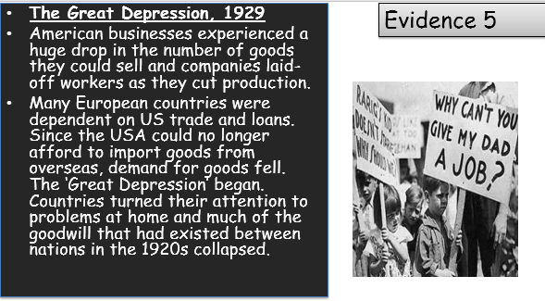

Q5a) What problems did the Great Depression cause?
……………………………………………………………………………………………………………………………………………………………………………………………………………………………………
Q5b) What did the event mean for international relations (relationships between countries?
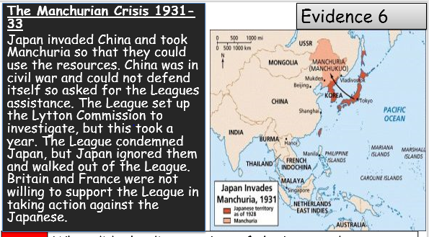
……………………………………………………………………………………………………………………………………………………………………………………………………………………………………

Q6a) What was the problem in Manchuria?
……………………………………………………………………………………………………………………………………………………………………………………………………………………………………
Q6b) What impact did the League have? What did the League do?
……………………………………………………………………………………………………………………………………………………………………………………………………………………………………
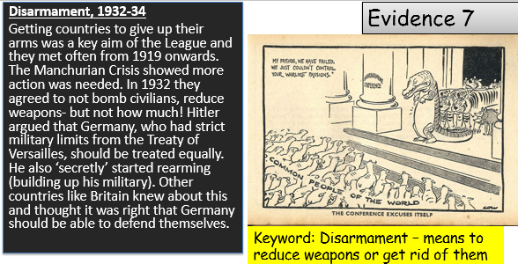

Q7a) What was agreed at the disarmament conferences?
……………………………………………………………………………………………………………………………………………………………………………………………………………………………………
Q7b) What impact did the League have? What did the League do?
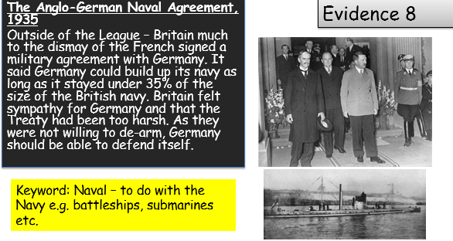
……………………………………………………………………………………………………………………………………………………………………………………………………………………………………
Q8a) What did Britain agree with Germany and why?
……………………………………………………………………………………………………………………………………………………………………………………………………………………………………
Q8b) How did Britain undermine (go against) the League? (what were they giving Hitler permission to do? Remember under the Treaty of Versailles – Germany’s armed forces were limited.)
……………………………………………………………………………………………………………………………………………………………………………………………………………………………………
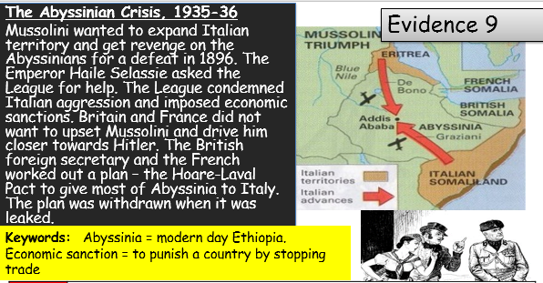

Q9a) What was the problem in Abyssinia?
……………………………………………………………………………………………………………………………………………………………………………………………………………………………………
Q9b) What impact did the League have? What did the League do?
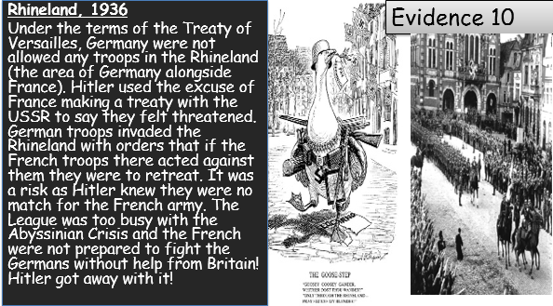
……………………………………………………………………………………………………………………………………………………………………………………………………………………………………
Q9a) What was the problem in the Rhineland?
……………………………………………………………………………………………………………………………………………………………………………………………………………………………………
Q9b) What impact did the League have? What did the League do?
……………………………………………………………………………………………………………………………………………………………………………………………………………………………………

By 1936, the League was virtually ineffective. Britain and France ended up negotiating outside of the League. Germany, Japan and Italy were becoming more aggressive as they seemingly got away with breaking League rules. The success of the League relied on co-operation, and these larger countries were difficult to handle without access to money and an army!
Review:
- What did the league succeed at?
……………………………………………………………………………………………………………………………………………………………………………………………………………………………………
- When were they the most successful?
……………………………………………………………………………………………………………………………………………………………………………………………………………………………………
- What were they not so good at dealing with?
……………………………………………………………………………………………………………………………………………………………………………………………………………………………………
- Why were problems after 1929 so difficult to tackle? (the Depression)
……………………………………………………………………………………………………………………………………………………………………………………………………………………………………
Answer:
- Why could the failure of the League of Nations be considered to be a cause of WWII?
……………………………………………………………………………………………………………………………………………………………………………………………………………………………………
……………………………………………………………………………………………………………………………………………………………………………………………………………………………………
……………………………………………………………………………………………………………………………………………………………………………………………………………………………………
……………………………………………………………………………………………………………………………………………………………………………………………………………………………………

