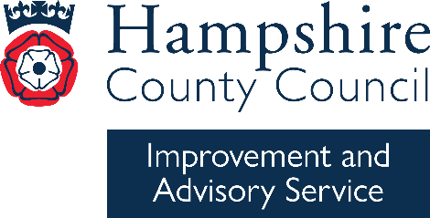

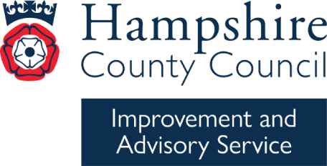
Medium-term plan
Year group: |  |  | Term:
Topic/unit:
Children make progress in |  | Evidence for knowledge/understanding developed
Substantive knowledge (what we want children to know and remember)
Disciplinary knowledge (use HIAS AREs)
Key question to drive the enquiry to promote children’s progress: why did the Great fire of London cause so much damage and what happened as a result?
Knowledge specific vocabulary |  | Promoting SMSC
 |  | Cross-curricular links
Resources

